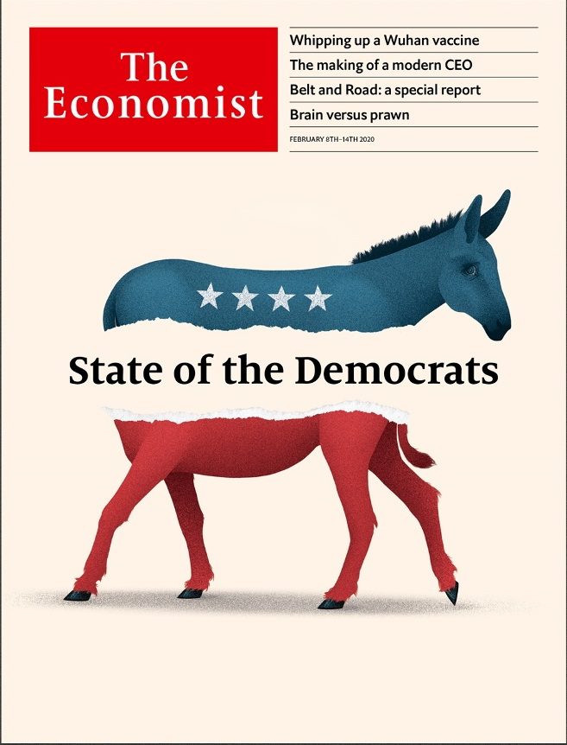

# Table of Contents

The world this week

Politics this week

Business this week

KAL’s cartoon

Leaders

Management in the 2020s: Meet the new boss

The presidential election: State of the Democrats

The economic fallout in Hong Kong: Three strikes

Congo and Malawi: A tale of two elections

Investing in rail: High speed ahead

Letters

Letters to the editor: On the Holocaust, #MeToo, diplomacy, Russia, mosques, Portugal, sporting metaphors

Briefing

The Democratic race: Iowa and after

Headhunters: Take me to a leader

United States

Donald Trump’s record: What he did, not what he said

New Hampshire’s turn: Waiting for Bernie

Testing and college admissions: What’s SAT

Government architecture: Column inches

Public transport: In a jam

Lexington: Trump unbound

The Americas

Ecuador: The future of the undoing project

Colombia: Wine whinge

Venezuela: Rum raisin’

Bello: A new war of religion

Asia

Law and order in India: Pish cosh

Shrimp-farming in Asia: Brain v prawn

Pakistani prisoners in Saudi Arabia: Junk bondage

Gambling in Japan: The chips are down

Banyan: The ministries of truth

China

The Wuhan virus: Under observation

Hong Kong and the mainland: Keep out

Chaguan: A people’s war

Middle East and Africa

Congo: Not much to celebrate

Kenya: Après Moi

Mixed marriages: Conscious coupling

Malawi: Let’s do this again

Yemen and Iran: The Houthi model of government

Europe

Germany: The splintering states

Turkey: The new Turks

Russia: The vagaries of memory

Ireland: The worrying rise of Sinn Fein

Norway: Ecowarriors bankrolled by oil

Charlemagne: The parable of the plug

Britain

EU-UK negotiations: There may be trouble ahead

Aristocrats’ jobs: Courting fame

Rail: Return of the fat controller

Urban infrastructure: Euston, we have a solution

Nuclear weapons: Critical condition

Slavery and universities: Ties that bind

Bagehot: Cummings v the blob

International

Coronavirus: Run, don’t walk

Special report

China’s Belt and Road: Return to centre

The belt: Tighten up a notch

The road: A long game

Of belts and roads: What’s in a name?

The digital Silk Road: The future stage

The future: Wanted: new maps

Business

USA Inc: Goldilocks and the three bears

Fast and furious: Tesla gains $60bn in market value in a week

Technology C-suites: Time for an update

Bartleby: I am Number 0.6

Goldmining: Golden retrievers

Business in India: Buy and sell tax-and-spend

Schumpeter: Ace in a hole

Finance and economics

Hong Kong’s economy: A train of troubles

China’s economy: Viral injections

Contagion effects: What the coronavirus means for financial markets

Financial markets: Knocking off work

ICE bids for eBay: Making an offer

Banking in India: Small change

Buttonwood: Two tribes

Free exchange: Progress of a sort

Science and technology

Agriculture: Farming with Tom, Dick and Harry

Oncology: The topography of tumours

Neuroscience: Lost in the city

Books and arts

French cinema: Sounding the alarm

Literature and beyond: Marriage story

Trade secrets: As you sow

Indian fiction: Tales of a city

War and its aftermath: The inferno

Economic and financial indicators

Economic data, commodities and markets

Graphic detail

Music and moods: Sad songs say so much

Obituary

Homero Gómez: Logger turned saviour



### Friday, February 7, 2020

|  |  |
| --- | --- |
| The world this week | 3 |
| Leaders | 5 |
| Letters | 1 |
| Briefing | 2 |
| United States | 6 |
| The Americas | 4 |
| Asia | 5 |
| China | 3 |
| Middle East and Africa | 5 |
| Europe | 6 |
| Britain | 7 |
| International | 1 |
| Special report | 7 |
| Business | 7 |
| Finance and economics | 8 |
| Science and technology | 3 |
| Books and arts | 5 |
| Economic and financial indicators | 1 |
| Graphic detail | 1 |
| Obituary | 1 |

|  |  |  |
| --- | --- | --- |
|  | Sections | Leaders |

The world this week

Politics this week

.

Business this week

.

KAL’s cartoon

.

|  |  |  |
| --- | --- | --- |
|  | Sections | Leaders |

|  |  |  |  |
| --- | --- | --- | --- |
|  | Articles | Sections | Next |

# Politics this week

Feb 8th 2020 |

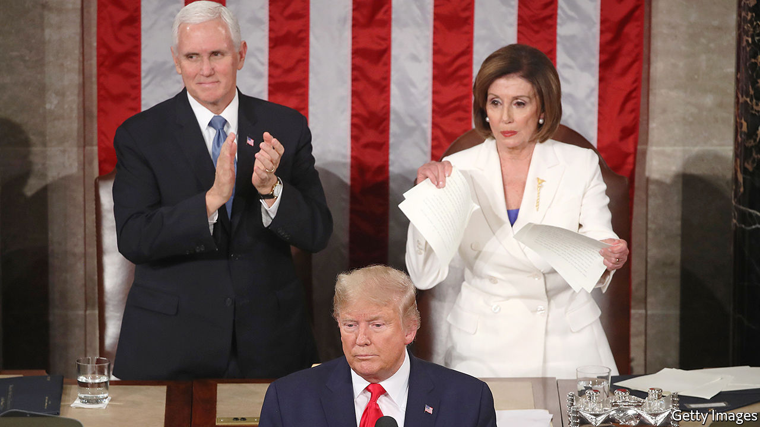

The American Senate acquitted Donald Trump of the impeachment charges laid against him, bringing a swift end to the trial of the president after the Republican leadership decided that no witnesses should be called. Mitt Romney was the only Republican to vote for conviction, denouncing Mr Trump for “an appalling abuse of public trust”. See [article](https://www.economist.com/node/21779278).

The day before the verdict Mr Trump used his state-of-the-union speech to laud a “great American comeback” under his administration. Congress was in a poisonous mood. Mr Trump refused to shake the hand of Nancy Pelosi, the Democratic Speaker. She ripped up a copy of his speech after he finished speaking.

The Iowa caucuses, the first stage in the race to nominate presidential candidates, were a mess. The state’s Democrats cast their votes for a champion to take on Donald Trump. But owing to a dodgy app and an insanely complex voting system, they struggled to count the results. Both Pete Buttigieg, a bright young moderate, and Bernie Sanders, an ageing socialist, claimed victory. The race now moves on to New Hampshire. See article.

The Trump administration added Eritrea, Kyrgyzstan, Myanmar, Nigeria, Sudan and Tanzania to a list of countries from which immigration to the United States is severely curtailed. The restrictions were imposed for failing to meet security criteria. The government said it was confident the countries would make “meaningful improvements” so that the curbs could be lifted.

## Invading the sanctuary

A tour guide at a Mexican reserve for Monarch butterflies was found dead. Last month the sanctuary’s manager, Homero Gómez, disappeared (see Obituary). His body was later found in a well. Environmentalists suspect that the two men were murdered by loggers, who operate illegally near the sanctuary in the western state of Michoacán. In a separate incident in the state, nine people were shot dead at an amusement arcade, probably by a drug gang.

A Canadian court rejected a challenge by indigenous groups to the government’s plan to expand the capacity of the Trans Mountain oil pipeline, which stretches from Alberta to the west coast. The court ruled that the government, which owns the existing pipeline, had carried out reasonable consultations with indigenous peoples.

## The Wuhan ban

The number of infections and deaths from the Wuhan virus continued to rise. More than 99% of the cases are in China. Several countries, including America and Australia, banned the entry of non-citizens who have recently visited China. Hong Kong announced that visitors from the Chinese mainland would have to undergo quarantine for 14 days; medical workers went on strike, calling for a complete closure of the Hong Kong-mainland border. A Chinese diplomat accused other countries of over-reacting by barring travellers from China. See [here](https://www.economist.com/node/21779300), [here](https://www.economist.com/node/21779300) and here.

India’s government unveiled a budget without any big increase in spending or cut in taxes, dashing investors’ hopes that it might try to stimulate the flagging economy. GDP grew by 4.8% last year, a big drop from 6.8% in 2018.

The vice-president-elect of Taiwan, William Lai Ching-te, said he would attend the National Prayer Breakfast in Washington, DC. He would be the most senior Taiwanese official to visit Washington since America established formal diplomatic relations with China in 1979.

## Movement for democracy

Malawi’s constitutional court nullified last year’s election, saying there had been “systematic and grave” flaws in the process. It is only the second time in African history that judges have overturned an iffy general election. The court ordered that a re-run be held within 150 days. President Peter Mutharika said he would appeal against the ruling. See here and here.

The wife of Lesotho’s prime minister was charged with murdering his previous wife. Maesaiah Thabane surrendered to police. The prime minister, Thomas Thabane, has also been questioned over the killing, which occurred during a heated divorce.

Daniel arap Moi, Kenya’s former strongman, died at the age of 95. Mr Moi led Kenya from 1978 to 2002, a period of relative stability. But he was also responsible for repression, corruption and ethnic division. See [article](https://www.economist.com/node/21779270).

Eight Turkish soldiers were killed in the Syrian province of Idlib during shelling by the Syrian army. In response, Turkey claimed to have “neutralised” 76 Syrian troops. Idlib is the last stronghold of the Syrian opposition. Turkey fears that if it falls people will flee over the Turkish border.

Muhammad Tawfiq Allawi, a former communications minister, was named Iraq’s prime minister. Mr Allawi’s predecessor, Adel Abdul-Mahdi, resigned in November amid large anti-government protests during which hundreds of people have been killed.

Iran stopped co-operating with Ukraine’s inquiry into the downing of a Ukrainian passenger jet by an Iranian missile over Tehran last month. The decision was made after Ukrainian TV aired an exchange between Iranian air-traffic control and a stunned pilot who saw the explosion. Iran at first tried to cover up the incident.

## They think it’s all over

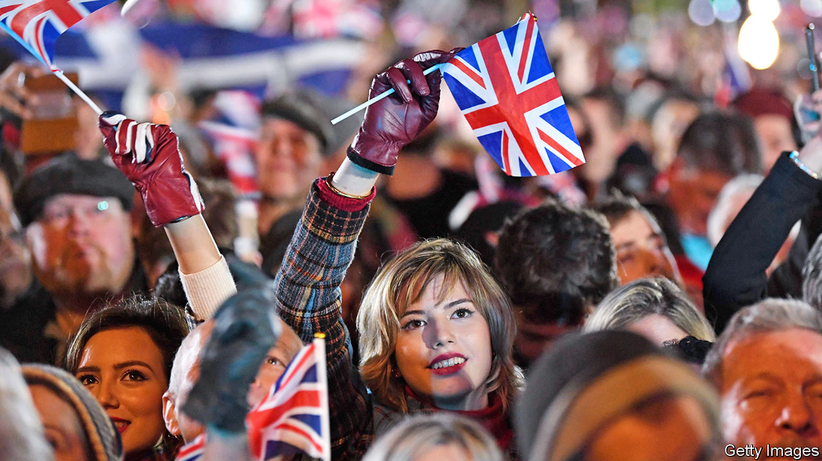

Boris Johnson’s government finally pushed Brexit over the line, but events to mark the occasion only underlined the lingering divisions between Leave and Remain supporters. The prime minister’s hope for a Canada-style trade deal was given short shrift, as the European Union signalled that any ambitious agreement would require Britain to commit itself to social and labour protections similar to the EU’s. The pound wobbled. See article.

The British government set a deadline for the end of February to pass emergency legislation removing the default that convicted terrorists are released after serving half their sentence. This follows the stabbing of two people in London by a jihadist who had just been released. A similar fatal attack last November raised questions about the effectiveness of rehabilitation for violent radicals. Six inmates are due for release in the coming weeks.

A minority administration under the Free Democrats was voted in by the German state of Thuringia, in eastern Germany. For the first time, a state premier took office thanks to support from the xenophobic Alternative for Germany. The vice-chancellor of the federal government said this distasteful alliance threatened to break up the ruling “grand coalition”. See [article](https://www.economist.com/node/21779263).

This article was downloaded by calibre from <https://www.economist.com/the-world-this-week/2020/02/08/politics-this-week>

|  |  |  |  |
| --- | --- | --- | --- |
|  | Articles | Sections | Next |

|  |  |  |  |
| --- | --- | --- | --- |
| Previous | Articles | Sections | Next |

# Business this week

Feb 8th 2020 |

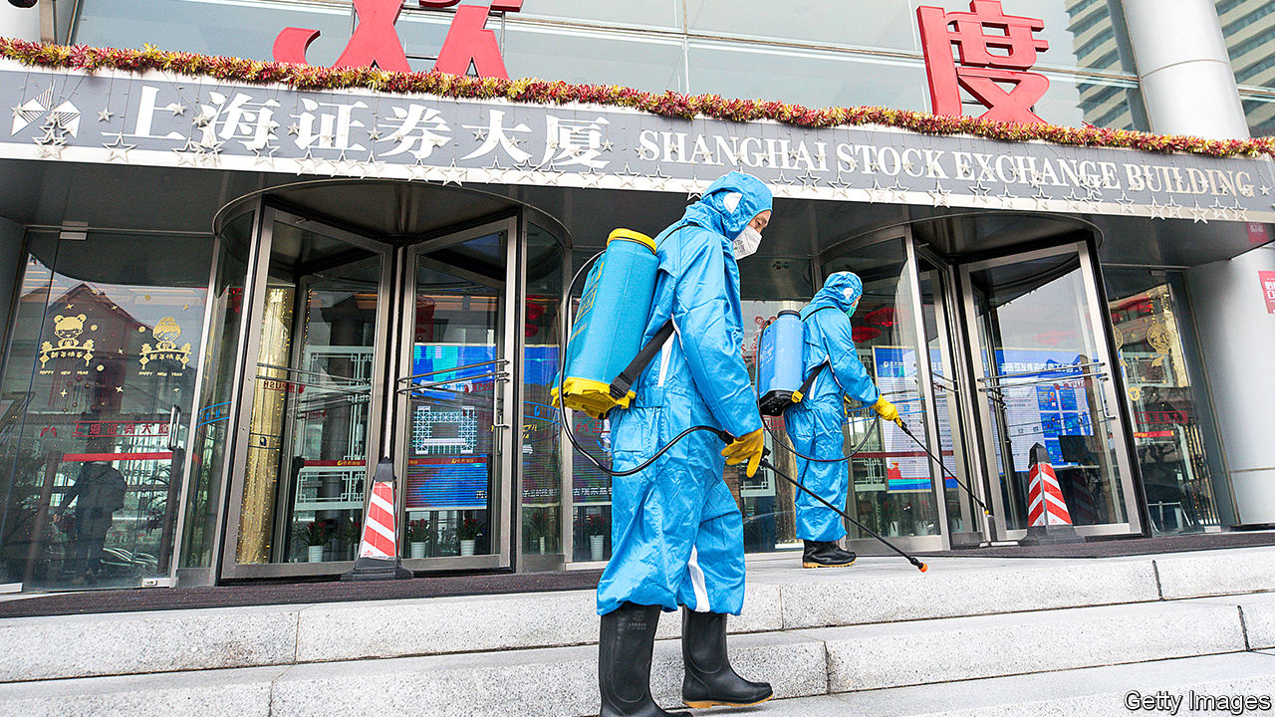

The coronavirus crisis in China unnerved the country’s stockmarkets. The CSI index fell by 8% in a day, its worst performance since August 2015, before rebounding somewhat. As an emergency measure China’s central bank injected extra liquidity into the financial system, the biggest such one-day intervention since 2004, and cut some interest rates. Macau closed its casinos for two weeks. See article.

China is the linchpin in the supply chains of many global manufacturers, but the disruption from the coronavirus lockdown has been most acute in the motor industry. Hyundai halted production at its factories in South Korea because it couldn’t get components from China. Many foreign carmakers in China extended the Chinese new year break and kept their plants closed.

Keeping to one of its pledges in the “phase one” trade deal with America, China’s government said it would cut tariffs on $75bn-worth of American exports. Some said the announcement was timed to cheer the markets. China is also committed to make extensive purchases of American goods under phase one, but that could be difficult amid the coronavirus outbreak.

The price of oil fell sharply, in part because demand from Chinese industry and international airlines is expected to drop because of the Wuhan virus. OPEC and Russia met to discuss emergency cuts to output that could shore up prices. BP said that the outbreak could reduce projected global growth in oil demand this year by up to 40%.

Along with other international energy companies, BP reported a plunge in annual income. The company’s headline profit, hurt by lower oil prices, fell by a fifth in 2019, to $10bn. Still, BP raised its shareholder dividend and said it had completed a share buy-back programme. It was Bob Dudley’s last earnings report as chief executive before handing the reins to Bernard Looney.

## Electrifying

Tesla’s share price crashed by 17% on February 5th, bringing an end to a remarkable rally. The carmaker had added more than $40bn to its value over two trading days, taking its market capitalisation to roughly $160bn; Ford is worth less than $40bn on the market. But will the rally resume? See article.

The British government brought forward a target for a ban on new diesel, hybrid and petrol vehicles from 2040 to 2035. The motor industry slammed the plan as unworkable. SMMT, an industry body, accused the government of moving the goalposts, noting that while new plug-in models are coming to the market, the overall demand for the “expensive technology” still makes up “a fraction of sales”. The government was unable to provide much detail on the cost implications for the industry or taxpayers, simply saying it would result in “a net saving”.

Aston Martin agreed to a rescue deal put forward by a consortium led by Lawrence Stroll, a Canadian businessman. Under the agreement the struggling British sports-car maker will receive a capital injection and issue new shares. Mr Stroll’s Formula One racing team will be rebranded with the Aston Martin name.

Disney+ now has 28.6m subscribers, according to Robert Iger, Disney’s chief executive. That is well above market expectations, less than three months after the streaming service was launched. The cost of rolling out Disney+ has dented profit. Although revenue was up by 36% in the last three months of 2019 compared with the same quarter a year earlier, Disney’s net income was down by 23%.

Tony Fernandes stepped aside as chief executive of AirAsia for at least two months, after the Malaysian airline was linked to a bribery investigation involving Airbus. Airbus recently settled with Britain’s Serious Fraud Office and regulators in other countries for $4bn. Mr Fernandes, an ebullient entrepreneur, who also owns Queens Park Rangers, a London football club, bought AirAsia in 2001 for 1 ringgit (26 cents) with his business partner, Kamarudin Meranun, who is also standing aside as AirAsia’s chairman. Both men deny wrongdoing.

The American economy grew by 2.3% last year. That was the slowest pace since 2016 but around the annual average since the global financial crisis of 2007-09. An initial estimate found that the euro zone’s GDP grew by 1.2% in 2019, the weakest rate since 2013. See article.

## The deepest cut

It was a hairy week for the razor industry, as the Federal Trade Commission launched a bid to block the proposed takeover of Harry’s, an online supplier of shaving gear, by Edgewell, which owns the Schick and Wilkinson Sword brands. The FTC described Harry’s as a “uniquely disruptive competitor in the wet shave market” that has broken the duopoly of Edgewell and Procter & Gamble’s Gillette. Harry’s co-founders bristled at the decision; they believe the acquisition should go ahead.

This article was downloaded by calibre from <https://www.economist.com/the-world-this-week/2020/02/08/business-this-week>

|  |  |  |  |
| --- | --- | --- | --- |
| Previous | Articles | Sections | Next |

|  |  |  |  |
| --- | --- | --- | --- |
| Previous | Articles | Sections | Next |

# KAL’s cartoon

Feb 8th 2020 |

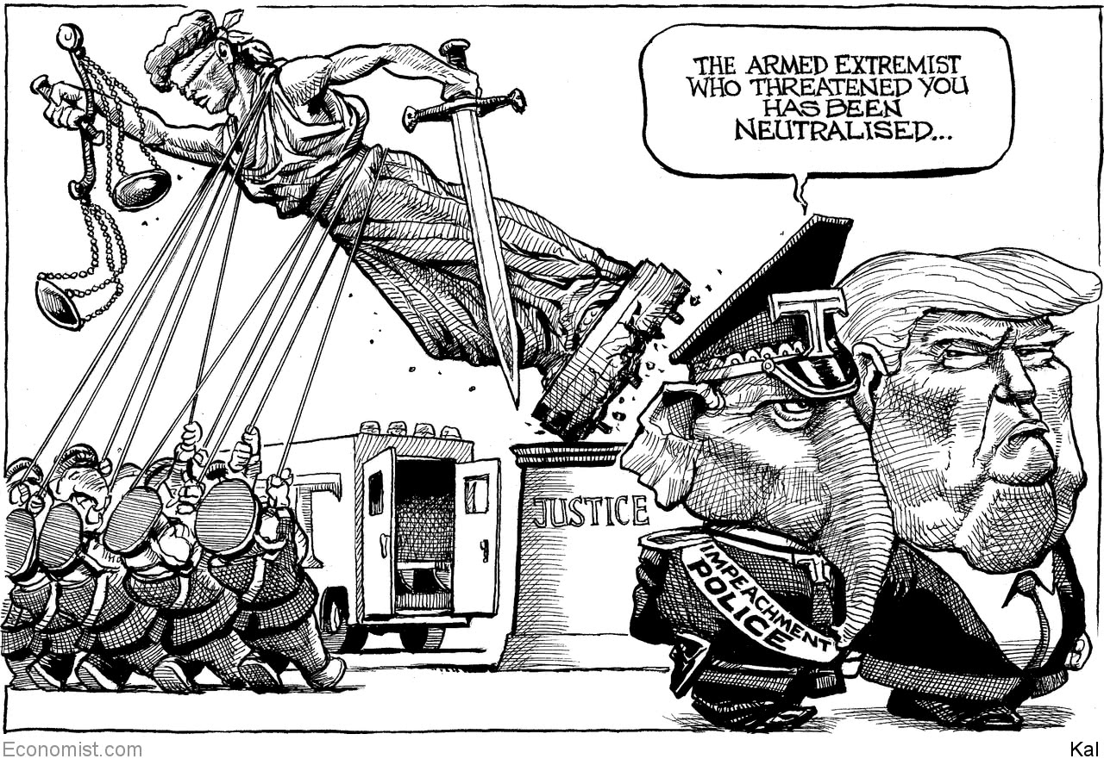

This article was downloaded by calibre from <https://www.economist.com/the-world-this-week/2020/02/08/kals-cartoon>

|  |  |  |  |
| --- | --- | --- | --- |
| Previous | Articles | Sections | Next |

|  |  |  |
| --- | --- | --- |
| The world this week | Sections | Letters |

Leaders

Management in the 2020s: Meet the new boss

.

The presidential election: State of the Democrats

.

The economic fallout in Hong Kong: Three strikes

.

Congo and Malawi: A tale of two elections

.

Investing in rail: High speed ahead

.

|  |  |  |
| --- | --- | --- |
| The world this week | Sections | Letters |

|  |  |  |  |
| --- | --- | --- | --- |
|  | Articles | Sections | Next |

#### Meet the new boss

# What it takes to be a CEO in the 2020s

The rules of management are being ripped up. Bosses need to adapt

Feb 6th 2020 |

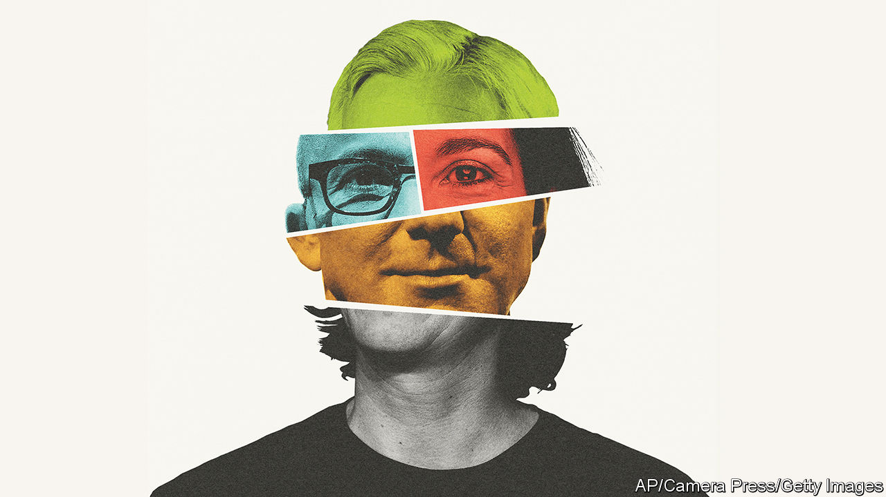

ON PAPER THIS is a golden age for bosses. Chief executives have vast power. The 500 people who run America’s largest listed firms hold sway over 26m staff. Profits are high and the economy is purring. The pay is fantastic: the median of those CEOs pockets $13m a year. Sundar Pichai at Alphabet has just got a deal worth up to $246m by 2023. The risks are tolerable: your chances of being fired or retiring in any year are about 10%. CEOs often get away with a dreadful performance. In April Ginni Rometty will stand down from IBM after eight years in which Big Blue’s shares have trailed the stockmarket by 202%. Adam Neumann got high in private jets and lost $4bn before being ousted from WeWork last year. The only big drawback is all those meetings, which eat up two-thirds of the typical boss’s working hours.

Yet CEOs say the job has got harder. Most point the finger at “disruption”, the idea that competition is more intense. But they have been saying that for years. In fact the evidence suggests that, as America’s economy has become more sclerotic, big firms have been able to count on cranking out high profits for longer. Nonetheless, bosses are right that something has changed. The nature of the job is being disrupted. In particular, CEOs’ mechanism for exercising control over their vast enterprises is failing, and where and why firms operate is in flux. That has big implications for business, and for anyone climbing the corporate ladder.

Few subjects attract more voodoo analysis than management. Even so, studies suggest that the quality of an American firm’s leadership explains about 15% of the variance in profitability. But boards and headhunters struggle to identify who will do a good job (see Briefing). Perhaps as a result, they tend to make conservative choices. About 80% of CEOs come from within the company and over half are engineers or have MBAs. Most are white and male, although that is changing slowly.

This tiny elite faces big changes, starting with how they control their firms. Ever since Alfred Sloan shook up General Motors in the 1920s, the main tool that CEOs have wielded is the control of physical investment, a process known as capital allocation. The firm and the CEO have had clear jurisdiction over a defined set of assets, staff, products and proprietary information. Think of “Neutron” Jack Welch, who ran General Electric between 1981 and 2001, opening and shutting plants, buying and selling divisions, and ruthlessly controlling the flow of capital.

Today, however, 32% of firms in the S&P 500 of big American firms invest more in intangible assets than physical ones, and 61% of the market value of the S&P 500 sits in intangibles such as research and development (R&D), customers linked by network effects, brands and data. The link between the CEO authorising investment and getting results is unpredictable and opaque.

Meanwhile the boundaries of the firm, and the CEO’s authority, are blurring. Uber’s 4m drivers are not employees and neither are the millions of workers in Apple’s supply chain, but they are mission-critical. Big firms spent $32bn last year on cloud services from a few powerful vendors. Factories and offices have billions of sensors pumping sensitive information to suppliers and customers. Middle-managers talk business on social media.

Even as CEOs’ authority is being redefined, a shift is under way in where firms operate. Generations of bosses have obeyed the call to “go global”. But in the past decade the profitability of multinational investment abroad has soured, so that returns on capital are a puny 7%. Trade tensions mean that CEOs face the prospect of repatriating activity or redesigning supply chains. Most have only just begun to grapple with this.

The last change is over the purpose of the firm. The orthodoxy has been that they operate in the interests of their owners. But pressure is coming from above, as politicians such as Bernie Sanders and Elizabeth Warren call on CEOs to favour staff, suppliers and clients more; and from below, as both customers and young workers demand that firms take a stand on social issues. Alphabet has faced rolling staff protests.

CEOs are experimenting, with underwhelming results. Reed Hastings at Netflix preaches radical autonomy. Staff decide their expenses and do without formal performance reviews, an idea that at most firms would cause chaos. Others assert authority by reviving the 1980s cult of celebrity. Sometimes it works: Satya Nadella has rebuilt Microsoft using “empathetic leadership”. Often it does not. Mr Neumann’s stint as WeWork’s party-animal-in-chief ended in fiasco. Jeff Immelt, the ex-boss of General Electric, has been accused of “success theatre” by making himself a jet-setting star as its cashflow fell by 36%.

Keen to show they are engaged, bosses are publicly weighing in on issues like abortion and gun control. The danger is hypocrisy. Goldman Sachs’s boss wants to “accelerate economic progress for all”, but it faces a huge fine for its role in the 1MDB corruption scandal in Malaysia. In August 181 American CEOs pledged to serve staff, suppliers, communities and customers as well as shareholders. This is a promise, made during a long economic expansion, that they will not be able to keep. In a dynamic economy some firms have to shrink and shed workers. It is silly to pretend there are no trade-offs. Higher wages and more cash for suppliers mean lower profits or higher prices for consumers.

## The very model of a modern CEO

What, then, does it take to be a corporate leader in the 2020s? Every firm is different, but those hiring a CEO, or aspiring to be one, should prize a few qualities. Mastering the tricky, creative and more collaborative game of allocating intangible capital is essential. A CEO must be able to marshal the data flowing between companies and their counterparties, redistributing who earns profits and bears risk. Some firms are ahead—Amazon monitors 500 measurable goals—but most CEOs are still stuck clearing their email inboxes at midnight. Last, bosses need to be clear that a firm should be run in the long-term interest of its owners. That does not mean being crusty or myopic. Any sensible business should face up to the risks from climate change, for example. It does mean avoiding mission creep. CEOs in the 2020s will have their hands full with their own company, so forget trying to run the world too. And if, in between meetings, you find time to smoke weed at 40,000 feet, don’t get caught.■

This article was downloaded by calibre from <https://www.economist.com/leaders/2020/02/06/what-it-takes-to-be-a-ceo-in-the-2020s>

|  |  |  |  |
| --- | --- | --- | --- |
|  | Articles | Sections | Next |

|  |  |  |  |
| --- | --- | --- | --- |
| Previous | Articles | Sections | Next |

#### America’s presidential election

# The Democratic primaries will be a contest between radicals and repairers

The repairers have the better case

Feb 6th 2020 |

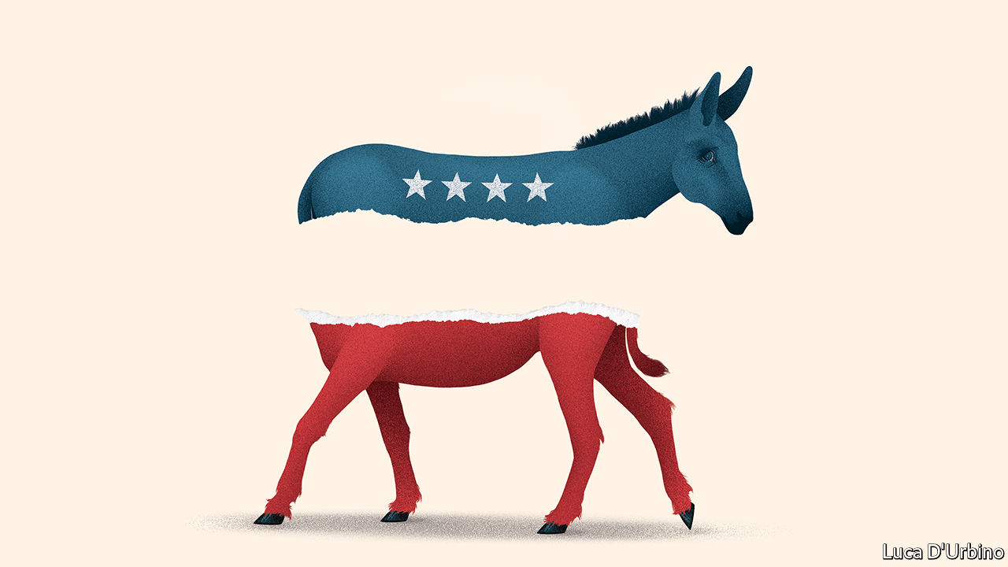

IT WAS A devastating contrast. As the Iowa caucus turned into a fiasco (Democrats blamed the software), President Donald Trump hailed an “American comeback” in the state-of-the-union message and basked in his acquittal by the Senate over impeachment. With the economy roaring and his approval ratings ticking up, Mr Trump looks likelier than ever to triumph in November. Compare that with the Democrats after Iowa, in which no candidate won the backing of much more than a quarter of caucusers.

Democrats agree that ending Mr Trump’s bombastic tenure is their priority. But their champions, now trudging round New Hampshire eking out votes before next week’s primary (see article), are starkly divided over what to offer Americans in his place. The left argues that America has stopped working for most people and thus needs fundamental restructuring. Moderates recommend running repairs. A lot rests on which side prevails—the radicals or the repairers.

Any of the front-runners could yet end up as the nominee: the radicals, Bernie Sanders and Elizabeth Warren; or the repairers, Pete Buttigieg and Joe Biden (despite his bad day in Iowa). So at a pinch could Michael Bloomberg, another repairer, who is spending gargantuan sums before Super Tuesday next month. But on every count the repairers have the better of the argument. They are more likely to beat Mr Trump, to achieve things and, most important, to do what America needs.

It is striking that all of the plausible nominees are campaigning to the left of President Barack Obama in 2012 and Hillary Clinton in 2016 (see Briefing). They all have ambitious plans on climate change; and, with the exception of Mr Bloomberg, are sceptical of free trade. Nevertheless, Mr Sanders, who calls himself a democratic socialist, and Ms Warren, a capitalist, are distinctly more militant in both style and substance.

This is partly a matter of degree, as health policy shows. All Democrats want the number of Americans without health insurance, which has risen from 27m to 30m under Mr Trump, to be reduced, ideally to zero. The repairers would expand Obamacare’s market-based system until everyone was covered. Mr Sanders and Ms Warren, by contrast, would nationalise health insurance, revolutionising health care, a $3.8trn business accounting for 18% of GDP and which employs 16.6m people.

There is also a fundamental difference about the role of government. Take labour rights, for instance. All Democrats evoke a mythical golden age when people were rewarded fairly for a day’s work. The reformers would increase minimum wages to, say, $15 an hour and spend more on education and retraining. The radicals would force any largish firm to put workers on its board—Ms Warren would give their representatives 40% of the seats, Mr Sanders 45%. Mr Sanders would require firms to transfer 20% of their equity to workers’ trusts. Both would create a system of federal charters to oblige firms to operate in the interests of all stakeholders, including workers, customers and the local community as well as shareholders. Such a government-mandated shift in corporate power has never occurred in the United States.

This radicalism is based on three misconceptions. The first is that Mr Trump showed in 2016 that you win elections through the fervour of your base rather than making a coalition. That is unlikely to work for Democrats in 2020. Presidential elections tend not to be kind to candidates who pitch their camp far from the political centre. Voters perceived Hillary Clinton as more extreme than Donald Trump in 2016, and it did not end well for her. In a 50:50 country, marginal handicaps matter.

Mr Trump would have fun with Mr Sanders, who wishes to double federal spending overnight and, perhaps more important to the president, honeymooned in the Soviet Union. It was no accident that in his state-of-the-union message Mr Trump pointed to Juan Guaidó, the Venezuelan opposition leader who was his guest for the evening, and reminded Congress that “socialism destroys nations”. Few voters are hankering to own the means of production in suburban Philadelphia or Milwaukee, where the presidential election will probably be decided.

Another misconception is that a radical who did get into the Oval Office would accomplish much. Some Democrats say that the intransigence of the Republican Party means an approach built around compromise is worthless. The pursuit of incremental change, they reckon, is an admission of defeat at the outset. They are right that the two parties in Congress have forgotten how to work together. Today’s Senate is likely to accomplish less than any other in the past half-century. Their idea is to take on Mr Trump’s reality-TV populism with red-blooded economic populism. That might thrill activists and terrify Wall Street, but it would be both unproductive and self-defeating. Democrats believe in the role of government. They are condemned to try to make it work, not demonstrate that it cannot.

The last misconception, and the most important, concerns the substance of what the radicals would like to achieve. Ms Warren takes her faith in government to extremes. If she had her way, the state would break up, abolish or impose fresh regulations on about half of the firms owned by shareholders or private-equity groups. Mr Sanders would go even further. Both candidates treat private capital as if it operates with sinister intent, even as they embrace the state as if it were benign, capable and efficient. That is naive. Just as thriving businesses at their best invigorate and enrich, so government at its worst can be capable of heartless cruelty and indifference.

There are moments when the United States has required something like a revolution—before the civil war, say, or in the years running up to the passage of the Civil Rights Act. This is not one of them. Unemployment is as low as it has been since the mid-1960s. Nominal wages in the lowest quartile of the income scale are growing by 4.6%. Americans are more optimistic about their own finances than they have been since 1999.

Instead America needs repairing—lowering the cost of housing and health care; moving to a low-carbon economy; finding a voting system that rewards consensus, not partisanship. For that, national politics needs to become boring again, not to be an exhausting, outrage-spewing fight between Mr Trump and the most extreme candidate the Democratic Party can muster. ■

This article was downloaded by calibre from <https://www.economist.com/leaders/2020/02/06/the-democratic-primaries-will-be-a-contest-between-radicals-and-repairers>

|  |  |  |  |
| --- | --- | --- | --- |
| Previous | Articles | Sections | Next |

|  |  |  |  |
| --- | --- | --- | --- |
| Previous | Articles | Sections | Next |

#### Three strikes

# Hong Kong’s economy is in peril, but its financial system is not

Its property market and finance industry are somewhat insulated from local worries

Feb 8th 2020 |



AS THEY REPAY their debt to society, many Hong Kong prisoners are put to work making useful items like road signs, uniforms, furniture—and the surgical masks that now obscure the faces of almost everyone on the city’s subdued streets. To help stop the spread of the Wuhan coronavirus, which has infected over 28,000 people worldwide, prisoners will now be employed round the clock, boosting mask production by as much as 60%.

That, sadly, is one of the few economic ventures that is still expanding in this thrice-struck city. Its GDP shrank last year for the first time in a decade, thanks to the trade war and anti-government protests. The coronavirus now poses a third threat. Some economists have slashed their growth forecasts for Hong Kong by more than for the mainland (see article).

Hong Kong’s economic fate is of international concern. Vast sums of global capital flow in and out of its asset markets and its border-straddling banks. Some speculators now fret about its financial resilience, noting its exorbitant property market, where prices have tripled in ten years, and top-heavy banking system, which has assets worth 845% of GDP. As protests intensified last year, bets against Hong Kong’s currency, which has been firmly pegged to the dollar since 1983, became unusually popular. The city’s monetary officials proclaimed no reason to worry. But that is the kind of thing you have to say only when others suspect that it is not entirely true.

The fear about Hong Kong’s domestic economy is warranted. Much of the city’s livelihood depends on the economic virtues of openness and propinquity. It excels as both an entrepot and a rendezvous, where people from far-flung places can gather in jam-packed proximity. It thrives on human interaction. But so does the virus. Thus efforts to impede the disease, such as discouraging visitors and gatherings, also paralyse the economy.

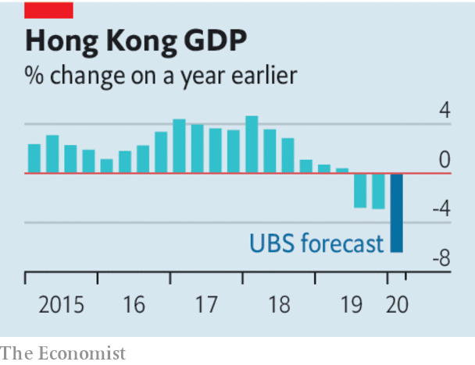

Unfortunately the government lacks authority just when it needs it. By so gravely mishandling the recent social unrest, it lost the public’s trust. It now struggles to convince people that it is doing all it should to stop the disease. Some hospital workers have gone on strike, demanding a complete closure of the border with the mainland (see [article](https://www.economist.com/node/21779302)). Others are furious about the shortage of masks. A more credible government might advise people that they do not need to wear one unless they are ill. But such advice would be scorned in Hong Kong. It has run out of masks because its government has run out of trust.

These justifiable fears for Hong Kong’s local economy do not, however, extend to its banks or its currency. Precisely because its property market and its financial system have become partially divorced from its local economy, they are somewhat insulated from domestic travails. And its banks have grown so big partly because they serve mainland firms with global ambitions, whose fortunes are decided outside Hong Kong. Most lenders are well-capitalised and mortgage lending is tightly controlled.

Hong Kong’s currency peg is also heavily fortified. Foreign-exchange reserves are twice as large as the money supply, narrowly defined. In principle, the banks would run out of Hong Kong dollars to sell to the monetary authority before it would run out of American dollars with which to buy them. In practice, interest rates would spike long before then.

That would make holding the currency more rewarding and betting against it more expensive. It would also inflict pain on the economy. For the peg to survive, the government would have to endure the agony longer than speculators could endure the expense. During the Asian financial crisis in 1997 (when overnight interest rates briefly reached 280%), Hong Kong showed how far it was willing to go. The peg’s survival back then has made it more likely to survive future tests, too. Hong Kong has built a reputation for competence and integrity with international investors. What a shame that the government has squandered its reputation for those very qualities with its own population.■

This article was downloaded by calibre from <https://www.economist.com/leaders/2020/02/08/hong-kongs-economy-is-in-peril-but-its-financial-system-is-not>

|  |  |  |  |
| --- | --- | --- | --- |
| Previous | Articles | Sections | Next |

|  |  |  |  |
| --- | --- | --- | --- |
| Previous | Articles | Sections | Next |

#### A tale of two elections

# A rigged vote is overturned in Malawi. Why not in Congo?

Outsiders bet on Félix Tshisekedi to stabilise Congo. He is failing

Feb 8th 2020 |

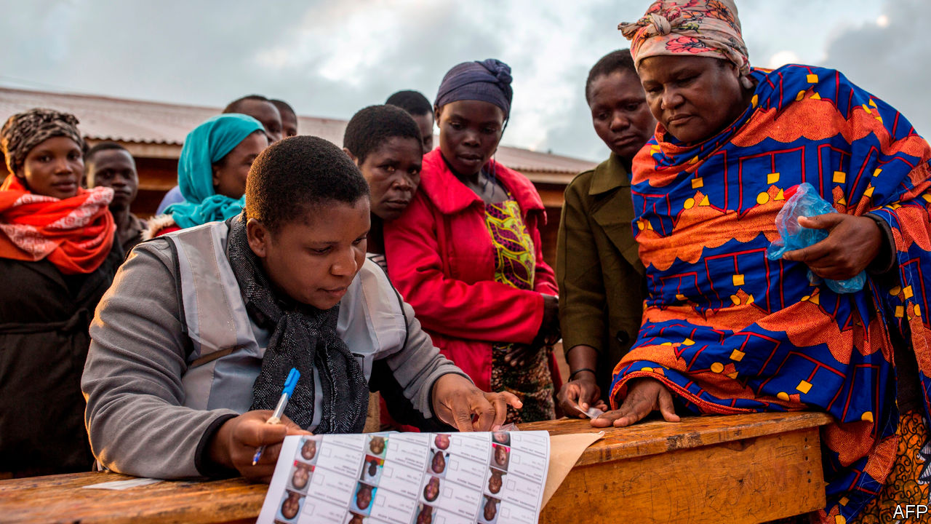

IN THE PAST 13 months Congo and Malawi have both held rotten elections. In Malawi tally sheets arrived at a central vote-counting station having been altered with Tipp-Ex, a correction fluid. The incumbent president, Peter Mutharika, narrowly “won”. In the Democratic Republic of Congo an independent tally organised by Catholic bishops has suggested that an opposition leader, Martin Fayulu, won about 60% of the vote, three times as many as Félix Tshisekedi. But Mr Tshisekedi was declared the winner and sworn in as president in January 2019.

What happened after these two pilfered polls was very different, however (see here & here). In Malawi this week the constitutional court overturned the result and ordered a new vote to be held within 150 days. This is only the second time in African history that a court has nullified a dodgy general election. It is a triumph for the rule of law. It shows that local judges can be stricter than foreign election monitors. And it gives Malawians hope that they can choose their own rulers.

No such luck in Congo. The top court there rubber-stamped the brazen ballot burglary a year ago. And the American government, among many others, followed suit. The administration’s Africa experts wanted to denounce Congo’s stolen poll, but were overruled by others closer to President Donald Trump.

The argument for pretending to believe Congo’s result was never openly stated, but goes like this: Congo is strategically important, a huge land mass at the centre of the continent with vast mineral reserves and enough hydroelectric potential to light up southern Africa. China and Russia are vying for influence there, and do not care a plate of fufu for democracy. If America makes a fuss about respecting the will of the Congolese people, Congo’s ruthless rulers will cosy up to Beijing. Vocally supporting Mr Tshisekedi is therefore the best way to preserve both stability and American influence in Congo.

One year later, this argument is not holding up well. American fears of Chinese influence in Congo were always overblown. The country is almost roadless. It needs more Chinese infrastructure investment, not less. And there is little sign that, in backing Mr Tshisekedi, America has made a wise long-term bet.

Granted, the new president has released political prisoners and allowed more open criticism than his despotic predecessor, Joseph Kabila, ever did. He has also toured foreign capitals declaring that Congo is open for business. But he has failed to curb corruption or improve lives. He promised free primary education and hired 40,000 new teachers, but they have not been paid and many have gone on strike. He vowed to improve security, but the fighting between mass-raping militias in eastern Congo is as bad as ever. He has floated the idea that neighbouring Burundi, Rwanda and Uganda might help pacify the east. This is risky: their previous incursions led to plunder and slaughter.

Not only is Mr Tshisekedi illegitimate, he is also weak. The backroom deal that brought him to office left Mr Kabila pulling many of the strings. The two men’s supporters squabble energetically over the spoils of power but barely bother governing. None of this is a recipe for stability, as the bloodshed in the east and protests in Congolese cities attest.

Reforming Congo will take decades, and is a job for the Congolese themselves. However, outsiders can help—with trade, know-how and a willingness to call a coup a coup. If a future American administration wants long-term influence in Congo or anywhere else in Africa, it should be more engaged and less cynical. Those who bless stolen elections share responsibility for what the thieves do with power. Those who press for the rule of law are not always disappointed—as Malawi shows.■

This article was downloaded by calibre from <https://www.economist.com/leaders/2020/02/08/a-rigged-vote-is-overturned-in-malawi-why-not-in-congo>

|  |  |  |  |
| --- | --- | --- | --- |
| Previous | Articles | Sections | Next |

|  |  |  |  |
| --- | --- | --- | --- |
| Previous | Articles | Sections | Next |

#### Investing in rail

# Why HS2 should go ahead

Britain is poised to decide whether to build an expensive new railway

Feb 8th 2020 |

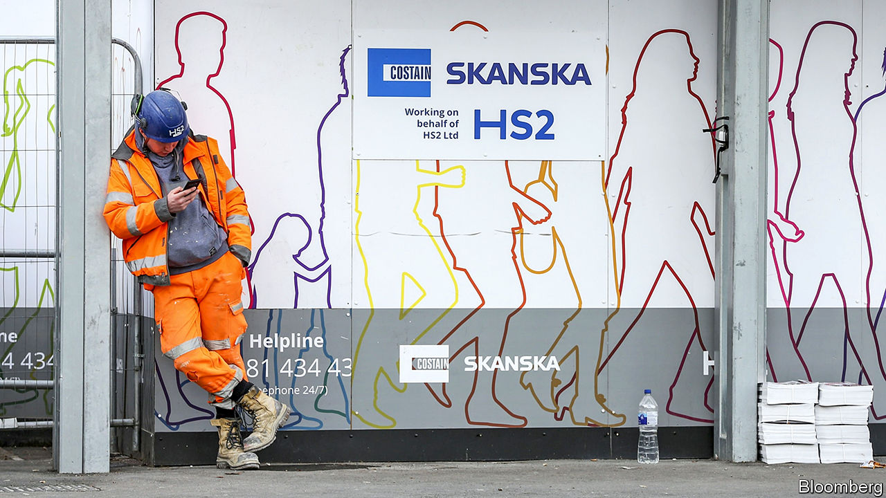

FOR THE country that invented railways, Britain has shown remarkably little interest in them lately. New networks have been built around Europe in the past few decades, but the only significant stretch of track laid in Britain in a century is the 67-mile (107km) HS1 railway that links London to the Channel Tunnel. Indeed, the country has half as much track as it had in 1963. Yet while Britain has an almost American reluctance to invest in railways, its commuting patterns are European: 10% of journeys are by rail, compared with 9% in Germany and less than 1% in America. The result is a lot of angry commuters.

Britain’s big problem is that, because it has built no new high-speed lines, it runs fast intercity trains on the same track as slow commuter ones. Long gaps have to be left between slow and express trains. The need to make way for high-speed trains thus limits the number of commuter services, and vice versa.

Eight years ago, the government decided to rectify this by building a new 345-mile railway from London to the north of England. Though branded as High Speed 2, its principal job was to boost capacity rather than speed. At the time, this newspaper argued against it. Although we supported the idea of investment in train capacity, we believed that there were better projects to spend money on than HS2.

Spooked by the costs—now put at around £100bn, against an original estimate of £42bn—and by the fury of 21 Tory MPs whose rural constituencies the track would slice through, the government is considering cancelling the project. A final decision was due as The Economist went to press. We now believe the line should go ahead—not because £8bn has already been spent, but because the circumstances have changed.

Rail is an increasingly important part of the transport mix. Climate change is putting a premium on carbon-efficiency. At the same time, passenger numbers have exceeded forecasts. The government had expected passenger volumes to increase by 17-21% in the decade from 2011; actually, they were up by 24% within just seven years and are expected to go on growing at a similar clip. The costs of other, cheaper ways to boost capacity, such as double-decker carriages and longer trains, have increased, along with the cost of engineering wider tracks and higher tunnels, and of buying more property around stations. Meanwhile interest rates are so low these days that the government can borrow long-term for virtually nothing.

The benefit-to-cost ratio (BCR) calculated for HS2, at around one, is hardly a ringing endorsement. But just as the costs of big transport projects are often underestimated, so are their long-term benefits. The extension to London’s Jubilee tube line, for instance, was approved with a BCR of less than one, but recent analysis suggests that it has been more like 1.75. And that includes only the revenues that go directly to the railway, not the economic consequences of the revival of London’s Docklands area, which the tube line made possible.

The main point of HS2, similarly, is its impact on the cities and towns along its route and beyond. Boris Johnson, the prime minister, is on a mission to boost growth in northern and western areas left behind by the country’s lopsided, London-centred pattern of growth. On its own HS2 won’t make that happen, but doing so without a new railway would be tough. The success of the “Northern Powerhouse” rail scheme, to link the north’s big towns, depends on it.

This is a tricky decision for Mr Johnson. It will be the biggest financial call of his time in office. His party is divided over the issue. HS2 will dog his premiership if it goes wrong. But if he wants his vision of Britain to work, he needs it.■

This article was downloaded by calibre from <https://www.economist.com/leaders/2020/02/08/why-hs2-should-go-ahead>

|  |  |  |  |
| --- | --- | --- | --- |
| Previous | Articles | Sections | Next |

|  |  |  |
| --- | --- | --- |
| Leaders | Sections | Briefing |

Letters

Letters to the editor: On the Holocaust, #MeToo, diplomacy, Russia, mosques, Portugal, sporting metaphors

.

|  |  |  |
| --- | --- | --- |
| Leaders | Sections | Briefing |

|  |  |  |  |
| --- | --- | --- | --- |
|  | Articles | Sections | Next |

#### On the Holocaust, #MeToo, diplomacy, Russia, mosques, Portugal, sporting metaphors

# Letters to the editor

A selection of correspondence

Feb 8th 2020 |

Letters are welcome and should be addressed to the Editor at letters@economist.com

## Data and the Holocaust

The Graphic detail section on the Holocaust ([January 25th](https://www.economist.com/graphic-detail/2020/01/25/archivists-are-racing-to-identify-every-jewish-holocaust-victim)) illustrated the great job archivists and others have done in identifying the victims and preserving the documentation. For most west European countries nearly all the victims have been identified; it is in some of the other Nazi-occupied territories that many casualties are still unknown. Post-war lists of those who were identified have been linked, for example, to Nazi-registration records. This has enabled memorial sites, such as the Dutch Digital Jewish Monument, to commemorate murdered Jews in context, such as their last location, household and occupation.

Around 73% of the Jewish population in the Netherlands did not survive the Nazi persecution. Slightly over half of that 73% died in Auschwitz and about a third perished in Sobibor, a lesser-known camp. But who survived and who did not varied significantly across the Netherlands; there is a huge variation in death rates in different locations.

Those differences in local death rates raise interesting questions about who was most at risk of persecution and why. But answering those questions requires analysing the retrieved data with advanced quantitative techniques. Yet within Holocaust literature, studies that use statistical methods are still unusual. We might be able soon to learn each victim’s name, but lag behind in our understanding of the Holocaust.

PETER TAMMES  
Senior research associate  
Population Health Sciences  
Bristol Medical School

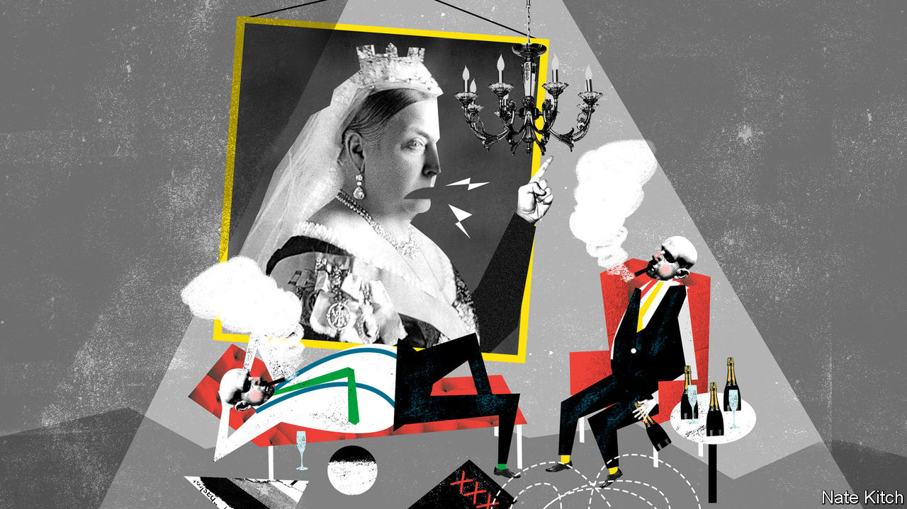

## A longer view of history

I was saddened to see Bagehot referring to the #MeToo movement as exposing “the seamy underbelly of the sexual revolution” ([January 11th](https://www.economist.com/britain/2020/01/11/gertrude-himmelfarb-and-the-politics-of-virtue)). Sexual abuse is not an offshoot of the sexual revolution. The Victorians’ adherence to “moral values”, lauded in Bagehot’s tribute to Gertrude Himmelfarb, were contradicted by the underside of life experienced by women, rich and poor, long before the swinging Sixties. The only underbelly #MeToo has exposed is the use of privilege to abuse with impunity.

JUDY STANLEY  
Scarsdale, New York

## Making diplomacy work

Violent conflict remains stubbornly resistant to resolution (“Not your average diplomats”, [January 25th](https://www.economist.com/international/2020/01/23/conflict-resolution-relies-increasingly-on-diplomatic-back-channels)). Half of all peace agreements collapse within seven to 12 years of being signed. One-third of peace deals never make it from being agreed to being implemented. Since the mid-1990s, most conflicts have been recurrences of old disputes rather than new ones.

One cause of these disappointing facts and failures is an imbalance at negotiating tables. Deals are being struck by the beneficiaries of conflict that emphasise short-term incentives, rewards and commitments. Effective conflict resolution requires more attention to longer-term solutions for the silent majority at the grassroots who pay the highest price during conflict and who have the most to gain from peace. That means fewer backroom peace deals agreed solely by elites, and more agreements that involve all groups and communities.

SIMON GIMSON  
Vice-president  
Interpeace  
Geneva

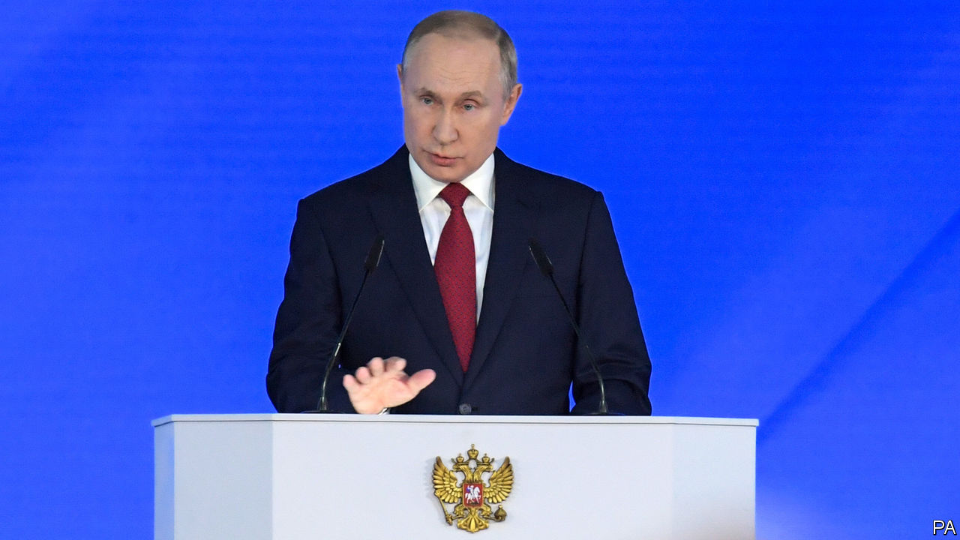

## Limited choices in Russia

You were rightly hesitant to draw any clear-cut conclusions about Vladimir Putin’s future plans based on the constitutional amendments he recently proposed (“Glued to the throne”, [January 18th](https://www.economist.com/leaders/2020/01/16/how-vladimir-putin-is-preparing-to-rule-for-ever)). The amendments don’t tell us who will occupy which high office in the Russian state after Mr Putin steps down as president in 2024. But perhaps we’re reading this crystal ball all wrong. If the Russian nomenklatura is anything like the big-business class in Russia, many will have a foreign passport or long-term foreign residence. These cosmopolites are now out of the game.

Real competition was eliminated from Russian elections years ago by preventing disfavoured candidates from even running, much less winning. This is the “Soviet restaurant” method of political popularity. When only one item on the menu is available, it will by default be the most popular.

WILLIAM SPIEGELBERGER  
Vienna

You assert that Russian economic growth has been “brought to an end by corruption, uncompetitiveness, the end of the oil boom and Western sanctions following the annexation of Crimea in 2014”. This would seem to be an exaggeration. The latest IMF projections show Russian GDP growth rising from 1.1% in 2019, to 1.9% in 2020 and 2% in 2021. Despite the factors you mention, it is nonetheless modest growth, and no doubt the envy of countries like France, Germany and Italy.

MARTIN GILMAN  
Professor of economics  
Higher School of Economics  
Moscow

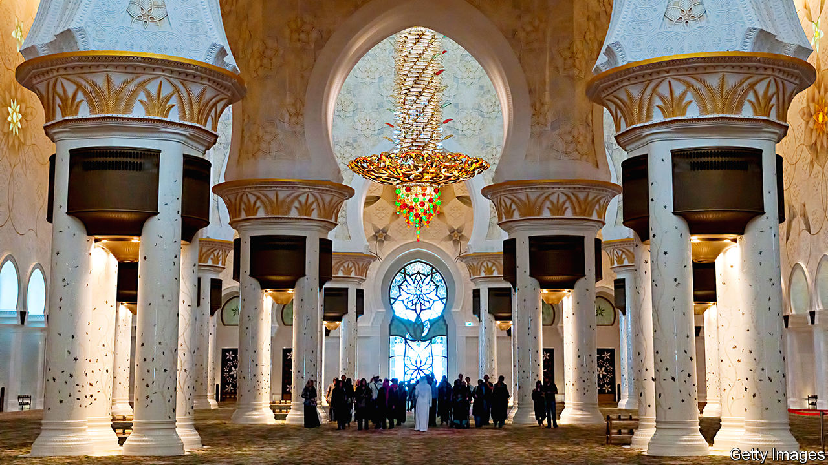

## Religious symbols

Many mosques built by Arab autocrats could be described as vulgar, but not in the case of the Sheikh Zayed mosque in Abu Dhabi (“Mine’s bigger than yours”, [January 11th](https://www.economist.com/middle-east-and-africa/2020/01/09/why-muslim-leaders-like-building-grand-mosques)). Size aside, the mosque is generally characterised by exquisite good taste and an architectural vision that seamlessly blends modern technology with the best of Islamic tradition. It is a remarkable achievement that transcends the motivations of the obscenely rich sheikhs of the United Arab Emirates. A similar disjuncture between self-serving autocratic motivation and genuine artistic merit was also associated with many of the celebrated architectural achievements of the past. Think Angkor Wat, the Alhambra, the Taj Mahal.

REG WHITAKER  
Victoria, Canada



## Obrigado

America is not Britain’s “oldest ally” (“Declarations of independence”, [January 18th](https://www.economist.com/britain/2020/01/16/johnson-trump-and-the-future-of-the-atlantic-alliance)). The oldest military alliance in the world is between Britain and Portugal, dating back to the Treaty of Windsor in 1386. Although seemingly irrelevant today, the alliance was instrumental during the Napoleonic wars and the fleeing in 1807 of the Portuguese monarchy to Brazil, leading to its subsequent independence. The treaty was invoked both during the second world war and the Falklands conflict to allow British refuelling in the Azores.

BENJAMIN JOHNSON  
London

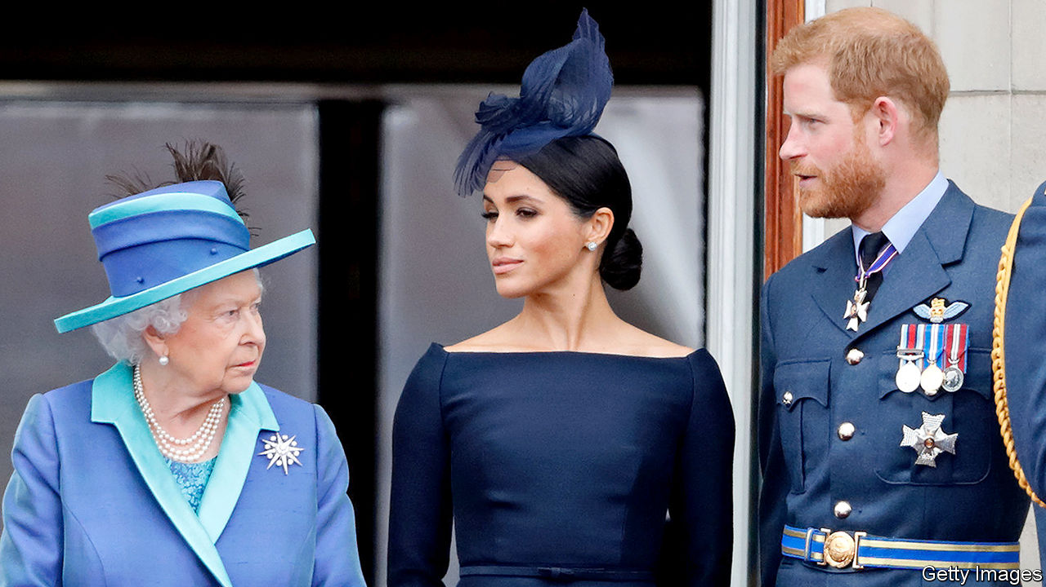

## A family of two halves

Upon hearing a third sports metaphor in as many minutes last week, I wondered whether the usefulness of such tropes in the workplace has played out. So it was with amusement that I read your comparison of an English football club to the royal family (“Losing the title”, [January 25th](https://www.economist.com/britain/2020/01/25/the-remarkable-similarities-between-queen-elizabeth-and-alex-ferguson)). I want to know Bartleby’s thoughts on the subject. Perhaps he can huddle with Johnson, draw up a game plan, and tackle this topic in a column. I’m confident he will knock it out of the park.

RYAN JUENGER  
Costa Mesa, California

The comparison of Sir Alex Ferguson, a former manager of Manchester United, to the queen, current manager of the monarchy, was fantastic. Sir Alex famously referred to a particularly tense period of his tenure as “squeaky-bum time”. I am sure the queen has an equally telling if not more elegant turn of phrase to describe the current position of the monarchy.

ZACK GOLDBERG  
London

This article was downloaded by calibre from <https://www.economist.com/letters/2020/02/08/letters-to-the-editor>

|  |  |  |  |
| --- | --- | --- | --- |
|  | Articles | Sections | Next |

|  |  |  |
| --- | --- | --- |
| Letters | Sections | United States |

Briefing

The Democratic race: Iowa and after

.

Headhunters: Take me to a leader

.

|  |  |  |
| --- | --- | --- |
| Letters | Sections | United States |

|  |  |  |  |
| --- | --- | --- | --- |
|  | Articles | Sections | Next |

#### Iowa overShadowed

# The shambolic Iowa caucuses did little to unite the Democrats

They were good for Pete Buttigieg and Bernie Sanders, bad for Joe Biden

Feb 8th 2020 | CONCORD, NEW HAMPSHIRE, INDEPENDENCE, IOWA, AND WASHINGTON DC

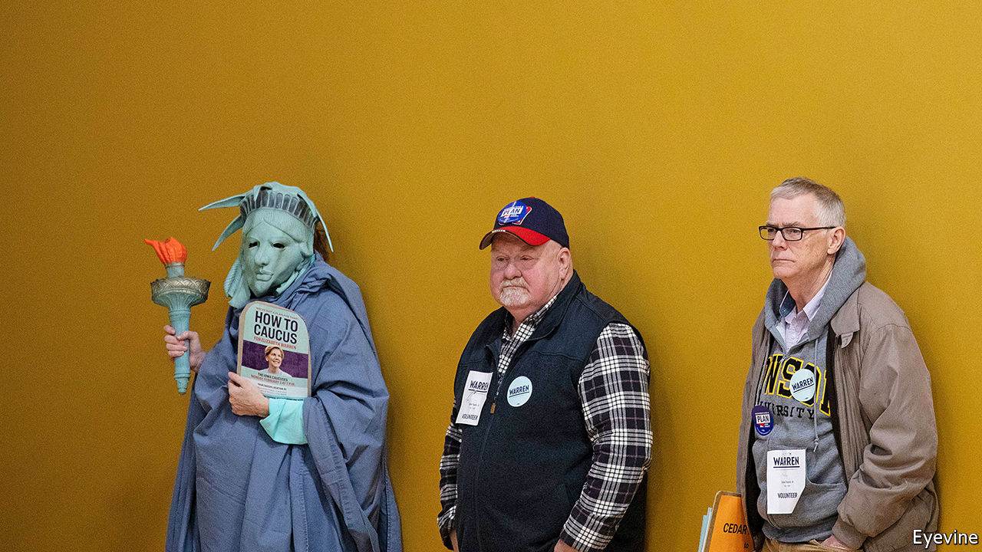

IN THE SMALL hours of February 4th a straggling squadron of private jets left Des Moines International Airport and headed east through a clear, cold sky, its clouds and the snowy land beneath them silvered by the light of a setting half moon. Conditions in the state the planes left behind them were far less perspicuous. A malfunctioning app made by a firm called Shadow Inc. meant that the results of the Iowa caucuses which are normally announced not much past nine o’clock in the evening, remained shrouded in mystery.

By the time Pete Buttigieg, an ex-mayor from South Bend, Indiana, heard that the first, partial release of results from Iowa showed him to have won the most “delegate equivalents” (27%) he was 2,100km (1,300 miles) away in Laconia, a lakeside town in New Hampshire. Bernie Sanders, a socialist senator from Vermont who the early results showed coming second with 25%, was an hour’s drive south in Milford. Elizabeth Warren, a senator from Massachusetts, heard of her third-place finish in the little city of Keene; in the larger city of Nashua, America’s former vice-president, Joe Biden, learned that he had managed only fourth place, with 15.6%.

Remarkably, final results had still not been published as The Economist went to press. With 97% of the count completed, Mr Buttigieg still had the edge in delegate equivalents; though Mr Sanders had slightly more actual votes, their concentration in urban areas counted against him a little. Mr Buttigieg also picked up more support than anyone else in the stage of the caucuses where votes originally cast for the less popular candidates are reallocated (see chart 1).

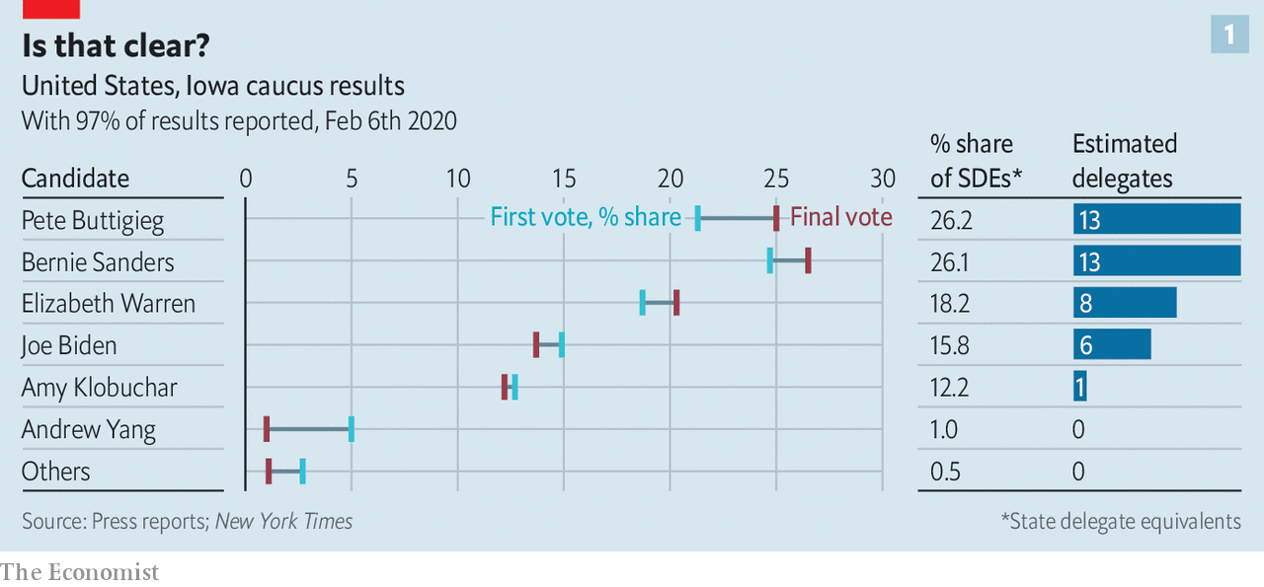

## Hate to wake you up

The Democrats have always been split, to a greater or lesser extent, between the more left-wing and the more centrist. Finding a candidate who can at least try to please both is part of the point of the primary process. Today the factions’ differences are more pronounced than usual, though—and they line up with two different approaches to what the election is about.

Democrats of all stripes say they care most about ousting President Donald Trump. But the two wings offer fundamentally different prescriptions for how to do it. Moderates offer something like a further-to-the-left version of the pre-Trump status quo. The radicals seek what Ms Warren calls “big structural change”. They want to fix the problems of concentrated power and influence they see as having led to Mr Trump in the first place. That difference could yet cost the party the election.

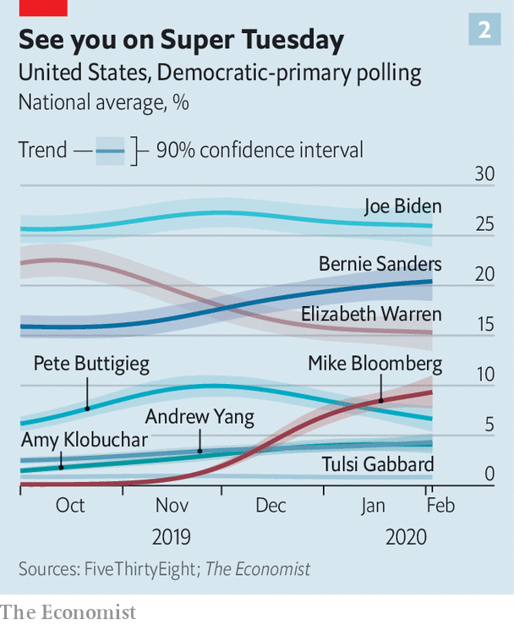

A nostrum from before the days of each candidate hiring their own jet held that there were only three tickets out of Iowa; candidates who did not win, place or show in the caucuses had no shot at the nomination. It would be rash to bet heavily on that rule of thumb holding. Fourth-place Mr Biden is a nationally popular figure with a long-standing lead in the polls (see chart 2). He may have a chance to redeem himself when South Carolina votes on February 29th; African-Americans, who have shown strong support for him, make up a majority of the electorate there.

Even so, Mr Biden was the only candidate who actually benefited from the slow dripping out of the results. The Super Bowl on Sunday, Mr Trump’s state-of-the-union address on Tuesday and the Senate’s acquittal of the president on Wednesday meant that the caucuses had only a small window in which to be a big story. When the results missed that window Mr Biden’s lacklustre performance—he may not have won a single delegate—got a lot less attention than it might have.

Of the people who did well out of the caucus, the most striking success belonged to Mr Buttigieg. For a young, gay local politician with a name many still struggle to pronounce, winning the most delegates was quite the coup. Some might see the fact that he spent heavily in the state—more by some accounts than any other top-tier candidate save Mr Sanders—as diminishing this achievement. But being able to raise such sums is an impressive feat in itself, and going all-in on must-win Iowa speaks well to his nous.

## Standing here outside your door

In high school Mr Buttigieg won a national contest with an essay praising Mr Sanders’s political courage. Today he is firmly in the party’s moderate wing. His plan to let people choose to subscribe to a public health-care insurance scheme is cheekily referred to as “Medicare for All Who Want It”, thus differentiating it from Mr Sanders’s more absolutist “Medicare for All”. He argues that subsidies for poor college students should be significantly expanded, rather than that college should be made free to all, as the radicals propose; he wants to see $700bn more spent on child care over the next ten years rather than to guarantee its free provision to everyone.

Like all the Democratic candidates, Mr Buttigieg has ambitious plans to tackle climate change. He prices his version of the “Green New Deal”—which includes a carbon tax, something orthodox economists like but many doctrinaire greens do not—at $2trn over ten years. That is a lot: the equivalent of 4.5% of federal spending at 2019 levels. But it is only marginally higher than the price tag on Mr Biden’s plan ($1.7trn) and far less than Ms Warren’s $10trn or Mr Sanders’s $16.3trn.

Along with an increase in the federal minimum wage to $15 an hour and an expansion of the earned-income tax credit—also espoused by all the other candidates—this might look like moderation in many of Europe’s political parties. It would never previously have been seen as such by the Democrats. Like Mr Biden’s, Mr Buttigieg’s agenda is considerably more progressive, and expensive, than that on which Barack Obama and Mr Biden ran in 2008, or than Hillary Clinton offered in 2016. None of them would have dreamed back then of explicitly treating their health-care plans as a step on the way to a universal single-payer scheme, as Mr Buttigieg does. Mrs Clinton’s biggest commitment on climate was costed at just $60bn.

In some ways Mr Buttigieg’s ideas are hard to distinguish from Mr Biden’s; their policies for capping the premiums sold on the Obamacare exchanges are identical down to a fraction of a percentage point. But Mr Buttigieg is more keen to be understood, at least in part, as the sort of progressive voice which his policies would have made him in every previous election since the Great Depression, not least because his youth can set a message of change apart in a field of septuagenarians.

Unlike Mr Biden, but like Mr Sanders and Ms Warren, he favours the legalisation of marijuana at the federal level. His carbon tax would be the basis of a rebate to all Americans. He is less of a free-trade fan than Mr Biden—though not as protectionist as Mr Sanders—and more hawkish on China. His plans to allow trade unions to bargain across sectors of the economy, borrowed from the Nordic countries, are far less ambitious than Ms Warren’s plans for the representation of workers on boards, but they are more achievable, and fresher than Mr Biden’s.

Mr Buttigieg is enthusiastic about the Midwest’s “strong progressive tradition” and pays tribute to William Jennings Bryan, the Nebraskan who was just 36 when oratory and populism won him the Democratic nomination in 1896. Mr Buttigieg is almost as young and widely seen as the best speaker in the current bunch, though he does not come up to Mr Obama’s standards. But he lacks Bryan’s polarising demagoguery. He is keen to build bridges to moderate Republicans—“future former Republicans”, as he likes to call them—and to convince party bosses that he can deliver their votes come November. Once happy to toy with structural reforms like eliminating the electoral college or enlarging the Supreme Court, today he talks less of such potentially divisive matters.

Elderly voters have taken a shine to Mr Buttigieg. Young voters have generally preferred the more radical camp. They favour Mr Sanders, who draws large, enthusiastic crowds and works the stage with the energy of a man half his age (which would still make him slightly older than Mr Buttigieg). He presents himself as a tribune of purity, unsullied by the politics of compromise.Polls suggest he will notch up a sizeable victory in New Hampshire’s primary on February 11th, and perhaps another in Nevada’s caucuses on February 22nd.

## Ready to go

Some of Mr Sanders’s advantage stems from the fact that he has been running since 2015, when he first took on Mrs Clinton. His surprisingly strong showing against her revealed an appetite for policies much further to the left than the party was used to, thus shifting its centre of gravity. It also gave him the basis for a run in 2020 three years before anyone else really got into the game. He used that head start to strengthen his organisation and develop his platform.

The most famous plank in that platform is Medicare for All, which would replace the entire private health-insurance industry with a government-run programme free to all Americans (including undocumented immigrants) at the point of service. He also wants to cancel $1.6trn in student debt, guarantee jobs for all—his version of the Green New Deal is meant to provide 20m new ones—and give workers 20% of the equity in large companies.

A rough estimate suggests that Mr Sanders’s plans would cost at least $50trn over a decade. His tax rises (which include, like Ms Warren’s but unlike those of the moderates, a wealth tax) might bring in $20trn in additional revenue—which suggests that the annual deficit could triple to $3trn. The Urban Institute, a think-tank, estimates that Mr Sanders’s health-care plan alone would cost $34trn over ten years.

Unlike Ms Warren, who got into a damaging flap over costing a similar promise and has since retreated to a position of “transitioning to” Medicare for All, Mr Sanders is not fazed by such numbers. He talks in broad terms of payroll taxes on employers and tax rises for wealthy and middle-class households (which he insists would be more than offset by reduced health-care costs). But he feels little need to trouble himself with specifics.

Mr Sanders would not be able to afford such nonchalance as president. Even if he were gifted a Democratic Senate and House, they would dread putting to the test his claim that Americans “would be delighted to pay more in taxes” to cover a comprehensive health-care system. Some of his surrogates softly proclaim him open to compromise, and cast his maximalism as more of an opening position than a fixed point. This suggests that, one way or another, the supporters to whom he promises radical change (and lots of free stuff) might find the reality of a Sanders presidency a terrible disappointment.

The prospect of a generation’s unrealistic idealism curdling, though, is not what most worries other Democrats about a Sanders candidacy. What they worry about most is that, like that fiery populist William Jennings Bryan, he would lead them to defeat. Socialised medicine may not turn off voters as much as it once did; socialism, though, is still an unpopular idea outside the world of millennial urbanites.

Mr Trump would hammer Mr Sanders’s proposals for a moratorium on deporting illegal immigrants, breaking up the Immigration and Customs Enforcement—since 2002 the country’s primary immigration-enforcement agency—and decriminalising unauthorised entry into the country. In swing states that produce oil and gas—notably Pennsylvania—he would make hay with Mr Sanders’s proposed fracking ban. Some of his attacks might be odd—at a rally in Des Moines four days before the caucuses he warned that the Green New Deal would “kill our cows”—but that does not mean they would be ineffective.

Mr Sanders is hardly a sure thing. But Mr Biden, long seen as topping the league in terms of electability, has started to falter, and the lead he enjoys over Mr Sanders in The Economist’s aggregate of national primary polls was narrowing even before the caucuses. With more candidates than usual getting tickets out of Iowa, Mr Sanders’s particularly devoted fan base could improve his chances of winning a plurality, if not a majority. Betting markets have him the front-runner. His support has been inching up in South Carolina and he is in the lead in California, the biggest of the 14 “Super Tuesday” states which, along with American Samoa and Democrats Abroad, choose their candidates on March 3rd.

Mr Buttigieg, on the other hand, is currently polling sufficiently poorly in New Hampshire, South Carolina and Nevada that he will need a peculiarly bountiful Iowa bounce to win in any of them. He is doing particularly poorly with black voters. His charm and popularity might cost Mr Biden a victory without winning one for himself. To avoid this, some mainstream Democrats may turn instead towards Ms Warren, suspecting her more likely than Mr Sanders of tacking to the mainstream. That would be likely to give Wall Street a fit of the vapours.

## But dawn is breaking

Voters could instead look elsewhere. As the Iowa circus flew into the New Hampshire morning, none with more than a dozen or so delegates, Mike Bloomberg was on a rather longer flight from California, which has 415 delegates up for grabs on Super Tuesday, to Michigan, where the primary a week later will decide the loyalties of a further 125. All told, the polls on March 3rd and 10th will provide 43% of the pledged delegates, more than ten times as many as those that can be won in all the primaries and caucuses of February. Taking this into account, Mr Bloomberg, a media entrepreneur and former (Republican) mayor of New York, is building his campaign for the Democratic nomination on the idea that running in the early states is not necessary if you are really rich.

This makes him, for now, literally unbeatable—how can you beat someone who isn’t there? He has also avoided innumerable fish fries, town halls and other intimate settings that favour practised, glad-handing politicians over uncharismatic billionaire technocrats. This abnegation denies him the possible advantages of early victories and whatever momentum they might offer. But he thinks he can make good that lack by spending truly remarkable sums on advertising in the states where he is running: according to FiveThirtyEight, a website, he has spent $255m so far, more than the rest of the field combined.

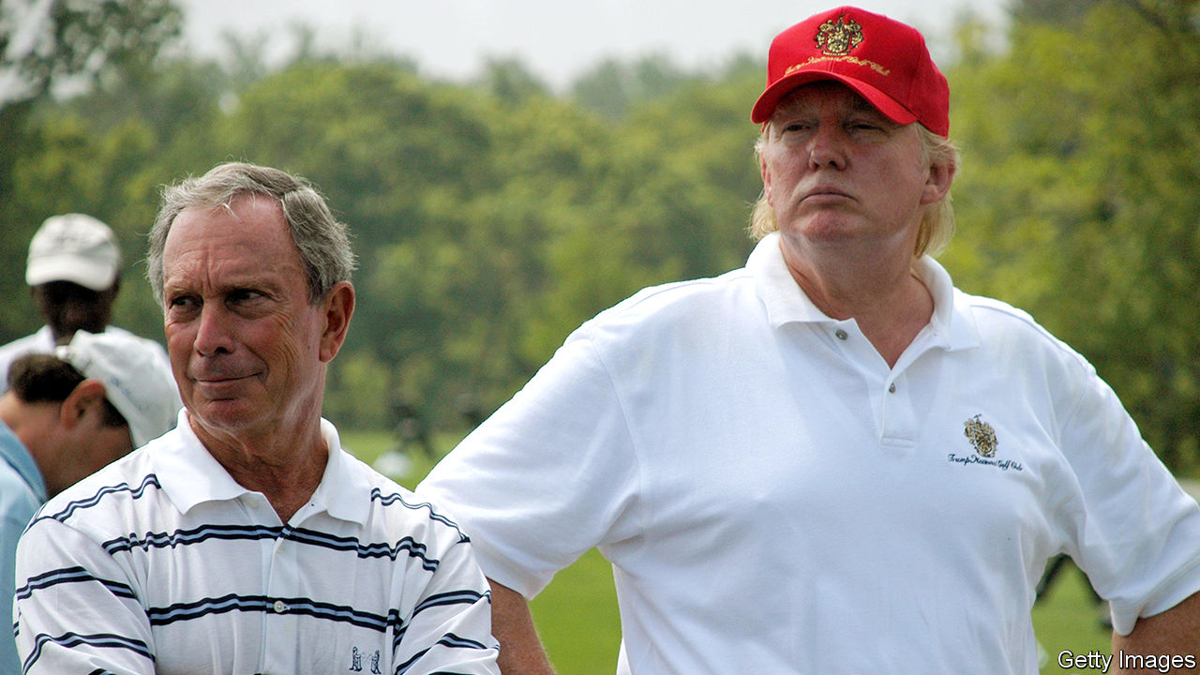

Two potential beneficiaries, back when they played with each other

The strategy remains widely seen as a long-shot. But it has made an impression in national polling, where pre-Iowa he had pulled clear of Mr Buttigieg, his fellow ex-mayor. The Democratic National Committee has altered the rules for its televised debates in a way that makes it possible for him to participate in one later this month. If Mr Biden’s campaign has not recovered by Super Tuesday—a situation Mr Bloomberg’s ads may encourage—he might change the contours of the race.

But as everyone else was flying around, the person who may have done best out of Iowa was tucked up in his doubtless splendid bed—or at least not tweeting. Democrats had expected that disapproval of Mr Trump would lead to much higher turnout at this year’s caucuses than 2016’s. It did not. After a year in which you couldn’t shake a corn-dog in Iowa without hitting a presidential wannabe, voters may have found the whole field rather uninspiring.

On Monday around 80 of Mr Trump’s surrogates—cabinet members, supportive legislators and his family—fanned out across Iowa where, unsurprisingly for a sitting president with no serious challengers, he won 97% of the vote. The next day the president delivered a jubilant state-of-the-union address. And in Wednesday’s vote on impeachment Republican senators backed him even more resoundingly than Iowa caucusers had. The Republicans will go into the campaign united. The Democrats have a lot of flights to take before they can promise the same. ■

This article was downloaded by calibre from <https://www.economist.com/briefing/2020/02/08/the-shambolic-iowa-caucuses-did-little-to-unite-the-democrats>

|  |  |  |  |
| --- | --- | --- | --- |
|  | Articles | Sections | Next |

|  |  |  |  |
| --- | --- | --- | --- |
| Previous | Articles | Sections | Next |

#### Take me to a leader

# The industry tasked with finding bosses is more powerful than ever

The benefits of using headhunters are hard to measure. They may be most useful as diplomats

Feb 6th 2020 | GENEVA, LONDON, NEW YORK AND PARIS



FOR A FEW months last year Matthieu (not his real name) was on the most important team in finance. SWIFT, a global payments-messaging service owned by 11,000 banks, was looking for a new chief. So was CLS, an institution that settles four-fifths of worldwide foreign-exchange turnover. Each had hired Matthieu’s firm to find one. He was aware of the stakes. Both outcomes were going to “impact everything” that money touches, he told The Economist at the time. His voice barely rose over the mellow music of a Manhattan hotel’s bar but nonetheless it carried a bass note of self-importance.

The firm got the job done. Javier Pérez-Tasso, SWIFT’s former Americas head, took over as boss in July. Marc Bayle de Jessé, an official at the European Central Bank, started at CLS in December. The placements testify to the brokering brawn of executive-search firms. The industry’s top tier is busier than ever. The bosses of 311 of America’s 3,600 listed firms left their jobs in 2019—the highest share on record. Someone needs to find their replacements.

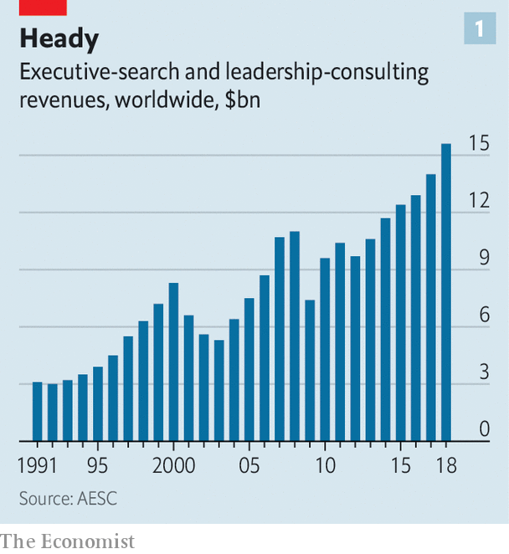

Like Matthieu, the search industry is secretive, and numbers are hard to pin down. Estimates from AESC, a trade body, suggest that the business has enjoyed strong growth for much of the past 30 years—with the exception of slumps after the dotcom bust in 2000 and the financial crisis of 2007-09 (see chart 1). AESC reckons global executive-search revenues grew by 12% in 2018 and that many firms had their best year ever in 2019 (for which it is still crunching the numbers).

Today, the biggest search firms hold sway over who rules many of the world’s most potent organisations. The best deserve their hefty fees, clients say. But the industry is facing increased scrutiny, amid suspicions that it may be holding back performance and diversity at the top.

Executive search—headhunting, in the vernacular—emerged in the post-war boom, when fast-growing firms in Europe and America began fighting over experienced leaders. The battle intensified in the 1970s as the internationalisation of business turned a consulting backwater into a mainstream profession. One recruiter’s ex-boss recalls opening 30 outposts that decade, from Singapore to Sydney.

Just as quickly, the business earned a reputation for sloppiness. Recruiters were “golf-course, back-slapping sales guys”, as one veteran admits. Candidates in their Rolodexes were lazily recycled. Criteria for drawing up shortlists were often a mystery, says Angeles Garcia-Poveda of Spencer Stuart, a search firm.

Fifty years later they have become tightly woven into the fabric of corporate life, and are seen by most multinationals as indispensable. Five giants—Spencer Stuart, Heidrick & Struggles, Russell Reynolds Associates, Egon Zehnder and Korn Ferry—dominate CEO search. This quintet, known as the “Shrek” firms, earned fees of $4.8bn in 2018, 14% more than the year before and 43% more than in 2014, according to Hunt Scanlon Media, a trade publisher. Spencer Stuart places an executive in a leadership role or boardroom 11 times a day, says Ben Williams, its boss. (The Economist Group has recently employed Egon Zehnder and Heidrick & Struggles to fill senior roles, including CEO and chairman.)

Interviews with more than 50 insiders suggest that 80-90% of Fortune 250 or FTSE 100 companies pay headhunters to find their CEO, even when the successful candidate is likely to come from within a firm’s own ranks. Among the next tier of companies, perhaps half do. Universities, sports clubs and officialdom enlist them, too. Last year their clients included English football’s Premier League and the International Paralympic Committee.

As the big headhunters have grown bigger, boutique firms have struggled to keep up. Nonetheless, some with deep expertise in specific industries or corporate functions have thrived, says Nancy Garrison Jenn, who helps multinationals headhunt the right headhunters. True Search, a tech-focused outfit, saw its revenues jump by 64% in 2018. Lower down the scale, the rise of online social networks has clobbered recruiters specialising in mere mortals like department heads and middle managers—since, as one puts it, “anyone can buy a computer, get a LinkedIn licence and call themselves a search expert”.

The big headhunters have benefited from the confluence of four forces. First, boards are looking for an ever broader skillset in modern CEOs. Bosses should be physically fit to withstand the brutal workload, comfortable dealing with the media and, increasingly, woke. They must grapple with complexity as big firms get bigger and industries converge—giants like Apple or Amazon are at once retailers, consumer-goods companies and tech firms—and with new threats, such as cybercrime.

Second, the rise of private equity (PE) means greater management churn at firms subject to buy-outs. America has some 8,000 PE-backed companies, double the number in 2006. Headhunters hustle in the hope of supplying bosses for PE firms’ entire portfolios. A partner at a buy-out giant says it works with just three providers because it wants VIP treatment.

The third reason for the headhunting boom lies in emerging markets. Scions of business dynasties in places like India increasingly want to devolve control of subsidiaries to professional managers, says Dinesh Mirchandani of Boyden, one of the oldest search firms. Startups like Ola, a ride-hailing firm, are looking for executives to help them conquer foreign markets. China, too, has champions keen to expand abroad but lacks managers with international expertise.

Lastly, boards and regulators are increasingly urging firms to plan for succession years in advance—and not, as in the past, to rely on a name in an envelope, to be unsealed should the boss be hit by a bus. Headhunters gladly help by benchmarking internal stars against potential external candidates. The pressure to plan ahead has led to the growth of all sorts of other ancillary services too, from leadership development to board-effectiveness assessment. Those now account for 43% of revenue at Korn Ferry, the largest Shrek.

Growth in demand has affected headhunting’s supply-side. Nobody has ever studied to become a headhunter but the profession is becoming more diverse. Those serving in its ranks include ex-engineers, a former Olympic gymnast and an erstwhile neuroscientist. The big five are big employers of former McKinsey consultants. New recruits like the fast pace and the opportunity to interact with boards.

They also enjoy the money. A median partner at the Shrek five typically earns $600,000 a year, according to industry veterans. The top 1% get $3m-4m, most of it bonus. Those hiring for finance usually earn the most.

## Seven-figure slice

Generous pay comes courtesy of eye-watering fees. For decades headhunters charged one-third of the chosen candidate’s first-year compensation (including any bonus). Caps became more common over the past decade as CEOS’ salaries climbed into the stratosphere, fees more often exceeded $1m—and clients started to rebel. Now fees at the top end are typically limited to between $500,000 and $1m, though the boom in ancillary fees means overall revenues continue to grow fast.

The search for a CEO takes anywhere from 90 days to a year. The board forms a committee to oversee the process, which the headhunter helps shape. It then helps directors crystallise what they want the new boss to achieve, such as boosting profits or expanding into new markets, and draws up a list of required competencies.

Once the actual headhunting begins, recruiters hire armies of researchers to comb through databases containing millions of profiles; gone are the days when a cabinet full of CVs and organograms of superstar firms like IBM would suffice. Lists of candidates who look good on paper are then compared against tips from informants, who are typically former colleagues or chatty middlemen.

To whittle down a longlist of 15 or so people, consultants quiz candidates’ suppliers, clients, ex-bosses and subordinates. They check Glassdoor, a website which lets workers rate employers. The phone is fine, but visits are better—valuable information can emerge in the last minutes of a meeting, or on the way to the lift.

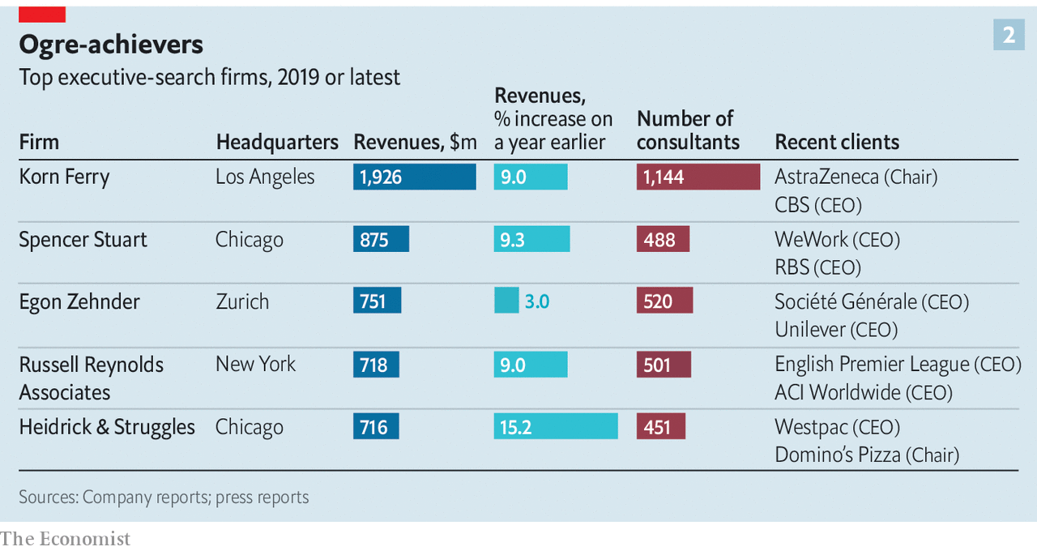

It is often only at this point that candidates are contacted. Since the most desirable hires typically already hold plush posts, and are constantly wooed by rival recruiters, headhunters must fight hard for their attention. They look to breakfast regularly with high-fliers, and mark their job anniversaries and dates when bonuses are due—discreet inquiries may elicit news of a disappointing payout, and signal that an executive may be looking for a change. They offer a shoulder to cry on when the going gets tough. Denis Marcadet of Vendôme Associés, a search firm in Paris, remembers humbled financiers weeping for hours in his office during the subprime meltdown.

In interviews headhunters deploy their charms to get candidates to lower their guard. But face-to-face assessment can be “a bit of voodoo”, says one. (It can also go awry if the chemistry is wrong. In his memoir, Robert Iger, Disney’s boss, recalls his interview for the job with Gerry Roche of Heidrick & Struggles as “one of the most insulting experiences of my career” because he viewed the questions as irrelevant and, worse, there was no food.) So recruiters have acquired tools to make it more scientific. They administer psychometric tests. Questionnaires gauge candidates’ norms and values. Synthesis, an advisory firm inspired by the recruitment of elite units in the Israeli army, even has shrinks dissect candidates’ answers to seemingly innocuous questions about their life stories.

Boards or headhunters sometimes outsource deeper probing to specialists such as Hakluyt or StoneTurn, two British firms staffed with former spies, journalists and cops. (Paul Deighton, The Economist Group’s chairman, also chairs Hakluyt.) These corporate sleuths aim to tease out how bosses do deals, how they behave under pressure and whether they have ever crossed any ethical lines.

Simulations are also becoming increasingly popular with clients (if not with candidates). Frontrunners might, for instance, be sent reports about an imaginary company, then asked to run mock board meetings, calm down emotional managers of troubled divisions or weather earnings calls with aggressive analysts.

In the end, though, closing a big deal still often requires the human touch. Jill Ader, the chairwoman of Egon Zehnder, recalls taking an ideal but hesitant candidate off-site for three days to discuss the purpose of his life.

For the headhunters, their candidate’s signature on a new contract equals success. For their clients, it’s more complicated. Plenty of data exist on would-be CEOs. Korn Ferry estimates that 87% of all executives aspire to become bosses; over one-third of applicants had career blow-ups before winning a top role, reckons ghSMART, an advisory firm; and so on. Yet it is trickier to measure the wisdom of choosing one candidate over another; it is impossible to know whether one of the rejected candidates might have done the job better.

Getting it wrong can be costly. The Conference Board, a think-tank, finds that the costs of changing bosses (severance, search, lost productivity during the transition, and so on) are generally equivalent to 5% of annual profit.

Lacking objective measures on which to judge headhunters’ performance, board members often rely on their own impressions. And although some praise the service they receive, among others frustration is mounting.

Plenty of the things that hamper the industry are no fault of its own. Many companies make exasperating demands of headhunters and candidates. Some, for instance, want would-be CEOs to have a tête-à-tête with each member of the board, which in America and Britain typically numbers at least ten people. They may also demand regular testing of in-house candidates, which can poison a firm’s internal politics. Others request assessments that seem bizarre to candidates. After being asked to take a graphology test, one contender for the top job at Alstom, a French engineering giant, asked sarcastically if he would also be subjected to an intrusive medical examination, recalls a recruiter.

Another problem stems from contracts that bar headhunters from poaching people from firms they have previously recruited for, usually for at least a year. As the Shrek firms grow, in other words, their hunting-ground shrinks. It is clients who demand such clauses, but it does not stop those shortchanged by them from getting irate. “They tell me the candidates aren’t there,” fumes an executive who has chaired several companies. “Then I find there’s an ideal candidate at PepsiCo, but they already work for PepsiCo so they can’t touch it.”

Some of the big recruiters’ problems, though, are of their own making. Growth, especially at the Shreks, also leaves senior partners with less time for any one client. They jet around to sign contracts, but leave underlings who have less access and experience to do most of the heavy lifting. Moreover, since the rainmakers pocket the largest cut of the fee, their subordinates have less incentive to do a fine job. “Clients pay for haute couture but they get prêt-à-porter,” says a former chief of a Shrek firm.

And although headhunters have grown less languorous since the easy-going 1970s, in one way they remain as lazy as before: many still seek to score easy wins by rehashing past work. A PE partner recounts being sent the same shortlist for two different finance-chief searches. A disproportionate share of CEOs are old-timers from a handful of blue chips, not all of which have had a stellar run (think of GE, several of whose past executives went on to Boeing).

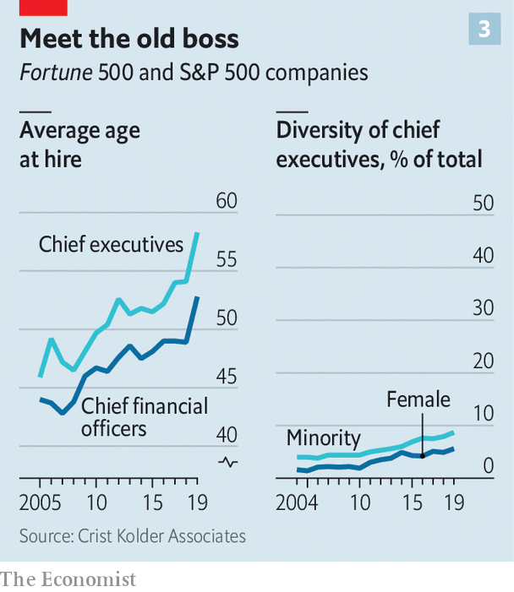

Senior headhunters admit the industry is sometimes too quick to recommend the safe option when boards are reluctant to gamble on unconventional candidates. Despite progress in recent years, just 38 of the bosses of America’s 675 largest listed firms are women, and 59 non-white. It has grown harder for bright young things to get a look in. The average age of incoming CEOs has risen sharply, to 58, since 2005 (see chart 3). A survey by AESC, which represents 16,000 search professionals, ranks “attracting diverse talent” as the seventh-most-pressing issue for their firms in 2019, behind such things as “attracting digital talent” or “creating a culture of innovation”.

## The search within

Growing doubts about the value headhunters bring has led some clients to take the work in-house. An expanding list of corporate titans, including all of the tech giants, are building private squads of headhunters—often by poaching from the Shrek firms. Having focused at first on junior hires, these are working their way up to the C-suite, says Ms Garrison Jenn.



Some company chairmen may wonder why they need an outside recruiter at all, when the ideal candidate is often staring them in the face. A recent Conference Board survey of executives and corporate secretaries found that 73% thought there was no need for a firm with a strong internal candidate for CEO to conduct an outside search. There appears to be no shortage of such talent within. Last year almost four-fifths of new S&P 500 bosses came from inside the firm, including that of Intel, a chipmaker. IBM recently picked the head of its cloud division to replace Ginni Rometty.

Yet most large companies will continue to use search firms—even if they do not fully buy the science, or harbour other doubts. That is because external validation has a value all of its own. Recruiters can be crucial in helping build consensus when, as is so often the case, boards are split. It is as diplomats that the best headhunters earn their keep.■

This article was downloaded by calibre from <https://www.economist.com/briefing/2020/02/06/the-industry-tasked-with-finding-bosses-is-more-powerful-than-ever>

|  |  |  |  |
| --- | --- | --- | --- |
| Previous | Articles | Sections | Next |

|  |  |  |
| --- | --- | --- |
| Briefing | Sections | The Americas |

United States

Donald Trump’s record: What he did, not what he said

.

New Hampshire’s turn: Waiting for Bernie

.

Testing and college admissions: What’s SAT

.

Government architecture: Column inches

.

Public transport: In a jam

.

Lexington: Trump unbound

.

|  |  |  |
| --- | --- | --- |
| Briefing | Sections | The Americas |

|  |  |  |  |
| --- | --- | --- | --- |
|  | Articles | Sections | Next |

#### What he did, not what he said

# What Donald Trump has done with the biggest budget in Washington

In the first of a series on the president’s record, we look at HHS

Feb 8th 2020 | WASHINGTON, DC

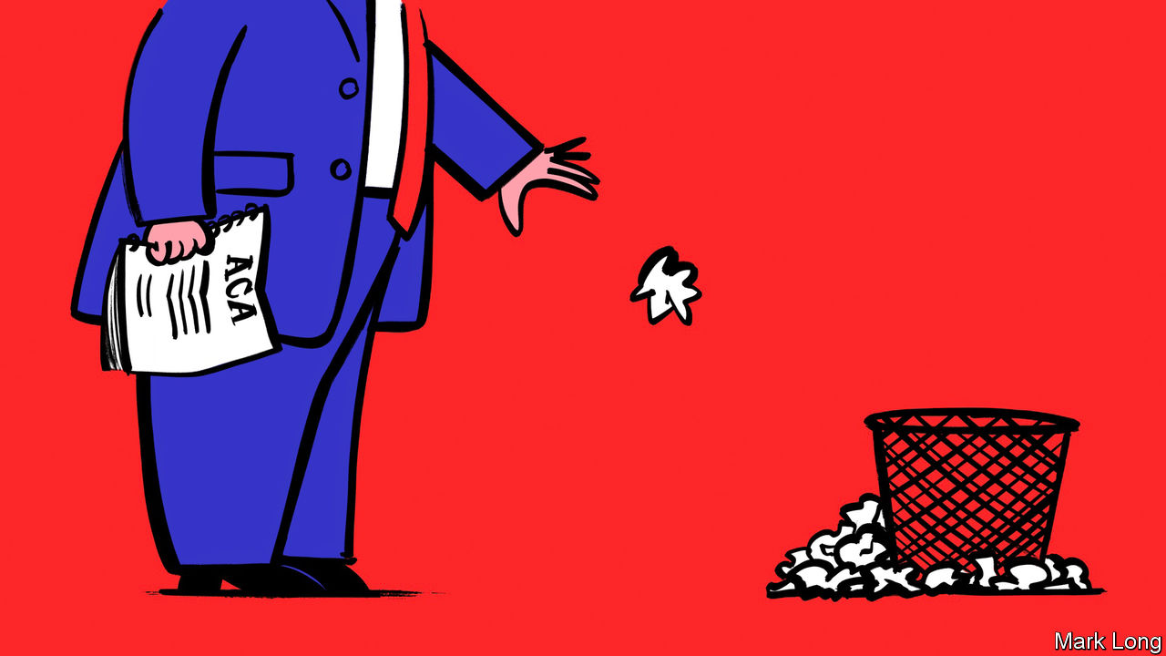

IF YOUR only source of information on Donald Trump’s record on health care was his state-of-the-union address, you would conclude that the president is hellbent on three things. The first is protecting patients with pre-existing medical conditions from insurers who would like to be rid of them. The second is making sure that illegal immigrants do not have access to subsidised health care. The third is bringing down the cost of prescription drugs.

But the president’s own words are not always the best guide to what the president does. He came to office promising to repeal Obamacare but failed to do so, and then lost control of the House of Representatives, and with it the opportunity to have another go. That does not mean his administration has done nothing, though. Presidents can have a lot of influence over American health care through the Department of Health and Human Services (HHS), an organisation that is much more interesting than it sounds.

Observers of American politics often forget that the distinction of having the biggest budget in Washington goes not to the defence department, but to HHS. In 2019, America spent a mere $685bn on defence compared to the $1.2trn spent at HHS—most of it on Medicare, the government health-insurance programme for the elderly, and Medicaid, the programme for the very poor. In addition to covering 109m Americans through these schemes, HHS has a sprawling mandate—to regulate the safety of food and drugs, to monitor epidemics, combat opioid addiction, provide direct health care for Native Americans living on reservations and take care of unaccompanied migrant children when they arrive at the border.

The first health secretary Mr Trump appointed to carry out these weighty tasks, Tom Price, had to leave after eight months, when a scandal about his use of private planes at taxpayer expense earned him the sack. His successor at the department, Alex Azar—who had been both an executive at Eli Lilly, a pharmaceutical giant, and a deputy secretary of the department in previous lives—has kept the job since and avoided much public notice or outrage. That is the result both of his better judgment and his rather ineffectual tenure. The sensible policies that Mr Azar has pushed—those aimed at reducing the price of prescription drugs—have gone nowhere.

Those changes that the department has successfully pushed through point in a different direction. HHS has set about destabilising the insurance markets set up under the Affordable Care Act (ACA), formally known as Obamacare, after Republicans failed to repeal it in Congress. It has also set about paring back Medicaid, the safety-net health-insurance programme. And it has tried to curb the work of abortion clinics.

The first of these tasks illustrates the strangeness of the Trump administration as it actually exists. Though unable to repeal the law, Congress got rid of the tax penalty for those who refuse to buy health insurance. The law used sticks and carrots to induce people to buy health insurance and Congress threw the main stick away. That development led Republican state attorneys-general to sue, arguing that the effective elimination of the individual mandate made the rest of the law invalid.

At first the Department of Justice declined to defend the main provisions of the law, leading one of its senior lawyers to resign. Later it hardened its position, and announced that the department agreed that the ACA had to go in its entirety. In a remarkable bit of up-is-downism, the president claims to be keeping the popular bits of Obamacare, such as the protections for patients with pre-existing conditions, safe from Democrats—at the same time as his justice department is pushing to eliminate those very protections.

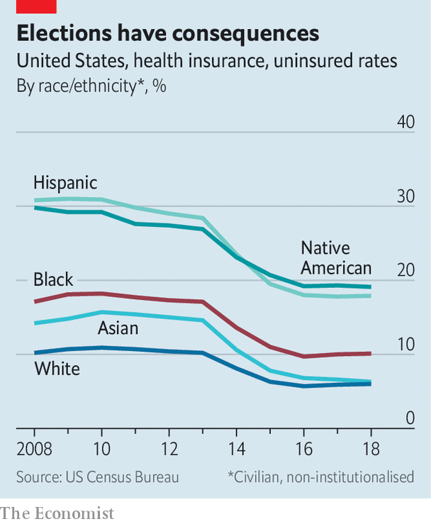

This has put HHS in a bind—duty-bound to implement a law that the president desperately wishes to overturn. One way it has circumvented the law’s spirit, if not its letter, has been to make it possible for organisations to offer health-insurance plans exempt from ACA rules that are cheap but prone to break down when they are most needed. These include faith-based medical plans that offer “Christian health care” with discretionary payouts. HHS has done a few other things to undermine Obamacare without actually flouting it. “I think there is a continued effort to—either by regulation, incompetence or intentional effort—undermine outreach and enrolment, which ultimately undermines the market,” says Kathleen Sebelius, Barack Obama’s first health secretary. The share of Americans who are uninsured fell steadily in Mr Obama’s second term. After 2016 that improvement ceased (see chart).

Perhaps the most consequential official at HHS now is Seema Verma, who runs the Centre for Medicare and Medicaid Services. Though Mr Azar is her boss, they do not get on. In December Mike Pence, the vice-president, and Mick Mulvaney, the president’s chief-of-staff, had to act as peacemakers between them. Ms Verma has pushed sweeping changes to Medicaid. The most significant was to allow states to implement work requirements for the first time in the history of the programme. Twenty states, mostly Republican led, have since announced plans to incorporate work requirements with health care for the poorest Americans. The fullest implementation to date, in Arkansas, resulted in 18,000 people (or 25% of those affected) losing coverage for a few months before a judge suspended the programme. Ms Verma has also proposed giving states a fixed grant to spend on Medicaid, which many wonks fear may augur future spending cuts.

Unlike Mr Azar, her boss and rival, Ms Verma has raised a few eyebrows and ethics reviews. One was for spending $3m in taxpayer funds on communications consultants to boost her personal image. A second was over a reimbursement claim she filed for $47,000 for jewellery—including an Ivanka Trump-brand pendant—and other personal effects stolen out of a hired car while she gave a speech. (She ended up receiving less than $3,000.) But Ms Verma, who was previously a health-care consultant in Indiana, is unlikely to go.

Most of the controversy over access to contraception and abortion has been focused on states, many of which have been passing laws that are almost outright bans in an attempt to bait the Supreme Court into taking a case and overturning Roe v Wade. Meanwhile, edicts from HHS attract less notice. In the name of expanding religious freedom, the administration finalised a regulation that would let employers claim a conscientious objection to paying for contraception—a requirement of the ACA. It has been held up in litigation since. Because of the so-called Hyde Amendment, the federal government does not pay for abortions except for cases of incest, rape or life-threatening complications to the mother. But HHS has also issued a rule banning any groups that take federal funding for family planning from referring patients to abortion providers.

All of these are traditional goals of past Republican administrations. Mr Azar’s heterodox efforts to use that authority to reduce drugs prices have stalled, even though there should be a bipartisan consensus there. In July 2019 the administration abandoned a plan to end the rebates that manufacturers pay to middlemen in the drug distribution system, known as pharmacy benefit managers, which critics claim inflate prices for consumers. Efforts to cap drug prices according to an international price index have been stuck in internal deliberations since October 2018. Plans to allow drugs to be imported from Canada into two test states—Vermont and Florida—look unlikely to materialise this year. New transparency rules, requiring drugs companies to include prices in advertisements and hospitals to publish their closely guarded price lists, are sensible but have been stalled by lawsuits.

Much of the administration’s health-care agenda has thus been delayed. These cases will eventually be resolved, though. Even if Republicans fail to win back Congress, with another four years Mr Trump could quietly reshape health care, without the need for any legislation at all.■

This article was downloaded by calibre from <https://www.economist.com/united-states/2020/02/08/what-donald-trump-has-done-with-the-biggest-budget-in-washington>

|  |  |  |  |
| --- | --- | --- | --- |
|  | Articles | Sections | Next |

|  |  |  |  |
| --- | --- | --- | --- |
| Previous | Articles | Sections | Next |

#### Living free

# Waiting for Bernie in New Hampshire

The oldest, leftiest candidate is expected to win round two of the Democratic primary

Feb 8th 2020 | DERRY

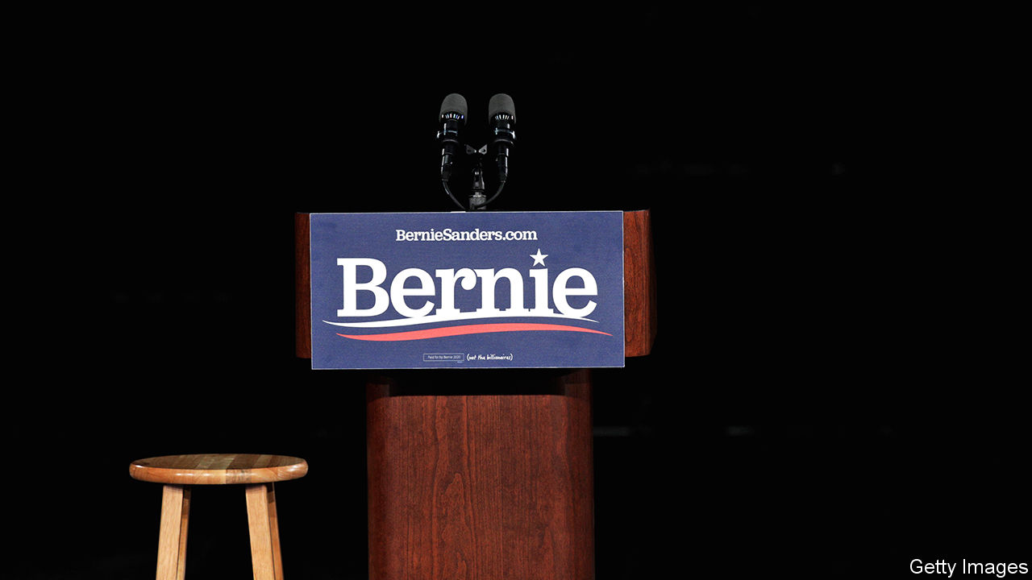

NEW HAMPSHIRE is a contradictory state. Its towns make good postcards, with saltbox houses meandering outward from a central green and a white clapboard church. Yet few states have lost a larger share of their population to opioids. Geographically, it resembles its twin, Vermont, but whereas the Green Mountain State has a genial, hippieish image, the Granite State is the watchful neighbour sitting on his porch, fingering his shotgun every time your dog wanders too close to his property.

Its political culture is similarly unusual. It has a libertarian spirit—eschewing sales and income taxes, and printing licence plates that read “Live Free or Die”. But it also has America’s biggest state legislature. What unites the two is a time-honoured commitment to participatory democracy. For 100 years it has held America’s first presidential primary election (Iowans caucus; New Hampshirites vote with ballots). Although many grumble over its primacy—some consider it too white (around 90%, compared with around 60% nationally) and too small—New Hampshirites take their politics seriously, and expect face time with any future president.

In the week before the primary, candidates planned to make more than 80 appearances around the state. The front-runners were making up for lost time. While they were in Iowa, Deval Patrick, a former governor of Massachusetts currently polling at “who?”, and Tulsi Gabbard, polling at “ugh”, had the state virtually to themselves.

Mr Patrick was a popular and accomplished governor, and may have made a decent run had he entered the race earlier. But he is out of step with the times: not only did he implement Mitt Romney’s health-care plan in Massachusetts, he worked at Mr Romney’s old private-equity firm, Bain Capital, until he launched his campaign. As for Ms Gabbard, she has long been erratic, but in January she sued Hillary Clinton for defamation, seeking $50m in damages for Mrs Clinton’s public remark that Russia was “grooming [her] to be the third-party candidate,” which Ms Gabbard denies.

The rest of the field arrived in the wee hours of February 4th. Local news the next morning showed each of them stepping off their planes, all looking bleary-eyed except for Elizabeth Warren, who was bouncing with her customary energy. At Pete Buttigieg’s event in Manchester the next morning, journalists embedded with the campaign competed to see who had slept least. Mr Buttigieg knows how to pander to a hometown crowd. Six days earlier, just before Iowa caucused, he said it was time for “a president whose vision was shaped by the American heartland.” In Manchester he praised New Hampshire’s “tradition of the town meeting and town hall.”

Mr Sanders also nodded to the town-hall tradition, at a rally in Derry the next day: “Probably in this very room, you have town meetings and people argue about how much you’re going to spend on the schools and roads...One person, one vote is what American democracy is supposed to be about,” he said, before launching into his customary stemwinder on concentrated wealth. His rally was well-attended, and not just by his usual supporters either. Alex, a business student from Massachusetts who favours Mike Bloomberg and plans to work in the health-insurance industry after he graduates, waited in line for two hours on a frigid morning to ask Mr Sanders what he planned to do about workers like him once private health insurance goes the way of the dodo. Mr Sanders asked, “Does anyone think that Alex is an enemy of mine?” and promised a “just transition.”

Mr Sanders will be hard to beat in the Granite State. Renny Cushing, the state legislator who introduced him, said that “Bernie has had an impact on our state for decades,” crossing the border to join picket lines and support workers trying to unionise. Though Elizabeth Warren represents New Hampshire’s southern neighbour, Mr Sanders has been in politics longer; people seem to know him better, and at least in that room, they liked him more. After that small triumph, Mr Sanders and the rest continued trundling along the state’s narrow, winding roads, looking for one more mic to grab, one more hand to shake.■

This article was downloaded by calibre from <https://www.economist.com/united-states/2020/02/08/waiting-for-bernie-in-new-hampshire>

|  |  |  |  |
| --- | --- | --- | --- |
| Previous | Articles | Sections | Next |

|  |  |  |  |
| --- | --- | --- | --- |
| Previous | Articles | Sections | Next |

#### What’s SAT

# Are test scores the backbone of meritocracy or the nexus of privilege?

University of California’s review of its admissions procedures smiles on sats

Feb 8th 2020 | BERKELEY

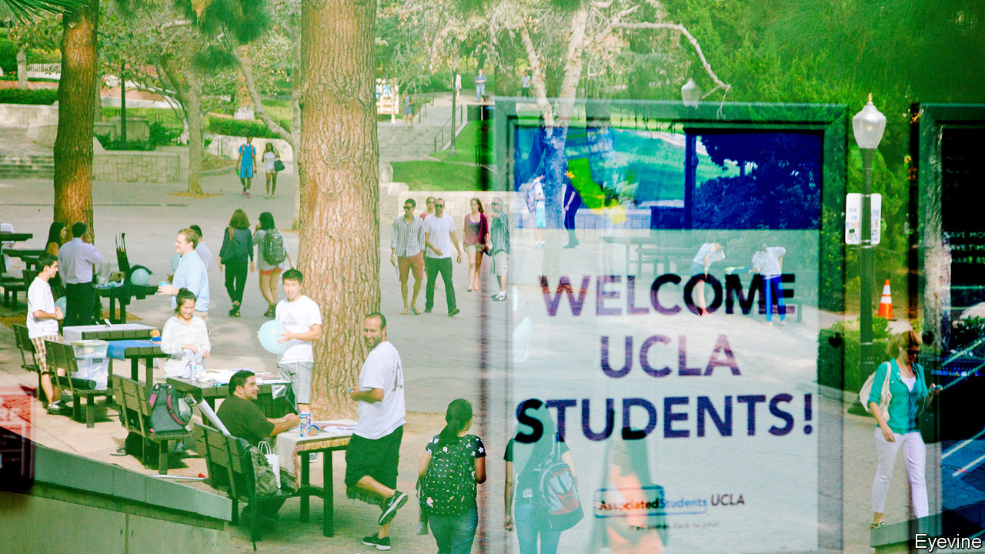

LIKE ANY hotbed of scholarly activity, the University of California (UC) is no stranger to rows. Recently a debate over the use of SATs and ACTs, tests used in college admissions, has spilled out from campus and into the courtroom. In December a lawsuit denouncing UC’s use of the tests was filed in the Alameda County court. On February 3rd a commission reviewing admissions procedures recommended that UC should resist calls to abandon tests. More than 1,000 colleges across America have made submitting test scores optional for many students, though hardly any are completely “test blind”. UC is by far the largest institution to consider abandoning them. UC’s size (it has about 220,000 undergraduates) and prestige means others will watch what it does carefully.

First administered in 1926, SATs have faced criticism for favouring the wealthy since the 1940s—an irony, since they were originally adopted by Harvard to expand its intake beyond the boarding schools of the north-east. While the College Board, which owns the SATs, has worked hard to eliminate egregious advantages for children from wealthy families—gone are the questions about oarsmen and regattas—there has been a persistent correlation between test scores and both socioeconomic status and race. The College Board acknowledges these correlations, but argues that they reflect “learning gaps that result from educational and societal inequities”, not bias in the test itself. All measures of college preparedness are affected by societal inequity, and it is unsurprising, if unfortunate, that students from poor backgrounds perform worse. Using test scores, the College Board argues, helps colleges to select those students most likely to thrive.

Academics have reached no consensus on how well the tests predict student success at university. Most agree on two things: that high-school grade point average (HSGPA) is the best predictor of college success and that the tests, when combined with grade averages, make predictions more accurate. How much tests add is disputed. The College Board claims that the additional predictive power offered by the SATs is significant. Many disagree.

Even if the question of predictive power were resolved, another question arises about how good the tests would have to be at predicting college outcomes to justify their use. If they significantly decreased the number of successful applicants from already disadvantaged groups, such a sacrifice would presumably not be justified by a minor gain in predictive power. How institutions judge this trade-off depends on their mission, circumstances and the cohort they want to attract. This goes to the heart of an age-old question. Should universities consider themselves primarily as centres of academic excellence, and therefore strive to accept the students most likely to excel academically? Or should they accept a broader mission to improve society, which could mean sacrificing some academic excellence in the pursuit of a different definition of equality?

The plaintiffs’ arguments imply that no amount of predictive validity justifies the use of the tests in admissions. They allege that UC’s use of tests that are “demonstrably discriminatory” against “talented and qualified students” from poor families, under-represented minorities and students with disabilities is illegal under California law. “Use of the SAT and ACT is not just indefensible policy,” argues Mark Rosenbaum, counsel for the plaintiffs; “it is illegal wealth- and race-discrimination.”

In January 2019, long before the lawsuit, UC commissioned a task-force to review its admissions procedures. It found that the tests are as good as or better than high-school grades at predicting student outcomes. For under-represented minority students, students from poor families and students who were the first in their family to go to college, tests were better predictors of success, as measured by subsequent undergraduate grades, than for other candidates. What is more, because tests and high-school grades are only two of 14 factors used in admissions decisions, students in these less fortunate groups were often admitted at a higher rate for any given test score. Admissions officers took into account factors such as inequality of school resources and access to test preparation, and decided accordingly.

The report expressed concern that whereas 59% of high-school graduates in California were under-represented minorities in 2019, only 37% of Californian students in the admitted freshman class came from these groups. However, it concluded that the tests were not the main culprit. Three-quarters of the opportunity gap was attributed to factors that preceded admission, most notably failure to complete required courses. Test scores were thought to play some role in explaining the remaining quarter, though they were “not the primary barrier to admission”. The report concluded by suggesting that UC should “study the development” for a new approach to assessing students, suggesting that this could be implemented in nine years.

Far from exonerating UC, the report validates the decision to file suit, according to Mr Rosenbaum. He argues that the report merely shifts the blame for the inequalities in the UC system away from the “unlawful use of discriminatory and meaningless tests” and onto the California public school system. Given the sensitivity of the issue, the suit will be controversial and closely followed. It is unlikely to produce a satisfactory outcome. After decades of debate, experts are still unable to agree on either the facts or the morality of the matter. Given this, what hope have the courts?■

This article was downloaded by calibre from <https://www.economist.com/united-states/2020/02/08/are-test-scores-the-backbone-of-meritocracy-or-the-nexus-of-privilege>

|  |  |  |  |
| --- | --- | --- | --- |
| Previous | Articles | Sections | Next |

|  |  |  |  |
| --- | --- | --- | --- |
| Previous | Articles | Sections | Next |

#### Beautifying government

# Donald Trump threatens to bring his taste to government buildings

Modernism is out, Corinthian columns are in

Feb 8th 2020 | WASHINGTON, DC



AS A PROPERTY developer, Donald Trump’s tastes were for the brash. The Trump Taj Mahal in Atlantic City, built at a cost of $1.2bn in 1990, featured neon-lit golden onion domes. The Trump International Hotel in Las Vegas, built at a reported cost of $800m and opened in 2008, resembles a golden tombstone, towering 600 feet above the Strip. In more recent years Mr Trump’s name has been attached to equally hideous edifices that he did not develop in places as far afield as Uruguay and India.

So perhaps it should come as a surprise that in government Mr Trump’s favoured architecture seems to be more conservative. On February 4th the Architectural Record, a trade journal, reported that it had been leaked a draft copy of an executive order the president intends to sign, ordering that new federal buildings should be designed in neoclassical style. According to the document, in recent decades, architects designing federal buildings have been too much influenced by “brutalism and deconstructivism” and should return to the era of America’s founding, when the inspiration, both politically and architecturally, came from ancient Athens and Rome.

It is unclear whether the order will ever be enacted. The White House refused to comment. But if it were, the edict would bring about the first major changes in almost 60 years to the guidelines set out for federal architecture by Daniel Patrick Moynihan, a sociologist-turned-senator, in 1962. He argued that the “development of an official style must be avoided” and that design “must flow from the architectural profession to the government and not vice versa.”

Moynihan’s ideas made the American government a remarkable sponsor of architectural experimentation. It may be exactly that which has drawn Mr Trump’s disapproval. According to the Record, the draft order specifically mentions three newish and very modern buildings, the Federal Building in San Francisco, built in 2007, and the United States Courthouses in Miami and Austin, built in 2007 and 2012 respectively, as having “little aesthetic appeal”.

Mr Trump has long been known to dislike brutalism. In 2018 the website Axios reported that he was “obsessed” with the Hoover Building in Washington, DC, the brutalist headquarters of the FBI. He has apparently called it “one of the ugliest buildings in the city”. Such opinions are not new. Jack Kemp, George H.W. Bush’s housing and urban development secretary, described his agency’s curvy brutalist headquarters in Washington as resembling “ten floors of basement”.

But Mr Trump’s interest brings a complication other critics do not: his own interests. The Hoover Building sits directly across from his Trump International Hotel, which occupies the Romanesque-revival former Post Office Building. The FBI has considered moving out of the city and selling the site, which Mr Trump opposes. If the site is ever redeveloped, its style may concern the president less than its function—lots of gold, fine, but absolutely not another hotel.

This article was downloaded by calibre from <https://www.economist.com/united-states/2020/02/08/donald-trump-threatens-to-bring-his-taste-to-government-buildings>

|  |  |  |  |
| --- | --- | --- | --- |
| Previous | Articles | Sections | Next |

|  |  |  |  |
| --- | --- | --- | --- |
| Previous | Articles | Sections | Next |

#### In a jam

# Angelenos are happy to pay for public transport, but loth to use it

Why LA’s lovely new trains have not lessened the time spent stuck in traffic

Feb 8th 2020 | LOS ANGELES



THE EXPO LINE, a light railway which connects the city of Santa Monica to downtown Los Angeles, is a marvel. For decades, Angelenos travelling to and from the beach had to sit in traffic on Interstate 10. Since 2012, when the line opened, repurposing a long-closed Pacific Electric rail line, they have been able to catch a sleek train instead. On board, Josh, clutching a smart yellow bicycle, says that thanks to the line he has managed to avoid buying a car since moving back to the city from New York three years ago. Instead, he commutes by bike and train to his tech-firm office each day.

Such stories delight urbanists, who want to make LA less dependent on the car. The city is trying hard to throw off its reputation as an automotive city. In 2016 71% of voters in Los Angeles County approved Measure M, a ballot initiative which imposed a sales tax to fund public transport. That and older taxes mean for every dollar they spend, people in the Los Angeles urban area now contribute 2 cents to public transport. Several new rail lines are planned. Last year the mayor of the city of Los Angeles, Eric Garcetti, announced that he wants to reduce the number of car trips there by half over the next 30 years.

Yet much more common than people like Josh are people like Debbie, a 22-year-old pharmacy worker. Standing waiting for a bus in El Monte, a city in the east of the sprawl, she looks sniffily around at her surroundings. Today her car has broken down; otherwise she would be in it. Driving “is just so much easier”, she says. Even as its budget has expanded, the number of people actually using public transport in LA has collapsed. Total ridership is down almost a quarter since 2013. Three in four Angelenos travel to work on their own in a car, the highest figure ever.

Half a century ago Reyner Banham, a British architectural critic, mocked urban planners who wanted to force LA to readopt public transport. “It will not be easy to persuade Angelenos… [to] climb into whatever coloured rolling-stock the new dream system offers,” he wrote. Some fear he may be proved right: it seems to be easier to persuade Angelenos to pay for public transport than to get them to use it.

According to Michael Manville, a professor at UCLA’s Institute of Transportation Studies, the driving factor behind the decline is that public transport in LA is mostly a safety-net for the poor, not a service for most people. In a typical year, the average person in southern California takes 36 bus or train trips. But most people take none at all. And in recent years, as sub-prime credit has proliferated and wages have risen, poor people in the city have acquired cars. The proportion of households without access to a car fell from 10% in 2000 to 7% in 2015. Among immigrants, the fall was even sharper, from 14% to 8%. For a while the opening of new rail lines balanced out falling use of buses but no longer.

According to Mr Manville, providing public-transport options is not enough to persuade people to get out of their cars. Trains and buses must be almost as fast and convenient as driving. In sprawling Los Angeles, with its extensive freeway system, even the almost permanent traffic jams do not slow people down to the speed of buses. With over 100 square miles of parking, over four Manhattans, there is usually somewhere to leave the car.

What can be done to turn things round? Jessica Meaney, who runs a charity which lobbies for transport for poorer people, says that the city’s planners have often been too “romantic”, prioritising grand new rail lines and trying to attract freewheeling yuppies. Meanwhile the needs of poorer people, who mostly use buses, have been neglected. She notes several simple things that need improvement. Pavements around bus routes should be less dangerous, so people do not feel scared of walking to the stop. Rail stations need toilets and baby-changing stations, so that people with children (or without) are not caught short. Police officers patrolling lines could be less aggressive towards young men.

Modest changes are already under way. Last month the Los Angeles County Metropolitan Transportation Authority, which manages most public transport in the LA urban area, announced that it will update its bus routes, which have been mostly unchanged for 30 years. Joshua Schank, the agency’s chief innovation officer, explains how a study of people’s travelling habits found that buses were particularly bad for short journeys out of normal commuting hours—taking a child to a doctor, for example. Make those easier, and some two-car families might drop one.

Yet such tweaks will probably not be enough to lessen LA’s legendary traffic jams. And as traffic worsens, it creates a downward spiral, as buses slow down even more and people switch to cars. Mr Schank says the city will eventually need some sort of congestion pricing. The roads “will never accommodate the demand as long as the price is zero,” he says. A pilot is already being planned. That will be controversial, however. Even removing a single lane of traffic to create a dedicated bus lane can cause a storm of anger.

For other American cities, or at least those which look a little like LA, all this ought to be worrying. Among the fastest-growing parts of America are sunbelt cities such as Houston, Atlanta and Phoenix. Such places also tend to have liberal leaders who want to move away from space-hogging polluting cars. Yet none of those cities have anywhere near the resources LA has put into public transport to such little effect. Money is important but to get people out of their cars it will take bravery too. ■

This article was downloaded by calibre from <https://www.economist.com/united-states/2020/02/08/angelenos-are-happy-to-pay-for-public-transport-but-loth-to-use-it>

|  |  |  |  |
| --- | --- | --- | --- |
| Previous | Articles | Sections | Next |

|  |  |  |  |
| --- | --- | --- | --- |
| Previous | Articles | Sections | Next |

#### Lexington

# Trump unbound

Donald Trump is acquitted by the Senate, adored by his supporters and wholly unrepentant

Feb 6th 2020 |

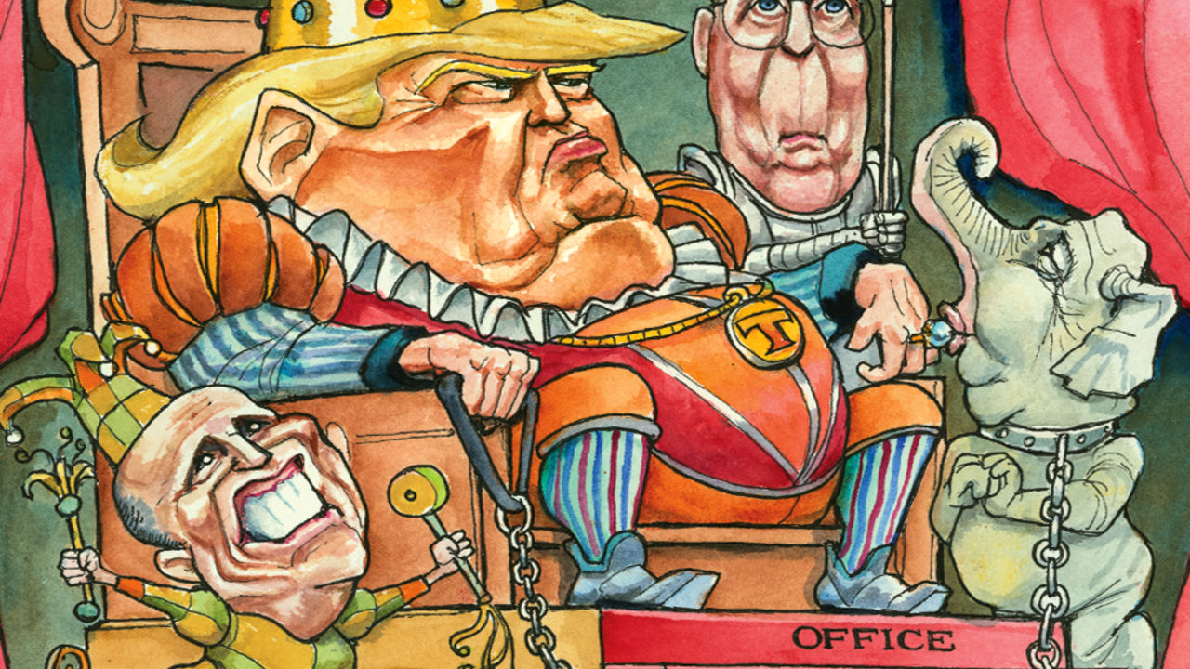

IN ANNOUNCING her decision to vote to acquit Donald Trump this week, Susan Collins said she believed the president had learned a “pretty big lesson” from his impeachment. When next tempted to extort a foreign leader to frame a political rival, the senator from Maine predicted, he would be “much more cautious”. Another view is that, having established Congress’s inability to restrain him, because of the tribalism of Republicans such as Ms Collins, Mr Trump may feel even more emboldened to disregard any rule or convention that stands in the way of his interests. His third state-of-the-union address, delivered to a packed House chamber on the eve of his acquittal on February 4th, offered evidence for that.

Unlike Bill Clinton, who expressed contrition during his mid-impeachment SOTU speech, Mr Trump did not mention his Ukraine scheme or Senate trial it occasioned—which ended in his acquittal on partisan lines the next day: Mitt Romney was the only Republican who voted to convict. Yet he had already repudiated Ms Collins, telling journalists he had nothing to learn, because his approach to President Volodymyr Zelensky was “perfect”. And his SOTU performance underlined that he truly believes this.

For most of American history, the annual presidential report to Congress was delivered by letter, because of Thomas Jefferson’s fear that a live address might seem too kingly. Yet an elected despot, with fawning courtiers and freedom to mingle personal and public interests at will, is what Mr Trump aspires to be. It is what he maintains, in his claim to unbridled executive power and attacks on institutions that would constrain him, it means to be president. On the eve of his party’s final capitulation to Trumpism, his last pre-election SOTU was an enactment of that unAmerican fantasy.

As he entered the chamber, Republicans jostled to shout praise in his ear, touch him, ask him to sign their clothing. At least it was familiar: Democrats drooled over Barack Obama too. The SOTU had become a partisan performance, watched by a president’s supporters and ignored by almost everyone else, before Mr Trump was elected. Yet no recent president has demanded, and received, the fealty that has become a cover for his rule-breaking.

Woodrow Wilson restored the in-person SOTU address with a view to humanising the presidency. Mr Trump uses it to suggest his precedence over not only his party, but all three branches of the government. He snubbed the Democratic Speaker of the House, Nancy Pelosi, refusing to shake her hand (she later responded by ripping up a copy of his speech). He boasted of his efforts to politicise the judiciary, by nominating the “187 new federal judges” his followers are counting on to pass judgments they like. (The smirks of his two Supreme Court appointees, Neil Gorsuch and Brett Kavanaugh, after he named them, probably did more to incite Democratic countermeasures than their elevations.)

Ronald Reagan started the tradition of inviting common folk as SOTU guests to express his modesty and empathy. Mr Trump uses his invitees as props to display beneficence and power. He conferred a surprise scholarship on a poor fourth-grader from Philadelphia, sitting in the gallery. He shocked a service wife by producing her husband, an army sergeant deployed to Afghanistan. He asked his wife Melania to fasten the Presidential Medal of Freedom—then and there!—around the neck of the talk-radio megastar, Rush Limbaugh, cancer-stricken and weeping besides her. Such boons owe less to reality TV than to Medieval kingship.

To what does Mr Trump owe his hold on his supporters? Some Trump defenders urge critics to look beyond the president’s excesses to his achievements. As he noted in his address, the economy is strong. Yet if his record were half as good as his defenders say, why does he misrepresent it so extremely? He claims endless things that are demonstrably false—to have vanquished ISIS though it is resurgent; to have cut the cost of prescription drugs though they have soared; to be guaranteeing health-insurance provisions his administration is suing to dismantle. If his supporters were primarily drawn to Mr Trump by his record, they might be expected to discern the facts from the nonsense; most know he is not honest. Yet, for the sake of political argument at least, they seem to accept whatever he claims. And in so doing they cede Mr Trump a power no other American president has claimed: over truth itself.

The real reason Republicans are so solidly behind Mr Trump is his genius at needling their political resentments and fears—against the liberal media, socialist Democrats, “illegal aliens”. Political scientists call this negative partisanship, and Mr Trump’s SOTU address was a masterclass in it. In the climax of its second half, he mentioned the word “alien” four times; also “socialist takeover”, “brutal rape”, “terror” and “evil”. The frightful language of his partisanship (which he learned from Mr Limbaugh, a fellow disseminator of the racist “birther” slur against the first black president) has helped drive his supporters’ increasing loyalty. Republicans are either scared by the fears he stirs; or having ridden along thus far with Mr Trump’s chauvinism it has become too hard for them to acknowledge. It is no wonder few deserted him over the relatively remote matter of his leaning on Mr Zelensky.

## UnAmerican activities

Republicans such as Ms Collins say an election is the only proper means of holding Mr Trump to account. Yet in the grip of their partisan affiliations, few voters will recall Mr Trump’s Ukraine scam next November—and if he wins re-election, will he have a licence to repeat it? Exonerated by the Senate, he may even do worse before then. He has fresh grudges to settle and political cover to do so.

Mr Trump’s sometimes comical strangeness long made the fears of despotism he stirred seem overblown. But think of authoritarianism as a corrosive process, not a dictatorial end-state, and they no longer do. He has never looked more threatening to American democracy. And thanks to Senate Republicans, with one laudable exception, it has never looked more vulnerable to him.■

This article was downloaded by calibre from <https://www.economist.com/united-states/2020/02/06/trump-unbound>

|  |  |  |  |
| --- | --- | --- | --- |
| Previous | Articles | Sections | Next |

|  |  |  |
| --- | --- | --- |
| United States | Sections | Asia |

The Americas

Ecuador: The future of the undoing project

.

Colombia: Wine whinge

.

Venezuela: Rum raisin’

.

Bello: A new war of religion

.

|  |  |  |
| --- | --- | --- |
| United States | Sections | Asia |

|  |  |  |  |
| --- | --- | --- | --- |
|  | Articles | Sections | Next |

#### Rafael Correa in court

# Ecuador’s trial of the century opens

A former president is in the dock. If acquitted, he could be a kingmaker

Feb 8th 2020 | QUITO

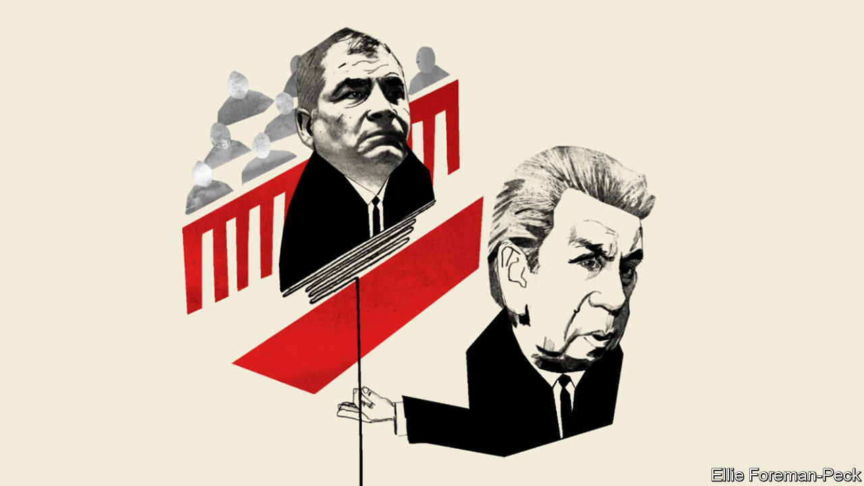

IT IS ECUADOR’S trial of the century. On February 10th the country’s top court is expected to open criminal proceedings against Rafael Correa, president from 2007 to 2017, and 20 other people. They are charged with taking and giving bribes, which they deny. Mr Correa, who moved to Belgium shortly after leaving office, hopes to play a big role in the presidential and legislative elections due in February next year. His trial may determine whether he can.

Ecuador’s current president, Lenín Moreno, has spent nearly three years trying to undo Mr Correa’s legacy. He had been Mr Correa’s vice-president and was seen as his heir. Once in office, Mr Moreno turned on his patron. He went after corrupt members of Mr Correa’s administration and took steps to restore independence to the judiciary and the press, which Mr Correa had curbed. The new president replaced his predecessor’s incontinent spending with a programme of austerity, backed with a $4.2bn loan from the IMF. He expelled Julian Assange, a co-founder of WikiLeaks, from Ecuador’s embassy in London, where Mr Correa had offered refuge.

But the undoing project has run into trouble. Mr Moreno’s attempt to end fuel subsidies provoked massive protests in October, which forced him to retreat. His approval rating is less than 20%. Mr Moreno says that he does not plan to run for re-election next year, but he is determined to ensure that correísmo does not come back. A trial that discredits Mr Correa would help.

The investigations of Mr Correa and his co-defendants began last May after two journalists, Fernando Villavicencio and Christian Zurita, revealed an alleged scheme to funnel bribes paid by companies into the campaign coffers of Alianza PAIS, then Mr Correa’s (and now Mr Moreno’s) political party. On the day after their first story appeared police arrested Pamela Martínez, a former Constitutional Court judge who had been an aide to Mr Correa, as she tried to board a flight to Mexico. A search turned up a deposit slip for a $6,000 cheque credited to Mr Correa’s account (he says it was a personal loan). Ms Martínez told a court that Mr Correa had asked her to confirm that she had destroyed incriminating evidence.

Also on trial is Jorge Glas, a Correa ally who was Mr Moreno’s vice-president and is in jail for arranging kickbacks from Odebrecht, a Brazilian construction firm that bribed officials across Latin America. Officials from companies that allegedly paid bribes, including SK Engineering, a South Korean builder, are in the dock. Several projects during Mr Correa’s presidency were badly built and busted their budgets. The government spent $3.7bn, 3% of 2019’s GDP, on two failed refineries.

Mr Correa, who will be tried in absentia, claims that he is the victim of a witch-hunt. He recently tweeted that his enemies are “terrified of the response that the people will give them at the polls”. Simón Pachano, a political scientist at FLACSO University in Quito, disagrees. “It’s a trial of politicians, not a politicised trial,” he says.

That would not have happened if Mr Moreno had not restored to the courts a measure of the independence they lost under Mr Correa. In 2018 Mr Moreno held a referendum, which gave him a mandate to set up an independent panel to review the judiciary. That body replaced senior prosecutors and the judges on the Constitutional Court, who were widely regarded as Mr Correa’s puppets. It also purged the members of the Judiciary Council, which Mr Correa had used to sack judges he didn’t like and intimidate others. Mr Moreno unmuzzled the press by abolishing the “Superintendancy of Information and Communication”, an agency that Mr Correa had used to control the media.

The reforms are imperfect. The Judiciary Council remains in place, points out Human Rights Watch, an NGO. The new media law still characterises the press as a “public service”. Even so, the press and the courts are less cowed than under Mr Correa.

These reforms and a crackdown on corruption brought Mr Moreno popularity, but weak growth and austerity have taken it away. The economy shrank last year and is expected to grow by less than 1% in 2020. Because Ecuador uses the dollar, it cannot devalue to compensate for wage rises that have outpaced productivity growth. After protesters blocked the abolition of fuel subsidies and the legislature weakened a tax reform, the IMF has set easier targets for the Moreno government. But it will still have to cut spending and raise tax revenue this year. Protests could resume.

The outcome of elections in February 2021 will depend on which forces can capitalise on the discontent. Mr Correa, who now hosts a show on RT, a Russian state broadcaster, on which he interviews such left-wing luminaries as Oliver Stone, a film director, and Nicolás Maduro, Venezuela’s dictator, cannot run for the presidency. But he no doubt hopes to be a kingmaker. If he is convicted, he may hope to obtain a pardon from whomever succeeds Mr Moreno.

The strongest challenger to correísmo in a crowded field looks like Jaime Nebot, the conservative former mayor of the coastal city of Guayaquil. He has not announced his candidacy but is acting like a presidential aspirant. If he runs and is elected, he would probably continue Mr Moreno’s undoing project. The path to power may go through a courtroom in Quito.■

This article was downloaded by calibre from <https://www.economist.com/the-americas/2020/02/08/ecuadors-trial-of-the-century-opens>

|  |  |  |  |
| --- | --- | --- | --- |
|  | Articles | Sections | Next |

|  |  |  |  |
| --- | --- | --- | --- |
| Previous | Articles | Sections | Next |

#### Wine whinge

# The costs of Colombia’s closed economy

Importers must run an obstacle course

Feb 8th 2020 | CARTAGENA

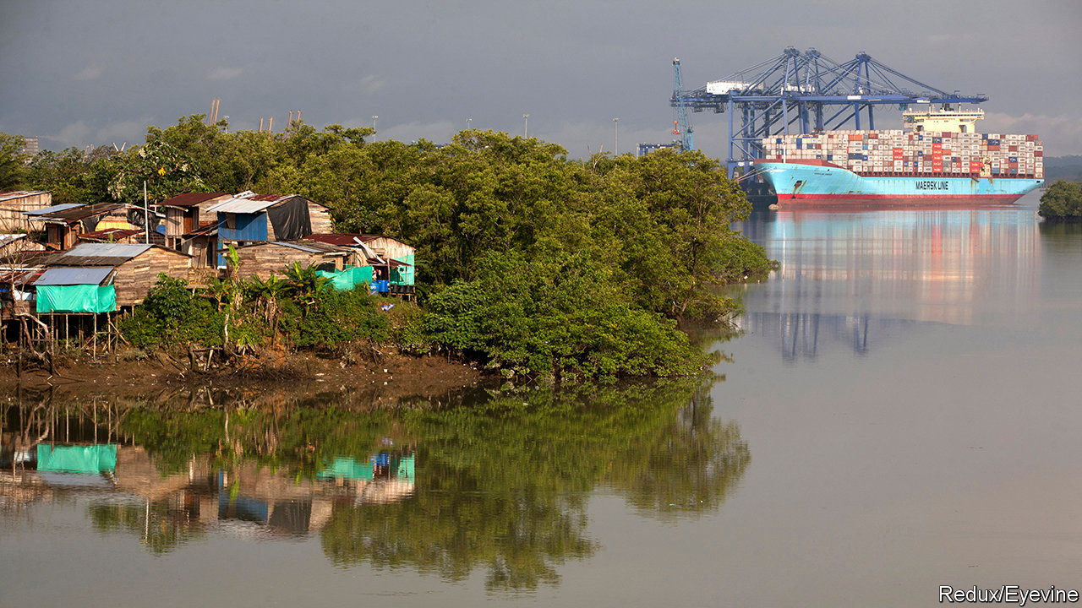

COLOMBIANS PAY more for wine than most Latin Americans. The price shoots up as soon as a case reaches shore. Each time a shipment arrives, importers must submit at least eight forms to as many agencies. Officials can take up to 15 days to clear it. In the meantime, importers store their bottles in climate-controlled warehouses. When a permit finally comes, bad roads and high trucking charges mean that merchants pay among the highest freight bills in the world to ship the wine to Bogotá, the capital, where most customers are. By the time it reaches a dinner table a bottle of wine costs eight times more than in its country of origin. Its costly journey is the rule, not the exception, for products imported by Colombia.

It used to be easier. The government liberalised the economy in the early 1990s after decades of protectionism. At that time Colombia depended on exports of coffee, the price of which was plummeting. In an effort to diversify the economy and make it more productive, the government reduced tariffs and eliminated lists of items whose import was prohibited.

That openness lasted just a few years. Owners of factories and sugar mills, dairy farmers, rice growers and regional governments, which own distillers of aguardiente, a local tipple, were hurt by competition. They lobbied to restore protection. The government could not reimpose tariffs, in part because of its commitments as a member of the World Trade Organisation. So it put up lots of non-tariff barriers.

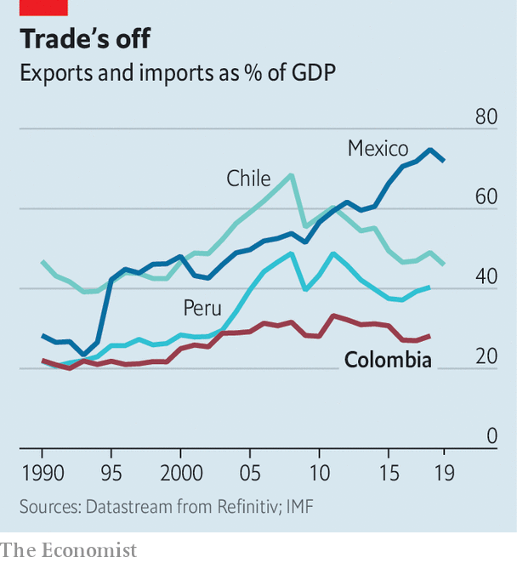

Colombia is now as closed as it was in the 1990s, according to a new book*. Total trade has increased fivefold, but the ratio of trade to GDP has not risen much (see chart). Non-tariff measures affect nearly four-fifths of imports, up from 27% in 1992, says the UN Conference on Trade and Development. The government has created new trade-related agencies, and has given existing bodies more power to meddle.

The coddling of domestic producers is one reason why productivity has barely grown since the 1990s. In 2012 farms produced less by value in real terms than they did in 1990. Peru and Chile, which have less variety in their growing conditions but more open economies, have doubled their output over the same period. Pricey imports raise exporters’ costs, making them less competitive.

Ports are suffering. Ships arrive in Buenaventura, the biggest port on the Pacific coast, loaded with containers, but they leave with nothing. Cartagena, on the Caribbean coast, makes its living as a transshipment port, shuffling goods from one ship to another. But that is less profitable than handling exports and imports. Colombia’s “main export is air”, says Anibal Ochoa, the port’s commercial director.

Until now, governments have ignored the costs of Colombia’s closed shop. That is partly because their priority was to defeat the FARC, a guerrilla group that waged a 50-year war against the state. From the early 2000s Colombia earned a decent living from oil and gas, which replaced coffee as the main export. They account for nearly 60% of goods exports.

Now pressure is building to liberalise. A peace agreement in 2016 ended the war. Oil prices fell in 2014 and have yet to recover fully. Reserves are running low. Trade could become the economy’s new engine, says Jorge García, one of the book’s editors.

So far, though, the push to open up has had little support from the top. The government has made some permits easier to apply for, but did not reduce their number or cost. For now, it seems, only rich Colombians will be able to afford wine. Others will drown their sorrows in aguardiente.■

*“Comercio Exterior en Colombia: Política, Instituciones, Costos y Resultados”, edited by Jorge García García, Enrique Montes Uribe, Iader Giraldo Salazar. Banco de la República.

This article was downloaded by calibre from <https://www.economist.com/the-americas/2020/02/08/the-costs-of-colombias-closed-economy>

|  |  |  |  |
| --- | --- | --- | --- |
| Previous | Articles | Sections | Next |

|  |  |  |  |
| --- | --- | --- | --- |
| Previous | Articles | Sections | Next |

#### Rum raisin’

# A share issue in Venezuela, the world’s worst-performing economy

An investment in the stockmarket is not as nutty as you might think

Feb 8th 2020 | CARACAS

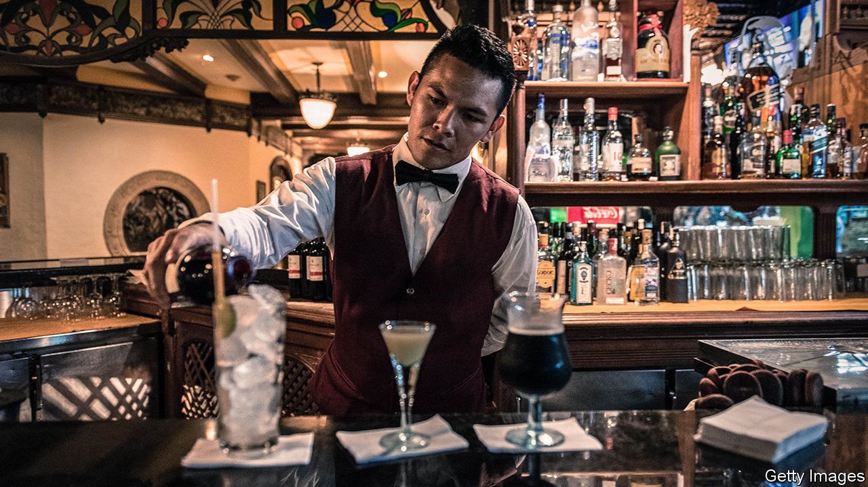

SOME WONDERED if the bosses of Venezuela’s oldest rum company had been sampling too much of their product. In January, with Venezuela in one of the deepest recessions in modern world history, Ron Santa Teresa launched the country’s first public share issue in more than a decade. The new equity was priced in bolívares, the world’s worst performing currency. Others speculated that the rum-maker, which cheekily notes on its website that its distillery in the Aragua valley near Caracas has survived “wars, revolutions, invasions, even dictators”, had decided that change was afoot.

Evidence of the latter interpretation is that the latest dictator, Nicolás Maduro, has recently become a capitalist, sort of. The disciple of Hugo Chávez (whose “21st-century socialism” set Venezuela on its road to ruin) has quietly lifted price controls and restrictions on dollar transactions. He now says firms can issue securities in hard currencies. He is thought to be contemplating a sale to foreign investors of a stake in PDVSA, the decrepit state oil company.

Ron Santa Teresa’s president, Alberto Vollmer, a fifth-generation rum-maker, says the company, whose shares were already listed, needs the money to buy barrels and build warehouses. It signed an international-distribution deal with Bacardi in 2016. Mr Maduro’s tentative pro-market turn is “a happy coincidence”, he says. The sale of 1m shares, which raised the equivalent of $300,000, was a fillip for the near-dormant stockmarket, which lists just 31 companies. Demand outstripped supply.

The investors are not as daft as you might think. Although denominated in bolívares, share prices tend to keep pace with inflation. This has dropped, from an annual rate of more than 2m% early in 2019 to a mere 9,500% for the year. That is partly because the government has increased the amount of reserves that banks must hold.

But this has caused a shortage of bolívares. The total amount of bank loans is the equivalent of $225m, less than 0.5% of GDP. Sanctions imposed by the United States and EU have made lending harder. The share issue raised more money in a day than the large banks could lend to Mr Vollmer’s firm.

No one expects a dramatic recovery of the economy, which has shrunk by two-thirds since Mr Maduro took over from Chávez in 2013. But Mr Vollmer welcomes the shift towards pragmatism. “That’s what happens when you run out of money to fund ideas that didn’t work.”

This article was downloaded by calibre from <https://www.economist.com/the-americas/2020/02/08/a-share-issue-in-venezuela-the-worlds-worst-performing-economy>

|  |  |  |  |
| --- | --- | --- | --- |
| Previous | Articles | Sections | Next |

|  |  |  |  |
| --- | --- | --- | --- |
| Previous | Articles | Sections | Next |

#### Bello

# Latin America’s new war of religion

Blurring the separation between church and state

Feb 8th 2020 |



UNDER THE banner of “religion and traditional (ecclesiastical) privileges”, in 1858 Mexican Conservatives rose in arms against a Liberal constitution which declared freedom of worship and ended a rule preventing Catholic church property from being transferred to anyone else. After a three-year war, the liberal principles of religious toleration and the separation of church and state triumphed. In the following decades they spread across Latin America. Now, it seems, this 19th-century political battle has to be fought all over again.

The new blurring of the divide between spiritual and temporal realms owes much to the rise of evangelical Protestantism. Although 69% of Latin Americans were still Catholics in 2014, 19% were Protestants (26% in Brazil and more than 40% in three Central American countries), says a Pew poll. The number of Protestants is likely to have risen since then. Most are Pentecostals.

They emphasise a literal reading of the Bible and a direct personal relationship with God through baptism with the Holy Spirit. Many want their beliefs to shape public policy. Their concern is mainly, but not solely, to oppose gay rights and abortion. In some cases they dismiss science and have intervened in foreign policy. Some question the separation of church and state.

Jair Bolsonaro, Brazil’s populist president, says he is a Catholic but was rebaptised in the river Jordan by a Pentecostal pastor. “The state is secular but we are Christian,” he has said, suggesting to some that he is out to undermine the former. After an uprising overthrew Bolivia’s socialist president, Evo Morales, in November, the caretaker conservative successor, Jeanine Áñez, declared that “the Bible has come back to the palace.” The new cabinet took the oath of office on a large copy of the scriptures and before a cross. Luis Fernando Camacho, who led the uprising and is now a presidential candidate, wants to end the secular state enshrined in the constitution of 2009.

Capitol Ministries, an American evangelical outfit that aims to set up Bible-studies centres in the legislatures of nearly every country on Earth, has opened eight in Latin America. More are “scheduled to launch”, according to its website.

The chief battleground for the new religious conservatism is personal behaviour. Mr Bolsonaro derides gay people. Damares Alves, a pastor who is his minister for women, family and human rights, promotes abstinence (rather than contraception) to prevent teenage pregnancy. Evangelicals opposed gay marriage even in communist Cuba. Their policy concerns go wider. Mr Bolsonaro has appointed a sceptic of evolution to head the agency that oversees the quality of higher education and a former evangelical missionary to run the body that deals with isolated indigenous tribes. Some pastors opposed the peace agreement of 2016 in Colombia between the government and the FARC guerrillas. Capitol Ministries has lobbied Latin American governments to follow the United States in moving their embassies in Israel to Jerusalem. Guatemala has done so.

The Catholic church, too, is no stranger to politics. It used to promote Christian Democratic parties in Latin America. It, too, has fought against abortion and gay rights and to preserve religious education. Pope Francis, an Argentine, has made no secret of his sympathy for Peronism, the ruling populist movement. But evangelical politics tends to have more vigour and organisation. In Brazil, 195 of the 513 deputies in the lower house of Congress are members of the evangelical caucus. They include the Republican party, formed by the Universal Church of Edir Macedo, a wealthy megapastor. Evangelical pastors are more likely than Catholic bishops to tell their flock whom to vote for.

Not all evangelicals are conservative. In Brazil’s election in 2018, Mr Bolsonaro got 22m evangelical votes but his left-wing opponent got 10m, estimates Datafolha, a pollster. Nor is religious conservatism carrying all before it. Brazil’s Supreme Court last year ruled that homophobic acts are criminal. Alberto Fernández, Argentina’s new president, has proposed a bill to legalise abortion.

Popular religiosity in Latin America has strong roots, as solace in an often unjust world. But secularism has served the region well. It has been free of religious strife since the 1920s. Latin America cries out for more, not less, science. Many of its citizens believe that their democracies owe them the right to live as they wish. The separation of religion and politics needs defending.

This article was downloaded by calibre from <https://www.economist.com/the-americas/2020/02/08/latin-americas-new-war-of-religion>

|  |  |  |  |
| --- | --- | --- | --- |
| Previous | Articles | Sections | Next |

|  |  |  |
| --- | --- | --- |
| The Americas | Sections | China |

Asia

Law and order in India: Pish cosh

.

Shrimp-farming in Asia: Brain v prawn

.

Pakistani prisoners in Saudi Arabia: Junk bondage

.

Gambling in Japan: The chips are down

.

Banyan: The ministries of truth

.

|  |  |  |
| --- | --- | --- |
| The Americas | Sections | China |

|  |  |  |  |
| --- | --- | --- | --- |
|  | Articles | Sections | Next |

#### Pish cosh

# India’s police are overstretched, poorly trained and politicised

Politicians seem to like it that way

Feb 8th 2020 | DELHI

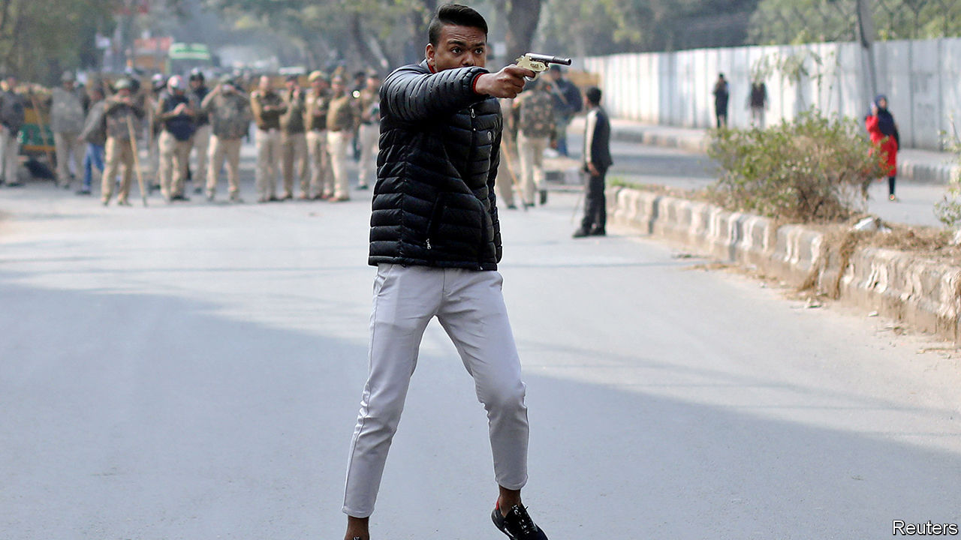

THE PUPILS at Shaheen School in Bidar, a big country town in the state of Karnataka, are learning some unusual lessons. In recent days a group of police inspectors has taken over a classroom. They are not there for educational outreach. Rather, the officers have been interrogating dozens of 9- to 12-year-olds. The focus of their inquiries is no grisly crime, but a play that the students wrote and performed on January 21st.

The trouble started when a proud parent posted a recording of the performance on Facebook. In one part, about a controversial new law on citizenship, a nine-year-old girl draws applause by waving a slipper and declaring she will hit anyone who asks for her identity papers. This scene angered a Hindu nationalist, who tipped off police, who raided the school. They have arrested both the head teacher and the girl’s mother, an illiterate widow, charging them with sedition, endangering social harmony and insulting Narendra Modi, the prime minister. The women remain in jail. The slipper has been held as evidence.

The story is symptomatic. India’s police, despite being woefully stretched—recent surveys suggest the average officer’s workday is 14 hours, and that the national force is 23% understaffed—nevertheless devote inordinate energy to tasks far removed from their core duties. All too often, as in Karnataka, a state currently run by Mr Modi’s Bharatiya Janata Party (BJP), they seem to put pleasing politicians above serving the public. And as at the Shaheen School, which happens to be owned by Muslims (but says that 45% of its students are Hindus, many from disadvantaged backgrounds), the police often appear to be guided less by the law than by gut prejudice and popular sentiment.

Police shortcomings are not limited to remote places such as Bidar. In the capital, Delhi, a pistol-wielding youth, pictured above, recently shot into a crowd protesting the citizenship law as a line of police looked on. Delhi’s finest have also mysteriously failed to apprehend a single one of several dozen masked raiders who savagely attacked protesting students at one of the city’s main universities in early January, despite evidence that includes eyewitness testimony, incriminating social-media messages, reams of film footage and even televised confessions by some of the alleged perpetrators.

“There is a police culture of capitulation to politicians,” explains Devika Prasad, who heads a programme on police reform at the Commonwealth Human Rights Initiative, a pressure group. Although the police are notionally independent, elected officials control budgeting and recruitment and can reassign officers to the back of beyond. In a survey last year of some 12,000 officers, almost two-thirds said they had faced pressure from influential people and three-fifths reported that the most common result of resisting such pressure was to be transferred to a different post. Another survey suggests that such transfers peak during election years. Vibhuti Narain Rai, a former state police chief, notes that state governments’ authority to postpone mandatory retirement creates another means of influence, as senior officers trade favours for a prolongation of their service or a plum post-retirement sinecure.

Interfering politicians are not the only problem. The survey in 2019 found that 50% of officers across the country think that Muslims are “naturally” prone to committing crimes, and 51% believe that complaints under anti-discrimination laws by low-caste Hindus are likely to be “false and motivated”. This may explain why 21% of those imprisoned while awaiting trial are Muslim, but only 16% of convicted prisoners are—a proportion much closer to their 14% share of the population. The tendency to arrest innocent Muslims may also reflect their low numbers in the police force and stark absence among officers. In 2013 Muslims made up just 2% of the force in Delhi, and barely 1% in the state of Rajasthan. Since then the government has stopped publishing such data.

The survey also reveals rather relaxed attitudes to such things as procedures and human rights. Three-quarters of officers said police were justified in using violence against criminals, and four-fifths saw nothing wrong with beating up criminals to extract confessions.

Critics of the police often trace the force’s trouble to colonial times, when its job was to suppress unruly “natives”. The Police Act of 1861 still provides the main legal framework. Among its archaic provisions is one that stipulates that officers are permanently on duty. Only very recently have some states begun to introduce eight-hour shifts for officers. As under the British Raj, the 5,000 highly trained, centrally appointed officers of the Indian Police Service form an elite corps, superimposed on less-well-paid and disgruntled state police. More than 80% of the overall force are barely trained constables. These footsoldiers’ self-esteem is generally low: on average, they are likely to receive just one promotion in a lifetime, even as higher officers sail up the ranks gaining such perks as staff cars, housing and, all too often, the services of constables as personal orderlies.

These failings have long been recognised. Repeated commissions and public inquiries have demanded reform. The Supreme Court itself issued a detailed list of demands in 2006, following a petition by a retired officer. Mr Rai, for his part, says there is no point in tinkering: “No reforms are possible until and unless the basic structure of the police is changed.” ■

This article was downloaded by calibre from <https://www.economist.com/asia/2020/02/08/indias-police-are-overstretched-poorly-trained-and-politicised>

|  |  |  |  |
| --- | --- | --- | --- |
|  | Articles | Sections | Next |

|  |  |  |  |
| --- | --- | --- | --- |
| Previous | Articles | Sections | Next |

#### Brain v prawn

# How artificial shrimps could change the world

A Singaporean technology could curb both slavery and environmental destruction

Feb 8th 2020 | SINGAPORE

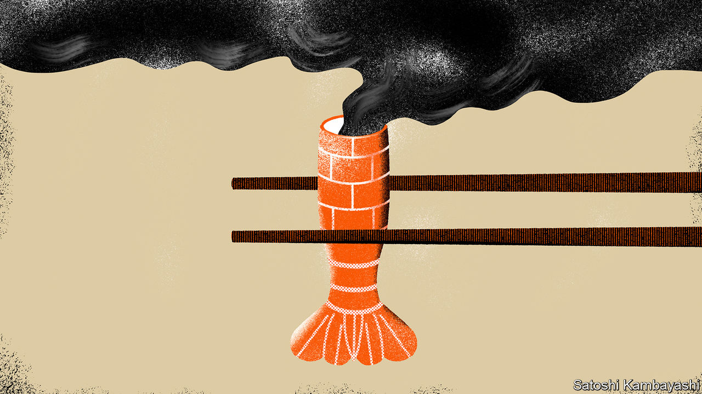

FOR A LONG time, beef has been a target of environmentalists because of cattle farming’s contribution to global warming. But what about humble shrimp and prawns? They may seem, well, shrimpy when compared with cows, but it turns out the tasty decapods are just as big an environmental problem. The issue is not so much their life cycle: shrimp (as UN statisticians refer to all commonly eaten species collectively) do not belch planet-cooking methane the way cows do. But shrimp farms tend to occupy coastal land that used to be covered in mangroves. Draining mangrove swamps to make way for aquaculture is even more harmful to the atmosphere than felling rainforest to provide pasture for cattle. A study conducted in 2017 by CIFOR, a research institute, found that in both these instances, by far the biggest contribution to the carbon footprint of the resulting beef or shrimp came from the clearing of the land. As a result, CIFOR concluded, a kilo of farmed shrimp was responsible for almost four times the greenhouse-gas emissions of a kilo of beef. Eating a surf-and-turf dinner of prawn cocktail and steak, the study warned, can be more polluting than driving across America in a petrol-fuelled car.

Eating wild shrimp is not much better: catches are declining around the world as a result of overfishing. Trawlers can pull as much as 20kg of by-catch from the sea for every kilo of shrimp. And reports abound of the appalling treatment of workers on shrimp-fishing vessels, including human-trafficking and child labour. When UN investigators interviewed a sample of Cambodians who had escaped virtual slavery on Thai fishing boats, 59% of them reported seeing fellow crew-members murdered by the captain.

Most of the world’s shrimp and prawns come from Asia. The continent accounts for 85% of the farmed sort and 74% of the wild catch. Global sales were around $45bn in 2018 and are thought to be growing by about 5% a year. But the industry is controversial, not just because of its part in global warming. Razing mangroves also leaves coastal regions vulnerable to flooding. Many shrimp farms are unsanitary; ponds often have to be abandoned after a few years because of problems with disease and pollution.

All this has given one Singaporean company a brain wave. “Farmed shrimps are often bred in overcrowded conditions and literally swimming in sewage water. We want to disrupt that—to empower farmers with technology that is cleaner and more efficient,” says Sandhya Sriram, one of the founders of Shiok Meats. The firm aims to grow artificial shrimp, much as some Western firms are seeking to create beef without cows. The process involves propagating shrimp cells in a nutrient-rich solution. Ms Sriram likens it to a brewery, disdaining the phrase “lab-grown”. Since prawn-meat has a simpler structure than beef, it should be easier to replicate in this way. Moreover, shrimp is eaten in lots of forms and textures: whole, minced, as a paste and so on. The firm is already making shrimp mince which it has tested in Chinese dumplings. It hopes the by-product of the meat-growing can be used as a flavouring for prawn crackers and instant noodles. Eventually it plans to grow curved “whole” shrimp—without the head and shell, that is.

The hitch is that producing shrimp in this way currently costs $5,000 a kilo. Shiok Meats thinks it can bring the price down dramatically by using less rarefied ingredients in its growing solution. People want to know more about where their food comes from and how it is harvested, argues Ms Sriram. “Cell-based technology is one of the ways to provide that accountability.” And even ordinary shrimp, whether farmed or fished, come at a heady price.

This article was downloaded by calibre from <https://www.economist.com/asia/2020/02/08/how-artificial-shrimps-could-change-the-world>

|  |  |  |  |
| --- | --- | --- | --- |
| Previous | Articles | Sections | Next |

|  |  |  |  |
| --- | --- | --- | --- |
| Previous | Articles | Sections | Next |

#### Junk bondage

# How poor Pakistanis are tricked into becoming drug mules

They face long prison sentences or execution if they are caught in Saudi Arabia

Feb 8th 2020 |

THE LAST time Abdul Haq saw his son, the young man was bound for a new life, with a work visa in his new passport and a lucrative job awaiting. The rickshaw with which he made a living had been sold to pay for the fresh start, but no matter: he was trading the poverty of Sargodha, a city in Punjab province, for the riches of Saudi Arabia. Unfortunately, his family’s dreams of better times thanks to regular remittances lasted only days. After an unexplained silence, their son eventually called from a Saudi prison using a borrowed phone. He explained he was being held on charges of drug-smuggling. The men who arranged his visa had insisted he first travel to Karachi, where they forced him to hide a small package in his bag. When he was stopped and searched on arrival in Riyadh it turned out to contain heroin. That was ten years ago; Abdul Haq’s son is now on death row. “They just exploited our poverty,” explains the old man.

Labour is one of Pakistan’s biggest exports and Saudi Arabia has for decades offered work to poor Pakistanis. The kingdom plays host to 2.7m Pakistanis, more than any other country. Remittances from Saudi Arabia to Pakistan are projected to reach $2.6bn this year.

Yet despite the importance of these workers to the economy, campaigning lawyers say, the government is doing too little to shield them from exploitation. Some 3,200 Pakistani convicts languish in Saudi jails, many on drugs charges. Stories of coercion, entrapment in debt and deception like the one told by Abdul Haq are plentiful, says Sara Bilal of the Justice Project Pakistan (JPP), which represents vulnerable prisoners. “These people are small fish, these are people who do not know how to read, they have never left the country, they don’t know what a passport is.” Given that the government actively encourages such people to seek work abroad, she argues, it should also make sure that they are not abused.

In theory, the government regulates employment agencies that send workers to the Gulf. In practice, a network of unregistered and often unscrupulous middlemen reaches every village. Even pilgrims are not spared. Mehboob Alam says his mother was offered a place on a trip to Mecca in 2017 by a benefactor in her village in Punjab, near the Indian border. Someone hid some heroin in her luggage. She was sentenced to 15 years.

Pakistani prisoners receive little support from their government. Diplomats seldom make consular visits, says Ms Bilal, who is suing the government to force it to take better care of its citizens. But Imran Khan, the prime minister since 2018, seems more receptive to such blandishments than his predecessors, she says. The former cricketer was himself Pakistan’s most famous expatriate worker for decades, when he plied his trade in Britain. He has often bemoaned the problems of Pakistanis abroad and encouraged rich expats to invest in their homeland or send money to relatives to help shore up the balance of payments.

When Saudi Arabia’s crown prince, Muhammad bin Salman, visited Pakistan in early 2019, he promised that his government would pardon and release 2,107 Pakistani prisoners. A year on, only 579 have been freed. Moreover, JPP says the great majority of these had in fact been freed before the crown prince’s announcement. When the rest will be released remains unclear. Pakistani officials blame the delay on inertia in the Saudi bureaucracy, rather than bad faith. What is more, says Syed Zulfikar Bukhari, Mr Khan’s point man on the issue, the Pakistani government has helped to repatriate another 2,600-odd people accused of minor infractions, such as overstaying their visas.

The gravity of Abdul Haq’s son’s crime means that he is unlikely to be one of those to be released. His family has tried to pursue the men who exploited their son, with little success. His father now watches as other young men set out on the same risky journey. “Because we have poverty, everyone wants to go there, clearly, and earn some good money.” ■

This article was downloaded by calibre from <https://www.economist.com/asia/2020/02/08/how-poor-pakistanis-are-tricked-into-becoming-drug-mules>

|  |  |  |  |
| --- | --- | --- | --- |
| Previous | Articles | Sections | Next |

|  |  |  |  |
| --- | --- | --- | --- |
| Previous | Articles | Sections | Next |

#### The chips are down

# The Japanese government wants to build three flashy casinos

Voters are not as enthusiastic

Feb 8th 2020 | TOKYO

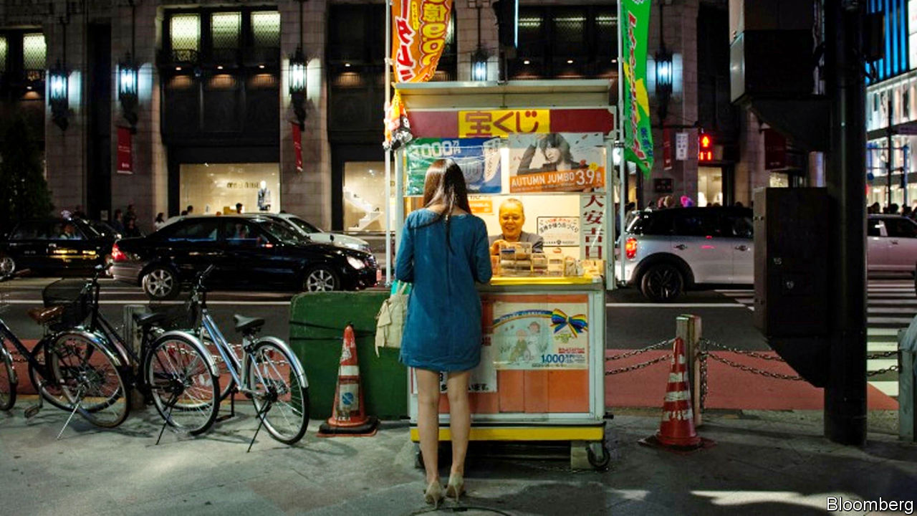

AS HE PACES the cramped cell in Tokyo where he is being held on suspicion of corruption, Akimoto Tsukasa may be wondering where it all went wrong. In 2017, while serving as the minister in charge of the government’s scheme to build Japan’s first casinos, he flew by private jet to China on a trip paid for by the boss of an online casino firm. He returned with a bag of goodies, including a pair of expensive shoes. Later, prosecutors claim, he pocketed over ¥3m ($27,000) from the same firm. He is said subsequently to have sounded out the transport ministry about building an airport for private jets in a ski resort on Hokkaido, a big northern island, to provide easier access for high-rollers. This week prosecutors filed a second charge of bribe-taking against him. What is more, since Mr Akimoto’s arrest on December 25th, the allegations have spooled out to ensnare five other politicians, all but one from the ruling Liberal Democratic Party.

Japan’s prime minister, Abe Shinzo, may also be asking himself how things came to this. In 2018 he pushed through parliament a measure allowing the construction of three “integrated resorts”: Las Vegas-style destinations for family holidays, with all sorts of wholesome attractions as well as slot machines. Before then, casinos were illegal in Japan, although betting on horse, boat and bicycle races is permitted, and local governments are allowed to run lotteries.

Mr Abe presumably thought that the promise of an influx of well-heeled tourists to regions with atrophying populations and economies would overcome popular misgivings. But even before the scandal broke, surveys found that a majority of Japanese were opposed. In Yokohama, a shrinking city on the outskirts of Tokyo seen as a potential site for a resort, 94% of residents do not want one, according to a survey conducted by the local government. Many Japanese seem to associate casinos with pachinko, a variation on pinball to which many Japanese are addicted and which attracts lots of attention from yakuza (gangsters). Last month four opposition parties asked the government to repeal the law paving the way for the resorts.

The response from local government has also been mixed. Two prefectures seen as potential sites for a casino—Hokkaido and Chiba—have ruled themselves out in recent months, saying the need to develop a detailed plan for a resort by the middle of next year would distract them from more important issues, such as disaster management. But other prefectures are eager. Hirata Ken, vice-governor of Nagasaki, says its population will shrink by 100,000 in the next decade. A resort would bring jobs and help “stem the haemorrhaging of young people to Tokyo”. Yokohama’s vice-governor, Hirahara Toshihide, is keen despite locals’ misgivings. The city does not have a single five-star hotel, he laments (wrongly). “The resort will bring them.”

Casino operators are, unsurprisingly, enthusiastic. The resorts could take in ¥1.75trn a year, according to the more bullish projections. Some of the biggest names in the business, such as Las Vegas Sands and MGM Resorts, are keen. President Donald Trump lobbied Mr Abe on behalf of American casino firms at a meeting in 2017, according to ProPublica, an investigative website. Sheldon Adelson, the boss of Las Vegas Sands, has also buttonholed him.

But the government and casino operators seem to have different ideas about how the resorts should operate. Officials talk about strenuous measures to prevent people from losing their shirts, such as a ban on cash machines on the premises, a limit on the number of visits allowed per month, and so on. A maximum of 3% of the floorspace of each resort will be devoted to gambling. Some local politicians have suggested that only foreigners should be allowed to bet. The developers, however, will want to lure as many of Japan’s well-heeled pensioners as it can, and persuade them to gamble freely. No wonder the government has not yet said on what basis it will award the three licences, or when. ■

This article was downloaded by calibre from <https://www.economist.com/asia/2020/02/08/the-japanese-government-wants-to-build-three-flashy-casinos>

|  |  |  |  |
| --- | --- | --- | --- |
| Previous | Articles | Sections | Next |

|  |  |  |  |
| --- | --- | --- | --- |
| Previous | Articles | Sections | Next |

#### Banyan

# Singaporean ministers can decide what is fake news

And then order websites and social media firms to delete it

Feb 8th 2020 |



AS SINGAPORE GRAPPLES with the first cases of local transmission of the Wuhan virus, its government is also worried about another form of contagion: fake news. The two are not unrelated. In late January a Singaporean website claimed that someone in the city-state had died of the virus, when no one has to date. And two Facebook posts claimed, wrongly, that a train station had been closed and cleaned because an infected person had been there.

With an evolving epidemic, false rumours can lead to panic. Cue the Protection from Online Falsehoods and Manipulation Act, or POFMA, which came into force four months ago. A new virus was not what the government had in mind when it framed the legislation, but rather the danger in a multiracial, multireligious society of incitement to hatred or violence based on false rumours. Online lies risked undermining faith in government itself. Such falsehoods were, the government claimed, being weaponised “to attack the infrastructure of fact, destroy trust and attack societies”.

All democracies are grappling with the challenges of fake news. POFMA is the most sweeping response to date. It outlaws any false statement deemed “prejudicial�� to public health, security or Singapore’s foreign relations, or which may “diminish” public confidence in government. It gives what Cherian George of Hong Kong Baptist University says is unprecedented discretion to individual ministers to pronounce on what is false or misleading. The minister may demand a correction notice or even the removal of any offending statement or the post or article in which it appears. Sanctions include hefty fines for individuals and companies and up to a year in prison. Ministers’ rulings may be challenged in the High Court. But it can rule only on whether disputed statements are indeed false, not on whether using POFMA is a reasonable response. What if a website exposed an official cover-up of shoddy construction work, say, but stated that the offending minister wore size eight shoes when they were in fact size ten?

Singapore’s minister of communications, S. Iswaran, insists that the new legislation, far from being a sledgehammer, adds finesse in dealing with fake news. “Before this, the only tool you really had was to block or to take down, right?” he says. “Now, you have a tool that allows this spectrum of possibilities.” POFMA’s defenders point out that in none of the ten cases since October have ministers demanded that offending posts be removed, merely that corrections be published. It is about restraint and proportionality, Mr Iswaran says.

Yet POFMA has been invoked mainly against opposition figures, activists and NGOs—at a time when the ruling party is skittish about an approaching general election. In one case the Singapore Democratic Party earned a correction notice for a discussion of unemployment and redundancies among white-collar Singaporeans. Its appeal in the High Court argues that the statistics are not in dispute, merely their interpretation. In another case, a Malaysian watchdog, Lawyers for Liberty, refused to issue a correction to its online claims about how Singapore carries out the death penalty, arguing that the demand curtailed freedom of speech in Malaysia. In response, Singapore blocked its website.

As for social-media companies asked to implement POFMA notices, such as WhatsApp, Facebook and Twitter, dismayed executives say the government has come very late to an understanding of the practical, commercial and ethical challenges. “They seemed to think we are like a bulletin board,” says one. Quite how—and to how many people—a general correction notice gets issued via a platform remains problematic. “One of the things they didn’t quite grasp,” says another executive, “is that they could end up driving people off our platforms really quickly, and that they would lose the audiences they wanted.” It is surely better for the government to get its own message out before policing others’. Yet the health ministry sent out zero tweets between May 3rd and January 29th.

As for Banyan, is he within his rights to call POFMA draconian? Go ahead, says Mr Iswaran, that’s an opinion. Yet the minister is an exception. The government is notoriously thin-skinned. It also lacks a funny bone—and POFMA contains no exemptions for satire. The government’s already frequent resort to the law has become something of a joke among some Singaporeans. Far from protecting citizens’ good opinion of their government, POFMA is undermining it.

This article was downloaded by calibre from <https://www.economist.com/asia/2020/02/08/singaporean-ministers-can-decide-what-is-fake-news>

|  |  |  |  |
| --- | --- | --- | --- |
| Previous | Articles | Sections | Next |

|  |  |  |
| --- | --- | --- |
| Asia | Sections | Middle East and ... |

China

The Wuhan virus: Under observation

.

Hong Kong and the mainland: Keep out

.

Chaguan: A people’s war

.

|  |  |  |
| --- | --- | --- |
| Asia | Sections | Middle East and ... |

|  |  |  |  |
| --- | --- | --- | --- |
|  | Articles | Sections | Next |

#### Under observation

# A weak health-care system complicates China’s coronavirus battle

More medical staff and better primary health-care facilities would help

Feb 8th 2020 | BEIJING



THE DOCTORS who examined Rana Zhou’s parents decided that the couple had probably caught the coronavirus which has been sweeping their home city, Wuhan, and spreading globally. But they said they did not have enough test kits to be sure. Instead of finding them beds in a hospital, officials in their neighbourhood told them to go to one of many hotels which the government has requisitioned in order to monitor and isolate people with minor virus-related symptoms. But when her father’s fever worsened, staff said they could not take care of him. They told the pair they would have to return home.

It is a scary time to be ill in Wuhan. The city has one-third of all confirmed infections by the virus and three-quarters of the deaths caused by it. People there are barred from travelling elsewhere (similar rules apply across Hubei, a Syria-sized province of which Wuhan is the capital). Since late January military medics have been piling into the city. Soldiers are helping enforce its cordons. The army’s growing presence reassures many people, says a resident. But some find it unnerving.

With hospitals brimming, the local government has announced new rules. Rather than visiting hospitals, people who think they might have the virus should tell district officials about their symptoms and seek examinations at local clinics—facilities which, in normal times, many people eschew in favour of what they regard as the hospitals’ more professional care. Wuhan has opened makeshift hospitals in an exhibition centre and a sports arena to house patients who are only mildly ill from the virus. Elsewhere in China health services are also under strain, even if the pressure is less than in Hubei. Officials in many places have banned non-essential hospital visits to avoid contagion. But many people, afraid of catching the virus, now avoid hospitals anyway, except in emergencies.

China’s health system can cope better with shocks than in 2003 during the SARS outbreak. At that time, officials feared that the spread of the virus might be hidden because rural residents, lacking health insurance, would avoid hospitals. The government tried to allay such concerns by offering free treatment for SARS. Since then it has considerably expanded access to state-funded insurance schemes. More than 95% of Chinese are now covered. Out-of-pocket payments have fallen from about 60% of medical expenses to 30%.

But for poorer people, the costs can still be crippling. The government recently promised that it would pay for all treatment related to the new virus. That was too late for a pregnant woman infected in Wuhan. She died after her husband decided he could no longer afford the bill, according to a doctor there interviewed by Caixin, a magazine. The policy changed the next day.

## Barely better than barefoot

The government has spent lavishly on infrastructure, but its investment in health care has failed to keep up. China says it has about 2.6 doctors for every 1,000 people, higher than the average for middle-income countries. But the World Health Organisation says half of China’s doctors do not have a bachelor’s degree. Among those in villages and small towns, only 10-15% do. Some practise traditional Chinese medicine, a form of treatment that has government approval but little scientific basis (stocks of an oral liquid based on such medicine have been flying off shelves since a recent report by Xinhua, an official news agency, that it can “suppress” the virus). There is also an acute shortage of nurses. The average in rich countries is three per doctor. In China it is only one.

China’s investment in health care has mostly gone to big hospitals in cities. Wuhan has about half of Hubei’s best medical facilities, but only about one-fifth of the province’s population. Far less attention has been paid to primary-care clinics, which in more developed systems handle minor ailments and escalate the rest to specialists. Only about 5% of China’s registered doctors serve as general practitioners. The average in the OECD, a club mostly of rich countries, is 23%. After Wuhan imposed a lockdown in late January, panicky residents converged on large hospitals seeking reassurance. The queues would have promoted cross-infection, says Xi Chen of Yale University.

Public anger about health care, including the gouging of patients by hospitals, has triggered occasional violence against doctors. In late January a man attacked medical staff in Wuhan after his father-in-law died from the virus. But the system’s public image may have improved during the current crisis. Many people praise doctors’ willingness to join the fight in Hubei, despite high rates of infection among medical workers there. They will need such support in the struggle ahead. ■

This article was downloaded by calibre from <https://www.economist.com/china/2020/02/08/a-weak-health-care-system-complicates-chinas-coronavirus-battle>

|  |  |  |  |
| --- | --- | --- | --- |
|  | Articles | Sections | Next |

|  |  |  |  |
| --- | --- | --- | --- |
| Previous | Articles | Sections | Next |

#### Keep out

# The coronavirus is fuelling tensions in protest-racked Hong Kong

An unprecedented strike by medical staff is piling pressure on the government

Feb 6th 2020 | HONG KONG

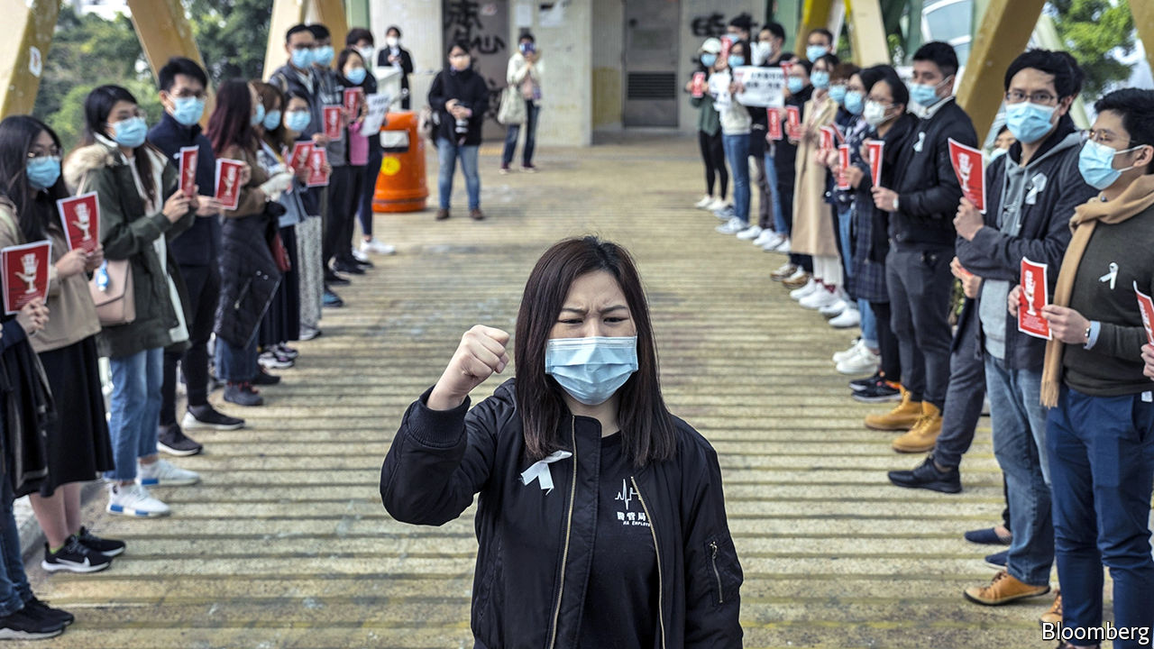

“THERE IS NO reason for measures that unnecessarily interfere with international travel and trade.” So declared the World Health Organisation’s chief, Tedros Adhanom Ghebreyesus, on February 3rd after several countries, to prevent the spread of the coronavirus, had closed their borders with China or (like America and Australia) announced that foreign citizens who had recently visited China would be barred from entering. Yet many people in Hong Kong want the territory to seal itself off from the Chinese mainland. Their demands are putting new political pressure on the territory’s leader, Carrie Lam, after months of pro-democracy unrest.

As The Economist went to press, 21 people in Hong Kong had been detected with the virus, of whom seven were from the mainland. Six of the others were Hong Kong residents who caught it while travelling in China. They included a man whose death, attributed to the virus, was announced on February 4th. It was the first such fatality in the territory and only the second outside the Chinese mainland (the other was in the Philippines). The remaining eight cases involved infections that occurred in Hong Kong itself.

Mrs Lam has responded with ever-tighter controls. On January 27th visitors from Hubei, the province where the virus was discovered, were banned from entering Hong Kong. On January 30th six of 14 border checkpoints were closed. Hong Kongers who had travelled to Hubei were ordered into quarantine centres. The mainland’s government also imposed restrictions, stopping the issuing of permits for tourist trips to Hong Kong. The number of mainlanders arriving at border posts other than the airport fell by 90% compared with two weeks earlier. Mrs Lam said that closing the border entirely would be “discriminatory”, but four days later she announced that remaining entry points, apart from the airport, two road bridges and a cruise terminal, would be closed from February 4th. On February 5th she announced that anyone arriving from the mainland would be quarantined for 14 days and the cruise terminal would be shut.

For some Hong Kongers, these measures have not been enough. On February 3rd around 3,000 non-essential medical staff working in public hospitals went on indefinite strike—the biggest such action in the health system’s history. Their demands include the full closure of the border. The following day their ranks swelled to 7,000. They have vowed to continue their strike, despite Mrs Lam’s measures.

She is in murky political water. The strikers belong to a recently formed union with links to activists who have been at the forefront of the anti-government unrest that has roiled the territory since June. Other pro-democracy unions have threatened to join them, including one for bus drivers.

The central government, however, would not be happy with a total ban. It accused America of sowing fear when it became the first country to bar foreign travellers coming from China. China’s acting ambassador to Israel compared such controls to the turning away of Jewish refugees during the Holocaust. The embassy later apologised, saying there was “no intention whatsoever to compare the dark days of the Holocaust with the current situation”.

But many Hong Kongers are fearful. Memories are still fresh of SARS in 2003, a disease caused by another coronavirus discovered in China. That outbreak infected about 1,750 people in Hong Kong and killed almost 300. Mrs Lam, not least, will be mindful of events that year. Public anger over the government’s perceived hesitancy in handling SARS fuelled unrest caused by a proposed national-security bill. The crisis eventually prompted the central government to replace Tung Chee-hwa, Hong Kong’s first post-colonial leader.

Mrs Lam appears to have retained the central government’s backing during the past few months of turmoil on Hong Kong’s streets. But in a territory where distrust of the government runs deep, it is unlikely that her response to the new coronavirus will boost her abysmal ratings at home. ■

This article was downloaded by calibre from <https://www.economist.com/china/2020/02/06/the-coronavirus-is-fuelling-tensions-in-protest-racked-hong-kong>

|  |  |  |  |
| --- | --- | --- | --- |
| Previous | Articles | Sections | Next |

|  |  |  |  |
| --- | --- | --- | --- |
| Previous | Articles | Sections | Next |

#### Chaguan

# China’s rulers see every crisis as a chance to tighten their grip

A viral outbreak is no exception

Feb 8th 2020 |

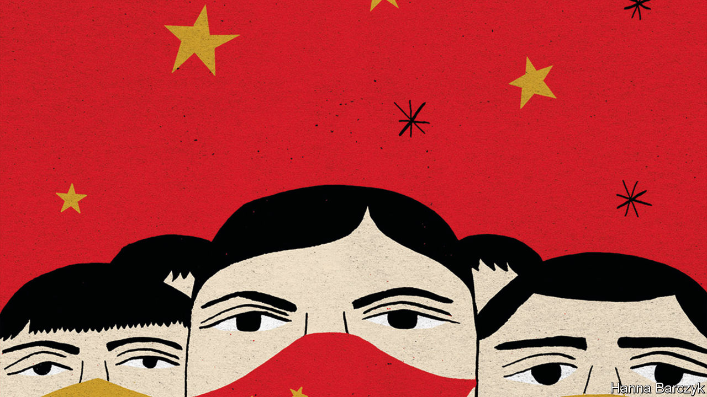

ASKED TO CRAFT a metaphor for all that the world admires and fears about modern China, a novelist could hardly improve on the coronavirus hospitals now rising, at fantastic speeds, in disease-stricken cities. Start with admiration. These construction sites are a fine example of decisive Communist Party action. Work had been under way for two days when Chaguan visited the Second People’s Hospital in Changde, a city in the central province of Hunan, 400km from the epidemic’s suspected birthplace in Wuhan. Half a dozen excavators roared and pawed at the rust-red ground. A road-roller flattened a gravel pad on which, by February 15th, a 200-bed fever hospital is due to stand.

Yet if China’s resolve impresses outsiders, the dark side of one-party rule also stands exposed. Changde must prepare for the worst in part because the authorities in Wuhan and the surrounding province of Hubei, Hunan’s neighbour, hid the virus’s impact for weeks. A desire to earn trust and avoid Wuhan’s fate probably explains why city-level propaganda officials in Changde—when this reporter was suddenly handed over to them by jumpy rural officials and police—granted unusual access to the new hospital.

The construction site is overlooked by an ageing hospital block which, at the time of writing, houses 62 confirmed cases. The whole hospital, emptied of ordinary patients and ringed by guards and warning signs, will soon have room for between 370 and 850 patients, depending on how many need strict isolation. It will serve Changde’s roughly 6m residents, who are divided between an urban centre and outlying rural counties. Officials say they hope not to need all the extra beds.

China’s pop-up hospitals do not merely awe foreigners. They have become a staple of domestic propaganda, with state media pumping out tales of building workers and medics labouring to the point of collapse. For all that, when trying to assess how this crisis may affect the party, it is a mistake to focus narrowly on top-down actions. For the party is also bent on a task that is less familiar to outsiders but central to how China works at times of stress: mobilising the masses, nationwide.

Some techniques hark back to Mao’s time. Grassroots party members are busy scolding and reporting neighbours who defy orders to stay indoors and avoid social gatherings. In some regions village loudspeakers, which in the days of collective farms blared out slogans, patriotic songs and injunctions to work harder, have crackled back to life.

Public opinion is hard to gauge in authoritarian China. In Fuqingshan village, perched amid strawberry farms outside Changde, locals describe how they watch for anyone arriving from Hubei and generally “dissuade people from wandering around”. Then their party secretary arrives on a moped to ban further interviews, declaring: “There is no infectious disease here.” Elsewhere villagers, of their own volition, refer to virus-control as a battle in which all are enlisted: a “people’s war”, as the party now calls it.

Until January the pole-mounted loudspeakers that loom over Chen Hongxia’s home in Guanyin village were mostly quiet, broadcasting only a news bulletin each evening. Now they blare out hours of virus-control information from eight each morning. Ms Chen, 41, concedes that the “very noisy” broadcasts make it hard for her son, who is eight, to study at home. As she speaks, an amplified voice recites rules against hunting or selling wild animals for meat. A cancer patient for two years, wearing padded pink pyjamas on a brief foray outdoors, Ms Chen stands out for not wearing one of the face masks that all Chinese are meant to wear outside, though stocks are running low. “I can’t find anywhere to buy a mask. But what should I do? I just stay at home,” she explains, as her son scampers up to join her. Asked whether the state or the masses are responsible for beating the coronavirus, she answers: both. “China has a huge population. If you ask me who I should depend on, I think I need to depend on myself,” she ventures. At the same time, she adds, the government has “a good understanding of the big picture, which individuals are incapable of”.

## Passing the buck to the grassroots

There are 99 party members in nearby Luluoping, a village of over 3,000 people. Guo Linlin is one of them. Locals are fearful, she admits, because “the situation is becoming more severe”. Her work of reassurance includes watching 14 villagers who returned from jobs in Hubei during the recent lunar new year, who must remain indoors, shun visitors and have their temperatures taken twice a day. This work leans on a “grid management” system which divides the village in two. Further subdivisions are monitored by officials and volunteers, some of them elderly folk in special red-and-gold disease-control armbands. A notice in the village listing new rules imposed by the local county, Taoyuan, concludes: “We invite the masses to supervise implementation.”

Mass mobilisation has a dark history in China. Majoritarianism is a temptation in a big and quarrelsome country because of its power to unite people against a suspect minority. Shamefully, local officials have been tolerating prejudice and vigilantism against migrants with identity papers from Hubei, even if they have not been there for months (reports and online videos abound of Wuhan folk being barred from hotels or sealed in their own homes behind front doors blocked with metal poles or chains).

Blaming external foes is a temptation, too. Chinese diplomats and state media have eagerly accused America of unfairly barring travellers from China—though numerous countries have imposed similar restrictions. China’s internet is full of conspiracy theories about the CIA creating the coronavirus to keep China down. It is tempting to shrug when Chinese officials play such politics. What really counts, surely, is building hospitals and saving lives? But to China’s rulers, politics is never play. Every crisis is a chance to strengthen the party’s grip. A virus is no exception. ■

This article was downloaded by calibre from <https://www.economist.com/china/2020/02/08/chinas-rulers-see-every-crisis-as-a-chance-to-tighten-their-grip>

|  |  |  |  |
| --- | --- | --- | --- |
| Previous | Articles | Sections | Next |

|  |  |  |
| --- | --- | --- |
| China | Sections | Europe |

Middle East and Africa

Congo: Not much to celebrate

.

Kenya: Après Moi

.

Mixed marriages: Conscious coupling

.

Malawi: Let’s do this again

.

Yemen and Iran: The Houthi model of government

.

|  |  |  |
| --- | --- | --- |
| China | Sections | Europe |

|  |  |  |  |
| --- | --- | --- | --- |
|  | Articles | Sections | Next |

#### Not much to celebrate

# Félix Tshisekedi has accomplished little in Congo

The president is still stuck in a struggle for power with his predecessor

Feb 8th 2020 | KINSHASA

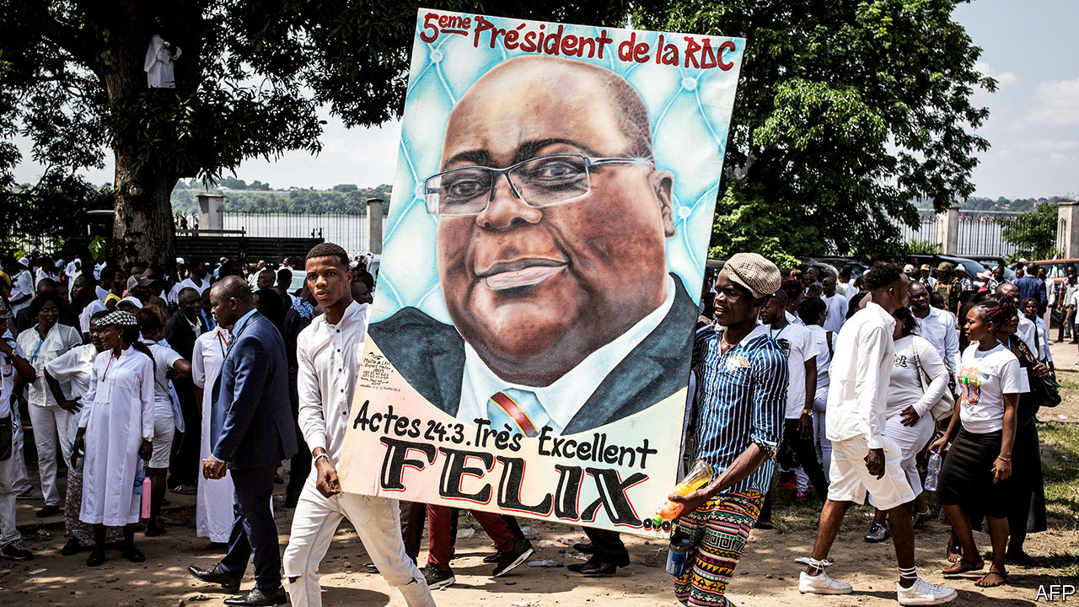

THERE WAS supposed to be a big party on January 24th. It was going to cost $6m and celebrate the first anniversary of Félix Tshisekedi’s inauguration as president of the Democratic Republic of Congo. The government presents this as Congo’s first ever peaceful handover of power. But the idea of the party enraged many Congolese, most of whom live on less than $2 a day. Their situation has hardly improved under Mr Tshisekedi, who took over after a rigged election, and whose powerful predecessor, Joseph Kabila, still looms in the background. In the end the party was cancelled.

Mr Tshisekedi (pictured) made three big campaign promises, and is struggling to keep any of them. He vowed to spend $2.6bn, or 40% of last year’s budget, on free primary education for all Congolese. The government hired over 40,000 new teachers in 2019. None, however, was paid. Some have already gone on strike. This year the government should have more to spend thanks to the IMF and World Bank, which have agreed to big loans (contingent on more transparency). But Mr Tshisekedi’s budget of $10.2bn (63% higher than last year’s) is also unrealistic. It assumes that domestic revenue will rise by 56%, mainly as a result of less fraud and tax evasion. Good luck with that.

Stamping out corruption was Mr Tshisekedi’s second big promise. Congo has more than half the world’s cobalt—a metal used in laptops, mobile phones and electric cars. But total recorded exports (which are mostly minerals) represent less than a dollar a day per citizen, and hardly any of this reaches ordinary people. The IMF ended its previous lending programme in 2012, concerned about dirty dealing in the mining industry. Its return appears to be based more on hope than progress. The Public Expenditure Observatory, a watchdog, claims that 21 public construction contracts totalling $2.3bn were handed out illegally.

The third area where Mr Tshisekedi vowed to make progress was in eastern Congo, where dozens of armed groups are wreaking havoc. The army has launched an offensive against one of the most brutal, the Allied Democratic Forces (ADF), which is alleged to have links to Islamic State. The government claims to have captured the group’s headquarters and killed five of its leaders. But attacks by the ADF and others continue. In 2019 over 500 people were killed in the region. On January 28th at least 36 people died in a suspected ADF attack in Beni. They were hacked to death, said Donat Kibwana, the region’s governor. More than 16,000 UN peacekeepers provide uncertain protection. Angry locals call them “the body collectors” and set fire to the UN office in Beni during protests in November. Millions have fled the fighting.

Mr Tshisekedi is beholden to his predecessor, who has not gone away. After 18 years of misruling Congo, Mr Kabila said he would step down after the election in 2018. But he rigged the vote to hold on to power. The effort did not go smoothly: his chosen successor proved so unpopular that he had to settle for Mr Tshisekedi, who came second with just 20% of the vote, according to impartial estimates. The real winner, with 60%, was a businessman called Martin Fayulu, who had promised to hold Congo’s corrupt leaders accountable. Mr Kabila also rigged the parliamentary election, which saw his party win 70% of the seats in the national assembly. It controls the senate and most ministries, too.

Messrs Kabila and Tshisekedi are now locked in a murky power-sharing deal. They bickered for months over who should be in the cabinet. In January Mr Tshisekedi threatened to dissolve the national assembly, which was thwarting him. They have also tussled over Gécamines, the state mining company, which is being investigated over a €200m line of credit it received from an Israeli billionaire, Dan Gertler, who is under American sanctions—and who is Mr Kabila’s friend. Most of these disputes seem to have been resolved to Mr Kabila’s liking. “Everything that Tshisekedi does first needs a green light from Kabila,” says a political analyst in Kinshasa, the capital.

Mr Tshisekedi has been more active abroad. In 2019 he wooed the IMF and World Bank and visited 20 countries. He began 2020 with a whirlwind tour of Europe. Western countries have debated whether to embrace him, given the way he came to power. But Congo is a vast and strategically important country. Many have followed the lead of America, which first called the election “deeply flawed and troubling”, then endorsed the result. In November the administration of Donald Trump agreed to give Congo $600m in aid over three years as part of what it calls a “privileged partnership”. Mr Tshisekedi visited Washington in April and spoke at the UN in New York in September.

Mr Trump has little interest in Africa. His administration has threatened to cut funds for the UN peacekeeping mission in Congo. But his advisers also view the country as a battleground for influence. In 2018 John Bolton, then Mr Trump’s national security adviser, condemned the “predatory practices” of China and Russia in the region. America seems willing to overlook Congo’s democratic shortcomings so long as Mr Tshisekedi stays close.

That is bad news for the people of Congo. Granted, in 2019 Mr Tshisekedi unmuzzled the media, allowed peaceful protests and released some 700 political prisoners. But as criticism of his presidency grows, he is looking less tolerant. A rally to be led by Mr Fayulu was banned. Thousands of people took to the streets of Kinshasa anyway on January 26th. Few believe Mr Tshisekedi when he says that this year is “the time to act”. “Tshisekedi is scared of Kabila,” says Firmin Yangambi, a former political prisoner. “A president who is scared can’t do anything for his country.” ■

This article was downloaded by calibre from <https://www.economist.com/middle-east-and-africa/2020/02/08/felix-tshisekedi-has-accomplished-little-in-congo>

|  |  |  |  |
| --- | --- | --- | --- |
|  | Articles | Sections | Next |

|  |  |  |  |
| --- | --- | --- | --- |
| Previous | Articles | Sections | Next |

#### Après Moi

# The legacy of Daniel arap Moi still haunts Kenya

The former strongman was responsible for repression, corruption and ethnic favouritism

Feb 6th 2020 | NAIROBI

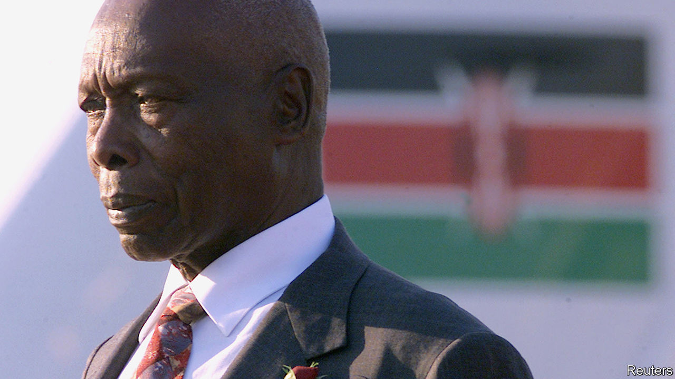

DANIEL ARAP MOI was in many ways an accidental president. Though he had been number two to Jomo Kenyatta, independent Kenya’s first leader, the Kikuyu elite looked down on him. They saw the former teacher from the Kalenjin group as a modest man with much to be modest about. But when Kenyatta’s death in 1978 led to a struggle for power among Kikuyu bigwigs, the pragmatists settled on Mr Moi, believing they could manipulate him from behind the scenes.

For a while it worked. Charles Njonjo, the powerful attorney-general, mentored Mr Moi, teaching him how to be an English gentleman. He took him to services at All Saints’ Cathedral in Nairobi, the Kenyan capital, and showed him how to pray like an Anglican: kneel here during the Eucharistic prayers, sing lustily from the hymnal. Meanwhile, Mr Moi got better at courting popular support, introducing a school milk programme (for which he is still praised) and releasing some political detainees.

But things changed in 1982, when Mr Moi pushed through a revision to the constitution that made Kenya a one-party state. That, in part, led to a coup by air-force personnel, which the president crushed. He ordered the arrest of the entire air-force staff, all 2,100 men. Some were never seen again. His earlier modesty went, and so too did Njonjo.

Ruthlessness came easily to Mr Moi. Opponents were locked up in underground torture chambers. A popular foreign minister, Robert Ouko, was killed in one of Mr Moi’s residences in 1990. His security forces brutally put down a Somali insurgency in the north. Hundreds of men were reportedly forced to lie on the ground at an airstrip in the town of Wajir before being shot in the back of the head.

To the public he presented a different face. His slogan was “nyayo” (footsteps) because he promised to follow in the hallowed footsteps of Kenyatta. In many ways he did, most notably when it came to tribalism—but instead of going to Kikuyus, the plum posts and money went to Kalenjins. (When the Kikuyus finally retook the presidency in 2002, many vowed that they would never give it back to the Kalenjins.)

While neighbouring Uganda, Ethiopia and Somalia fell into civil wars, Mr Moi presided over nearly a quarter-century of relative stability in Kenya. He never got bored of pointing this out. “Are you tired of peace?” he asked before stepping down. But during his rule the economy often stagnated and corruption spread. Investigations after he left office showed that as much as $4bn may have gone to his family and allies. Though not flashy, he acquired vast amounts of farmland in the Rift Valley.

The West tolerated Mr Moi’s repression, seeing him as a bulwark against communism in Africa. But when the cold war ended, America and its allies pressed him to restore a multiparty system. He did, and won two elections in 1992 and 1997 after the opposition failed to unite behind a single candidate. A good thing too, said some Western diplomats, who thought that no one else could hold Kenya’s more than 40 tribes together. “Après Moi, le déluge” was a popular joke.

Many were surprised when Mr Moi stood down in 2002, as required by the constitution. On his way out, though, he tried to select a pliant successor. His choice, Uhuru Kenyatta (Jomo’s son), was trounced in that year’s election and his party, which had ruled since independence in 1963, collapsed. His car was pelted with mud after he formally handed power to his vice-president-turned-opponent, Mwai Kibaki, who won the election.

Mr Moi’s legacy is still contested in Kenya. Moi day, a national holiday he created for himself, was scrapped in 2010—then reinstated by the high court in 2017. Recently Mr Moi asked for the day to be rebranded as “Huduma day”, a day of service. In many ways the Moi era continues. Corruption and ethnic favouritism still poison Kenyan politics. Most of today’s top politicians served under him (including Mr Kenyatta, who became president in 2013). That is one reason why, despite his atrocities, there has been no shortage of eulogies. ■

This article was downloaded by calibre from <https://www.economist.com/middle-east-and-africa/2020/02/06/the-legacy-of-daniel-arap-moi-still-haunts-kenya>

|  |  |  |  |
| --- | --- | --- | --- |
| Previous | Articles | Sections | Next |

|  |  |  |  |
| --- | --- | --- | --- |
| Previous | Articles | Sections | Next |

#### Conscious coupling

# More Africans are marrying spouses of different ethnicities

Education and urbanisation are only part of the explanation

Feb 8th 2020 | JOHANNESBURG



IN 2018 A dating app was launched targeting African diasporas in America. CultureCrush was described by its founder as an “inclusive ecosystem”. And if that were not romantic enough, the app promised to be the first to allow users looking for love to search mates by “nationality, ethnicity and tribe”.

For lonely hearts in Chicago or New York it may well be a useful feature. But in Africa, love, or at least marriage, is increasingly transcending ethnic boundaries. That is according to several studies published in the past two years, all of which find that it is becoming more common for Africans to get hitched to partners from other groups.

A paper published in January by Juliette Crespin-Boucaud of the Paris School of Economics found that the share of marriages that are “interethnic” ranges from 10% of the total in Burkina Faso to 46% in Zambia. The average share in the 15 countries she looked at is 20%. Another study, published as a working paper in 2018 by Sanghamitra Bandyopadhyay and Elliott Green, respectively of Queen Mary University of London and the London School of Economics, found a similar figure among a sample of 26 countries: 22%.

All researchers note that younger generations are more likely to spurn ethnic barriers. About 17% of women’s first marriages in 1984 were interethnic, rising to 26% in 2014, according to Ms Bandyopadhyay and Mr Green.

Urbanisation is one reason for the increase. In cities there are more people from different backgrounds with whom to consort than in villages. It is harder for nosy relatives to interfere. Education matters, too. More schooling means higher incomes and more choices.

Yet there is more to the trends than schooling and cities, says Ms Crespin-Boucaud. Also important are changing cultural attitudes. These days marrying outside one’s group is less likely to be taboo. Why this has happened faster in some countries (such as Uganda) than others (such as Niger) is unclear.

Whatever the reasons, boundary-spanning marriages are good news, and not just for the happy couples. Another paper, published in 2018 by Boniface Dulani of the University of Malawi and three co-authors, suggests that children of mixed marriages are less likely to vote along ethnic lines. Ethnically driven politics has been used to explain many African woes, from conflict to corruption. So if love can blur these boundaries, all the better.

This article was downloaded by calibre from <https://www.economist.com/middle-east-and-africa/2020/02/08/more-africans-are-marrying-spouses-of-different-ethnicities>

|  |  |  |  |
| --- | --- | --- | --- |
| Previous | Articles | Sections | Next |

|  |  |  |  |
| --- | --- | --- | --- |
| Previous | Articles | Sections | Next |

#### Let’s do this again

# A historic day for Malawi’s democracy

For only the second time in African history, judges nullify a flawed general election

Feb 8th 2020 | LILONGWE

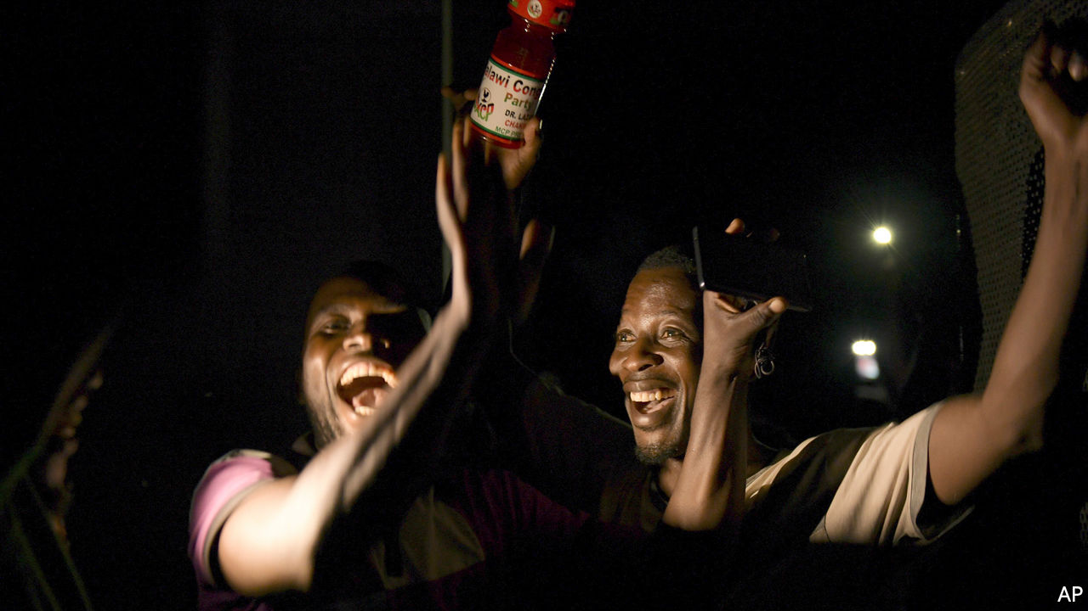

THERE ARE many ways to rig an election. Voters can be beaten or bribed. Ballot boxes can be stuffed. Computers tallying results can be hacked. But few methods are more rudimentary than that used last year in Malawi’s general election. In the southern African country of 18m people the dastardly tool was Tipp-Ex, the correction fluid that has saved many a teenager’s error-strewn homework.

On May 27th the Malawi Electoral Commission (MEC) announced a victory for the 79-year-old incumbent president, Peter Mutharika. The MEC said it had received 147 reports of “irregularities”, including the use of Tipp-Ex on results sheets, but refused to call for another vote. Opposition candidates petitioned the country’s constitutional court, asking judges to nullify the election. Protesters, many of them young Malawians born after the end of dictatorship in 1994, took to the streets to keep up the pressure on the bench.

It worked. On February 3rd the court said there had been “widespread, systematic and grave” flaws in the electoral process. It ordered a re-run of the general election to be held within 150 days. For months millions of Malawians have followed the twists and turns of the case live on radio broadcasts—but few could have hoped for such a decisive verdict.

The judgment is a historic moment for one of the world’s poorest countries. Income per person is just $389 a year according to the World Bank, a quarter of the amount in neighbouring Zambia. The flawed democracy that replaced the one-man rule of Hastings Banda has done much to enrich an elite, but little to lift the vast majority out of poverty. The hope is that the court’s verdict ushers in a new era in which politicians must govern well rather than cheat to stay in power.

Malawi’s case matters beyond its borders. African courts and international election observers have a history of accepting suspicious results. Last year, for example, the constitutional court in the Democratic Republic of Congo affirmed that Félix Tshisekedi had won the presidency fairly despite bucketloads of evidence to the contrary. Regional political organisations have proved similarly short of backbone. The invertebrate Southern African Development Community quickly endorsed Malawi’s election, echoing its hurried acceptance of Zimbabwe’s iffy count in 2018.

A single verdict will change only so much. But the Malawian judgment follows that of Kenya’s Supreme Court, which in 2017 declared void the victory of President Uhuru Kenyatta. “Two African courts have now set tougher standards for elections than international election observers,” says Nic Cheeseman, an expert in African politics at the University of Birmingham. In doing so they have made it a little more difficult for politicians to rig elections.

Malawians will hope that the aftermath of their historic court verdict is smoother than it was in Kenya. Raila Odinga, Kenya’s main opposition leader, boycotted the re-run, citing yet more irregularities. In Malawi there are obstacles to a clean and peaceful second vote: the MEC will need new leadership, and Mr Mutharika says he will appeal the court’s decision.

For now, though, Malawians are proud that the rule of law has prevailed. The verdict shows that though Tipp-Ex may hide the truth, it cannot erase it. ■

This article was downloaded by calibre from <https://www.economist.com/middle-east-and-africa/2020/02/08/a-historic-day-for-malawis-democracy>

|  |  |  |  |
| --- | --- | --- | --- |
| Previous | Articles | Sections | Next |

|  |  |  |  |
| --- | --- | --- | --- |
| Previous | Articles | Sections | Next |

#### Mimicking the mullahs

# The Houthi model of government

It looks a lot like that of Iran

Feb 8th 2020 |

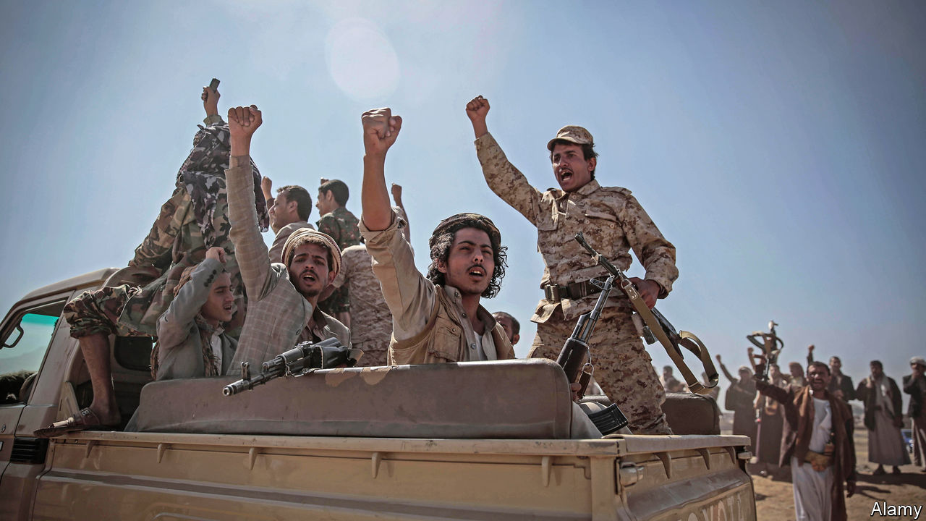

THE WAR in Yemen escalated last month when a missile hit a mosque at a military training camp near Marib, killing over 100 soldiers. The government blamed the Houthi rebels, who control much of the country (see map). Fierce fighting broke out in the days that followed, with the Saudi-led coalition that backs the government striking rebel-held territory from the air. The Houthis, in turn, fired rockets at targets inside Saudi Arabia.

Before the flare-up the conflict appeared to be winding down. The government and the rebels are mulling UN proposals to share power and allow the president, Abd Rabbo Mansour Hadi, to return from exile. Saudi Arabia has carried out fewer air strikes since October. It now seems less concerned with restoring the government-in-exile to the capital, Sana’a, than with reaching an agreement that safeguards its borders from Houthi attacks.

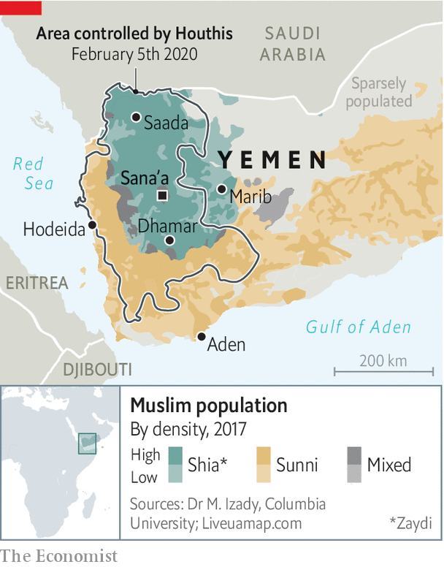

The Houthis (who prefer to call themselves Ansar Allah, or the Partisans of God) are “behaving like they’ve already won”, says an international official in Yemen. After five years of fighting more powerful armies, they still control land on which 70% of Yemen’s 30m people live. Now they are consolidating their grip and establishing a state modelled on the theocracy in Iran, which arms them.

The Houthis belong to a small branch of Shiism called Zaydism, which is closer to Sunnism than most other branches. For decades Saudi missionaries crossed into Saada, the Houthis’ home province, converting Zaydis into Sunnis. But Abdel-Malik al-Houthi, the 41-year-old leader of the rebels, has tried to stem Saudi influence and has embellished Zaydism with symbols of Shia resistance. The Houthis’ flag, like that of Hizbullah, the Lebanese armed movement backed by Iran, features a clenched fist, a Kalashnikov and the words “Death to America” and “Death to Israel”.

After taking control of Sana’a in 2014, the Houthis shared power with Ali Abdullah Saleh, Yemen’s ex-dictator. But in 2017 they killed him, purged his loyalists and monopolised the state. They appointed mushrifeen, or supervisors, at every level of government. On Wednesday afternoons civil servants, university lecturers and policemen must attend dourat thiqafiya, or cultural sessions, where they swear allegiance to Mr Houthi. (The least convincing are sent to indoctrination camps.) The rebels have preserved parliament and the army, but created a parallel tier of government which wields ultimate power. The Supreme Political Council runs day-to-day affairs and a new security force acts as the regime’s Praetorian guard. Mr Houthi has adopted the title of wali al-alam, which loosely translates as supreme leader.

Sana’a is changing under Houthi rule. The rebels have closed cafés where men and women once mixed. They have ordered private primary schools to segregate boys and girls (public ones already did). Austere fighters back from the front enforce the new rules. The city increasingly resembles Baghdad or parts of Beirut run by Hizbullah, say visitors. Huge billboards honouring “martyrs” loom over its thoroughfares. Schools have been infused with anti-Western thought. “The trajectory is towards a Zaydi version of the Taliban,” says Abdul-Ghani al-Iryani, a Yemeni analyst.

The Houthis say they are leading a Zaydi revival, but they are also changing the way Zaydism is practised, bringing it more in line with mainstream Shiism. They have opened husseiniyas, halls to mourn the Prophet Muhammad’s grandson, Hussein, and organised large marches for Ashura and Eid al-Ghadir, holidays ostentatiously marked by Shias elsewhere. Unlike in the past, they adorn the capital with green and black flags and splash green paint on cars to mark the Prophet’s birthday.

Many northern Yemenis initially backed the Houthis in their struggle against the government. The group’s anti-Saudi rhetoric and appeals for resistance echoed past calls to combat Sunni empires, such as the Ottomans, that attacked from the north. But as the Houthis’ rule has grown more predatory and paranoid, people appear increasingly unhappy.

Some predict that the Houthis will relax once the war subsides. But even if the Saudis retreat, the fighting may not stop. Yemen’s civil war is now multi-sided, with several groups vying for control of parts of the country. Last month America reportedly launched an (unsuccessful) air strike on a senior member of Iran’s Revolutionary Guard Corps inside Houthi territory. Mr Houthi, for his part, says he is leading a massira quraniya, or Koranic march. His followers say he will next take Islam’s holiest cities—Mecca, Medina and Jerusalem—from the infidels and their lackeys. ■

This article was downloaded by calibre from <https://www.economist.com/middle-east-and-africa/2020/02/08/the-houthi-model-of-government>

|  |  |  |  |
| --- | --- | --- | --- |
| Previous | Articles | Sections | Next |

|  |  |  |
| --- | --- | --- |
| Middle East and ... | Sections | Britain |

Europe

Germany: The splintering states

.

Turkey: The new Turks

.

Russia: The vagaries of memory

.

Ireland: The worrying rise of Sinn Fein

.

Norway: Ecowarriors bankrolled by oil

.

Charlemagne: The parable of the plug

.

|  |  |  |
| --- | --- | --- |
| Middle East and ... | Sections | Britain |

|  |  |  |  |
| --- | --- | --- | --- |
|  | Articles | Sections | Next |

#### The splintering states

# A shock in Thuringia shows the consequences of Germany’s fragmented politics

The hard-right AfD win a publicity coup

Feb 6th 2020 | BERLIN

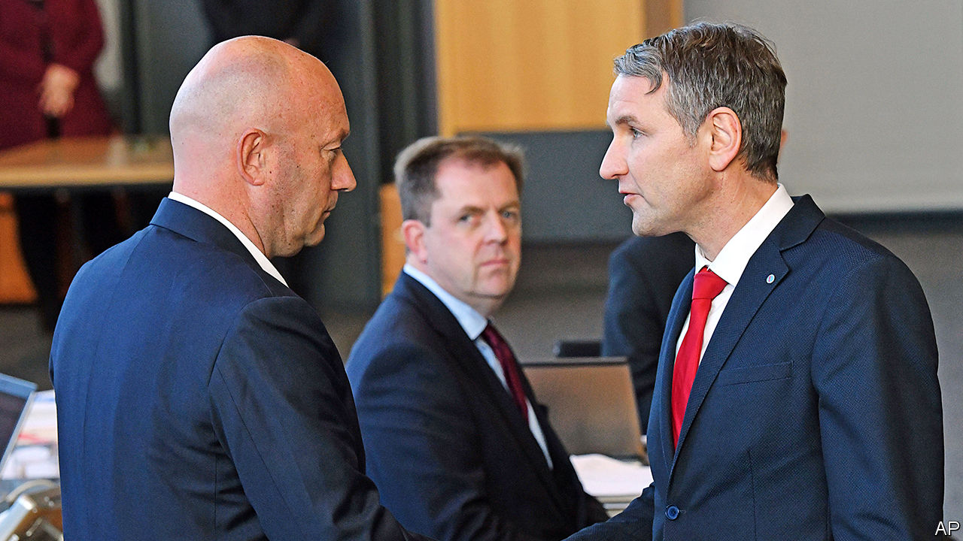

NEVER LET anyone say a handful of votes changes nothing. Last October, had Germany’s liberal Free Democrats (FDP) won 74 fewer votes in an election in the east German state of Thuringia, they would not have entered its parliament. Bodo Ramelow, the popular state premier, might have had the numbers to renew his left-wing coalition. And Thomas Kemmerich, the FDP’s leader in Thuringia, would not have scandalised the country on February 5th by leaning on the votes of the far-right Alternative for Germany (AfD) to win a parliamentary ballot to succeed Mr Ramelow.

No German state premier has ever been elected on the back of AfD support. As demonstrators chanted anti-fascist slogans outside the state parliament in Erfurt, and MPs inside jeered, Mr Kemmerich vowed to maintain the firewall against the AfD, whose branch in Thuringia is especially noxious (its race-baiting leader, Björn Höcke, pictured right with Mr Kemmerich, runs the party’s extremist “Flügel” wing).

The reaction was swift and savage. Angela Merkel, the chancellor, called the stitch-up a “bad day for democracy”, saying that it broke with the values of the centre-right Christian Democratic Union (CDU). The Social Democrats (SPD), junior partner in the national government, denounced the vote as a low point in post-war German history. On February 6th Mr Kemmerich bowed to the inevitable and offered to resign, calling for fresh elections. It was anyway unclear how the FDP, with just five out of 90 seats, could have run a government.

Yet Thuringia is just the most extreme example of the fragmentation of German politics. For decades the country’s big-tent Volksparteien (“people’s parties”) guaranteed stability and a certain predictability. West German governments tended to swing between centre-left (the SPD) and, more often, centre-right (the CDU, plus their Bavarian sister party, the CSU), with the FDP usually acting as kingmaker. In the 1970s the CDU/CSU and SPD together commanded over 90% of the national vote.

This cosy picture was to be triply disrupted. First came the Greens, founded in 1980, who quickly morphed from hirsute radicals into a party of government. Reunification in 1990 brought in the former eastern communists, who later merged with west German leftists to form Die Linke, Mr Ramelow’s party. The biggest jolt was the rise of the AfD, which began in 2013 as an anti-euro party but soon curdled into xenophobic populism. Today there are six parties in parliament, and the decline of the Volksparteien means three of the four governments Angela Merkel has led since taking office in 2005 are “grand coalitions” of the CDU/CSU and SPD; two faltering giants leaning on each other for support. On current polling they attract barely 40%.

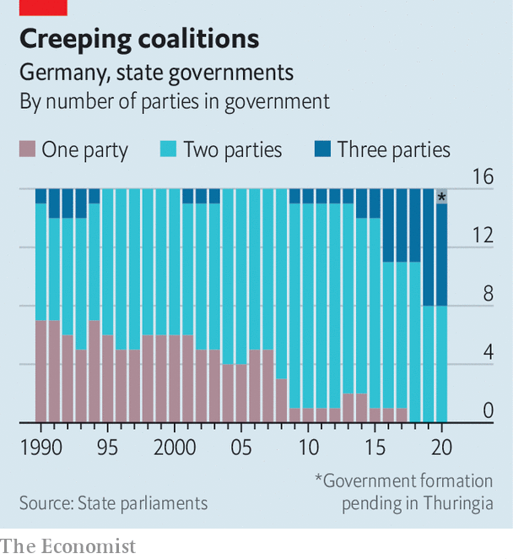

Fragmentation is at its starkest in Germany’s unusual federal system. Thirty years ago seven of its 16 Länder (states), which have powers in education, policing and infrastructure, were ruled by single parties; all but one of the rest had two-party coalitions. Today almost half are governed by three (see chart). There are a head-spinning 13 coalition combinations in the 16 states (see map). Eastern Germany is particularly afflicted, thanks to the strength there of the untouchable AfD. Saxony, Saxony-Anhalt and Brandenburg are all run by “Kenya” CDU-SPD-Green coalitions (the parties’ colours match the Kenyan flag), fragile and unloved contraptions erected solely to keep the AfD out of office.

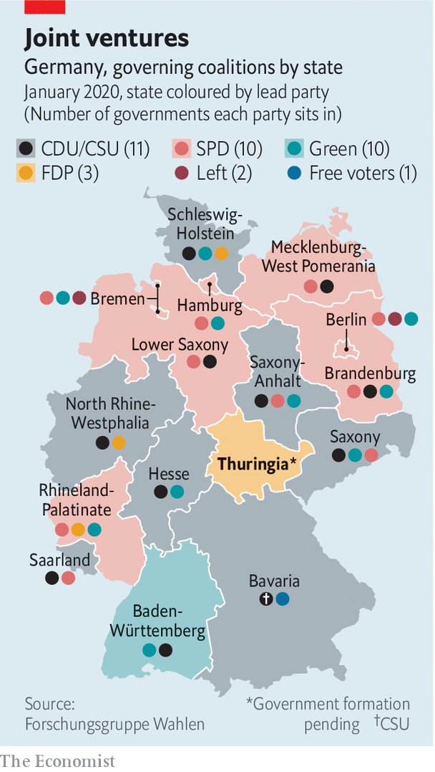

Federalism has its uses. States can serve as laboratories for unusual coalitions. Today’s tie-ups between the Greens and CDU in Baden-Württemberg and Hesse, for instance, are dry runs for a potential national government. But ideologically disparate coalitions often struggle to govern effectively, voters cannot predict how they will rule and they can gum up works in the Bundesrat, Germany’s upper house, which is made up of state government representatives. Moreover, uniting to stop the AfD has served merely to confirm its anti-elite argument, says Thomas Poguntke of the Institute of German and International Party Law and Party Research in Düsseldorf.

There is another difficulty in a system where politics in one state inevitably resonates in another. It is CDU policy never to work with Die Linke or the AfD in government. Yet some party grandees thought the CDU in Thuringia should grit its teeth and prop up Mr Ramelow, an avuncular, charismatic type who has run the state competently since 2014. Ms Kramp-Karrenbauer feared that approving such a deal would embolden conservative CDU members in states like Saxony or Saxony-Anhalt to ask why they should not be allowed to cosy up to the AfD. But avoiding that headache merely created another one: now she must mop up the mess created by her Thuringian colleagues, who have exposed the CDU to charges of collaboration with extremists. As state politics fragments and polarises further, tensions between parties at federal and state level seem bound to worsen.

After briefly lifting Mr Kemmerich to victory in Thuringia, the AfD was quick to crow that it had made itself indispensable to building conservative majorities. That argument looks somewhat less convincing now that its rumoured deal with the FDP has ended in disarray. Even so, there are several instances of the CDU and the AfD quietly co-operating at municipal level. Many analysts have long assumed the CDU’s anti-AfD cordon sanitaire would eventually buckle in one state or another. Thuringia may not have reached that level, but it shows more clearly than ever the dangers of Germany’s political fragmentation—and all thanks to those 74 votes. ■

This article was downloaded by calibre from <https://www.economist.com/europe/2020/02/06/a-shock-in-thuringia-shows-the-consequences-of-germanys-fragmented-politics>

|  |  |  |  |
| --- | --- | --- | --- |
|  | Articles | Sections | Next |

|  |  |  |  |
| --- | --- | --- | --- |
| Previous | Articles | Sections | Next |

#### The new Turks

# Syrians are putting down roots in Turkey

But trouble knocks at the gates

Feb 8th 2020 | REYHANLI

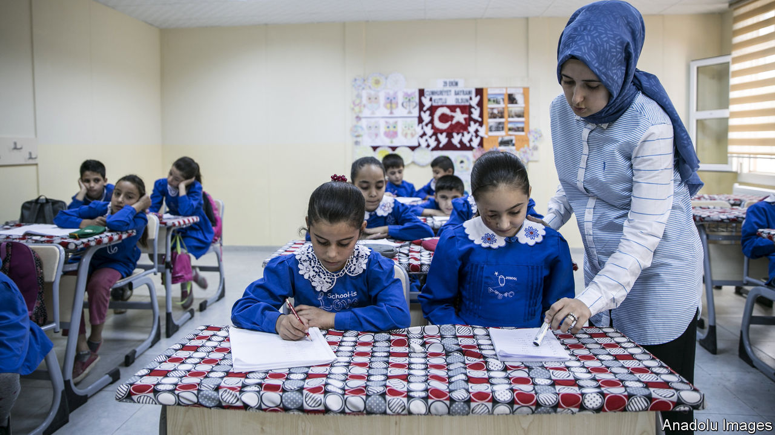

TEN YEARS ago it was just a big, sleepy village, says Mohammed Duveydar, a doctor from neighbouring Syria, as he looks out onto Reyhanli’s busy main street. When he visited before the war locals would turn in early and wake up before dawn. But habits changed after the refugees came. Reyhanli, a short walk from the border, now sealed off by a concrete wall, remains a poor and conservative town, but seems to have a bounce in its step. Since the start of the war next door, its population has nearly tripled, to about 250,000. Syrians, most of them natives of devastated Idlib, now outnumber Turks. The main streets are thick with shops. Young people, Syrian and Turkish alike, stay up late into the night, inhaling cups of coffee or narghile smoke at newly opened cafés. Some Turkish girls have started wearing the Islamic headscarf the Syrian way, says a teenager. Some Syrian women have started wearing it like the Turks.

Refugees from Syria’s war were greeted with open arms when they began arriving in Turkey nine years ago. No longer. Polls show that over 80% of Turks want the 3.6m refugees their country hosts to go home. President Recep Tayyip Erdogan’s government has drafted plans to resettle up to half of them in areas wrested by its troops from Kurdish insurgents in an offensive last year. (That no longer seems feasible: Turkey nabbed only a third of the area it wanted.) But despite hardening attitudes, the refugees are putting down roots, especially in border towns like Reyhanli, picking up Turkish habits and spreading their own. Most have no intention of going home, whatever the situation in Syria. Over 110,000 Syrians, including Mr Duveydar, have received Turkish citizenship.

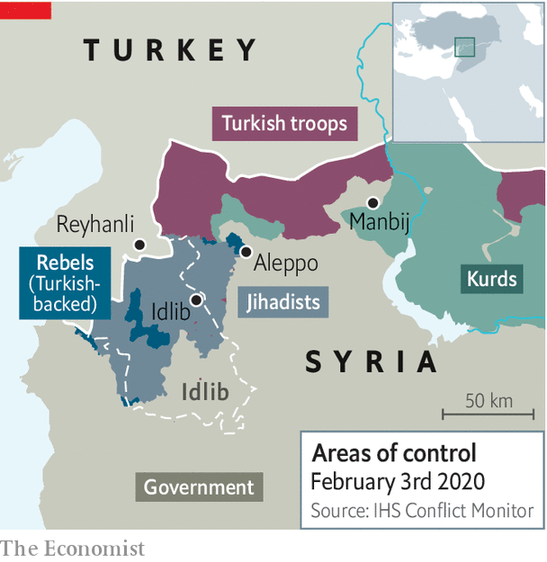

Syrians do not have it easy in Turkey. With some exceptions, they have no right to own property or to work. Most work illegally, while the authorities turn a blind eye. Thousands have been deported. But quietly, so as to avoid a nativist backlash, the government is helping Syrians make themselves at home. Access to education has improved. The government has been phasing out special refugee learning centres, where most courses are taught in Arabic, placing the pupils in Turkish schools.

Tensions in Reyhanli peaked in 2013, when car bombs killed 52 people in the town centre. Some locals responded by attacking Syrian shops, forcing hundreds of people to flee. Security has since improved, as have relations between locals and newcomers. But a fresh crisis is knocking at the town’s gates. In neighbouring Idlib, regime and Russian forces have unleashed a bloody offensive against Turkish-backed Syrian rebels and foreign jihadists. Hundreds of thousands of people displaced by the fighting have massed near the border.

Desperate to avoid another wave of refugees, Mr Erdogan’s government has pledged to stop the regime advancing. On February 2nd, after shelling killed eight Turkish soldiers deployed to Idlib under an agreement with Russia, Turkey responded with air and artillery strikes against Syrian positions. Three days later, Mr Erdogan warned that “Turkey would have to take matters into its own hands” unless regime forces pulled back by the end of February.

The stand-off has already strained Turkey’s relations with Russia, which backs the regime, but which Mr Erdogan has courted as a strategic partner. During a visit to Ukraine on February 3rd, Mr Erdogan accused the Russians of negligence. He said Turkey did not recognise Russia’s annexation of Crimea, which he correctly called illegitimate. He also greeted Ukrainian troops with a nationalist slogan that irks the Kremlin.

Yet there is a limit to how far Turkey’s leader can go. Confrontation with the Syrian regime in Idlib is manageable. Confrontation with Russia is dangerous. After Turkey shot down a Russian warplane in late 2015, Moscow imposed heavy sanctions and cut Turkey off from its proxies in Syria. It was only after Mr Erdogan apologised and made a series of concessions to Russia that the rapprochement between the two countries began. Turkey will try to stop the offensive in Idlib. But it will probably not risk conflict with Russia. And indeed, Russia does not want a war with Turkey, a NATO member. Meanwhile, Syria may have to brace for more bloodletting, and Reyhanli for more refugees. ■

This article was downloaded by calibre from <https://www.economist.com/europe/2020/02/08/syrians-are-putting-down-roots-in-turkey>

|  |  |  |  |
| --- | --- | --- | --- |
| Previous | Articles | Sections | Next |

|  |  |  |  |
| --- | --- | --- | --- |
| Previous | Articles | Sections | Next |

#### The vagaries of memory

# A museum in Russia for a man who never existed

The communists destroyed so much that even an imaginary past appeals to Russians

Feb 8th 2020 | TOMSK



ENTER AN ELEGANT two-storey Art Nouveau house in Tomsk, a Siberian university town, walk up a solid wooden staircase and step into the measured world of an early 20th-century university professor.

The visitor to this private museum is invited to look through old family albums, sit at the professor’s desk and sniff a perfume made for the 300th anniversary of the imperial Romanov dynasty in 1913 (rebranded “Red Moscow” after the revolution). You can put on the professor’s pince-nez and leaf through his 1909 wall calendar. A cup of tea from a period china set and an authentically warming schnapps poured by a considerate guide at the end of the tour completes your immersion in a world that has not been touched by the Bolshevik revolution, the second world war or the Soviet Union’s collapse. You half expect the professor to shuffle back in.

There is only one catch. There was no professor. Both he and his apartment were created about a year ago by a businessman from Novosibirsk who had bought the flat in an old wooden house for his son, a student at Tomsk university, and furnished it with objects he had collected over 20 years.

In countries where old homes and objects often stay in the same family, such a project might come across as false or redundant. In Russia, where family histories were cut to shreds by the 20th century’s man-made disasters, holding on to the past is a fixation. “We try to preserve a past that can disappear at any moment,” says Katerina Kirsanova, the museum’s curator.



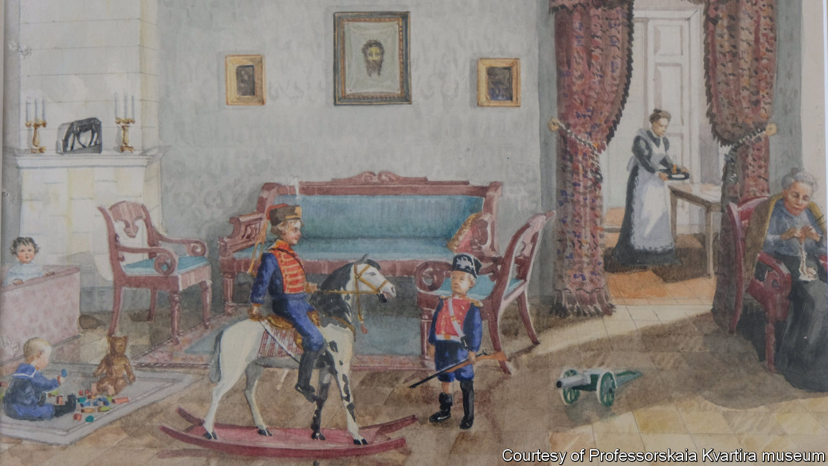

Tomsk, bypassed by the trans-Siberian railway and spared the architectural excesses of 20th-century modernisation, suffered in the early years of the 21st century when unscrupulous businessmen set many of its protected buildings ablaze (sometimes with residents inside) to grab land in the historic centre. The professor’s building was also damaged in a fire in which a student died. Its conversion into a museum is not so much a tribute to the continuum of history, as a testament to its constant disruptions.

This article was downloaded by calibre from <https://www.economist.com/europe/2020/02/08/a-museum-in-russia-for-a-man-who-never-existed>

|  |  |  |  |
| --- | --- | --- | --- |
| Previous | Articles | Sections | Next |

|  |  |  |  |
| --- | --- | --- | --- |
| Previous | Articles | Sections | Next |

#### From handguns to handouts

# The rise of Sinn Fein, an Irish party that once espoused violence

Young voters like its promises of free money

Feb 8th 2020 | DUBLIN

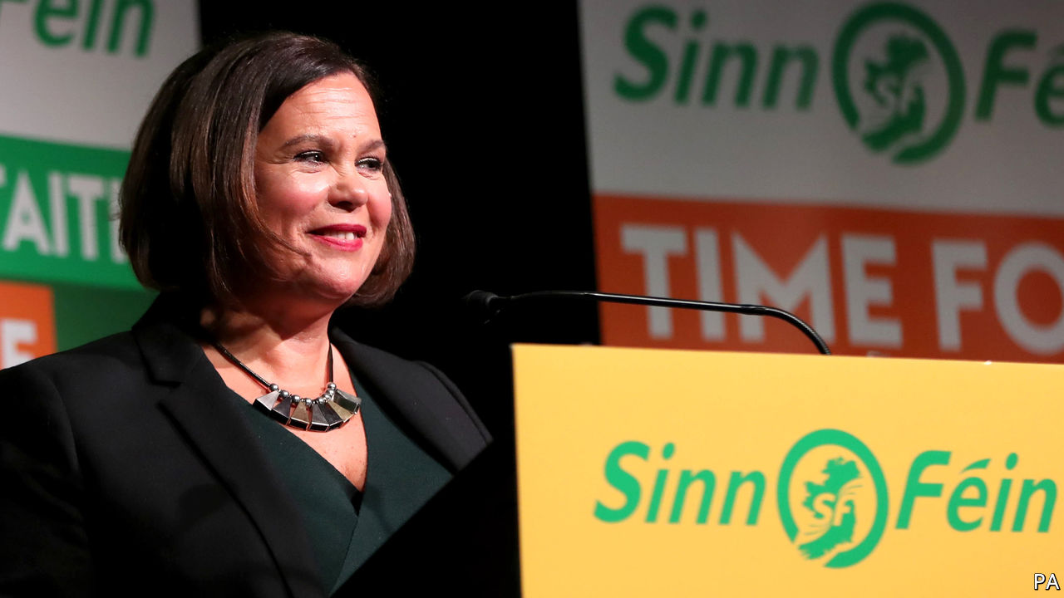

NOT SINCE the days of Eamon de Valera has Ireland had a leader as globally recognisable as Leo Varadkar. Both men owe their prominence to vexed Irish relations with Britain. De Valera emerged as the senior surviving leader of the Easter uprising against British rule in 1916. Mr Varadkar rallied EU support in a stand-off with Boris Johnson over the terms of Brexit last year.

Yet whereas de Valera spent half a century in and out of high office, building modern Ireland in the process, Mr Varadkar faces the sack. Polls suggest that his centre-right Fine Gael party will slump to third place in an election on February 8th, falling behind not only its traditional rival, Fianna Fail, another party of the centre-right, but also Sinn Fein, the shock leader. If so, it would be the first time since the 1930s that Fianna Fail and Fine Gael have not been the top two.

Mr Varadkar’s career may have peaked at the tender age of 41, less than three years after he became not only Ireland’s youngest ever taoiseach (prime minister) but also its first openly gay one, and the first to have non-European heritage (his father, a doctor, is originally from Mumbai).

Fine Gael had based its re-election campaign on Mr Varadkar’s success in negotiating a deal with Britain over Brexit and on GDP growth of almost 5% last year, compared with 1.8% for the rest of the EU. But, says Professor Jane Suiter of Dublin City University, a series of unfortunate events have interfered with Mr Varadkar’s plans. Voters fret about a health service near collapse, and a cost-of-living and housing crisis. Ireland has some of the highest rents in the world, and soaring homelessness.

Theresa Reidy of University College Cork says that conservative voters who want to punish the government can look to Fianna Fail’s Micheal Martin as another leader who would probably do a similar job to Mr Varadkar. Since 2016 Fianna Fail has supported Fine Gael’s minority government in a confidence-and-supply arrangement that it is now tired of.

Angry younger voters are turning to a range of green and centre-left parties, but most of all to Sinn Fein. Formerly the political wing of the Provisional Irish Republican Army (IRA), the party is led by Mary Lou McDonald, a personable Dubliner with no history of involvement in the IRA. The other two big parties have both pledged to shun Sinn Fein for its past support for violence, but making a government without it will be hard, since Fianna Fail has vowed not to continue its arrangement with Fine Gael. Most of Sinn Fein’s policies are well to the left. It promises a rent freeze, earlier retirement and lavish public spending on nearly everything. It is also committed to a referendum on uniting Ireland.

“Sinn Fein have never been in government in Dublin before, so they are not held responsible for the present problems in the way that Fianna Fail and Fine Gael are,” says Ms Reidy. “They are responsible for some other things, for sure, which is why older people, who remember the Troubles, aren’t flocking to them in the same numbers. But young people don’t remember that. And [they] are the ones who can’t afford to buy or rent homes, and who are being quoted €3,000 for car insurance.”■

This article was downloaded by calibre from <https://www.economist.com/europe/2020/02/08/the-rise-of-sinn-fein-an-irish-party-that-once-espoused-violence>

|  |  |  |  |
| --- | --- | --- | --- |
| Previous | Articles | Sections | Next |

|  |  |  |  |
| --- | --- | --- | --- |
| Previous | Articles | Sections | Next |

#### Green tomorrow

# Why every Norwegian ecowarrior has 200,000 petrodollars

Climate-friendly startups in Norway are bankrolled by the state oil fund

Feb 8th 2020 | OSLO

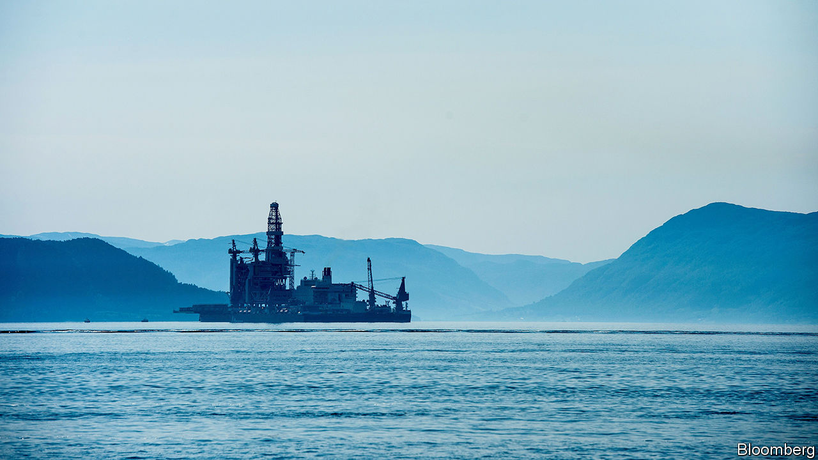

SEVERAL TIMES a year neighbours in Norway get together to sweep leaves, trim bushes, weed flowerbeds and fix up their communal areas. These occasions belong to a tradition called dugnad (communal volunteering). Cilia Holmes Indahl says Norway now needs dugnad on a much bigger scale to turn it into a greener society. Ms Holmes Indahl is the 30-year-old boss of Katapult, a group of companies that invest in technology firms with green aims. Katapult organises an annual three-day “future fest” in Oslo, a mix of tech conference and Burning Man.

Many young Norwegian greens want to wean their country off oil. Technology startups are proliferating in Oslo, helped by generous subsidies from the government. The startups have names like “Douchebags” and “Monster”. They meet in rooms called “Creative Cocoon” or “Bug Fixer”. They sit in open-plan offices in trendily converted factories, surrounded by fruit bowls and bean bags, clad in the obligatory black sweatshirts and beanies. Last year Oslo came third in a ranking of the world’s most talent-competitive cities by INSEAD, a European business school. Engineering graduates used to flock to the lucrative oil sector; these days oil majors have trouble recruiting talent.

Yet although Innovation Norway, a state-owned agency, has in recent years done a good job of promoting startups, Norway’s economy will remain dominated by oil for the foreseeable future. Petroleum has transformed the country since it was discovered at the Ekofisk oilfield in the North Sea in 1969. Norway is one of the world’s largest oil exporters. Hydrocarbons account for half its exports and 19% of GDP. And another oil rush is beginning. Johan Sverdrup, a giant new oilfield in the North Sea, could earn Norway an estimated $100bn over the next 50 years.

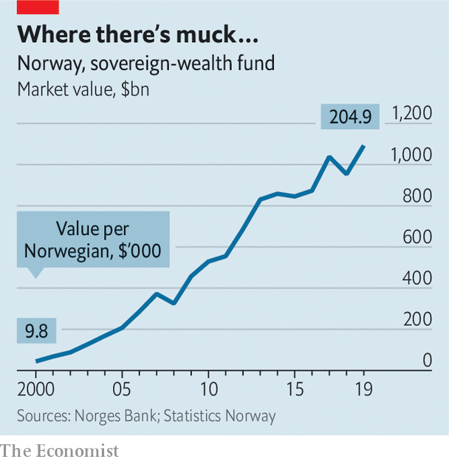

Sveinung Rotevatn, the 32-year-old newly appointed minister of climate and the environment, admits that Norway is a paradox—one of the world’s leaders in the use of renewable energies and technologies, but also a fossil-fuel giant. Almost all Norway’s electricity comes from renewable sources. Heating with oil will be banned this year. Half of newly registered cars are electric (Norway is one of Tesla’s biggest markets). Oslo was the first city in the world to set a ceiling every year for its greenhouse-gas emissions. In late 2018 it removed nearly all parking spaces from the city centre, replacing them with benches, bicycle docks and more pavements. In October last year Norway’s $1.1trn sovereign-wealth fund, the world’s largest, established in 1990 to prepare the country for a post-oil future, announced that it would sell all its shares in companies dedicated to oil and gas exploration.

Is Norway doing enough to prepare for that post-oil future? Some argue that it should do more. “The government is deeply embedded in old industries, but has shown no interest in investing directly in tech firms,” says Trond Riiber Knudsen, chief executive of TRK, an Oslo-based investment firm. The state owns a third of the shares on the Oslo stock exchange, including large stakes in Telenor, the country’s biggest telephone operator; Norsk Hydro, its biggest aluminium producer; Yara, its biggest fertiliser-maker; and DNB, its biggest bank. It also controls some non-listed giants such as Statkraft, a power generator, which if listed would be the third-biggest company on the stockmarket. However, the state has not fussed when several successful technology firms were sold to foreigners. In 2010 Cisco, an American tech titan, paid $3.3bn for Tandberg, a Norwegian maker of videoconferencing kit. In 2016 a Chinese group bought Opera, a Norwegian software company.

Ivar Horneland Kristensen, boss of the federation of trade and services, argues that the government should pay more attention to the services sector. Services account for 55% of GDP. According to Mr Horneland Kristensen, Norway faces four challenges. It needs to reduce its focus on oil and gas, increase its productivity through the use of technology, decarbonise the economy to meet the goals of the Paris agreement on climate change and create 25,000 jobs a year so that laid-off oil workers remain gainfully employed.

Norway has profited from its wise decision to save the principal and invest the returns of its oil riches. But the sheer size of its sovereign-wealth fund—more than $200,000 for every citizen—encourages dependency. Fully 20% of Norwegians rely on welfare, and that does not include pensions. Norway spends 4.3% of GDP on incapacity benefits, the second-highest in the OECD after Denmark. Youngsters have never known a country without oil riches. They are used to excellent free schools and universities as well as free health care. But for how long?

“There is no future for oil,” insists Mathias Mikkelsen, the 29-year-old CEO of Memory, a startup that developed an app to track time at work. Oil is the new coal, so clever investors are putting their money elsewhere, says Inge Berge, CEO of Wastefront, which, backed by Innovation Norway, is building a factory to recycle tyres. Yet both Mr Mikkelsen and Mr Berge benefited from the ecosystem for startups financed by oil wealth—and would have a much tougher time building their companies without it. ■

This article was downloaded by calibre from <https://www.economist.com/europe/2020/02/08/why-every-norwegian-ecowarrior-has-200000-petrodollars>

|  |  |  |  |
| --- | --- | --- | --- |
| Previous | Articles | Sections | Next |

|  |  |  |  |
| --- | --- | --- | --- |
| Previous | Articles | Sections | Next |

#### Charlemagne

# The parable of the plug

How plugs explain the potential and limits of the EU’s strange superpower

Feb 8th 2020 |

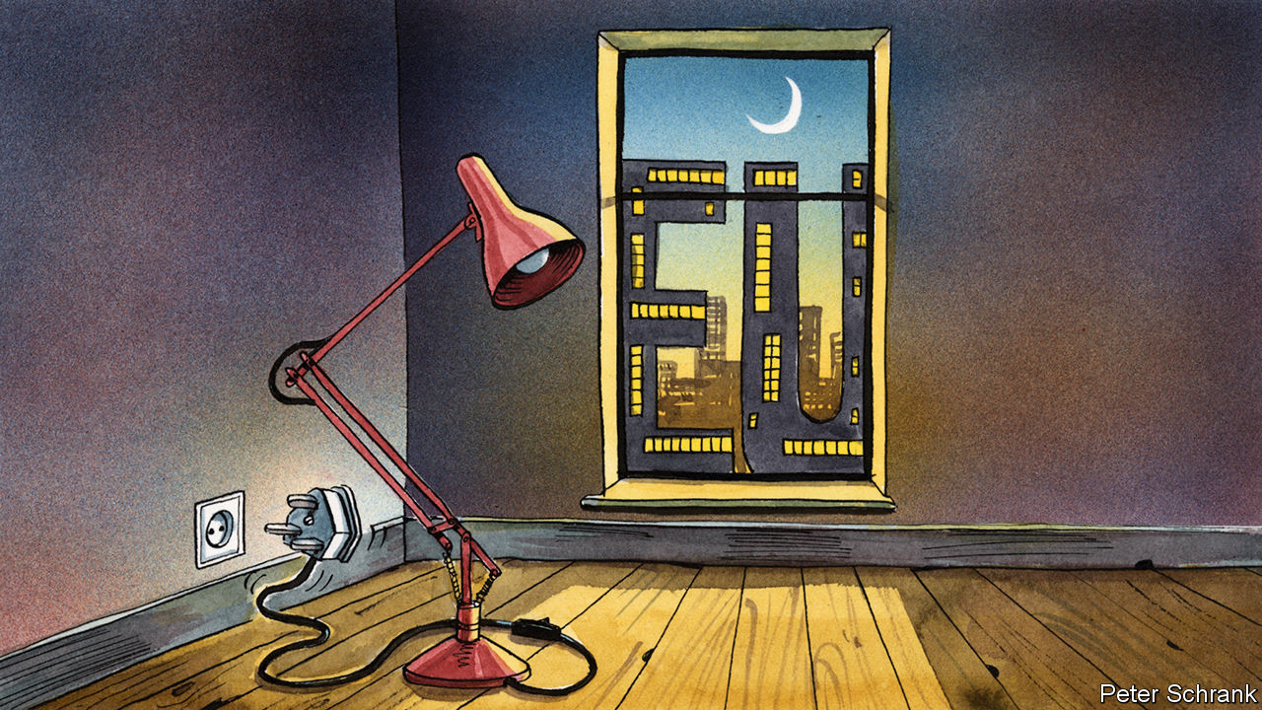

THE BRITISH plug is a marvel of design. Its insulated prongs make electric shocks nigh on impossible, even if it is hanging out of the socket. Shutters cover the live holes on the socket until the earth is engaged, meaning even the most adventurous toddlers struggle to electrocute themselves. Yank out the cable and the live wires will disconnect before the earth, further reducing the chance of anyone being fried. It is probably the safest plug on the planet (unless trodden on). Yet apart from Britain and a few countries that lived under its imperial rule, the Great British plug is spurned for flimsy, sometimes dangerous two-prong affairs.

As sales of British plug adaptors suggest, it takes more than good design for standards to be adopted globally. For such influence, an alchemy of regulatory clout and market power that Britain simply does not possess is required. But it is a blend that the EU has learned to master. Everything from timber production in Indonesia to internet privacy in Latin America is now settled by a bunch of bureaucrats, diplomats, MEPs and lobbyists in the middle of Belgium. This has been dubbed the “Brussels effect” by Anu Bradford of Columbia Law School, in a new book of the same title, which explains how the EU quietly has become a regulatory superpower.

The EU, no superpower in the traditional sense, pulls this off in three ways. First, the EU’s market is so enormous—roughly a fifth of global GDP at market exchange rates—that producers cannot ignore the continent, no matter how onerous its regulation. Second, in contrast to America where light-touch regulation is the goal, Brussels revels in making its rules exacting. It prides itself on having the toughest regulations on everything from privacy to the environment. So if a company wants to sell the same product everywhere, rather than wasting money on having lots of different versions, it has to meet European standards. These two factors combine to introduce a third way of influencing global regulation, as companies sometimes lobby their domestic governments to raise their regulations to European levels, lest a rival gain an advantage by producing shoddy stuff solely for their home market.

In this way, the Brussels effect has turned the EU into a self-perpetuating policy machine. While more countries and global businesses find themselves sucked into its regulatory tractor beam, one country is trying to escape. Boris Johnson’s British government is cherishing divergence at a time when convergence with the EU’s rules is the order of the day. Britain wants to build relationships with countries outside of Europe. Often, though, these same countries are moving in the opposite direction. Increasingly, globalisation resembles Europeanisation. Britain can try to go it alone in its own regulatory sphere, but it will probably prove as popular as its three-pronged plugs.

The latest manifestation of this Brussels effect comes in the form of another type of plug. The European Commission is pondering how to compel phone companies to come up with a universal plug for their chargers. Apple, which uses its own design for its charger cables, is mithering about the change. Critics fear phone companies may end up stuck with outdated chargers until regulators grant permission to change. But Apple’s complaints are likely to be in vain, leaving the company with a choice: abide by the law only in the EU, or change its plug in all markets. The latter option is probably less costly. And unlike its British cousin, this type of plug could well go global, whether it is a good idea or not.

Brussels can bend the likes of Apple to its will, but being only a regulatory superpower has limits. When America killed Qassem Suleimani, an Iranian commander, earlier this year, the commission president, Ursula von der Leyen, summoned her team. Weirdly, the commissioners responsible for such things as demography, youth and health had to have their say on the prospect of war in the Middle East. When it comes to soft power and tweaking plug design, the EU reigns. In terms of hard power, the EU is left resembling Oasis guitarist Noel Gallagher’s description of his brother Liam: “a man with a fork in a world of soup”.

Even where Brussels does run the show, the upside is not obvious. Brussels increasingly sets the rules for the internet. But it is still large American companies that make the money (and the American government which reaps the tax revenue). Indeed, whereas Facebook and Google are big enough to digest whatever regulation they are force-fed, smaller European firms may end up choking. Aside from providing lobbyists with a healthy living and keeping overpriced restaurants in Brussels’ European quarter in business, the benefits of this arrangement are sometimes unclear.

Such advantages are not only limited but may also be short-lived. The EU’s regulatory dominance is a recent affair. And the blocks upon which the EU built this power are shuddering. The EU is still one of the world’s biggest markets, but its share of the global economy is likely to fall in the coming decades. As it shrinks, so does the incentive to follow Brussels’ diktats.

## From Brussels to Beijing

Technological change may further weaken the EU’s power. Producing a complicated widget to different standards costs lots of money as manufacturing must be rejigged. If 3D printing becomes the norm, the costs of abiding by both European and other standards might well fall. In some areas, high standards may become a curse, rather than a virtue. With artificial intelligence, companies under sketchier regulatory regimes may build an insurmountable lead via unethical experimentation. “What today amounts to the Brussels effect may one day be described as the Beijing effect,” warns Ms Bradford. Such shifts may be some way off. Countries are increasingly forced to pick a sphere of influence. When the other choices are an erratic America and an undemocratic China, the EU has something to offer. But hegemony rarely lasts and the EU’s regulatory supremacy is unlikely to be an exception. Even the highest standards can end up ignored. Just look at the British plug. ■

This article was downloaded by calibre from <https://www.economist.com/europe/2020/02/08/the-parable-of-the-plug>

|  |  |  |  |
| --- | --- | --- | --- |
| Previous | Articles | Sections | Next |

|  |  |  |
| --- | --- | --- |
| Europe | Sections | International |

Britain

EU-UK negotiations: There may be trouble ahead

.

Aristocrats’ jobs: Courting fame

.

Rail: Return of the fat controller

.

Urban infrastructure: Euston, we have a solution

.

Nuclear weapons: Critical condition

.

Slavery and universities: Ties that bind

.

Bagehot: Cummings v the blob

.

|  |  |  |
| --- | --- | --- |
| Europe | Sections | International |

|  |  |  |  |
| --- | --- | --- | --- |
|  | Articles | Sections | Next |

#### EU-UK negotiations

# The risk of Britain leaving the EU with no trade deal remains high

Compromise ought to be possible but is not guaranteed by year-end

Feb 8th 2020 | BRUSSELS AND LONDON

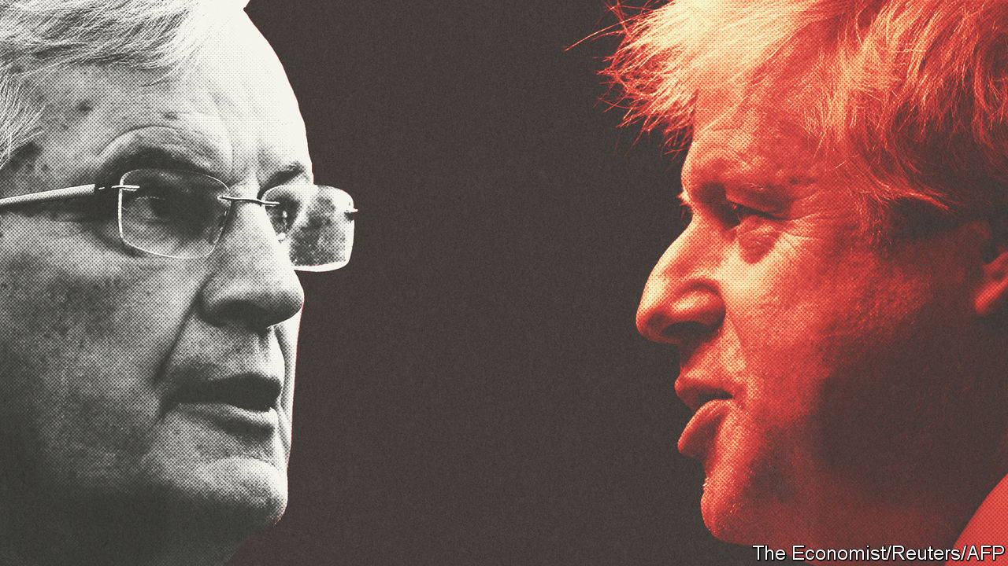

IF BREXIT-WEARY BRITONS hoped they would be able to read about something other than deadlocked talks once they had left the EU, they were disappointed this week. The transition period into which Britain has gone lasts only until the end of the year, by which time a trade deal needs to be done. But when negotiations began on February 3rd, the differences between the two sides seemed as wide as ever.

It was Britain’s choice, insisted Michel Barnier, the EU’s chief negotiator, to have a more distant relationship than the EU had wanted. But he said the bloc was ready to offer a zero-tariff, zero-quota free-trade deal that is more generous even than Canada’s—with conditions.

The most contentious is a “level playing-field” designed to prevent Britain from undercutting its largest trading partner. This, says the EU, will require British observance of EU rules on state aid to companies and on environmental, workplace and labour standards. The EU also wants to maintain its access to British fishing waters. And it insists on a governance system for settling disputes that maintains a role for the European Court of Justice (ECJ).

Speaking in the old Royal Naval College, Greenwich, a monument to Britain’s seafaring power, Boris Johnson dismissed these demands in muscular terms. He wants a free-trade deal like Canada’s. But just as Canada is not bound by stringent level-playing-field conditions, Britain should not be. There was no need for any deal to involve accepting EU rules on competition, subsidies, social protection or the environment. Instead, he argued, Brussels should trust his promises to keep to the highest possible standards. The EU, already suspicious that Britain may not fulfil its obligations under the withdrawal treaty to impose border controls between Northern Ireland and Great Britain, is reluctant to rely on trust alone.

As for fish, Mr Johnson declared that the EU must accept British control of its own waters. Nor could post-Brexit Britain allow any ECJ jurisdiction over its laws. And if a Canada-style deal cannot be negotiated by year-end, he concluded, Britain would be happy to trade like Australia. That is a euphemism for having no-deal and instead trading on World Trade Organisation terms (in fact, Australia is trying to get its own free-trade deal with the EU).

There is only limited time in which to narrow such differences. That is because, against the EU’s advice, Mr Johnson is refusing even to consider extending the transition period beyond the end of the year. The withdrawal treaty allows him to ask for this by the end of June. But EU lawyers say that, if he misses this deadline, it will no longer be possible to get more time.

Yet a free-trade deal that takes in not only goods but also extras like services, data rules, public procurement, aviation, transport and security normally takes several years to agree (and more to ratify). When talks begin in March they will at first see more posturing than negotiating. EU diplomats do not expect real horse-trading to begin until June. As Mujtaba Rahman of the Eurasia Group consultancy says, the time-frame with just months left will dictate the terms of any deal, not the other way round. And that means a bare-bones agreement covering mostly trade in goods.

The big question is whether even this will now be possible. Much gloomy commentary suggests not; but there is a decent chance that it might. After all, both sides prefer a deal to no-deal. As Mr Johnson’s flexibility over the withdrawal treaty last year shows, he is willing to make big concessions to get agreement. Unlike Theresa May, his predecessor, he has a huge parliamentary majority, which means that he need not worry about Westminster MPs rejecting it. Even on fish, his offer of an annual agreement on catchable quotas points to some room for compromise.

As for the EU, its hard line on the level playing-field could yet soften. What matters, says a diplomat, is not forcing Britain to adhere religiously to EU rules but having a reliable enforcement mechanism if it strays. He calls this having a gun on the table that can be picked up and fired if need be. Even the role of the ECJ in a governance structure can be fudged: it must have the exclusive right to interpret the EU’s laws and thus police its side of any deal, but that need not imply intrusion into Britain’s.

Geopolitics would urge a deal, too. Nobody in the EU wants Britain to drift off across the Atlantic or towards Asia. And despite chatter by some of his more rabid allies, there is little sign that Mr Johnson favours either (though he is bullish about a trade deal with America). Failure to reach even a basic agreement would reflect badly on both sides. And it ought to be possible later to build on such a plain deal to cover the more complex issues left over.

A big worry is that both sides may be drawing the wrong conclusions from the tortuous negotiations on the withdrawal treaty. The EU reckons it won by being firm and united, and by using its superior weight to force successive British prime ministers into concessions. Mr Johnson believes that Mrs May failed because she was not ready to walk away from the table and into no-deal, partly because her own MPs would not let her. Brussels may be underestimating a newly empowered Mr Johnson’s willingness to accept no-deal, while the prime minister may be overestimating the EU’s fear of this outcome.

This is partly because, for both sides, the cost of no-deal has shrunk. The withdrawal treaty will remain in place to cover the first-round issues of money, EU citizens and averting a hard Irish border. Except for a few vulnerable sectors, the trade losses from moving from unfettered single-market access into a bare-bones deal for goods are not that much greater than those of switching to trade on WTO terms alone. If the political price for either side to reach an agreement starts to look too high, no-deal may start looking like a plausible alternative. That is the biggest reason why it might actually happen.■

This article was downloaded by calibre from <https://www.economist.com/britain/2020/02/08/the-risk-of-britain-leaving-the-eu-with-no-trade-deal-remains-high>

|  |  |  |  |
| --- | --- | --- | --- |
|  | Articles | Sections | Next |

|  |  |  |  |
| --- | --- | --- | --- |
| Previous | Articles | Sections | Next |

#### Courting fame

# Why aristocrats are flocking to the creative arts

Once they ran the empire, today they run Instagram accounts

Feb 8th 2020 |



PETER CZERNIN is a successful Hollywood film producer who has been nominated for an Oscar. Yet the Internet Movie Database (IMDb) is more interested in his blood than his talent. “I was horrified to see that it said, ‘Peter Czernin is the heir to a baronial title’,” he says. “I don’t want to be defined by the fact that I’m the grandson of the Baron Howard de Walden.”

Prince Harry and Meghan Markle’s decision to choose Disney over ribbon-cutting startled their family and fans, but they are part of a broader trend. A genealogical audit of the modern House of Windsor reveals that 42% of King George V’s great-great-grandchildren—who are mostly young adults today—work in the arts and entertainment businesses.

It was not always thus. Just six of Queen Victoria’s 132 great-great-grandchildren landed in the creative industries, not that they would have recognised the term. Some ended up penniless; many more were in public service. Today’s lot are better off—the modern economy has been kind to those well-endowed with property—and tend to be enmeshed in a celebrity circus of professional creatives and Instagram icons. Lady Amelia Windsor, granddaughter of the Duke of Kent, is a model and social media influencer. Her brother, Lord Downpatrick, founded a fashion brand. The Lascelles family, descended from Mary, Princess Royal, is now thick with musicians and filmmakers. Other aristos have been muses to Giorgio Armani, made crystal jewellery and daubed graffiti.

Aristocrats presumably choose the creative arts because they offer pleasanter and more prestigious employment than most fields do, there is no clear definition of success, and the low pay and scant benefits common in the industry’s lower reaches are less troublesome to those whose existences are cushioned by wealth. Why the creative arts should choose aristocrats takes a bit more explaining.

It could be connections. Those help, particularly in the art-dealing business, which involves persuading one lot of rich people to sell their paintings and another lot to buy them. Princess Eugenie and Lady Helen Taylor are art dealers. Not all aristocrats are happy to admit the power of connections. “There are individuals who’ve assumed I live a particular lifestyle and have managed to obtain my role in the luxury industry thanks to help from my extended family,” says Zenouska Mowatt, who is 56th in line to the throne. She works at Halcyon Days, who make luxury enamelled goods and have three Royal Warrants.

But it may have more to do with what has happened to the creative arts. Success in the field depends on the ability to market oneself, and people with a bit of inherited stardust have a big advantage on social media. Sam Chatto’s 60,000 Instagram followers may be attracted by his ceramics, but the fact that he is Princess Margaret’s grandson probably adds to his charms.

Many younger aristocrats’ brands and businesses are intertwined with their families’. The Manners sisters, two models and a singer, daughters of the Duke of Rutland, use their popular social media accounts to promote events at Belvoir Castle, the family’s estate. Viscountess Weymouth’s recent stint on “Strictly Come Dancing”, a TV show, raised the profile of Longleat House, the family seat, along with aristocratic eyebrows. Viscountess Hinchingbrooke is an American blogger whose appearance on “An American Aristocrat’s Guide to Great Estates” and “Ladies of London” has boosted turnover at Mapperton House.

Sam Friedman, a member of the government’s social mobility commission, thinks aristocrats in the creative arts have some cultural significance. “These are people who are mediating really important stories about who the British are today.” Economically, though, their new occupations probably do not add up to much: the Earl of Burlington’s photography and his wife’s fashion business are not what’s keeping Chatsworth House standing. And whether what they do actually counts as work or not varies from case to case. “There are some,” says Mr Czernin, “who think ‘job’ is just a book in the Old Testament.” ■

This article was downloaded by calibre from <https://www.economist.com/britain/2020/02/08/why-aristocrats-are-flocking-to-the-creative-arts>

|  |  |  |  |
| --- | --- | --- | --- |
| Previous | Articles | Sections | Next |

|  |  |  |  |
| --- | --- | --- | --- |
| Previous | Articles | Sections | Next |

#### Rail

# HS2 and the return of the fat controller

Labour promised to renationalise the railways. The government is sort-of doing it anyway

Feb 8th 2020 |

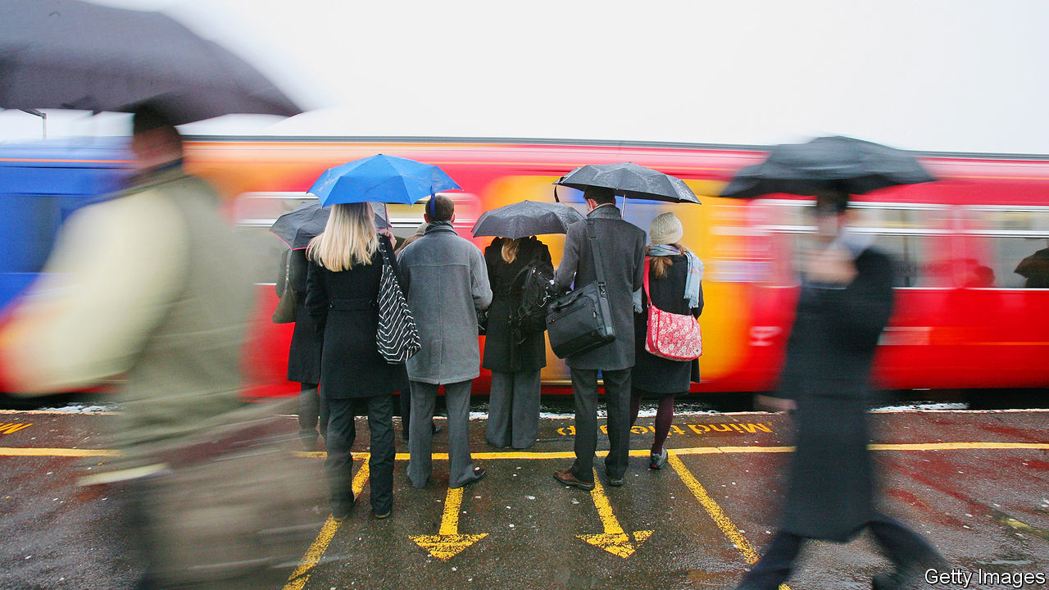

THE RUSH to board the 17.46 from London Euston to Crewe begins the moment the platform is announced. Passengers, many of them commuting the 33 minutes to Milton Keynes, run past the gates while station staff try to keep out of their way. The train’s eight carriages, in theory, each carry 70 passengers. But the London-Crewe line is Britain’s busiest rail service. It leaves Euston carrying, on average, more than twice as many passengers as it has capacity for. Sitting on the floor, Becky, a local government worker laments that, “It’s like this every day. I get a seat maybe once a week. And I pay five grand for this season ticket.”

At peak times 19% of London rail users are forced to stand. The problems stretch across Britain: 17% are seatless at peak times in Birmingham and 15% in Leeds. With a poor punctuality performance by international standards and a high cancellation rate, commuting by rail in Britain is often a miserable experience. The government is now set to try to relieve some of the suffering with a major expansion of Britain’s rail network and a reorganisation of the sector. More government money looks set to be coupled with more government direction. The fat controller is returning to the railway.

Britain’s railways have a physical geography that reflects the economy of the Victorian era and an ownership structure based on decisions taken in the early 1990s. Both now look set to be reformed. The government is expected to give the go-ahead to High Speed 2 (HS2), a new line from London to the Midlands and the north, while the Williams Review of the structure of the sector is due to report in the coming weeks.

After the Victorian boom, the railways went into a long decline. Traffic fell for half a century after the second world war. But over the past 25 years they have more than doubled: there were 1.8bn rail journeys in 2018-19, more than at any time since the early 1920s. But while in 1963 Britain had 17,500 miles of track, it now has under 10,000 miles.

That is the root cause of much of the commuter woe. According to the Railway Industry Association track utilisation is 60% higher in Britain than the EU average. According to Network Rail, the publicly owned manager of the track, around 70% of delays are the knock-on effects of congestion. The shrinkage of Britain’s network has also forced operators to run freight, intercity and commuter trains on the same stretches of track. The need to accommodate slower running stopping trains reduces the number of higher speed trains which can run on the same length of track. In mainland Europe, there has been a push to move freight and commuter trains onto different lines.

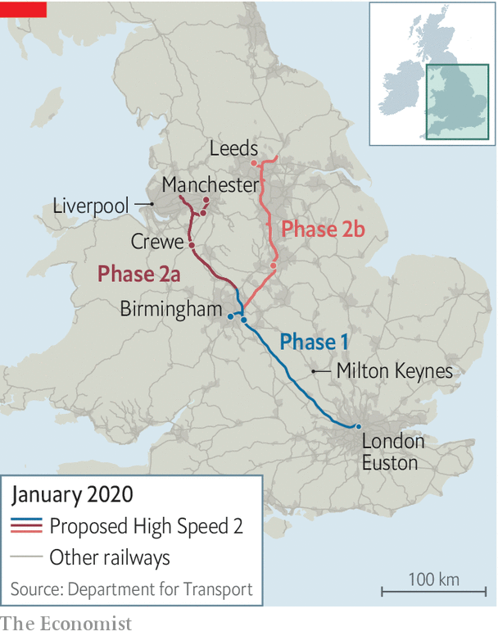

The core argument for HS2 was always about capacity, but in the late 2000s the then transport secretary Andrew Adonis (a real “rail geek”, according to transport officials) was determined to build a super high spec line rather than simply mirroring the existing West Coast Mainline. The result is HS2, which will run from London to Manchester and Leeds (see map).

The plan is ambitious. Eighteen trains an hour will run to and from London compared with a typical two to six an hour on continental high-speed lines. That volume of traffic requires a greater level of structural reinforcement and Britain’s new line will generally be in a sunken embankment rather than running at surface level. A certain macho enthusiasm to achieve greater speeds than France means the lines will have to be straighter to reduce the need for slowing on bends.

The project was greenlit in 2012 and placed under review last summer by Boris Johnson, partly because of opposition from MPS with constituencies the train would go through, and partly because of cost escalations. An initial estimate of £42bn a decade ago has now risen to around £100bn, or roughly 5% of GDP. The most recent official benefit-cost ratio estimate still suggests the project is value for money. Rail bosses argue that alternative schemes to increase capacity would not work in Britain. The double-decker trains used in the Netherlands and Italy are too wide for Britain’s track, and longer trains would mean building longer platforms all over Britain.

Perhaps as important as network expansion is industry structure. The government has taken back control of two of the franchises operated by private companies that ran northern and east-coast routes, but renationalisation is an interim measure. In the longer run, the government is likely to change the relationship between the state and the operating companies.

Britain’s model of railway ownership—large multi-year regional franchises—is unique in major countries. According to a former rail boss, the structure reflects the way the railways were seen in the run-up to privatisation in the early 1990s—as a sunset industry with declining passenger numbers and not much hope of a turnaround. The franchises were designed to attract bidders who would be able to manage decline while making some money rather than as components in a network vital to the economy.

Rail’s recent renaissance has changed all that. The industry expects the Williams Review to recommend a move from a franchise model to a concession one, as already used in London Overground and Merseyrail and is common overseas.

Under the concession model, private firms still manage trains but they do so for a fee and pass on the fare income to the government. The model should make it easier to maximise economic benefit to the country rather than operator profits. It could mean, for example, more trains at peak times and more co-ordination across routes. It has worked well in London and Merseyside. But with more control comes more financial risk. If a recession or a new technology, such as driverless cars, emerges as a serious competitor, taxpayers will bear the losses.

The problem will be matching up the rail geography of Britain to the political geography. In London and Merseyside an authority exists to run the concession process but it is hard to see who could manage the Transpennine route, which cuts across several local boundaries or the larger intercity network contracts. Whatever the size of his waistline, the transport secretary will be back in control.■

This article was downloaded by calibre from <https://www.economist.com/britain/2020/02/08/hs2-and-the-return-of-the-fat-controller>

|  |  |  |  |
| --- | --- | --- | --- |
| Previous | Articles | Sections | Next |

|  |  |  |  |
| --- | --- | --- | --- |
| Previous | Articles | Sections | Next |

#### Urban infrastructure

# How HS2 will transform a forlorn part of London

Euston, we have a solution

Feb 8th 2020 |



WHEN EUSTON STATION was built in 1837 it was an elegant terminus for the London and Birmingham Railway, with a much-admired Doric arch at its entrance on Drummond Street. But all that was knocked down half a century ago, to be replaced by a concrete carbuncle that destroyed the arch and chunks of nearby streets and has been making commuters miserable since 1968. Now HS2, whose terminus is at Euston, offers a chance to remedy those errors.

Unlike the redevelopments of London’s grand Victorian stations, Euston is not hampered by heritage concerns. Last month Camden council, within whose boundaries the station wholly lies, published a draft planning brief, which envisages up to 3,800 new homes, a quarter of a million square metres of commercial space and as many as 14,000 new jobs in a project that has the potential to become not only a massive transport hub but also what the plan calls “a new piece of the city”.

Partly because the station has blighted the area, Somers Town—jammed between Euston to the west, St Pancras to the east and the roaring traffic of the Euston Road to the south—is among the most deprived neighbourhoods in England. A woman born there can expect to live a decade less than her counterpart in leafy Hampstead, three miles to the north. Those leaving the station to its east are greeted by a row of porn shops.

The plan imagines green spaces, housing, offices and retail above the new station, as well as building over exposed, below-street-level tracks that extend north for nearly a mile. It foresees bringing back the ancient street pattern to reconnect Somers Town and Regent’s Park with pedestrian and cycle routes over the roofs of the stations. Camden council has experience in such matters. The redevelopment of King’s Cross, a nearby station, transformed a huge chunk of derelict land into a vibrant quarter of the city. Google is building its London headquarters there.

Like that project, Euston will involve multiple agencies, ministries and companies working together. Unlike it, Euston will prioritise what Danny Beales, a Camden councillor, calls “inclusive retail”—or shops that sell things Somers Town residents can actually afford. King’s Cross may be great for boutiques, but it is rubbish for daily necessities. If all goes to plan, few will lament the disappearance of 20th-century Euston, as they did the 19th-century version.

This article was downloaded by calibre from <https://www.economist.com/britain/2020/02/08/how-hs2-will-transform-a-forlorn-part-of-london>

|  |  |  |  |
| --- | --- | --- | --- |
| Previous | Articles | Sections | Next |

|  |  |  |  |
| --- | --- | --- | --- |
| Previous | Articles | Sections | Next |

#### Defence

# Botched nuclear projects put the future of Britain’s defences at risk

Costs have ballooned as decrepit facilities remain in use

Feb 8th 2020 |

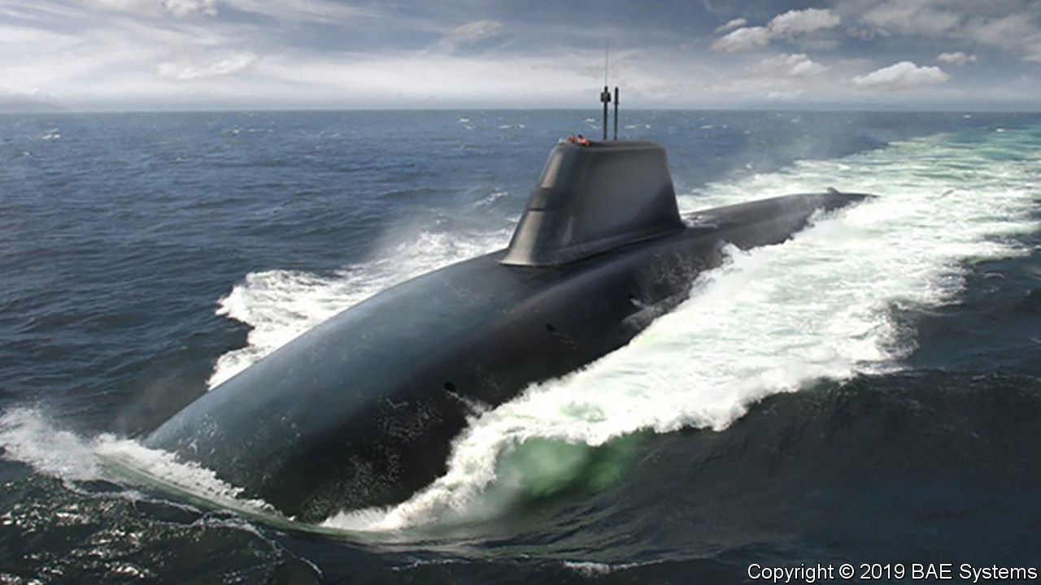

FOR OVER 50 years without pause, there has always been a British submarine hidden somewhere in the depths of the world’s oceans, loaded with thermonuclear weapons. This unceasing prowl—known as a Continuous At-Sea Deterrent (CASD)—depends on a sprawling infrastructure of nuclear sites across Britain. But a report published in January by the National Audit Office (NAO), Parliament’s spending watchdog, suggests that Britain’s nuclear complex is in the throes of crisis.

The NAO reviewed three construction projects: a facility to build the Dreadnought-class submarines that are scheduled to carry British nukes from the early 2030s, another to produce their nuclear reactor cores and a third, known as MENSA, to assemble new warheads and dismantle old ones. All three have been fouled up. Costs have ballooned by £1.35bn, over twice the original estimate, with half of that caused by construction starting prematurely. Badly written contracts left the government, rather than contractors, on the hook. And MENSA is so severely delayed, by over six years, that decrepit 1960s facilities are being used long after they should have been decommissioned.

The report makes for “grim reading”, says Tom Plant, an expert at the Royal United Services Institute, a think-tank, and formerly an official at the Atomic Weapons Establishment (AWE), which builds and maintains Britain’s nuclear warheads. But the situation is even worse, he says. Two other desperately needed facilities have also been botched. AWE was supposed to have built a £634m site for handling enriched uranium—the fissile material, along with plutonium, which goes inside bombs—four years ago, but the project was put on ice years ago. The facility used instead is so rickety that it had to be shut down for safety reasons in 2012-15.

Then there is the question of designing the warheads in the first place. For over 18 years Britain’s nuclear scientists have said that they need better data from hydrodynamic experiments, which model the high pressures and shock waves that occur when fissile material implodes inside a warhead. Britain has not conducted a live nuclear test since 1991, and signed a treaty forgoing all tests in 1996. But a planned facility which would have allowed three-way X-ray photographs of implosions was canned in 2010, though not before blowing through £120m. An equivalent capability, based in France as part of an Anglo-French agreement, is not due to turn up until 2022 at the earliest.

All this could have serious implications for Britain’s status as a nuclear-armed country. Its stockpile of 200 warheads is expected to become obsolete in the late 2030s. Extending their life or making new ones (a decision is due shortly) would require modern facilities in good working order. If delays persist or the new sites are sub-par, “then clearly CASD as we currently know it would be at risk”, warns Mr Plant, “perhaps from a safety-related shutdown to an ageing programme-critical facility, or from a lack of data or components to design and produce new warheads.”

Dominic Cummings, Boris Johnson’s chief aide, is already on the warpath over mismanaged defence projects and profligate spending. The nuclear complex may be next in his sights.■

This article was downloaded by calibre from <https://www.economist.com/britain/2020/02/08/botched-nuclear-projects-put-the-future-of-britains-defences-at-risk>

|  |  |  |  |
| --- | --- | --- | --- |
| Previous | Articles | Sections | Next |

|  |  |  |  |
| --- | --- | --- | --- |
| Previous | Articles | Sections | Next |

#### Ties that bind

# British universities are examining how they benefited from slavery

For some this is uncomfortable. For others it is an opportunity

Feb 8th 2020 | BRISTOL, GLASGOW AND LIVERPOOL

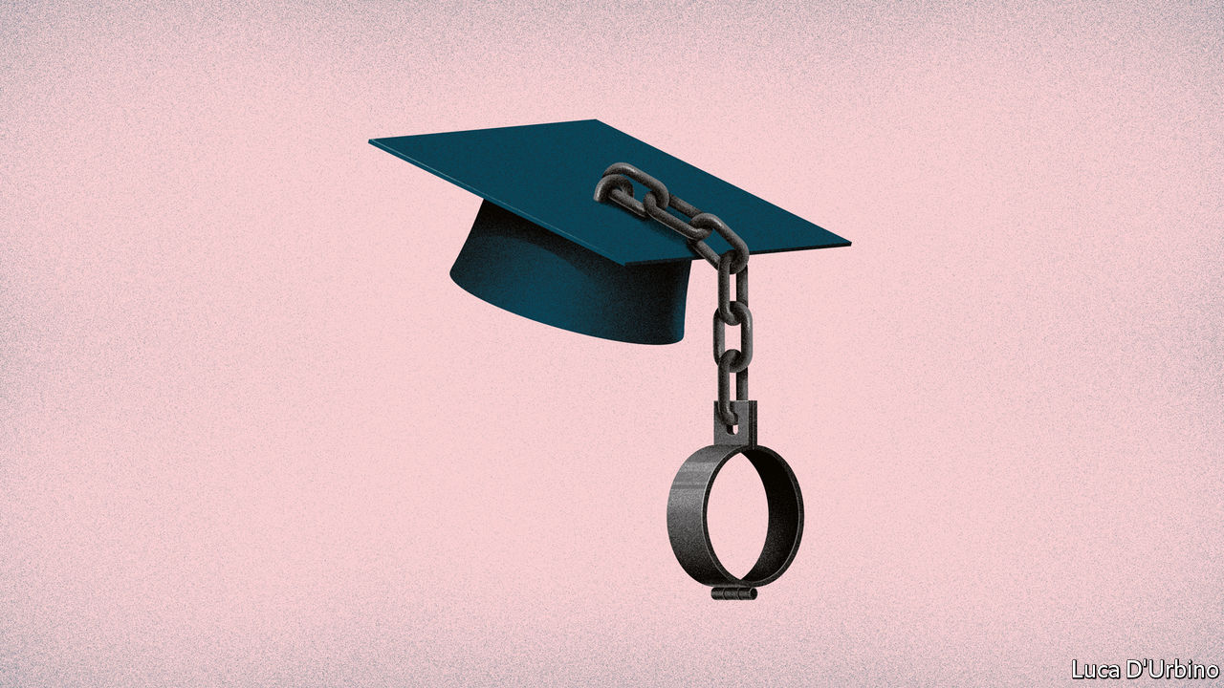

EVERY YEAR, in early December, Jesus College, Cambridge, hosts the Rustat Feast. The tables in hall are lit with candles. There is wine, and music from the college choir. The assembled diners raise a glass to Tobias Rustat, whose generosity three centuries ago allowed generations of orphans to go to Cambridge and be ordained as Church of England clergymen. Then, last November, just before the latest feast, Rustat’s name was quietly dropped from the jollities.

Rustat was a courtier to King Charles II. John Evelyn, a contemporary diarist, described him as “a very simple, ignorant, but honest and loyal creature”. Rustat was also a big investor in the Royal African Company (RAC), which trafficked more African men, women and children to the Americas than any other British institution. According to one historian, in the half-century after it was founded in 1672 the RACshipped close to 150,000 enslaved Africans, mostly to the Caribbean.

When they think of their role in the history of slavery, Britons like to focus on William Wilberforce and his fellow abolitionists rather than on the role of slavery in building the British empire during the previous two centuries. That is changing. Pushed by student activists and inspired by work done, among others, by Brown University, Yale and Georgetown, to uncover the slave-owning beginnings of America’s earliest colleges, in Britain universities are taking the lead. University College London (UCL) has created a database of British slave-owners which has been critical in pushing institutions, in higher education and beyond, to look into how they benefited from slavery and the slave economy.

To persuade MPs to support the Slavery Abolition Act, which was passed in 1833, the government borrowed £20m from Nathan Mayer Rothschild, a banker, and his brother-in-law, Moses Montefiore, to compensate slave-owners for the loss of what was considered their property. The loan accounted for 40% of the Treasury’s annual income in 1834, the year the payments began—or about 5% of Britain’s GDP. It took until 2015 to pay it off. UCL’s database names more than 46,000 slave-owners who got compensation; it can be searched by name, village, county, occupation, religion or number of slaves owned.

Beneficiaries were spread all over the country, but the biggest concentration was in Scotland, whose young men had for decades gone to make their fortunes in the Caribbean. Some had become big landowners or businessmen engaged in shipping, finance and insurance, but many were ordinary middle-class citizens who owned, say, just one or two slaves whom they were happy to rent out for work-gangs on plantations across the Caribbean. Many British slave-owners, among them thousands of widows, were upstanding members of Victorian society; they also championed civic causes, particularly education.

After London, the biggest concentration was in Bristol, Edinburgh, Glasgow and Liverpool, which is one reason why universities in most of those cities have taken the lead in studying their connections with slavery. Bristol, the centre of the Wills tobacco fortune and the site of an elegant but controversial statue of Edward Colston, a wealthy slave trader, has just appointed Britain’s first professor of the history of enslavement, memory and the politics of memorialisation of the past—Olivette Otele, a Cameroonian historian who was trained at the Sorbonne.

Last year Cambridge announced a university-wide study. “History is inescapable,” said Stephen Toope, the vice-chancellor. Dons at three Cambridge colleges are listed in the slave-compensation scheme, but so far only Jesus College—Rustat’s father’s alma mater—has hired researchers to look into its links with slavery. The University of Nottingham is doing a similar study. Aberdeen will soon do the same, and Hull is expected to follow. St Andrews and Edinburgh universities are the rare silent exceptions.

But it was Glasgow, whose former rector, Robert Cunninghame Graham, had once been a slaver, that kicked things off, setting a high bar. After releasing a forensic study in 2018 which showed that 23 donors, whose family fortunes came from slavery or trade in slave-produced goods, had given £11,325 (equivalent to almost £20m today) to the university between 1866 and 1880 to build its new campus in the west of the city, the university turned to the thorny issue of what, if anything, should be done to atone for this bloody largesse. Opinions ranged from nothing at all (“Some historical injustices are just too distant,” wrote Nigel Biggar, director of Oxford University’s “Ethics and Empire” project last year) to a formal apology and paying of widespread reparations to slave descendants.

Glasgow decided on a programme of “reparatory justice” instead of reparations. It teamed up with the University of the West Indies (UWI) to create a new initiative, the Glasgow-Caribbean Centre for Development Research in Kingston, Jamaica. The programme focuses on three areas: research into health care, particularly diabetes, which is endemic to the Caribbean; into the degradation of the environment, especially along the coasts around the islands; and the creation of an online history museum that will be accessible to the whole region. At the suggestion of the UWI, Glasgow has promised to raise £20m—a symbolic figure—for the project over the next two decades. “People like to see their institution doing the right thing,” says the university’s chief operating officer, David Duncan. “This was the right thing to do.”

Glasgow’s approach may indeed be ethical, but it is also self-interested. The university hopes that it will be helpful when it applies for funding for its Caribbean initiative to global bodies, such as the Global Challenges Research Fund and the Bill and Melinda Gates Foundation, which assess applications on a competitive basis. And for an institution whose business is study, studying its past wrongdoings hardly counts as penance. ■

This article was downloaded by calibre from <https://www.economist.com/britain/2020/02/08/british-universities-are-examining-how-they-benefited-from-slavery>

|  |  |  |  |
| --- | --- | --- | --- |
| Previous | Articles | Sections | Next |

|  |  |  |  |
| --- | --- | --- | --- |
| Previous | Articles | Sections | Next |

#### Bagehot

# Cummings v the blob

The prime minister’s special adviser faces a tough adversary

Feb 8th 2020 |

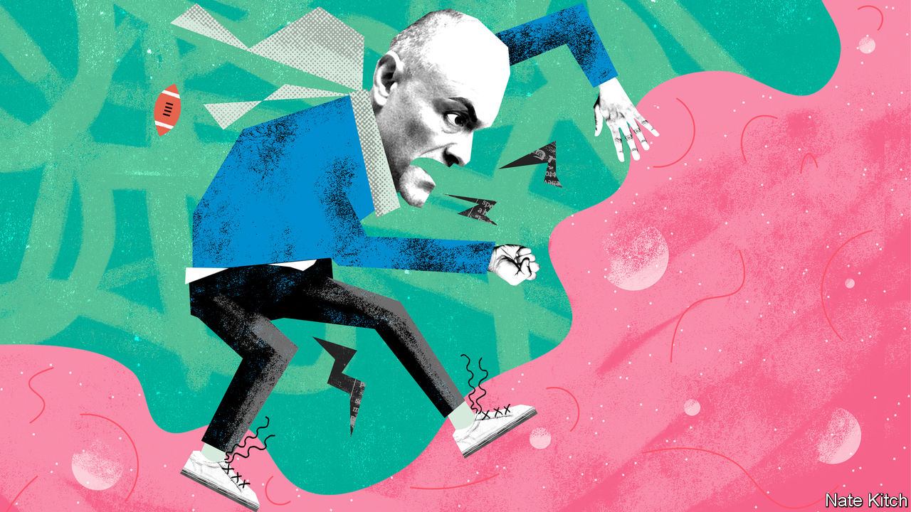

FOR A MAN widely regarded as a cross between Machiavelli and Rasputin, Dominic Cummings has lost a lot of battles lately. The prime minister’s special adviser opposed both Huawei’s involvement in Britain’s 5G networks and the HS2 rail network (which he labelled “a disaster zone”). Boris Johnson has given the green light to the first and is shortly expected to approve the second. Mr Cummings’s plan to cut the size of the cabinet and create a super-department of business has been ditched. So have his schemes to turn Downing Street into a NASA-style mission-control centre and to ship Conservative Party headquarters to the north of the country.

He suffered yet another embarrassment this week when he tried to challenge the prerogatives of the lobby—the collection of political journalists who get special briefings from “Westminster sources”. Mr Cummings has been waging war on the media for some time, for instance by banning ministers from appearing on programmes that he regards as hostile, and he kicked the conflict up a notch on February 3rd, allowing only selected members of the lobby to attend a briefing. The rejects included a disproportionate number of journalists from left-wing publications.

Mr Cummings’s attack on the lobby was as politically inept as it was illiberal. The entire lobby walked out of Downing Street in solidarity and even the Tory-backing Daily Mail wrote an angry editorial. And rightly so: Mr Cummings offended against a basic principle of a free society that the government can’t pick and choose who gets official press briefings. Mr Cummings made his reputation as a campaigner, and campaigners can set whatever rules they like for the press. Government officials need to understand that they are accountable to the public that pays their salaries.

Yet Mr Cummings should not be written off as a spent force or serial bungler. His squabble with journalists is part of a wider war on what he likes to call “the blob”—the BBC, the universities, the quangos, the law courts and the Whitehall machine—whose functionaries slither from one comfortable berth to another regardless of who wins the general election.

Mr Cummings explains his loathing for the blob in his long and entertaining blog. He argues that it is made up of “grotesque incompetents” who managed to lose the EU referendum despite having the resources of the state at their disposal. They think alike; they are more interested in using ideas to signal that they’re respectable members of the in-group than in engaging in constructive argument; they are woefully ignorant of vital forces such as AI that are revolutionising the world. A recent advertisement for “weirdos and misfits” to join him in Downing Street nicely illustrates his thinking. “What SW1 needs,” he argues, dismissing the collective brainpower of the district that includes the country’s politicians and top civil servants, is “true cognitive diversity” rather than “more drivel about ‘identity’ and ‘diversity’ from Oxbridge humanities graduates.”

The term “blob” was originally invented by William Bennett, America’s education secretary in 1985-88, to describe the nexus of officials, teachers and educationalists who always had an argument against what the government wanted to do. Mr Cummings once worked as a special adviser to Michael Gove, then education secretary and subsequently one of the principal forces driving the campaign to leave the EU. Messrs Gove and Cummings happily borrowed it. The two battled furiously for more self-governing academies free from local-authority oversight. They fought the blob—and the blob fought back. David Cameron grew so worried that the government was alienating parents and teachers that he moved Mr Gove sideways and banned Mr Cummings from working in Whitehall, dubbing him a “career psychopath”.

But as the referendum proved, Mr Cummings is closer to the spirit of the modern Conservative Party than is Mr Cameron. The party is never happier than when it is slaying dragons. And now that the trade unions and the Eurocrats are lying prone the blob is a promising adversary. It is full of bureaucrats who have grown fat on restrictive practices and gripped by a woke ideology that started in university campuses but is now spreading to law and business.

Despite Mr Cummings’s recent setbacks, the war against the blob is advancing on several fronts. Take the BBC. The government is holding a public consultation into the case for decriminalising the non-payment of television licences, through which the BBC is funded. Or the senior judiciary. Furious at the Supreme Court’s unanimous decision against Mr Johnson’s proroguing of Parliament last year, some leading Conservatives are thinking of using the opportunity of a constitutional review, announced in the manifesto, to abolish the Supreme Court and return its functions to the House of Lords.

The government is taking on some more unlikely examples of “blobism”. It is increasingly treating the Confederation of British Industry (CBI) as a bosses’ trade union that is more interested in spouting platitudes about corporate social responsibility than embracing disruption. Mr Johnson delivered the organisation a calculated snub this week by not inviting any of its representatives to his big speech on Britain’s future trading relationships.

And Mr Cummings has an even bigger force on his side than the Conservative Party’s instincts—the technological revolution that is reordering the world and that, according to him, most people in SW1 know almost nothing about. It is particularly menacing for the liberal professions that depend on licences and restrictive practices. Can the BBC survive in a world of multi-screens and multichannels? Or can the CBI continue to represent business when companies are being born and destroyed at a furious rate?

The combative Mr Cummings may pick too many fights for his own good. He might get edged out of Downing Street, or just flounce out. But if that happens, the blob should not kid itself that it has won, for it has other, more dangerous enemies. ■

This article was downloaded by calibre from <https://www.economist.com/britain/2020/02/08/cummings-v-the-blob>

|  |  |  |  |
| --- | --- | --- | --- |
| Previous | Articles | Sections | Next |

|  |  |  |
| --- | --- | --- |
| Britain | Sections | Special report |

International

Coronavirus: Run, don’t walk

.

|  |  |  |
| --- | --- | --- |
| Britain | Sections | Special report |

|  |  |  |  |
| --- | --- | --- | --- |
|  | Articles | Sections | Next |

#### Run, don’t walk

# The race to produce a vaccine for the latest coronavirus

Even if scientists are too late for this outbreak, their work will not be wasted

Feb 6th 2020 |



IN RECENT WEEKS searches on Google for “contagion movie” have soared. In the film, a thriller from 2011, a virus spreads rapidly around the world, killing 26m people. The plot follows the frantic efforts of scientists to produce a vaccine. Some 133 days after the first infection, they succeed.

In the real world most recent vaccines have taken years to develop. Some have taken more than a decade. Others, such as a vaccine to stop HIV, the virus that causes AIDS, still elude scientists. But technological innovations and a more streamlined development process could dramatically shrink the time it takes to produce a vaccine against a new pathogen that has the potential to cause an epidemic.

The new coronavirus that emerged in the Chinese city of Wuhan in December presents vaccine-makers with an urgent test. It has so far killed almost 600 people and infected more than 28,000. Scientists in China published the Wuhan virus’s genetic sequence on January 12th, less than a week after they isolated the bug from a patient suffering from a mysterious respiratory infection. By late January, several groups around the world had started work on a vaccine using these genetic data. The first clinical tests on humans, for safety, could begin as early as April. With luck, a vaccine could be ready within a year. Next week the World Health Organisation (WHO) will convene a global meeting to set a research agenda. It will agree on rules, or protocols, for trials and work out which medical advances should be priorities.

People have rushed to make new vaccines before. The west African Ebola outbreak of 2013-16 tested the world in many ways, but particularly in the need to speed up the delivery of new treatments. Organisations and institutions that normally work slowly, and at arm’s length, came together to get the job done faster. Drug regulators from America and Europe, pharmaceutical firms, charities, experts and the WHO all worked closely to advance the trials and technologies needed. They succeeded. An outbreak of Ebola in 2018 in the Democratic Republic of Congo, which now appears to be on the wane, has been contained largely as a result of the wide availability of a vaccine. This process of scientific acceleration is under way again, this time “on steroids”, says Seth Berkley, the boss of GAVI, a vaccine-finance agency.

Even if a vaccine were ready within a year, it would be too late to stem the current epidemic in China. But it could help other countries. Fears are growing that the Wuhan virus will spread more widely and become an established seasonal disease around the world, like the common flu. China’s extraordinary efforts to contain the virus, including quarantining over 50m people, may stave off epidemics in other countries until next winter. It is too soon to tell how deadly the Wuhan virus is. But if it is at least as bad as seasonal flu, a vaccine for those most at risk will be vital. In 2017-18 more than 800,000 people were hospitalised and about 60,000 died in America alone as a result of influenza.

The rush to develop a vaccine against the Wuhan virus has been led by the Coalition for Epidemic Preparedness Innovation (CEPI), a group set up in 2017 in the wake of the west African Ebola outbreak. CEPI’s purpose is to forearm the world against future outbreaks of disease, without knowing what those diseases will be. Its aim is to have a vaccine against a previously unknown pathogen ready to test in humans within 16 weeks of its identification. To that end, some of the university research centres and biotechnology firms that it has funded have been working on “plug-and-play” vaccine design and manufacturing technologies that can be used for a number of pathogens. This allows the genetic sequence of a particular pathogen to be slotted into an existing molecular platform that forms the basis of the vaccine.

In the past, laboratory work on a vaccine required stocks of the actual virus. It would be treated to make it harmless but still able to tickle the immune system into producing antibodies—proteins that fight off the wild virus if it attacks. Working with a deadly virus is tricky, naturally. It requires special containment facilities and exhaustive procedures to prevent it from escaping or infecting scientists.

Gene sequencing has made this process quicker, safer and easier. Researchers can build synthetic versions of parts of viruses to work on vaccines without needing complete samples of the pathogens.

Scientists have produced vaccines against other viruses, including Zika, Ebola and two other coronaviruses—SARS (Severe Acute Respiratory Syndrome) and MERS (Middle East Respiratory Syndrome)—using such technology. The vaccine research on these two cousins of the Wuhan virus has come in handy in recent weeks.

## Going viral

Once a vaccine has been developed in a laboratory, it is sent to a factory where it is turned into a sterile vaccine mix. This is then put into vials and tested to ensure it is not contaminated before clinical trials in humans can be carried out. Many of these tests are done in petri-dishes; the process takes several months. Genetic sequencing can do the job much faster. By sequencing the DNA of everything in a vial of vaccine and examining the result, scientists can spot traces of viruses that should not be present. Vaccine research groups in Britain are in talks with the country’s medicines regulator about an approval process for such alternative testing methods.

The development of a vaccine can be speeded up if bottlenecks in the process are eliminated, says Sarah Gilbert. She leads a group at Oxford University which is working on a vaccine against the Wuhan virus. Her group has developed a template for vaccines that can be adapted quickly for new pathogens. The researchers can make the first small quantities of a new vaccine in just six to eight weeks. In the past the process would have taken up to a year. The other groups trying to come up with a vaccine for the Wuhan virus are using similar methods involving templates that have already been proven to work.

Faster regulatory approval can also speed vaccines through clinical trials. Even as it started making the vaccine, Dr Gilbert’s group began putting together an application for clinical trials for it. The group plans to apply for an expedited ethical and regulatory review, which can be granted within days as it was for clinical trials of the Ebola vaccine conducted in Britain in 2014. Normally, the process takes about three months, says Dr Gilbert.

Even if a vaccine is developed and approved, the rapid rise in cases of the Wuhan virus in China and its spread to other countries has created a new urgency: planning ahead for ways to make massive quantities of a vaccine quickly. There are not many factories that can mass-produce vaccines, so new vaccines often wait in a long queue. Aware of this problem, the American government has built dedicated manufacturing facilities that can produce vaccines rapidly for emergencies. Britain is doing something similar.

When CEPI was planning its work, those involved were thinking about epidemics (outbreaks limited to one country), not pandemics (global epidemics), explains Richard Hatchett, the head of the group. Last week CEPI put out a call for vaccine candidates for the Wuhan virus that can be manufactured on a large scale with existing capacity. On February 3rd it brought on board as a partner GSK, a big drug firm, which has agreed to lend its highly effective adjuvant to a new vaccine. An adjuvant is a special ingredient that makes vaccines more efficient by boosting the immune response—which means that fewer doses of the vaccine or a lower concentration of its core ingredient is needed for vaccination.



Even if a vaccine can be produced in sufficient quantities, getting it to the people who need it, regardless of where they live, can still be a problem. In theory, a vaccine for the Wuhan virus would go to those most at risk, such as health workers, the elderly and those with conditions that appear to make the virus more lethal, such as patients with immune deficiencies. The problem is that politics often intervenes during a pandemic, and governments that are the home to vaccine-making facilities can requisition some of it for their own use, citing national defence or security.

This is a problem Mr Hatchett knows all too well; he worked at the White House on medical preparedness during a flu pandemic in 2009. The outbreak had a very low mortality rate, but exporting any vaccine before it was available to American citizens quickly became a vexed issue. Mr Hatchett is working with the WHO to try to ensure that the Wuhan virus vaccine is made at a number of different sites around the world including ones in small countries which would quickly be able to meet the needs of their entire populations.

## A jab in the dark

The issues surrounding any potential vaccine make questions about medicines to treat those who have become gravely ill particularly acute. Licensed medicines to treat coronaviruses do not currently exist, but experimental drugs are in development, with some early data on their use. One that has been highlighted as promising is called remdesivir, which is made by Gilead, a drug firm. Two randomised controlled trials will start enrolling patients in mid-February. Remdesivir was developed to treat Ebola but in laboratory tests has been shown to be effective against a range of viruses. A combination of two drugs usually used in HIV treatment also looks promising and is already being tried on patients, says Vasee Moorthy who helps set research and development priorities at the WHO during epidemics.

Randomised controlled trials—in which some people are given the drug being tested and some are given a placebo—are the gold standard of scientific evidence. These will probably go ahead in the coming weeks when it is clear which drugs seem most promising. Trials with hospitalised patients will probably involve a placebo arm. Everyone in the trial would receive intensive care but some would also be given the drug being tested. This is because no one yet knows whether the new drugs, which may have side effects, do more harm than good. The most gravely ill patients may also be allowed to try untested drugs.

Only so much preparation is ever possible in advance of a new disease. A drug or vaccine’s efficacy can only be tested during an outbreak. The urgency behind the search for treatments for the Wuhan virus is understandable. Such efforts were effective in the case of Ebola. People are willing to rush vaccines and drugs into use for a disease with a fatality rate around 70%, as Ebola’s was. The calculus is different for one that kills 2% (or less) of those infected. Should hasty decisions lead to products that are not completely safe, people’s faith in vaccines could be damaged. If so, the harm done to the world’s health could rival the worst feared of the Wuhan virus. ■

This article was downloaded by calibre from <https://www.economist.com/international/2020/02/06/the-race-to-produce-a-vaccine-for-the-latest-coronavirus>

|  |  |  |  |
| --- | --- | --- | --- |
|  | Articles | Sections | Next |

|  |  |  |
| --- | --- | --- |
| International | Sections | Business |

Special report

China’s Belt and Road: Return to centre

.

The belt: Tighten up a notch

.

The road: A long game

.

Of belts and roads: What’s in a name?

.

The digital Silk Road: The future stage

.

The future: Wanted: new maps

.

|  |  |  |
| --- | --- | --- |
| International | Sections | Business |

|  |  |  |  |
| --- | --- | --- | --- |
|  | Articles | Sections | Next |

#### China’s Belt and Road

# China’s flagship foreign policy aims to put itself at the centre of the world once again

The Belt and Road Initiative revives memories of China’s imperial tributary system, says Dominic Ziegler

Feb 8th 2020 |

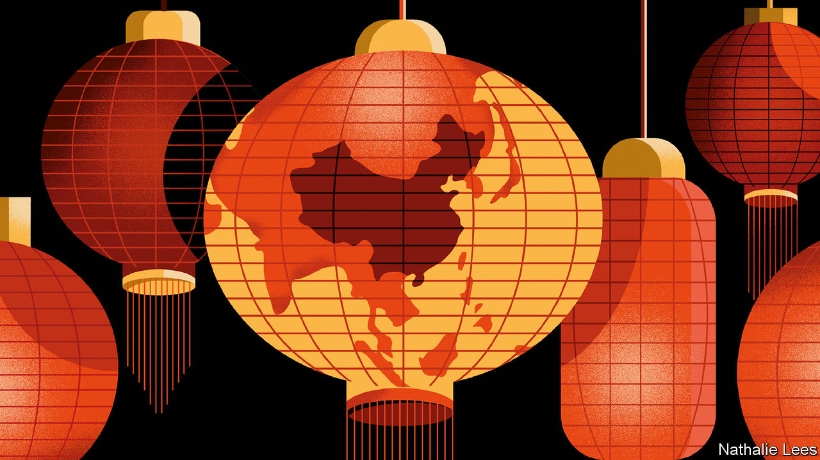

ON CHINA’S BORDER with Kazakhstan, a new Silk Road city has sprung up with such speed that Google Earth has scarcely begun to record the high-rises that now float on a winter mist above the steppe. What once would have been flattered to be called a hard-scrabble border town is now home to 200,000 people, giant outdoor video screens extolling the glories of a new Silk Road, and restaurants serving sashimi and European wine. Khorgos has become China’s gateway to Central Asia, and all the way to Europe.

A twin town is going up in Kazakhstan. A duty-free mall already straddles the border for Kazakhstanis to get deals on booze, perfume and cut-price Chinese goods. But the key features, just across the border, are the giant gantry cranes more usually seen in the world’s ports. The Khorgos Gateway is a container terminal, a “dry port” built from scratch in 2014. The transport hub is intended as a critical link in what China’s president, Xi Jinping, has called the “Eurasian land bridge”. Among its investors is China’s COSCO, one of the world’s shipping giants. It is run by DP World, Dubai’s port operator. Last year the dry port handled 160,000 TEUs (a unit equivalent to a 20-foot container). Hicham Belmaachi, its Moroccan manager, expects that to rise to 400,000 in 2025.

Khorgos is in the middle of nowhere: Eurasia’s pole of inaccessibility, the point on Earth farthest from any ocean, lies not far away. Now, beyond it, a vast new Eurasian supercontinent is forming. The promise is not just of railways through Central Asia to Europe but of gargantuan plans—some already realised—for pipelines, roads, high-speed rail and fibre-optic cables.

It is reshaping the geography of the Earth’s biggest land mass. In this new space, the obstacles of the recent past—the Iron Curtain, China locked in its Mao-made autarky, even the physical impediments of the Himalayas, the Inner Asian deserts and the melting Arctic itself—are of diminishing consequence. The physical and psychological distance between Europe and East Asia is shrinking as the sparsely populated expanse at the heart of Eurasia is being wrangled, through new infrastructure, to manageable size. That, at least, is how Chinese planners see it. And, taking the historical view, if there is a surprise, it is that the transformation is not being made in the West’s image or according to its rules. Asia is coming to Europe, not the other way around.

The Silk Road’s renaissance has been turbocharged as part of a Chinese expansion that has come to be known as the Belt and Road Initiative (BRI). The BRI is China’s signature, indeed all-encompassing, foreign policy—the “project of the century”, as Mr Xi calls it. But what exactly is it? Is it mostly aid or trade? Is it a Chinese Marshall Plan? Does it have real substance or is it just a branding exercise for China’s international rise? And why is the land part called a belt, and the sea part called a road?

The Communist Party is using the BRI to reshape a world order more to its liking

The World Bank has an elemental definition of the BRI: “a China-led effort to improve connectivity and regional co-operation on a trans-continental scale through large-scale investments”. That is a good summary as far as it goes, and helping poor countries build infrastructure is an important component. The global need for new infrastructure is immense. The Asian Development Bank (ADB) estimates that Asia alone needs to invest $26trn between 2016 and 2030, or $1.7trn a year, if it is to maintain economic growth, eradicate poverty and respond to climate change.

But this special report will argue that, above all, the Chinese Communist Party is using the BRI to reshape a world order more to its liking. The focus is economic engagement and clever diplomacy. Leaders in Beijing ink BRI projects with countries for strategic or political reasons. Often, these are hidden by the sheer commercial anarchy that the BRI has engendered. (For those puzzled as to whether the BRI is a top-down, dirigiste initiative or a bottom-up frenzy, the answer is both.) Yet for China’s leaders, it represents a prototype for an emerging geopolitical bloc at a time when the rules-based order is under shaky American management.

The notion of a new order, baldly stated, might alarm. So a more benign idea puts the BRI in a broader historical context: the tributary system of old. China sits at the centre of the world, bringing its wealth and power to bear, first on its near-abroad, and linking people into the concept of China as a beneficent power and an alternative locus to the West. Those who buy into it receive munificence from Beijing. Those who do not will not. It is a way to help knit together continents through improved infrastructure and a catch-all phrase to make anything China does abroad look unthreatening. Crucially, it is Mr Xi’s own baby: as much a political project to reflect well on the emperor as an economic one. One if by land, two if by Xi

## One if by land, two if by Xi

Mr Xi launched the initiative in two speeches in 2013. The first—in Astana (now Nursultan), the capital of Kazakhstan—presented the policy’s overland component, the “Silk Road economic belt”. It links China to Central, South-East and South Asia, and on to Europe. The word “belt” has that curious name to imply something more than mere transport, energy or other nodes. Rather, an interconnected network of infrastructure would grow into something thicker: industrial zones and economic corridors with manufacturing, logistics, construction and more.

Soon after, Mr Xi presented the maritime component in the Indonesian capital, Jakarta. A “21st century maritime Silk Road”, a network of port cities in the South China Sea, the Indian Ocean and the Mediterranean would tie China closer by sea to these regions. Mr Xi has unveiled further dimensions to the plan: a “polar Silk Road” to develop Arctic shipping routes; a “digital Silk Road” of undersea cables, 5G telecoms and cloud computing; and even a “space information corridor” to open up satellite- and space-launch capabilities.

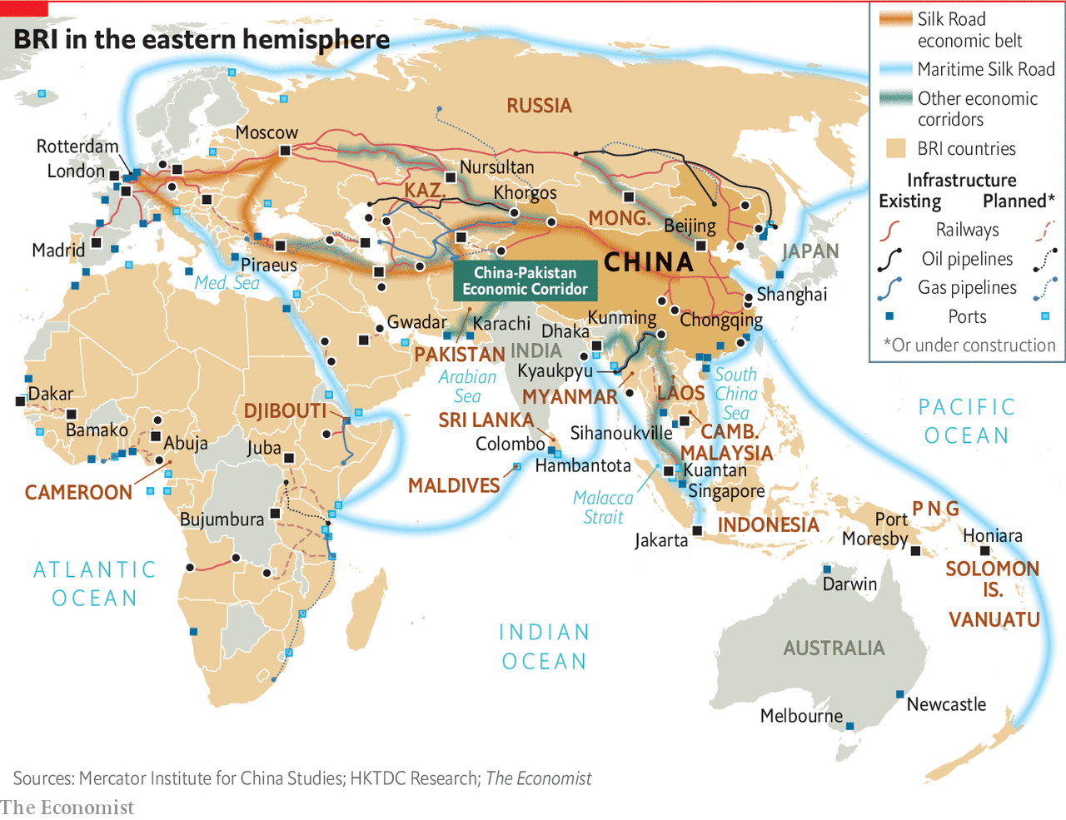

The debates about the BRI began from the outset. At one level, it merely extended a trajectory China had followed for some time, meshing with its major resource suppliers worldwide, as well as its European markets. At another, it was a response to the global financial crisis of 2007-9, which removed a large source of demand for Chinese goods. The lesson was that in future China had to make its own markets abroad. At a third level, it represented an internationalisation of Chinese industrial policy. Faced with overcapacity in steel, cement and more, a party-state whose legitimacy hangs on creating jobs and investment could hardly shut down capacity, as Western countries might do. Instead it must try to export it. Lastly, at a time when the West appeared to be stumbling, both in terms of growth and global leadership, here was a bend in the historical road. Everything was contingent, but China’s moment had come and needed to be seized—more Leninist opportunism than Marxist determinism.

The BRI is about all these things and more. Mr Xi calls it a decades-long project, while some estimates put spending on schemes both built and intended at $6trn. But sift through deals actually built or signed for, and the initiative is far smaller than some of the wilder figures imply. Yet it is so broad and amorphous it is meaningless to say you are for or against it. Any investment that China undertakes abroad can be, and is, lumped into it.

Even inside China, where the party ensures unstinting praise for the BRI, a surprising vagueness reigns. No authoritative figure is published for what is invested where. The best guess is that $400bn of financing, in grants but especially in loans, has been or is about to be spent in more than 160 countries with three-fifths of the world’s population. In real terms, that dwarfs the Marshall Plan ($130bn in today’s money) that America advanced to revive Europe’s war-ravaged economies.

But the economic benefits of projects often fall short of the claims made. A vast, bottom-up push to sell the BRI brand and pay lip-service to Mr Xi has produced hare-brained and duplicate schemes. Many provincial enterprises “going out” for the first time had no experience of operating abroad. At the first BRI Forum in Beijing in 2017, convened to spread awe and wonder at China’s generosity, there was already disorder under heaven. By the time of the second, last April, more disciplined guidelines were published about lending, the environment and more.

Projects may fall short economically for another reason: their priority is strategic, above all, securing critical supplies of natural resources, to drive economic growth at home. Shanghai now gets half its natural gas from Turkmenistan. Such pipelines neatly get around the “Malacca Strait dilemma”: seaborne supplies of oil and gas that could easily be choked off in time of war.

Elsewhere, strategic benefits might come from developing ports and cementing dominance in the global shipping industry. They could be stepping stones to China one day projecting naval power far from home—with big implications for Japan, South-East Asia, India and other countries that depend on the world’s busiest sea lanes. By rolling out infrastructure across the Eurasian land mass, China becomes the indispensable power in an emerging supercontinent. Crucially, the state directs giant enterprises to do the national bidding, and state banking institutions to provide the financial firepower.

From a Communist Party perspective, cultivating political relationships, and what the party likes to call “people-to-people” ties, bends the world, bit by bit, to China’s will. As Bruno Maçães, a former Portuguese foreign minister, puts it in “The Dawn of Eurasia”, the spillover effects from infrastructure, trade and finance into politics, culture and security are not “a bug in the project”, but its most fundamental feature.

Above all, the BRI is the world’s greatest branding exercise. A foreign country or leader usually signs up to the brand in the form of a vague memorandum of understanding lauding “win-win co-operation”. After that, it is very hard to be disloyal. Praise the plan and you will be rewarded. Criticise it, and not only have you offended China. You have offended the cosmos, or at least the “Silk Road spirit” of “peace and co-operation, openness and inclusiveness, mutual learning and mutual benefit.” This branding, with sanctions, is powerful and it works. Foreign loyalty, in turn, reinforces the brand for a domestic Chinese audience: look what a peaceable, open and future-facing country China is, ready to join in endeavours for mutual benefit.

Not everyone buys it. The harshest criticism comes from the incumbent superpower, whose global dominance the project is challenging. America’s National Security Strategy claims that the BRI is “predatory economics”; to borrow money from China is to fall into a well-laid trap. In December Adam Boehler, the head of the new US International Development Finance Corporation, told the Financial Times that China’s overseas investments were “100%” like a house of cards, because of heavy debts, badly built infrastructure, corruption and lack of transparency.

That is an overstatement. Certainly, China applies dodgier lending criteria than do members of the Paris Club of major sovereign lenders. Yet there is no nefarious master plan. Indeed, that is part of the problem. Nearly every major project meets bumps along the way. Out of sight, deals often get renegotiated, with lower interest rates and longer grace periods and repayment terms.

China knows flexibility serves its image best. It offers development money and diplomatic support not available elsewhere. If there is to be an American-led pushback, it must work by attraction, too, by offering developing countries better options than China does. The new connectivity must work well for client states.

## Laptops via Central Asia

In January 2017 a train quietly pulled into the sidings on the outskirts of London. Its containers had started their journey just 12 days earlier in eastern China, less than half the time than had they gone by sea, at less than half the cost by air, travelling through Khorgos. The route is rapidly becoming more popular. HP, an American computer giant, has moved its computer factories to the inland Chinese city of Chongqing, building its business model on rail delivery via Khorgos to the Netherlands.

In part because of HP’s move, trains from China to Europe have risen from three a week in 2013 to over 25. An industrial zone and distribution centre is being built in Khorgos with $600m of investment from the provincial government of Jiangsu province 3,700km to the east. The hope is to attract businesses that serve the through-trade—packaging and putting price tags on retail products, for instance—and light manufacturing migrating from higher-cost China. Coming the other way, BMW sends several trains a week to China, its biggest market. Yet, for all this new connectivity, much still can, and does, go wrong. ■

This article was downloaded by calibre from <https://www.economist.com/special-report/2020/02/08/chinas-flagship-foreign-policy-aims-to-put-itself-at-the-centre-of-the-world-once-again>

|  |  |  |  |
| --- | --- | --- | --- |
|  | Articles | Sections | Next |

|  |  |  |  |
| --- | --- | --- | --- |
| Previous | Articles | Sections | Next |

#### The belt

# Chinese investment in Eurasia is not always smooth

Problems with investments under the Belt and Road Initiative show some of China’s weaknesses abroad

Feb 8th 2020 |

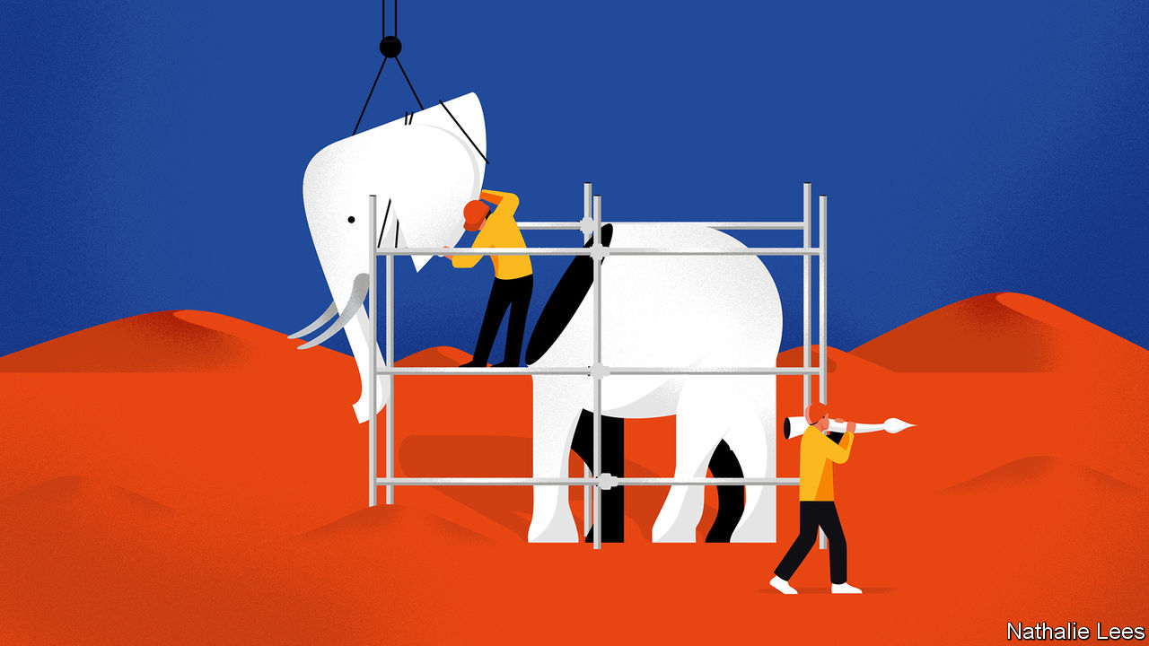

IF ANYWHERE ALONG the belt and road should be benefiting from Chinese largesse, it is Pakistan. The country counts as China’s only real ally, as a partner on China’s vulnerable western flank and a balancer against India. China gave Pakistani scientists the know-how and materials to build a nuclear bomb. A joint-venture slogan factory had long churned out declarations of a friendship “higher than the Himalayas”. So, although financing for BRI projects everywhere has slowed over the past year (see chart), Pakistan seems like a place where it should naturally have taken hold.

Yet, in Karachi’s expo centre, staff from 120 Chinese firms are having little success as they stand, brochures and electronic translation devices in hand, touting everything from hoses to pumps to window frames. Alex Hou, from a firm in Zhejiang province that sells PVC film to factories, says Pakistani officials could have done a lot more to promote the event. More broadly, Pakistan is a lesson in how China can fumble the politics of its prime foreign policy.

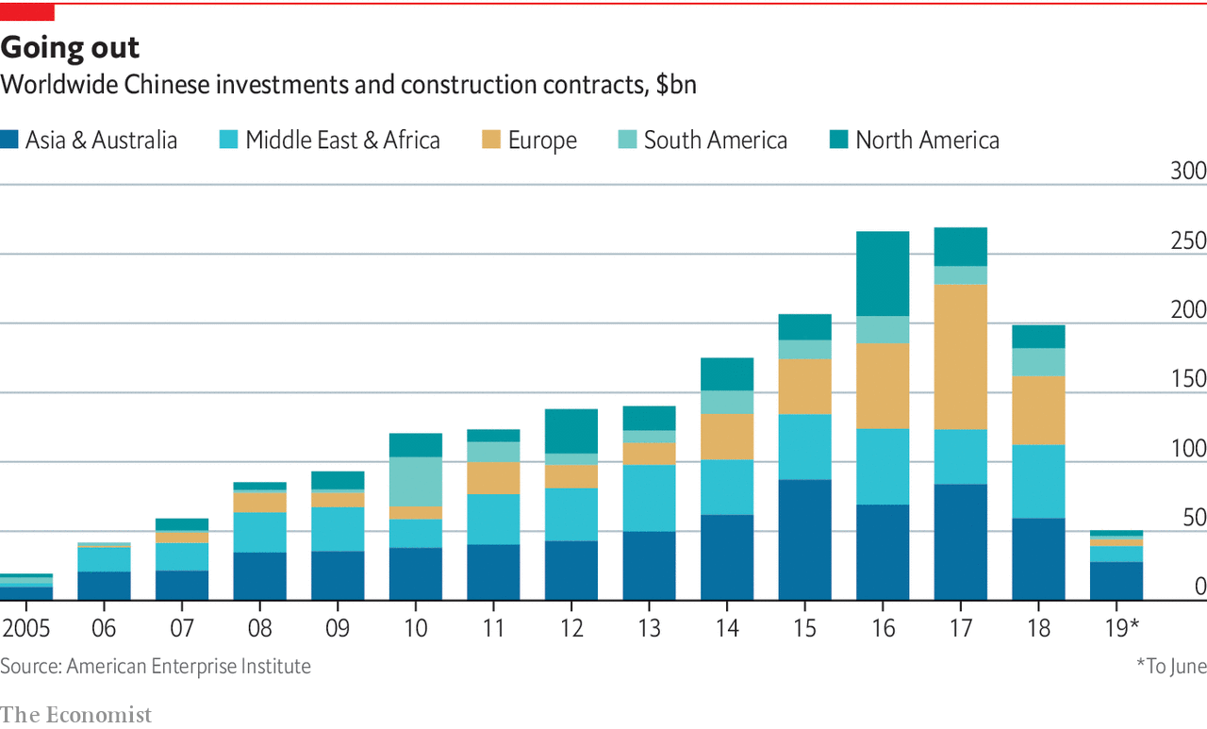

When the initiative emerged in 2013 it needed a signature project. The answer was the China-Pakistan Economic Corridor (CPEC)—what China’s prime minister, Li Keqiang, called a transformative economic programme that “could wean the populace from fundamentalism”.

The timing seemed fortuitous. In 2013 a civilian government came to power with a yen for big infrastructure projects and a promise to fix Pakistan’s notorious electricity blackouts. The price tag attached to CPEC grew from $46bn to over $60bn. Plans were drawn up for power plants, roads, railways and the development of a port at Gwadar, a fleapit on the Arabian Sea, that would, as the Pakistani planning minister boasted, “benchmark” Singapore.

Yet as China was helping lay the ground for a boom in Pakistan, it failed to lay the political ground in the region. India in particular was touchy. (It still has not joined the BRI.) Meanwhile, all the talk of a new “corridor” brought opposition from hawks in Washington, DC. Since 2017, the administration of President Donald Trump has developed a pointed narrative: CPEC, it says, is driven above all by China’s long-term strategic objective to link its far western regions to the Arabian Sea, so as to have new energy routes and to project power into the western Indian Ocean. The scheme, the Americans say, will leave Pakistan in debt, littered with white elephants, internally divided and under Chinese sway.

The Chinese government also misread Pakistan’s internal politics, as Imran Khan and his Pakistan Tehreek-e-Insaf (PTI) swept to power having campaigned against corruption, including that in CPEC projects. Soon, the inexperienced PTI faced a full-blown balance-of-payments crisis to which the CPEC frenzy had contributed by pumping up domestic demand, pushing up the value of the currency and sucking in imports. In 2018 the bubble burst, the Pakistani rupee slid and the economy slowed sharply. Mr Khan, cap in hand, garnered help from China with conditions attached.

In truth, CPEC was always a corridor only in name, says Andrew Small of the German Marshall Fund of the United States, a Washington think-tank. Pumping oil or gas over high-altitude passes would cost too much and was never seriously considered. And Gwadar port has future strategic value to China regardless of the hinterland behind it. Rather, CPEC can better be understood as an investment package of roads, rail and power plants, some of which were useful but much of which will never come to pass.

Too much is at stake for China to abandon CPEC. But ambitions have been pared right back. Only already agreed projects are likely to proceed, notably an $8bn railway from Karachi to Peshawar that the government can ill afford. The all-weather friendship will carry on, but where CPEC promised to take it to new heights, it has merely defined its limitations.

## All joined up

South-East Asia has long been important to China’s economy—not least because of its 30m “overseas Chinese”, many with capital and management nous. In electronics and other sectors, the ten-country Association of South-East Asian Nations (ASEAN) is enmeshed in China-centred supply chains. Three-fifths of China’s computer imports come from the region, along with a third of its integrated circuits. In the 12 years to 2017, Chinese investment in South-East Asia grew almost 30-fold, to nearly $40bn.

Historically China’s intercourse with South-East Asia has been by sea. That, now, is changing. In recent years China’s industrial centre of gravity has shifted away from the coast towards the south-west, centred around Chongqing and Kunming, capital of Yunnan province. A priority of China’s belt is to improve cross-border transport. It squares with ASEAN’s desire for regional integration. As elsewhere, the soft infrastructure lags the hard, particularly at borders. Hence a new body called the Chongqing Connectivity Initiative, set up with Singapore, to seek a single electronic platform for speeding up customs clearance.

Most ASEAN states have long viewed their big northern neighbour with wary caution

Yet China’s growing presence in South-East Asia comes at a price. Its grand projects, such as the high-speed railway under construction from Kunming to Singapore, and hydroelectric schemes along the Mekong river for exporting power, are of enormous importance to the leadership in Beijing. But an obsession with corridors does not always mesh with the interests of those who live along them. In tiny Laos, many villagers have been displaced by the railway and dams that bring little benefit to them.

And, though they rarely say so in public, most ASEAN states have long viewed their big northern neighbour with wary caution. By contrast, Cambodia, under its long-serving strongman, Hun Sen, opened the door to China. In return for goodies, it has proved a staunch ally, frustrating ASEAN’s efforts to resist China’s assertive maritime claims in the South China Sea.

The impact on Cambodia of Chinese involvement has been immense and baneful. Dam-building threatens the once-abundant fish stocks of the Tonle Sap, Cambodia’s giant, seasonably expanding lake on which 1m fishermen’s livelihoods depend. The haunting ruins of Angkor Wat now have the feel of a Chinese theme park. Chinese land grabs for forestry concessions are threatening biodiversity. Corruption and Chinese development in the capital, Phnom Penh, go hand in hand. Chinese plans will up Cambodia’s carbon emissions by a tenth. And Cambodia’s (dollar-based) economy helps to get cash out of China: of its ten airlines, most are Chinese-owned and several reckoned to be laundering fronts.

How this all plays out in Cambodia can be seen in the seaside town of Sihanoukville. It was once a sleepy, beach-flanked city beloved of holidaying Cambodian families and Western backpackers. Then the Chinese came. In 2015 Hun Sen’s government designated the city as one of Cambodia’s flagship BRI projects. Gambling for foreigners (though not Cambodians) was legalised in Sihanoukville, both online and in new casinos. Firms from China were welcomed. Some 80,000 Chinese—construction workers, investors, casino operators and tourists—arrived.

More buildings are in a state of hasty construction than are completed—last year a high-rise collapsed, killing 28 workers. The city’s drains cannot cope. Maggie Eno, who runs the M’Lop Tapang school for street children, shows how monsoon floods turned the ground floor and playground into seas of raw sewage. Brothels operate out of plyboard shanties on construction sites. Thugs murder rivals in gangland killings, dumping victims’ bodies out of cars in the middle of town. And Sihanoukville’s beaches are piled high with plastic detritus from the Chinese invasion.

Perhaps the worst is over. Last year the Cambodian government, reacting to the chaos at last, banned most gambling. In one of the town’s casinos recently, a Chinese construction foreman said he was having one last fling before heading home. The bubble has burst. But it will be many years before the city recovers. ■

This article was downloaded by calibre from <https://www.economist.com/special-report/2020/02/08/chinese-investment-in-eurasia-is-not-always-smooth>

|  |  |  |  |
| --- | --- | --- | --- |
| Previous | Articles | Sections | Next |

|  |  |  |  |
| --- | --- | --- | --- |
| Previous | Articles | Sections | Next |

#### The road

# China is making substantial investment in ports and pipelines worldwide

Many are worried they could be used for military or other strategic purposes

Feb 8th 2020 |

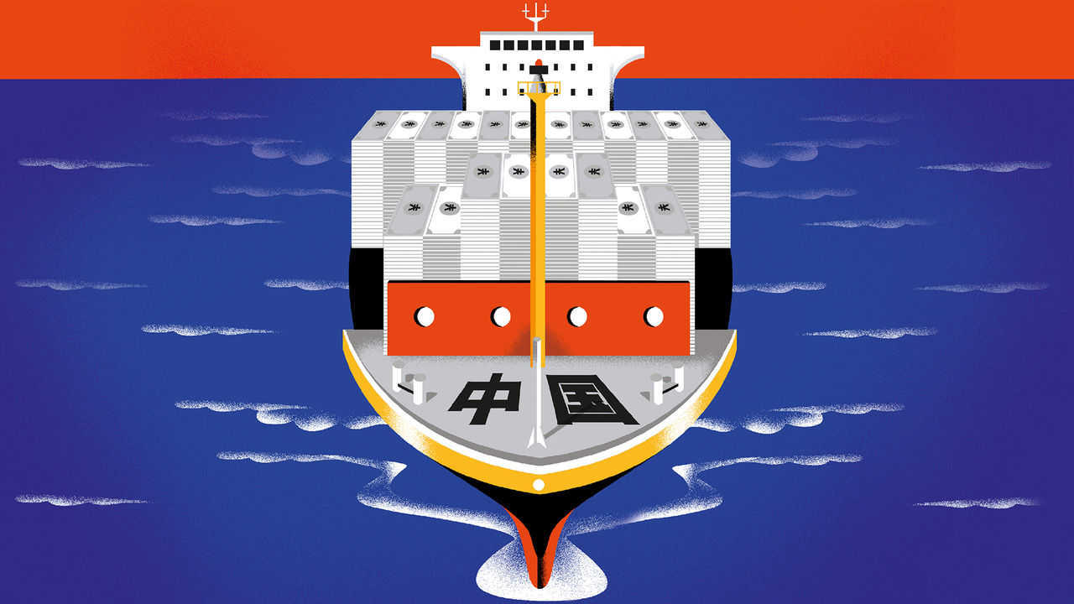

NO CHINESE REFERENCE to the maritime Silk Road is complete without mention of the voyages of Zheng He. The eunuch admiral, a Muslim at the Ming court, led seven voyages in the early 15th century in a fleet of vast sailing barges known as “treasure ships”. The official narrative is that he went abroad to spread peace, carrying treasures for the potentates he would meet from South-East Asia to east Africa. Back came fabulous curiosities, including a giraffe, which he fashioned as tribute to the emperor. The peaceful nature of Zheng’s trips is greatly embellished—the fleet was well armed and got into scuffles. But few tales better show the mix of hard power and emoluments that embodied imperial China’s tributary relations with others. Barbarians were worthy of engagement if they accepted China’s cultural and military superiority and moved into China’s orbit.

The idea of emissaries bringing peace lingers on in schematic maps of the 21st-century maritime Silk Road. What jumps out is how vague and imprecise are these doodles of desire. The routes themselves chart sinuous curves. The waypoints speak more to exotic places from the old spice trade than to where concrete is being poured (no mention of a military base in Djibouti, for instance). The lines copied out in the Pentagon, by contrast, are harder and firmer. American strategists believe China is sending out modern treasure fleets laden with goodies, such as offers to build ports, that will pave the way for deploying warships in future.

China downplays such notions. Yet it is rarely easy for observers to separate the commercial from the strategic along the maritime road. Nearly everything, potentially, can be used to make money and project power.

The road starts by coursing innocently through the South China Sea. Already the paradox is glaring. This is a seat of heightened geopolitical contest on account of disputes among littoral states over maritime claims in the sea—none more hyberbolic than China’s. It is aggressively asserting its claims (and disregarding others’), through a large naval, coastguard and fishing-fleet presence, as well as huge terraforming around reefs and rocks to create runways, quays and military bases.

The approach is at odds with protestations of peace and mutual co-operation embodied in the BRI. But the contradiction is resolved if you consider that by enmeshing neighbours in ports and other projects, and by increasingly dominating the sea lanes with Chinese vessels, China hopes to settle the matter of sovereignty by giving neighbours little choice but to be drawn into its embrace.

So far, most Chinese investment has gone into commercial ports. The maritime push is being led by a handful of giant state enterprises with close links to the Communist Party’s leaders. China Communications Construction Company (CCCC) is the biggest company on the belt and road. COSCO, a shipping behemoth, is the world’s third-biggest container line and has investments in 61 port terminals around the world. China Merchants, founded as a patriotic enterprise in 1872 to attract Chinese capital to take on Western shipping lines, manages 36 ports in 18 countries. Since 2010 well over $20bn of Chinese money has been poured into foreign ports.

One dimension is the “port-park-city” concept: a port is more likely to thrive with a hinterland in the form of industrial zones and a growing city. Following the model are Kuantan on peninsular Malaysia’s east coast and Gwadar in Pakistan on the Arabian Sea. In both places, Chinese-built industrial parks are going up close to new port development, with plans for urban expansion. In Colombo in Sri Lanka, next to the busy container port, controlled by China Merchants, CCCC has won 269 hectares from the sea to extend the business district and build glitzy flats. It is not clear whether such projects are intended more for property speculation by rich locals and Chinese keen to park money abroad, or organic evolutions of an existing city’s fabric. The domestic reception often hangs on the answer.

Another plan is for major ports to serve as regional hubs at which the biggest container ships can dock; their cargoes are then unloaded and despatched on smaller vessels serving other regional ports. Colombo is one example. Sri Lanka sits at the crossroads of major shipping lanes in the Indian Ocean, and Colombo is one of the world’s busiest—and most profitable—container ports.

The most notable success of a hub port is COSCO’s involvement in Piraeus, Athens’s ancient harbour. China arrived when the financial crisis of 2008 had brought Greece to its knees. COSCO took a long lease on two terminals of the container port with a promise to build a third. Soon, the contrast in productivity between those and the remaining Greek-run one, plagued by inefficiency and powerful unions, was stark. The left-wing government of the day had refused the sale of that pier. But in 2016, needing funds demanded by the EU in return for a third bailout, it offered COSCO control of the whole port. COSCO has invested $5bn, with more promised for everything from a ship-repair business to turning warehouses into hotels for cruise passengers.

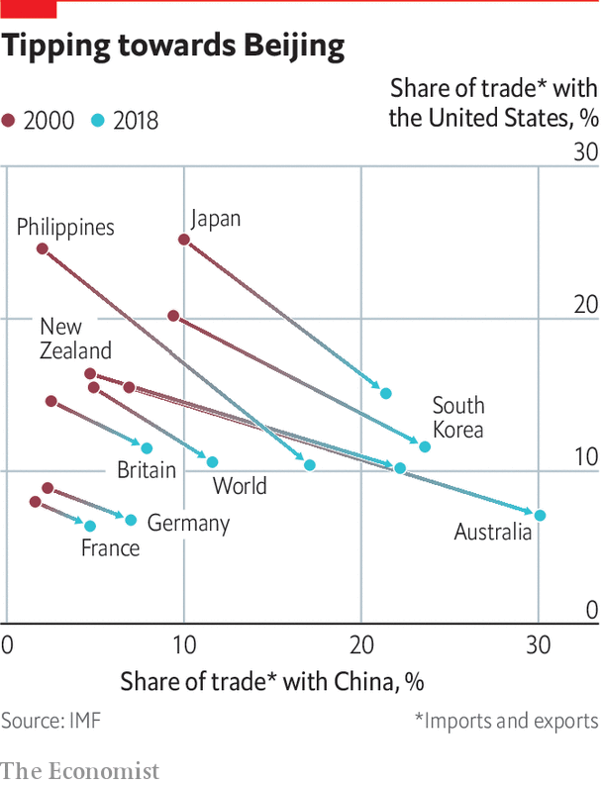

Under COSCO, container volumes have grown by more than 700%. Next year Piraeus may overtake Valencia in Spain to become the biggest port in the Mediterranean and the seventh biggest in Europe. Its value to Asian exporters is as a trans-shipment hub. Goods arriving in Piraeus via the Suez Canal are quickly shipped to other parts of the Mediterranean. That saves time and money compared with unloading in the giant ports of northern Europe, such as Rotterdam (though COSCO has stakes there too). COSCO is also investing in a rail route for sending freight from Piraeus to the Balkans and beyond to the German-led manufacturing cluster in eastern Europe. The railway neatly connects the land-based approach with that by sea.

## Shake Djibouti

But for every success, there are other strange, stalled or suspicious Chinese port ventures. The merging of commercial and military potential is glaring in tiny Djibouti, guarding the approach to the Red Sea and the Suez Canal. There, China opened its first overseas military base in 2017, ostensibly for Chinese UN peacekeepers in the Horn of Africa as well as to combat piracy. Djibouti has not been fussy about hosting bases, so long as it makes money from them, and China’s sits not far from those of the United States, France and Japan.

But a few months later the Djibouti government nationalised the main port, tearing up the long-term deal it had signed with DP World, Dubai’s port operator. Soon after, it handed a stake in the port to China Merchants, which has taken over its running. International arbitration courts have ruled in DP World’s favour, though that is unlikely to dislodge China Merchants. A Chinese state-owned enterprise, therefore, handles nearly all the incoming supplies for the other bases, a source of alarm for the United States and its allies. Similarly, China may have the upper hand in Djibouti now, but the country’s fiscal position is the most parlous of all BRI countries—and more than half of its debt is to China. To hawks it means China holds all the cards. Others point to China’s reputational risk should Djibouti default.

Another case is Hambantota, a port at the southern tip of Sri Lanka often cited as a notorious instance of debt-trap diplomacy. Opened in 2010, China Merchants took control of the new port in 2017 on a 99-year lease when the government struggled to service its debt. The debt-trap accusation is off the mark here, for China built the port chiefly to indulge the president of the time (and now prime minister), Mahinda Rajapaksa, in the region of his family’s political base. Chinese enterprises were already making out like bandits at the Colombo port. Besides, given the riskiness of the proposition, Chinese banks made sure to charge commercial rates of interest.

There was, in other words, no well-laid plan. Yet it remains the case that Hambantota sits strategically just a few miles north of one of the world’s busiest sea lanes. Moreover, once bunkering facilities are installed, and ships start to call in to refuel, Hambantota may no longer be the white elephant it is today. Thus China will have one more strategic stepping stone in the Indian Ocean in years to come.

Accusations of debt-trap diplomacy are especially rife in the Pacific. In November 2018 America’s vice-president, Mike Pence, told Asia-Pacific leaders: “Do not accept foreign debt that could compromise your sovereignty.” The perils would be especially acute for its remote and fragile economies. Yet a paper by Roland Rajah, Alexandre Dayant and Jonathan Pryke of the Lowy Institute, a Sydney think-tank, paints a nuanced picture of China’s Pacific activities. They conclude that China is not pursuing a policy of deliberate entrapment. Only in Tonga does China account for more than half of outstanding debt. Meanwhile, nearly all official lending comes in the form of concessional loans with low interest rates and long grace periods—a stark contrast to China’s lending in the other parts of the world.

Certainly the sheer scale of Chinese lending poses risks in future. But the debt-diplomacy debate should not overshadow more salient problems with China’s activities in the Pacific. For Mr Pryke of the Lowy Institute, they include both the quality of Chinese lending, and the way relationships are forged. “They’re using corruption to lubricate their engagement,” he argues. By striking murky deals with politicians, China undermines already weak governing institutions.

There are accusations elsewhere of projects that aggravate domestic problems in the countries in which they are undertaken. In January President Xi Jinping became the first Chinese leader to visit Myanmar in 20 years, a trip over which much was at stake. With a deap-sea port being built at Kyaukpyu in Rakhine state, a corridor is to connect landlocked parts of south-west China to the Indian Ocean. Myanmar offers China a crucial energy route from Kyaukpyu to Kunming, capital of Yunnan, its most south-westerly province. One pipeline has the capacity to pump 12bn cubic metres of gas a year from fields in the Bay of Bengal. A second is for oil from the Middle East. A planned railway is to run from Kyaukpyu to Kunming via Mandalay, a city in central Myanmar with a large Chinese presence.

The pipelines have special value to China, whose strategists have long fretted over a “Malacca Strait dilemma”. The strait, which the American navy dominates, is the world’s busiest maritime area, with nearly a third of world seaborne trade passing through it a year—including 80% of China’s energy imports. China’s concern is that at a time of crisis or war, America and its allies could choke off the narrow strait, throttling China.



But the planned corridor in Myanmar runs through a violent and highly complex land, home to over a dozen insurgent armies in the borderlands financed by China-linked drugs, jade and logging rackets. Chinese projects are as likely to throw fuel on the fire of ethnic conflicts as bring peace and development. As for the Myanmar government, China is too big to ignore. But it is also too big to want to be dominated by, and many in the establishment, from Aung San Suu Kyi down, have longstanding ties with the West and Japan. For now, Myanmar is in the doghouse with the West, for its army’s ethnic cleansing of Muslim Rohingyas. Mr Xi certainly does not believe that will last.

Strategic dimensions along the maritime Silk Road are not limited to ports. Chinese engineering companies have lobbied Thailand’s army establishment about digging a 100km-long canal across the Kra Isthmus in the country’s south. Supporters say vessels heading for East Asia from the Arabian Sea would shave 1,200km off their passage. The Chinese navy could get quickly to the Indian Ocean. A canal would put Thailand at the heart of a regional e-commerce economy built around quick delivery times.

Not everything is guaranteed to go China’s way

Though the generals want development, they are nervous about the Kra canal. They fear Chinese dominance. And Thailand’s south is complicated by a long-running Muslim insurgency—an attack on a security checkpoint in November left 15 dead. The army’s sacred mission has always been to hold the country together. Physically slicing it in two and isolating the restive Muslim south makes them queasy.

Not everything, then, is guaranteed to go China’s way. Certainly, it is the Eurasian geopolitical force, a combination of economic might and geographic extent. But along both the belt and the road, Chinese-led efforts meet those of other powers. In continental Eurasia, as the Silk Road reconfigures, other former empires make their mark along it. Turkey has long-standing ethnic ties with Turkic peoples in Central Asia, and construction and business expertise to offer. Iran, while facing American hostility and sanctions, has made developing ties with Central Asia a “fundamental policy”. As for the Indian Ocean, India remains the regional naval power. In Colombo, alongside China Merchants, India and Japan are jointly to develop a new container terminal.

China claims that “win-win co-operation” is what the BRI is all about. Who would want it any other way? Yet along the fast-emerging digital Silk Road things look increasingly zero-sum. ■

This article was downloaded by calibre from <https://www.economist.com/special-report/2020/02/08/china-is-making-substantial-investment-in-ports-and-pipelines-worldwide>

|  |  |  |  |
| --- | --- | --- | --- |
| Previous | Articles | Sections | Next |

|  |  |  |  |
| --- | --- | --- | --- |
| Previous | Articles | Sections | Next |

#### Of belts and roads

# How the Belt and Road Initiative got its name

It sounds better in Mandarin

Feb 8th 2020 |

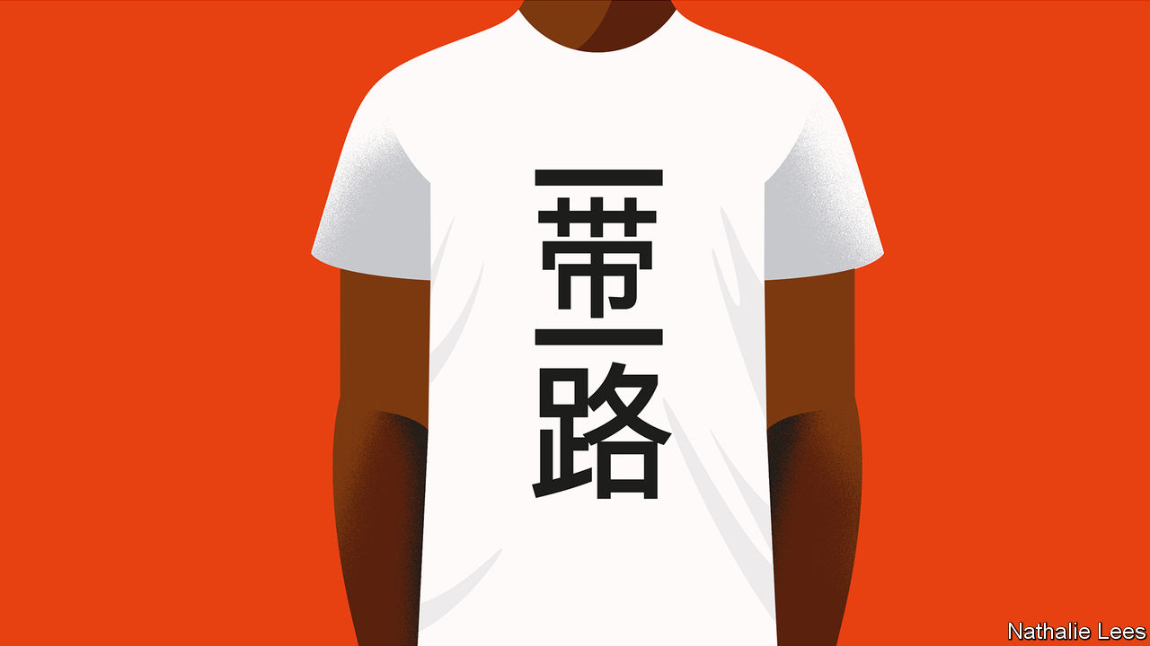

SUPPOSE YOU wanted to imagine a new world, or even a new world order. How, then, would you go about conjuring it up? You would do well to start with a name.

Forget for a moment the significant problems of translating President Xi Jinping’s grand project for an English-speaking audience. In Chinese it is called yi dai yi lu: literally, “one belt, one road”.

Such correlative, four-character phrases are common in Chinese, and imply balance, harmony, wholeness. Yi fu yi qi, or “one husband, one wife”, is monogamy; yi xin yi yi, or “one heart, one soul” means wholeheartedly. As Eyck Freymann at Oxford University writes in a forthcoming book, “One Belt One Road”, to a Chinese audience the phrase has a classical, even epic ring.

It evokes an image of China “going forth to encompass the world on land and sea, at once opening to the world and binding the world more closely to China, in a balanced and harmonious way.” To a Chinese ear, that would carry echoes of the ancient concept of tianxia (literally, “all under heaven”), by which emperors ruled. In an orderly, peaceful hierarchy, your obligations depend on your relationships within the hierarchy. China’s status as hierarchical leader goes without saying. There are, admittedly, obligations there too. China keeps the whole cosmic show on the road.

And in English? “One Belt One Road”, or OBOR for short, was the official name at launch. But in 2015 the Communist Party’s Central Compilation and Translation Bureau issued an English name change, to the “Belt and Road Initiative”, or BRI.

That sounded easier on an English speaker’s ear. Not least, it allowed semantically for the possibility of multiple belts and roads (even if confusion remained about what a belt was, and why a road should go by sea).

But calling the dream an initiative is suggestive. First, by abandoning the classical intimations implied in the Chinese phrase, a sense of China’s return to historical greatness has been removed for the benefit of foreign audiences. Second, a power that wants to conceal from other countries what, in terms of loftier ambitions for global pre-eminence, it is signalling to its own people, could do worse than choose a bland, unthreatening word like “initiative”.

Meanwhile, official Chinese sources publishing in English have not all fallen into line with the translation bureau’s ruling. “OBOR” is still used, along with the “Belt and Road” and, often, the “New Silk Road”. Not only, says Mr Freymann, does the party-state want to communicate two very different interpretations of the BRI concept to domestic and foreign audiences respectively. It has also been rather sloppy in doing so.

This article was downloaded by calibre from <https://www.economist.com/special-report/2020/02/08/how-the-belt-and-road-initiative-got-its-name>

|  |  |  |  |
| --- | --- | --- | --- |
| Previous | Articles | Sections | Next |

|  |  |  |  |
| --- | --- | --- | --- |
| Previous | Articles | Sections | Next |

#### The digital Silk Road

# The digital side of the Belt and Road Initiative is growing

Many believe it is where much of the rivalry over the plan will play out in future

Feb 8th 2020 |

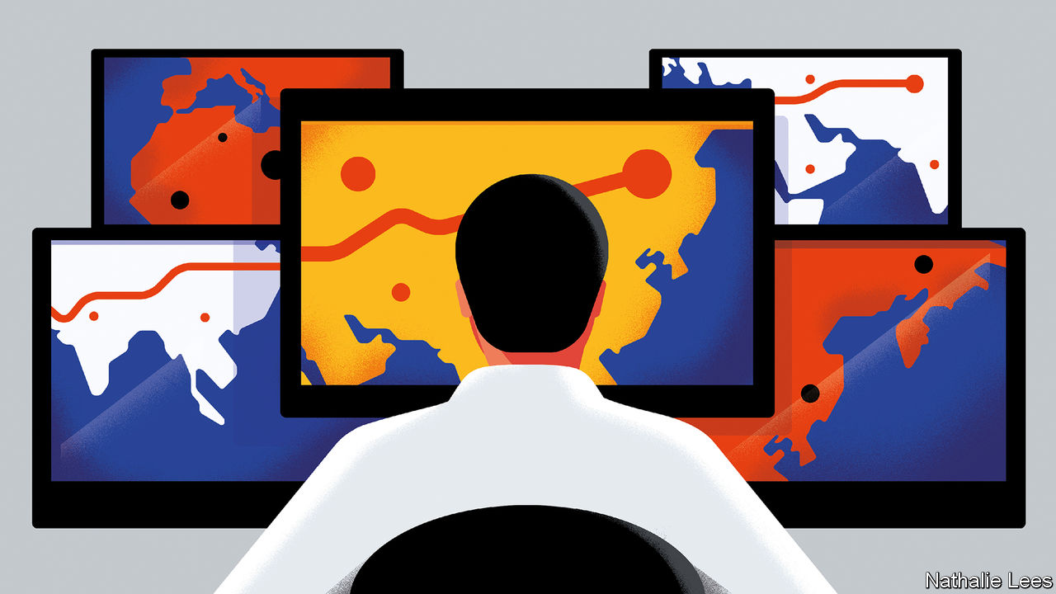

ONE TROPICAL evening in November, the 9,800-tonne Ile de Bréhat slipped from the quay at Honiara, capital of the Solomon Islands, and steamed out of Iron Bottom Sound. For weeks the boat had been a familiar sight as it finished its job of laying 4,700km of fibre-optic cable from Sydney to Honiara on Guadalcanal and 730km among the main outlying islands, with another branch heading to Port Moresby, capital of neighbouring Papua New Guinea. Less than a fifth of Solomon Islanders have access to the internet. The Ile de Bréhat is about to transform more lives than any ship since the Los Reyes, the first European vessel to discover the islands, in 1567.

Two-thirds of the $93m cost of the Coral Sea Cable System was borne by the Australian government. It got wind that China was proposing to do the job, led by Huawei, China’s telecoms giant. Australian intelligence types view Huawei as a national-security concern. Australia is also the biggest donor to Pacific Island nations and is used to being top dog in its backyard. It told leaders in Honiara and Port Moresby that Huawei was not to be considered.

Yet Australia has taken its eye off the Pacific in recent years, as China has stolen a march. Two-way trade with the Pacific has grown tenfold, from under $1bn in 2005 to over $8bn in 2018. Chinese tourists to the region jumped from under 4,000 a year a decade ago to more than 140,000 in 2017. China’s leaders extol the potential for BRI co-operation with Pacific nations. A “new Pacific diplomacy” has gathered pace since President Xi Jinping made his first trip to the region in late 2014. Pacific Island leaders frequently head for China.

When Australia’s security establishment woke up to the growing Chinese presence, it did so with alarm. Australia had its way over Huawei. But just weeks before the Ile de Bréhat departed (and days before the 70th anniversary of the founding of the People’s Republic of China), the new Solomon Islands government switched diplomatic allegiance from Taiwan to China—as, too, did the atoll nation of Kiribati. The switch was accomplished with offers of bribes to MPs and, according to Graeme Smith, of the Australian National University, a $500m package of loans and grants dangled by a Chinese state enterprise before the prime minister.

Huawei’s loss, in other words, is just one battle in a larger contest. Increasingly, the digital Silk Road, which Mr Xi declared at the second BRI forum last year to be a priority for co-operation, is gaining prominence. China, he says, must become a “cyber superpower”. That is fast becoming the most controversial aspect of the BRI too, as security concerns in the West grow over Huawei’s provision of fibre-optic cables and 5G networks.

Digital spending along the belt and road still lags that on energy and other hard-infrastructure projects. But, as the Mercator Institute for China Studies in Berlin points out, it is growing fast. The institute has tracked at least $7bn in loans and investment in cables and telecoms networks, over $10bn on e-commerce, mobile payments systems and the like, and more on research and data centres. The digital dimension has expanded hugely from an initial focus on fibre-optic cables to cloud computing, big data and “smart city” projects.

The approach, both with top-down guidance and bottom-up buccaneering, resembles the rest of the BRI (not least in the vagueness of the Silk Road terminology used). Most of China’s tech giants, such as Huawei, Alibaba and Tencent, are private firms and are more entrepreneurial than the state behemoths. But close links to the Communist Party and powerful financial incentives keep their activities aligned with state priorities—and help them to become global champions. Chinese banks provide funding, as they do to more traditional infrastructure companies. It was a concessionary loan that allowed Huawei to lay a 6,000km fibre-optic cable across the Atlantic, between Brazil and Cameroon.

For China, it is not just a question of fostering world-beaters in high-tech. It also wants to encourage the wider adoption of homegrown cyber norms and standards. For instance, fintech brands like WeChat Pay and Alipay can help to internationalise the yuan and establish cross-border payments infrastructure to compete with SWIFT, the American-led system which currently dominates. Undersea cables and cloud computing could provide user data around the world, boosting China’s efforts to surpass America in artificial intelligence.

While cheaper telecoms and easier ways to pay are welcome, China’s digital initiatives concern those who care about open societies. First, along with Chinese standards some countries are also signing up to its digital authoritarianism. In setting up telecoms systems, Huawei and others happily help states snoop on communications. Without its citizens’ consent, Zimbabwe supplies data to China’s facial-recognition programmes. That is one reason to predict that rivalry over BRI will in future play out more in the digital realm than in the world of concrete. A second is that, in tech, a small handful of huge firms dominate. The next 4bn internet users are a huge prize, one which China thinks it has a shot at winning.

A final reason is that, even more than other dimensions, the digital one lends itself to dual-use possibilities. For instance, the global version of Beidou, China’s answer to America’s GPS, will launch this year, and will increase China’s surveillance and its military command-and-control capabilities. Beidou requires a network of ground stations around the world, for which China needs friendly states. For Mr Xi the Marxist, technology is, as Julian Gewirtz of Harvard University puts it, “power in practice...historical change in material form”. Many believe China intends the digital Silk Road to be the main stage on which the BRI plays out in future. The question is whether the West will let it.

The answer will come in part from how Europe handles the challenge. In places the digital dimension China is pushing is indistinguishable from the others. For instance, Huawei’s 5G proposals for Greece are pitched in part to help drive the next phase of the logistics transformation under way at Piraeus port, which Mr Xi calls the “dragon’s head” of Chinese investment in Europe.

Last year Greece became the first western European country to join the 16+1 (now 17+1), a group of central and eastern European countries happy to work with Beijing. China’s influence over this group is a source of growing concern in Brussels as lines harden over Huawei’s future involvement in 5G. Europe’s biggest states are agonising over whether to let Huawei develop 5G, or ban it and face China’s wrath. America may insist that any compromise, in which Huawei is excluded from core parts of the 5G system, is unworkable. It is hard to imagine the EU splitting with America on such a profound matter—and the new government in Greece under Kyriakos Mitsotakis is more Western-friendly than its predecessor. But it is clear. The digital battle lines are about to be drawn.■

This article was downloaded by calibre from <https://www.economist.com/special-report/2020/02/08/the-digital-side-of-the-belt-and-road-initiative-is-growing>

|  |  |  |  |
| --- | --- | --- | --- |
| Previous | Articles | Sections | Next |

|  |  |  |  |
| --- | --- | --- | --- |
| Previous | Articles | Sections | Next |

#### The future

# Will China sit again at the heart of its own cosmos?

And does it have more than just cold, hard cash to offer?

Feb 8th 2020 |



BACK in KHORGOS one winter’s morning, a press of shopworkers—members of the ethnic Han majority, along with Kazakhs and Uighurs—line up in front of border officials to enter the duty-free mall shared with Kazakhstan. Four city officials from the propaganda department have got wind of this correspondent’s presence, and insist on accompanying him, nervously calling their boss for instructions. Even in this zone of declared openness, the contradictions multiply. Not least, Kazakhs and Uighurs—though not Han Chinese—must surrender their passports if they want to work in the zone, so that they may not cross over into Kazakhstan.

It is a small mark of a much larger campaign of high-tech surveillance and incarceration in which China has sent over 1m innocent Muslims in Xinjiang to indoctrination camps. Though most caught up in the dragnet are Uighurs, the biggest ethnicity in the region, some 1.5m ethnic Kazakhs live in Xinjiang, too. Every family he knows, says one young Kazakh man, has at least one member in the camps. His uncle, a local-government official, disappeared six months before, for having needlework verses from the Koran on his wall. “It is meant to make us love the authorities,” says the woman, “but it only makes us hate them more.”

The anti-Muslim repression sends ripples across Central Asian borders. In September anti-China protests erupted in western Kazakhstan, in large part against the Xinjiang campaign. It is, a Kazakhstani foreign-ministry official admits, a highly delicate issue. Practically the only thing China demands of Central Asian states in return for BRI money is unquestioning allegiance to a fight against supposed separatism in Xinjiang. Indeed, one main motivation for the BRI was to do an end-run around China’s restive province, putting Central Asia out of bounds as an anti-China base. And by bringing development to Xinjiang itself, the BRI might address the economic backwardess of the province that the authorities assume must be at the root of its restiveness. So far, it has failed.

It points to a big question over the BRI: how to square all the fizzing connectivity implied in it with China’s dystopian techoauthoritarianism at home? It is the BRI’s foundational paradox.

In grappling with it, it helps to sort BRI projects into three buckets, assessing each bucket separately. First come projects intended to promote local development or growth. Power stations in Pakistan are a case in point: who can doubt Pakistanis’ need for more electricity? Yet even here come questions, above all, about the environment. The great bulk of BRI energy spending is in carbonintensive areas—especially coal-fired power stations. The emissions from such projects are not counted under China’s own undertakings under the Paris agreement. Neither are they usually factored into recipient countries’ commitments, as the World Resources Institute, an environmental group, points out. The BRI severely undermines China’s own green credentials.

The second bucket contains those connectivity-related projects that boost transport and trade—the Khorgos corridor is a prime example. Here the potential benefits need to be more rigorously assessed. A study by the World Bank last year, “Belt and Road Economics”, concluded that, by shortening transport time and lowering trade costs, the BRI can expand trade and investment, and lift 7.6m people out of extreme poverty, mainly in “corridor” economies like those in Central Asia. But the gains will only happen with complementary reforms that increase transparency, cut hassles at borders, face up to environmental and social consequences, and ease labour mobility. As it is, in some countries, like Mongolia, the costs of new infrastructure outweigh the gains.

The final bucket holds those aspects of the initiative that ostensibly promote greater openness and global interconnectedness. They include much of the BRI’s digital strategy. But all the highlevel and “people to people” diplomacy is key for China’s leaders too. It is here that the paradox is starkest. At home, the Communist Party monopolises the political space, prevents debate and enforces an information autarky. Abroad, its obsessive attempts to stifle critics suggest limits to the openness it will tolerate. That undermines the BRI’s attractions. One development economist from Ethiopia says that its training courses on Chinese campuses to which many foreigners are invited are stifling and dogmatic.

These flaws are baked into the belt and road. But they do not mean that the project of the century is heading for the buffers. The goodies China offers reflect well on leaders. And Chinese construction companies and workers get stuff done. Even politicians who, in opposition, make much of China’s rapaciousness usually come round once in power. In Malaysia, the threat by the prime minister, Mahathir Mohamad, to spike $20bn-worth of rail and other projects turned out to be a negotiating ploy.

What is more, China is unquestionably now the dominant Eurasian force, and a canny one at that. One instance is its dealings with Russia, another Eurasian former empire with aspirations to greatness again. In 2015 Russia formed the Eurasian Economic Union (EAEU) with former Soviet states of Central Asia, the better to draw them close and stipulate economic terms. But after facing censure from the West over its annexation of Crimea, Russia needed China for economic and diplomatic support. China has since co-opted the EAEU for its own purposes. The union’s common customs zone from Kazakhstan to Belarus makes it much easier to get cargoes to Europe—bypassing much of Russia altogether. This is just one example of how things are tipping in China’s favour.

Yet one thing is glaringly absent in China’s attempts to bend the world to its will. The last time countries circled in China-centred orbits, before the 19th century, China’s moral and cultural authority played as big a part as its sheer size. Japan, Korea and Vietnam all used Chinese characters in their writing systems and organised their societies according to Confucian precepts. Today, China lacks moral or cultural appeal. Its attraction is its cold, hard cash.

## Not yet Pax Sinica

It is in this context that America has been grappling for a response. Three years ago the Trump administration made a first attempt: a “Free and Open Indo-Pacific”, in conjunction with Japan, Australia and India. It emphasised a strong naval dimension. But with no development dimension, and a sense of sharpening big-power rivalry, the region has been reluctant to embrace it.

Now the West is offering developing countries alternatives that emphasise transparency, debt sustainability, environmental safeguards and solid social and economic returns. America has set up the new US International Development Finance Corporation. Its available money is a fraction of what China can offer. But its strength may prove to be in involving private capital in projects. Meanwhile, in late 2018, Australia launched its Infrastructure Financing Facility for the Pacific, worth A$2bn ($1.4bn) in loans and grants. And in September Japan and the EU signed a wide-ranging deal for joint infrastructure projects, setting clear standards for investments ranging from transport to digital industries.

Such ventures may start to make a mark in the next year or two. Meanwhile, democratic countries are quietly finding other ways to push back against China. Japan has long been active in South-East Asia and its ties with India have grown. Chinese plans for a port in Bangladesh were shunted aside by offers from India and Japan. India has also come to the aid of the tiny Maldives, whose previous repressive government racked up debts with China. Pakistani officials, burned by their experience with CPEC, now stress how much they welcome American development initiatives. Even the Rajapaksas in Sri Lanka suggest they will be more careful to cultivate India in future.

Countries’ leaders say they welcome having more options. They do not relish being forced to choose between the historical global power and the ascendant one. That is why they worry about the growing American and Chinese rivalry over telecoms and cyberspace. America should be careful not to hasten a situation in which countries fall on one or other side of a digital iron curtain—with rich, open societies taking their tech from American, European and Japanese suppliers, while poorer, less democratic ones take theirs—and their political direction—from China. Then Chinese leaders would indeed have their new order. They would sit again at the heart of a China-centred world, an echo of the tributary relationships of old. But it will be a hard-edged cosmos and it will not be one in which its citizens have chosen to live. ■

This article was downloaded by calibre from <https://www.economist.com/special-report/2020/02/08/will-china-sit-again-at-the-heart-of-its-own-cosmos>

|  |  |  |  |
| --- | --- | --- | --- |
| Previous | Articles | Sections | Next |

|  |  |  |
| --- | --- | --- |
| Special report | Sections | Finance and ... |

Business

USA Inc: Goldilocks and the three bears

.

Fast and furious: Tesla gains $60bn in market value in a week

.

Technology C-suites: Time for an update

.

Bartleby: I am Number 0.6

.

Goldmining: Golden retrievers

.

Business in India: Buy and sell tax-and-spend

.

Schumpeter: Ace in a hole

.

|  |  |  |
| --- | --- | --- |
| Special report | Sections | Finance and ... |

|  |  |  |  |
| --- | --- | --- | --- |
|  | Articles | Sections | Next |

#### Goldilocks and the three bears

# After a nervy year America Inc has a bounce in its step

The corporate earnings recession may be over. But risks loom

Feb 8th 2020 | NEW YORK

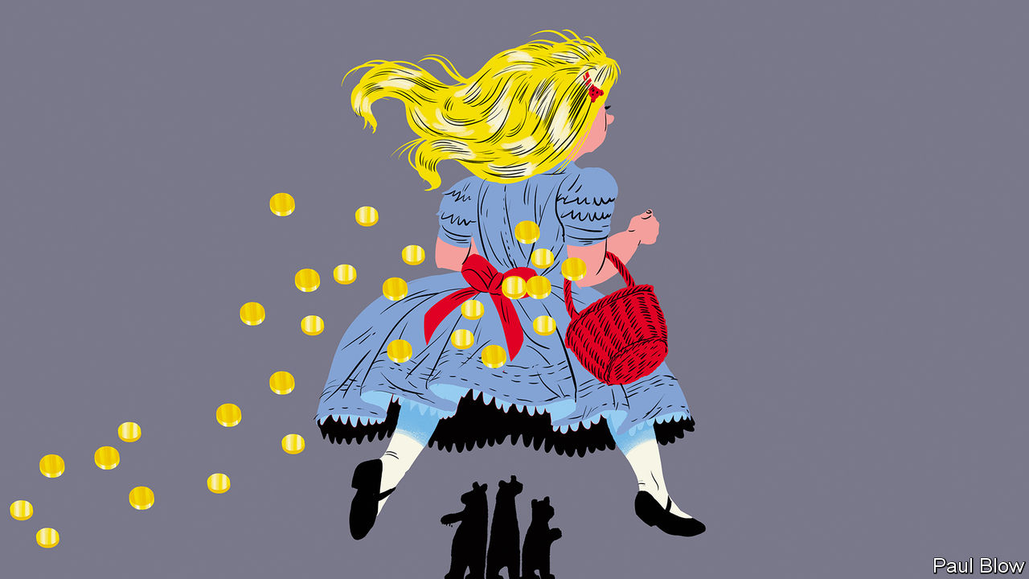

IS THE EARNINGS recession over? Many observers of corporate life have been asking this question as America’s listed companies report last quarter’s results in January and February. The omens going into the decade’s first earnings season did not look good. The current expansion is the longest in American history, so a downturn seemed inevitable. Indeed, the first three quarters of 2019 saw year-on-year declines in earnings for the S&P 500 index of leading firms. Financial analysts had forecast another drop, of 2% or so, in the fourth, marking the first such prolonged malaise since 2015-16, when America suffered a manufacturing slump.

With firms accounting for two-thirds of S&P 500 earnings out of the way, the mood has shifted—and then some. American bosses have unfurrowed their brows. A survey of big firms’ chief executives by the Conference Board, a business think-tank, showed a rebound in confidence from a ten-year low in the third quarter. The latest poll of smaller firms by the National Federation of Independent Business, a trade group, also recorded greater optimism. Equities may be headed for what Michael Wilson of Morgan Stanley, an investment bank, calls “a Goldilocks environment”.

America’s biggest firms are leading the charge. Apple’s net income grew by 11% to a record $22.2bn thanks in part to surprisingly strong iPhone sales. A surging cloud business boosted Microsoft’s net income by 38% to $11.6bn. Even Amazon, renowned for profitless growth, increased net income by a tenth, year on year, to $3.3bn. But Big Tech is not alone. Industries from utilities to banks to health care appear to be back in business—prompting analysts to revise upwards their forecasts for 2020. Jill Casey of Bank of America expects profits to rise by 8% this year, compared with the latest estimate of about 1% for last year.

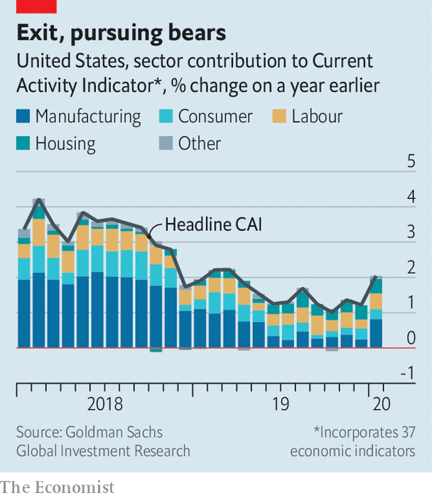

What happened? For a start, fears of a recession have not materialised. If anything, America’s economy is perking up. In January the IMF forecast that American GDP would grow by 2% in 2020, faster than the euro area (1.3%) or Japan (0.7%). The “current activity indicator”, an aggregate of 37 economic metrics compiled by Goldman Sachs, an investment bank, rose sharply in January (see chart). Even manufacturing, where activity had been slowing since mid-2018, looks in better nick. A survey published on February 3rd by the Institute of Supply Management points to the first expansion in months.

America’s commercial truce with China announced in December played a role. Most bosses know that this “phase one” deal is imperfect. China’s commitment to purchase $200bn of American agricultural and other exports in 2020 and 2021 is widely seen as unrealistic. But the deal did make clear that President Donald Trump is willing to avoid an all-out trade war with America’s Asian rival, at least for the time being.

Mr Trump’s massive corporate tax cut continues to be a source of bosses’ contentment, as are low interest rates. So too is the absence of wage inflation—a big concern in boardrooms last year. David Kostin of Goldman Sachs argues that it should not be. He calculates that for the median stock in the American market, labour costs (including everything from salaries to share options to health insurance) are stable at around 13% of revenues—despite record-low levels of unemployment. Overall wage growth has been stuck around 3% a year for a while.

A balmier business climate is encouraging companies to invest. Morgan Stanley’s index of capital-expenditure plans, which combines various indicators, moved up in January after falling for seven straight months. The bank’s economists attribute this capex revival in part to “more positive headlines on global trade”.

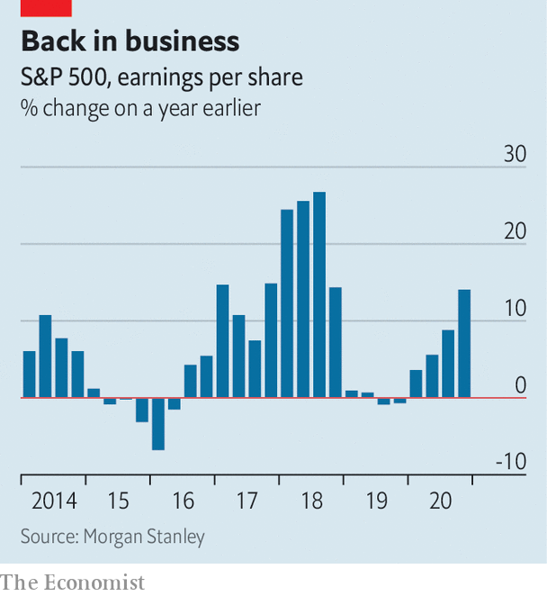

Jonathan Golub of Credit Suisse, an investment bank, argues that if the expansion since the global financial crisis of 2007-09 is measured not in time but in GDP, which has grown unusually slowly by historical standards since 2008, it may have life in it yet. The business cycle is not dead, he says. But it is “elongated”. Economists scoff at such simplistic metrics, but a version of this argument is an increasingly common refrain among bulls on Wall Street. Their poster child is Tesla, an electric-car manufacturer whose market value nearly quadrupled in four months.

Lest the bulls get carried away, they should consider the three risks facing America’s Goldilocks market. First, the coronavirus from Wuhan is infecting American firms’ Asian supply chains—and global confidence (see article). Manufacturers in particular are vulnerable to contagion. Most economists, pointing to the modest global impact of outbreaks such as SARS in 2003, remain cautiously optimistic. But if the Wuhan virus turns into a deadlier global pandemic equity markets would invariably suffer.

Another worry is that the entire stockmarket is skewed by Big Tech. Apple, Microsoft, Amazon, Alphabet and Facebook account for 18% of the S&P 500. Cassandras note that in 2000, on the eve of the dotcom bust, the giants of the day—Microsoft, Cisco, GE, Intel and ExxonMobil—also made up 18% of the index. Because of their exposure to other tech firms, including frothy startups, Microsoft, Intel and especially Cisco were brought low by the crash rather than being a counterweight to it.

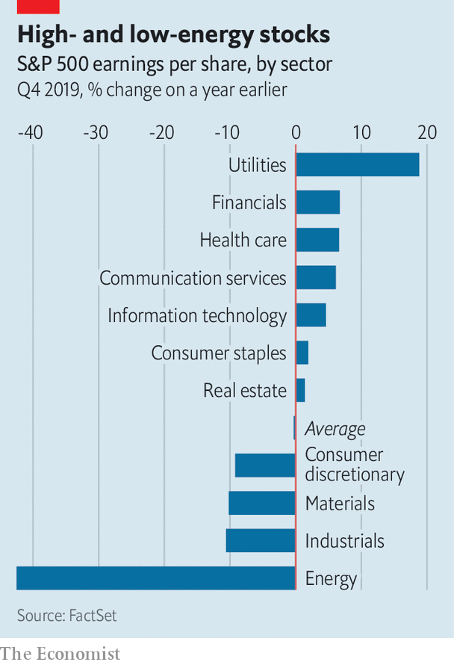

Mr Kostin notes that today’s big five are different. They trade at lower multiples of annual earnings than the big five of 2000 did (30 now versus 47 then) and reinvest more capital into the business (48% against 26%). The implication is that today’s giants have room to grow. Even so, their shares are looking pricey; Tesla’s plunged by 17% on February 5th. The companies remain vulnerable to antitrust action, privacy regulation, uncertain succession (see article), as well as the health of their myriad Asian suppliers.

The final bear case has to do with potential weakness in American household consumption. Ellen Zentner of Morgan Stanley notes that real personal consumption spending grew at an annualised rate of 1.8% in the fourth quarter, down from 3.2% in the third. She calculates that the annualised growth in spending on non-durable goods last quarter was only 0.8%, down from 3.9% in the one before. Spending on food and beverages fell by 0.5% on an annualised basis in the fourth quarter of 2019, down from an increase of 5% in the previous three months.

The profits just reported by big banks, which owe their strength in part to credit-card spending and mortgages, suggest that consumers are in a buying mood for now. Bosses have reason to kick back and relax. Farsighted ones know that this warm feeling will not last for ever. ■

This article was downloaded by calibre from <https://www.economist.com/business/2020/02/08/after-a-nervy-year-america-inc-has-a-bounce-in-its-step>

|  |  |  |  |
| --- | --- | --- | --- |
|  | Articles | Sections | Next |

|  |  |  |  |
| --- | --- | --- | --- |
| Previous | Articles | Sections | Next |

#### Fast and furious

# Tesla gains $60bn in market value in a week

And then sheds some $30bn in a day. Go figure

Feb 8th 2020 |

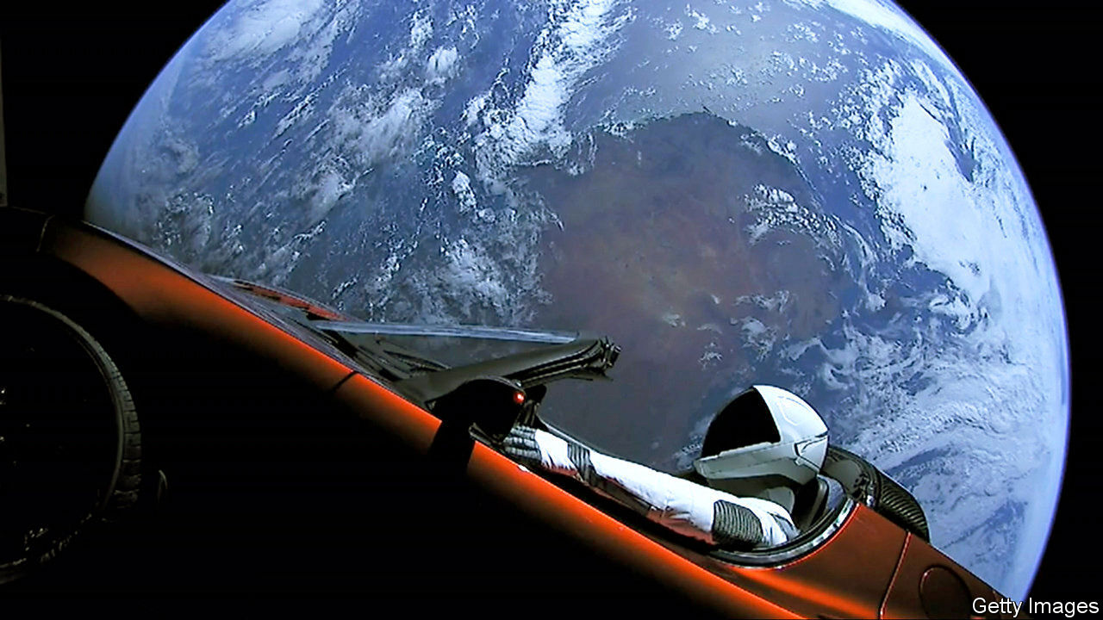

SMALL STARTUPS’ market value has been known to soar by 50% in a few days. It is almost unheard of for $100bn companies to gain that much so fast. Unless you are Tesla. Since we wrote about Elon Musk’s electric-car firm’s performance last week, when it reported a quarterly operating profit of $359m, its market capitalisation swelled by nearly $60bn—never mind that it still lost money for the year as a whole and makes one car for every 30 produced by Germany’s Volkswagen (with a market capitalisation of $95bn). On February 5th it shed some $30bn. The reasons for the volatility remain as mysterious as Mr Musk’s mood swings.■

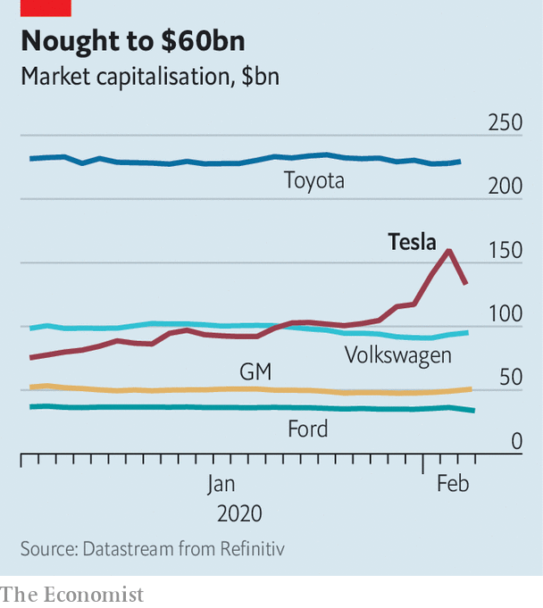

This article was downloaded by calibre from <https://www.economist.com/business/2020/02/08/tesla-gains-60bn-in-market-value-in-a-week>

|  |  |  |  |
| --- | --- | --- | --- |
| Previous | Articles | Sections | Next |

|  |  |  |  |
| --- | --- | --- | --- |
| Previous | Articles | Sections | Next |

#### Time for an update

# Talk of succession atop Big Tech grows louder

Giants including Salesforce, Apple and Microsoft may get new bosses in the next year or two

Feb 8th 2020 |



MOST BOSSES, even of multibillion-dollar businesses, are anonymous to anyone who is not their employee or an equity analyst. Except, that is, technology bosses—and not just founders like Amazon’s Jeff Bezos or Mark Zuckerberg of Facebook. Many bystanders are familiar with the bespectacled visages of Satya Nadella, who runs Microsoft, or Tim Cook, from Apple. Over the next year or so people may need to learn some new faces.

The first notable tech succession of the decade was announced on January 30th, when IBM said that Arvind Krishna will take over from Ginni Rometty, a rare female Big Tech boss, in April. Two days later Sandeep Mathrani was named as the chief executive of WeWork, a troubled pseudo-tech firm which rents office space. In December Google’s founders, Larry Page and Sergei Brin, handed control of Alphabet, the search firm’s parent company, to Sundar Pichai, who ran its core business.

More turnover is afoot. Marc Benioff, founder and co-CEO of Salesforce, which sells cloud-based business services, is expected to step down this year. Some Uber investors and executives wonder if Dara Khosrowshahi is the right person to bring the ride-hailing giant to profitability. Questions are even being raised about superstars like Mr Cook, who turns 60 in November and will then have run Apple for nearly a decade, and Mr Nadella, a 52-year-old who has been in the top job for six years. Who takes their place will say a lot about America Inc’s sexiest sector.

The names bandied about share a lot in common. For one thing, they are all male. Mr Cook’s heir-apparent is Jeff Williams, currently in charge of the iPhone-maker’s operations. Mr Nadella’s likeliest replacement is Kevin Scott, Microsoft’s chief technology officer, whose upcoming tome, “Reprogramming the American Dream”, looks like a book-length job application. Mr Benioff is expected to hand over his co-CEO role to Bret Taylor, Salesforce’s president and chief operations officer.

Ms Rometty’s departure leaves only two prominent female leaders in tech: Lisa Su at AMD, a chip-design firm (who was reportedly considered for the IBM job) and Safra Catz at Oracle (though Larry Ellison remains the power behind the throne at the business-software giant he founded). Microsoft has nurtured a generation of impressive female talent, including Lila Tretikov, a vice-president of its artificial-intelligence (AI) business. But none of these executives appears likely to succeed Mr Nadella unless he sticks around for a few years more.

Besides more men, Big Tech corner offices can expect more geeks. Whereas Ms Rometty and Mr Benioff came from sales, Mr Krishna (who oversees IBM’s cloud and AI business) and Mr Taylor (who worked as Facebook’s technology chief before he joined Salesforce) are engineers by trade. Mr Williams, too, has an engineering degree. Mr Scott is a computer scientist. All are also seasoned managers by now.

Each new CEO will face distinct challenges. Mr Krishna has to complete IBM’s pivot from conventional computing, such as mainframes and information-technology services, to AI and the cloud. Mr Taylor would have to integrate Salesforce’s recent acquisitions. Mr Williams’s main task would be to grow Apple’s services business as it sells fewer iPhones. Whoever takes over at Microsoft must ensure that Mr Nadella’s remarkable reinvention of the software-maker as a big-data and cloud-computing behemoth stays on course.

If Mr Benioff goes, only three of America’s ten biggest tech firms will be run by their creators: Amazon, Dell and Facebook. Mr Bezos and Michael Dell are in their 50s. Mr Zuckerberg is a stripling 35. Neither is going anywhere; Mr Dell tried retirement once before and it did not agree with him. They could nevertheless take some pointers from tech’s new chiefs, who tend to be less abrasive and more politic than flamboyant founders. Those are useful traits at a time of techlash from politicians and calls for cuddlier behaviour from woke consumers and employees.■

This article was downloaded by calibre from <https://www.economist.com/business/2020/02/08/talk-of-succession-atop-big-tech-grows-louder>

|  |  |  |  |
| --- | --- | --- | --- |
| Previous | Articles | Sections | Next |

|  |  |  |  |
| --- | --- | --- | --- |
| Previous | Articles | Sections | Next |

#### Bartleby

# How modern workers are at the mercy of ratings

I am Number 0.6

Feb 8th 2020 |



A CLOSE FRIEND of Bartleby’s just got the news that their department was shedding 2.6 workers. At first sight, the concept of 0.6 of a worker sounds pretty odd. But workers who are freelance, on temporary contracts, or in part-time employment register in the headcount as less than a whole number.

Being classed as 0.6 of a worker seems dehumanising. Few people want to be thought of as just a number, let alone a fraction. In “The Prisoner”, a cult British television series from the 1960s, the hero, played by Patrick McGoohan, resigns from his job as a secret agent only to be abducted and taken to a village. He is only referred to as “Number 6” and his frequent escape attempts are frustrated.

Although he insists that “I am not a number, I am a free man”, the audience never learns his name. The programme has a very 1960s vibe—it focuses on the individual’s efforts to assert himself in the face of a repressive, conformist society. At one point, the title character declares: “I will not be pushed, filed, stamped, indexed, briefed, debriefed or numbered. My life is my own.”

These days many workers would sympathise. They feel pushed, filed, indexed and numbered. When they apply for a job, they may be assessed by artificial intelligence, which parses résumés for key words without which an applicant’s odds of an interview lengthen. Based on works like “Evidence-Based Recruiting” by Atta Tarki, who claims that scores in general-mental-ability tests have a strong 65% correlation with job performance, firms may ask candidates to take an intelligence test.

When they get a job, employees find the indexing and numbering continues. Workers at warehouses have to pick a certain number of items per hour; those at call-centres are assessed by software that monitors their hourly number of calls, and the amount of time spent on each one. Fall behind the target and you may feel unable to take a break. When their task is completed, employees are often rated again, this time by the customers.

Manufacturing workers have long faced these kind of numerical targets, as well as the need to clock in and out of work. The big change is that similar metrics and rating systems are spreading to more and more parts of the economy. Academics get rated by students; nurses may be judged on a “behaviourally anchored rating scale” which assesses how much empathy they showed to patients.

Ratings are at the heart of the gig economy, where workers are connected with employers and customers via the internet. Just as TripAdvisor ratings allow holidaymakers to assess hotels, Uber drivers get a score out of five. The same goes for ratings on services like TaskRabbit (for odd jobs) and Etsy (for arts-and-crafts sellers).

Such systems are understandable in parts of the economy where output is difficult to measure precisely. But they can be arbitrary. People might give an Uber driver a poor rating because they are in a bad mood or because they encountered unexpected traffic disruption (the drivers themselves also rate customers, which is meant to discourage abuse).

The result can be increased insecurity for gig-economy workers. Their income is uncertain when they are at the mercy of the assessment system. Even a tiny fall in their rating—of, say, 0.6—can harm their job prospects. A detailed study* of 65 gig-economy workers found that they relished their independence but it came with a host of personal, social and economic anxieties.

Even full-time workers may find themselves dependent on their score in one category or another. Businesses want to avoid accusations of hiring biases on grounds of gender or ethnicity; using “objective” rating systems can protect them from discrimination lawsuits. And employees need to be concerned about how they are rated.

Gianpiero Petriglieri of the INSEAD business school says that, since firms no longer offer jobs for life, everyone is an independent worker whether they like it or not. The key passage in your CV may not be the universities you attended, but your rating in categories like teamwork, innovation and adaptability.

Heaven forbid, the system even extends to journalists. Some publications reward writers based on the number of clicks their articles attract. Find out more in next week’s Bartleby column: “How the Kim Kardashian diet can boost your IQ and job prospects”.

* “Thriving in the gig economy”, by Gianpiero Petriglieri, Susan Ashford and Amy Wrzesniewski, Harvard Business Review, March-April 2018

This article was downloaded by calibre from <https://www.economist.com/business/2020/02/08/how-modern-workers-are-at-the-mercy-of-ratings>

|  |  |  |  |
| --- | --- | --- | --- |
| Previous | Articles | Sections | Next |

|  |  |  |  |
| --- | --- | --- | --- |
| Previous | Articles | Sections | Next |

#### Golden retrievers

# Gold companies try to restore their sparkle

The mining industry’s glitterati have not dug themselves out of their hole quite yet

Feb 8th 2020 | CAPE TOWN

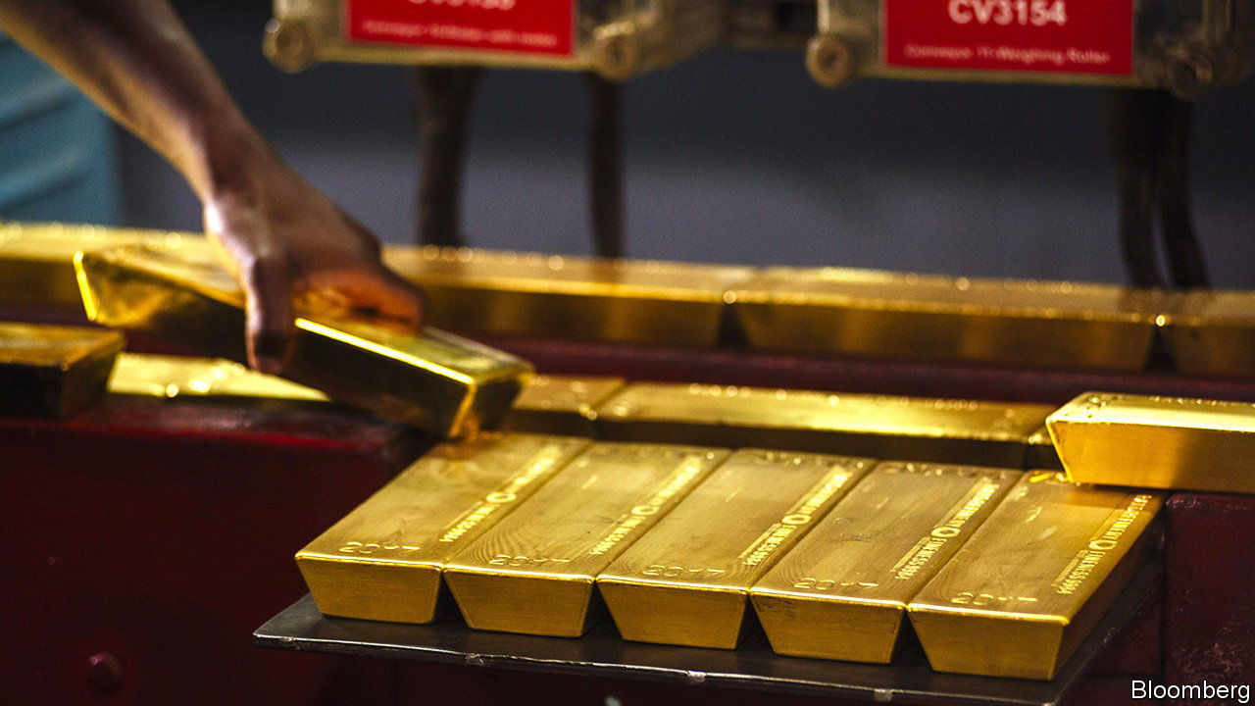

FOR MUCH of the 2010s gold companies looked rather leaden. At roughly $300bn the world’s dozens of listed gold firms have a combined market value that is less than that of the maker of Nescafé Gold coffee. Yet when miners of all the Earth’s riches gathered in Cape Town on February 3rd-6th for their biggest investment jamboree of the year, those digging for the shiny stuff were aglitter. As economic uncertainty and low interest rates pushed gold prices up by 19% last year, the quickest rate since 2010, goldminers’ share prices surged, too—and twice as fast.

Mining the yellow metal is a thankless business. Gold executives must reinvest constantly just to sustain production—the average gold deposit is smaller and more rapidly depleted than many other ores. At the same time, they must return money to shareholders, pay taxes and royalties in countries where they operate and safely close ageing mines that used cyanide to leach gold from ore. For years many firms balanced these demands with the grace of a toddler bearing a tray of champagne. As they unveil their full-year earnings in the coming weeks, their investors are looking for signs of sure-footedness.

In the last big bull market for gold, from 2009 to 2012, companies splurged on big deals and loaded up on debt. A subsequent fall in prices exposed poor management, says Josh Wolfson of RBC Capital Markets, an investment bank. In the past five years gold companies’ return on equity was negative 5%, even as companies in the S&P 500 index averaged a positive return of 15%.

Now gold firms are benefiting from an amalgam of pricier gold and cheapish oil, which is an important input. But miners have also learned from past mistakes. Between 2013 and 2017 the aggregate net debt of the top 20 gold companies tracked byGDX, a specialised exchange-traded fund, fell by 42%. Costs to sustain production dropped by about 20% from 2012 to 2017, says Credit Suisse, a bank.

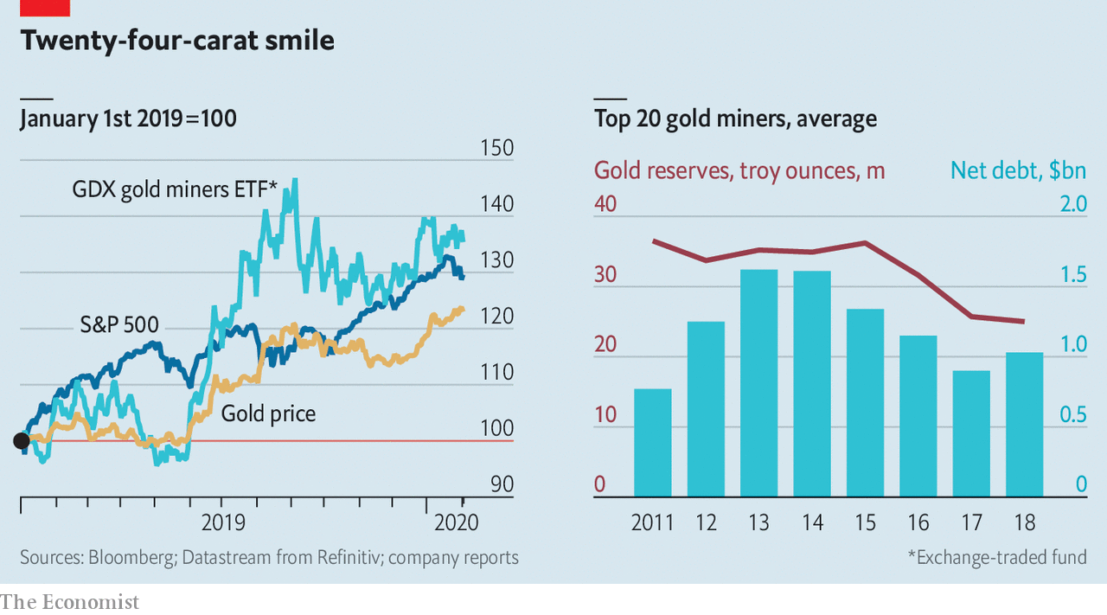

The industry has consolidated. Last year saw more than $33bn of mergers, acquisitions and joint ventures (JVs), according to Refinitiv, a data provider. That included two mega-deals. Barrick Gold of Canada paid $7bn, including net debt, for Randgold Resources, with mines across Africa. Newmont Mining, an American firm, purchased Goldcorp, another Canadian one, for $12bn. Many companies, including Barrick and Newmont, are at last shovelling more cash to shareholders.

Gold bosses must now prove that all the dealmaking was wise. Barrick’s new chief executive, Mark Bristow, earned investors’ trust as head of Randgold, which successfully weathered past declines in the gold price. There were too many mediocre managers and not enough good assets to go around, Mr Bristow says. Scale, he contends, will attract more non-specialist investors to the industry.

Mr Bristow has moved quickly to make his case for consolidation. He has trimmed Barrick’s head office and settled a long-running tax dispute with the government of Tanzania. When Barrick’s hostile bid for Newmont failed, he helped engineer a JV between the two, which is wringing savings from their vast assets in Nevada. Since some of the world’s most promising remaining deposits of gold also produce copper, Mr Bristow wants to dig up more of the red metal (demand for which should grow with the real economy, where it has a practical use).

The industry has not dug itself out of its hole quite yet. The miners’ recent spending restraint has also meant less money for all-important exploration. Since 2011 the reserves of the 20 biggest GDX firms have fallen by 36%, to 12,400 tonnes (worth $624bn at current prices). Analysts reckon that gold production may be about to peak, with declines forecast in the 2020s.

At the same time, investors increasingly attentive to firms’ environmental, social and governance metrics eye with suspicion energy-intensive businesses operating in places with a history of corruption and instability—or, as goldminers describe them, “complex jurisdictions”. Despite gold companies’ efforts to lower carbon emissions and behave more ethically, investors still see the grubby reputational risk of crude, minus the generous dividends.■

This article was downloaded by calibre from <https://www.economist.com/business/2020/02/08/gold-companies-try-to-restore-their-sparkle>

|  |  |  |  |
| --- | --- | --- | --- |
| Previous | Articles | Sections | Next |

|  |  |  |  |
| --- | --- | --- | --- |
| Previous | Articles | Sections | Next |

#### Buy and sell tax-and-spend

# Why India’s annual budget is a powerful market force

Each year bosses and investors are glued to TV screens to learn whose business found favour and whose fell out of it

Feb 8th 2020 | MUMBAI

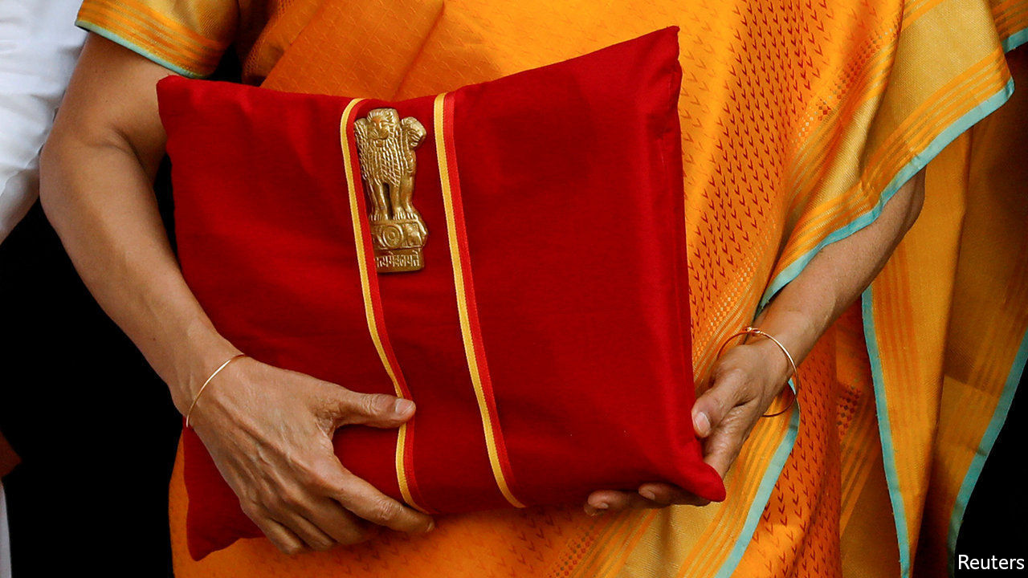

IN MOST BIG economies the government’s budget plans seldom drive large movements in the stockmarket. Except in India. Bosses and investors parse the documents for clues about which industries or firms gained favour and which fell out of it. Markets react accordingly. In February 2008 the Mumbai bourse’s main index fell by 12% in five days after India’s then-rulers were perceived to have responded inadequately to the global financial crisis. This year’s budget came on February 1st, a Saturday. Stockmarkets held a special weekend session. Bosses and investors were glued to TV screens as the finance minister, Nirmala Sitharaman, recited the provisions—until, after a record two hours and 41 minutes, she was too exhausted to go on.

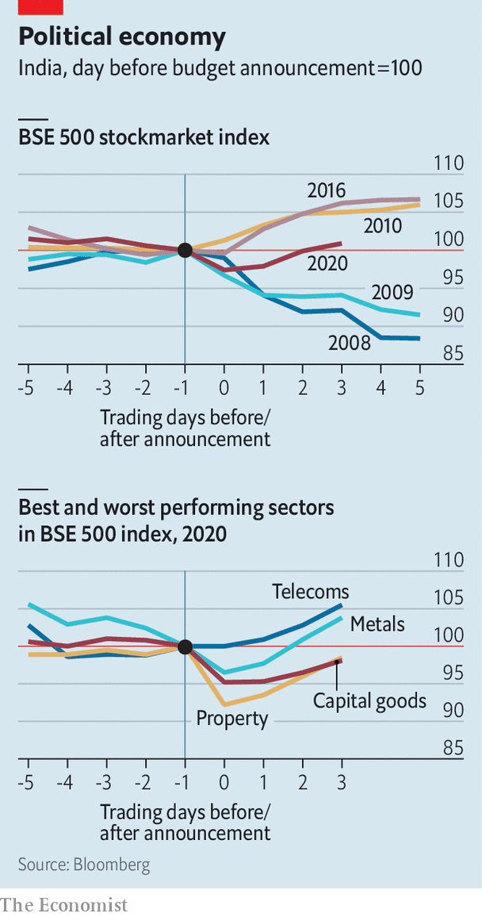

The viewers apparently felt as deflated; share prices sagged. New duties were imposed on, among others, paper clips, crockery, fridge compressors and circuit boards, and lifted on thoroughbred horses, for example. Over the next three days shares rebounded, perhaps out of optimism that measures such as the sale of state assets might actually come to pass for once. ■

This article was downloaded by calibre from <https://www.economist.com/business/2020/02/08/why-indias-annual-budget-is-a-powerful-market-force>

|  |  |  |  |
| --- | --- | --- | --- |
| Previous | Articles | Sections | Next |

|  |  |  |  |
| --- | --- | --- | --- |
| Previous | Articles | Sections | Next |

#### Schumpeter

# Away from the headlines, defence is Boeing’s next problem

Ace in a hole

Feb 8th 2020 |

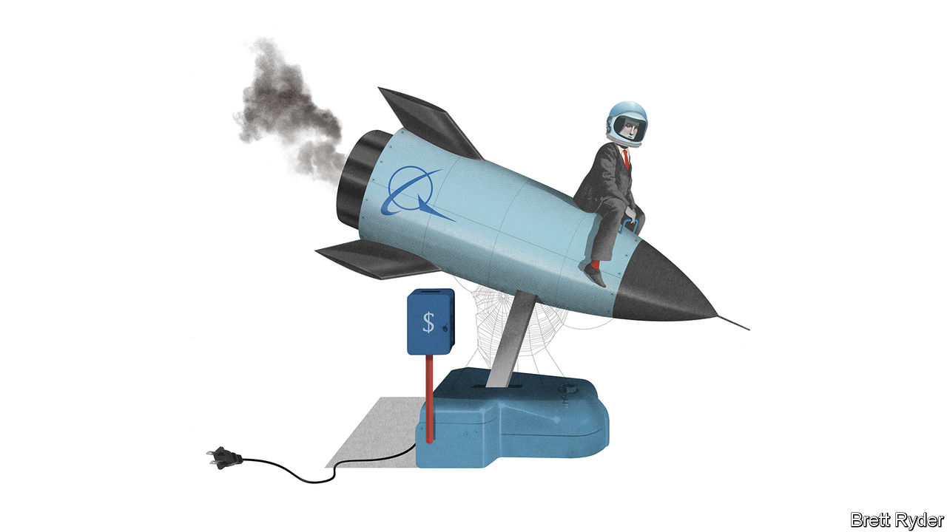

AMID THE crisis over the 737 MAX it is easy to forget that there is more to Boeing than passenger jets. Its Minuteman intercontinental ballistic missiles, which John F. Kennedy called America’s “ace in the hole” during the Cuban missile crisis, and the B-52 bombers (“Big Ugly Fat Fellas”) that lumbered over Vietnam are not just part of America’s 20th-century iconography. These pieces of military hardware are still in use today. Boeing’s space business, which helped put Americans on the Moon, is again trying to fly them into orbit. With its huge commercial-aviation division in disarray, it should fall to Boeing’s venerable defence, space and security division (known as BDS) to bolster earnings and morale. Yet it, too, appears to be suffering from neglect: subscale, long in the tooth and in slow relative decline.

For most military contractors apart from Boeing, this is boom time in America. Defence budgets have increased since the start of Donald Trump’s presidency in 2017. Share prices are buoyant. Last year revenues at Lockheed Martin, Northrop Grumman and Raytheon rose by more than 10% on average, largely because of snazzy fighter-jet and missile contracts. At BDS they fell by 1%.

The reasons for BDS’s weakness were not MAX-related. They reflected a combination of factors, including the end of sales of C-17 transport aircraft and Boeing’s costly failure just before Christmas to dock its Starliner spacecraft at the International Space Station. Some revenue also went into Boeing’s relatively new services arm. Few analysts cared. As Ken Herbert of Canaccord Genuity, a financial firm, notes, the MAX crisis has sucked everyone’s attention away from other parts of the business. Still, deep-seated problems at BDS could weigh further on Boeing’s profitability and reputation even once it puts the MAX crisis behind it. As if he did not already have enough on his plate, David Calhoun, Boeing’s new boss, faces a strategic quandary.

Boeing has long proclaimed the merits of running defence and space alongside its commercial-aircraft business. Though the commercial side is bigger, their relative weights fluctuate in times of trouble. Last year, for instance, as a result of the MAX’s grounding, commercial-aviation’s share of group revenues fell from 57% to 42%. BDS’s share jumped to 34% from 26%. While the commercial arm suffered a huge loss, BDS made a decent profit. This shows how the structure can help smooth earnings. The company says that BDS showed its mettle in 2018 by winning highly contested defence contracts, such as a programme to provide trainer jets to the air force and aerial refuelling drones to the navy, which could be highly lucrative. Moreover, the almost 50-year-old F-15 fighter jet, one of its profitable warhorses, has been given a new lease of life. Late last month the air force said it would buy from Boeing its first new F-15EXs.

This account masks problems. Some were long overlooked while its passenger-jet business was booming. First, BDS is sub-scale. Its revenues last year were less than half those of Lockheed, and a bit smaller than those of Northrop and Raytheon. Its capital expenditure was a sixth of an average of the three. It is decades since Boeing won the most coveted sort of Pentagon contract, to design and build a new military aircraft from scratch. BDS has no role in the F-35 Joint Strike Fighter led by Lockheed, nor in Northrop’s long-range stealth bomber. Both could reap huge windfalls for their makers. Its lack of commitment to bold innovation is reminiscent of Boeing’s fateful decision to tweak the ageing 737, which ultimately contributed to the MAX’s tragic technical failures, because of pressure to keep up with Airbus, its biggest passenger-jet rival.

Second, it is poor at carrying out the projects it wins. This is a growing financial risk, because the Pentagon is offering fewer cushy “cost-plus” contracts, where it pays contractors an agreed premium over a project’s expenses. These are being replaced by fixed-price deals in which the armsmakers bear more risk. Soon after winning the trainer-jet and drone contracts in 2018, Boeing recorded a nearly $700m loss on them, suggesting it had underestimated development costs. It has also booked losses of more than $3.7bn on a long-overdue contract, potentially worth $44bn, to provide airborne tankers to refuel planes. The air force has criticised Boeing’s performance on the nine-year-old project.

Third, the MAX crisis compounds BDS’s problems. Defence contracts are lumpy, requiring high upfront spending for a large long-term pay-off. While Boeing is burning cash with the MAX, its ability to bid big in defence contracts is constrained. Last year the company pulled out of a contest worth at least $62bn to replace the Minuteman-series missiles, the sort of contract that used to be its bread and butter. Boeing insists its withdrawal had nothing to do with the MAX crisis. Analysts speculated that the cash commitment required to win this Ground-Based Strategic Deterrent contract may nevertheless have played a role in its decision.

## Defenceless?

If the MAX returns to the skies soon, as Boeing hopes, investors’ attention may turn to bigger-picture issues, including the future of the defence business, says Seth Seifman of JPMorgan Chase, a bank. One option is a break-up, but if nothing else, the bigger Boeing is, the less likely it will be allowed to fail. BDS’s main customer, America’s Defence Department, which frets about insufficient competition, would object to any weakening of BDS. So would many Boeing investors, who hope budgets for defence and space will keep rising if Mr Trump is re-elected. Yet Boeing may need to consider selective defence and space divestments, perhaps combined with targeted acquisitions. It is increasingly clear to everyone, including no doubt Mr Calhoun, that Boeing’s problems go beyond the MAX. The company is misfiring on many cylinders. The Big Ugly Fat Fella, a lovely moniker for a B-52, sounds less appealing when applied to Boeing itself.■

This article was downloaded by calibre from <https://www.economist.com/business/2020/02/08/away-from-the-headlines-defence-is-boeings-next-problem>

|  |  |  |  |
| --- | --- | --- | --- |
| Previous | Articles | Sections | Next |

|  |  |  |
| --- | --- | --- |
| Business | Sections | Science and ... |

Finance and economics

Hong Kong’s economy: A train of troubles

.

China’s economy: Viral injections

.

Contagion effects: What the coronavirus means for financial markets

.

Financial markets: Knocking off work

.

ICE bids for eBay: Making an offer

.

Banking in India: Small change

.

Buttonwood: Two tribes

.

Free exchange: Progress of a sort

.

|  |  |  |
| --- | --- | --- |
| Business | Sections | Science and ... |

|  |  |  |  |
| --- | --- | --- | --- |
|  | Articles | Sections | Next |

#### A train of troubles

# Just how stable is Hong Kong’s economy?

The financial centre faces protests, a trade war, and now the coronavirus

Feb 8th 2020 | HONG KONG



“I WANTED TRAVELLERS to arrive and know exactly which city they were in,” wrote Andrew Bromberg, an architect, to explain his design for West Kowloon station, where high-speed trains arrive in Hong Kong from mainland China. The platforms are deep underground, but passengers can enjoy the city’s skyline through 4,000 glass panes suspended from the station’s tilted roof. The more adventurous can go up to the rooftop for a better view.

But not anymore. The station and its rooftop are cordoned off. Four of the 21 people in Hong Kong that have been infected with the Wuhan coronavirus arrived in the city by high-speed rail. The station has now been closed, alongside ten of the other 13 entry points from the mainland.

These closures may or may not slow the spread of the disease. But they will certainly hamper an economy already debilitated by months of fierce anti-government protests. Figures released on February 3rd showed that GDP shrank by 2.9% year-on-year in the last quarter of 2019, when the protests reached a peak. Worse may be to come. Analysts at UBS, a bank, expect a fall of over 6% in the first quarter of this year compared with the same period last year.

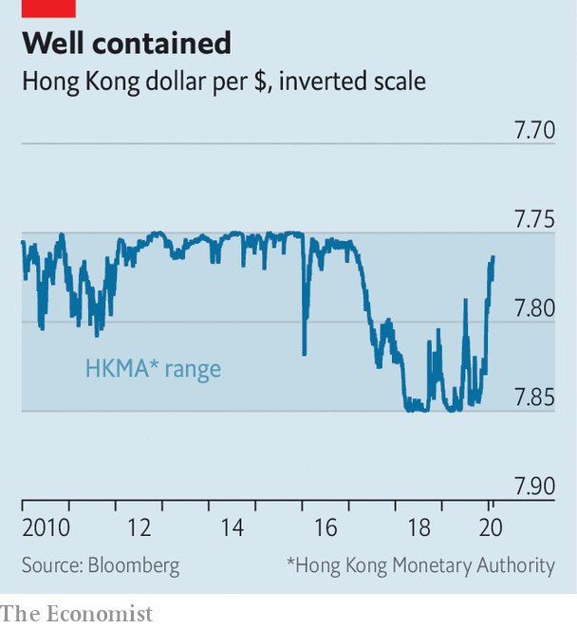

In other economies rocked by the virus, such as mainland China, Thailand and Singapore, the central bank has let the currency depreciate, easing financial conditions. But Hong Kong is different. Its currency has been tied to the American dollar since 1983 and confined to a narrow trading band of HK$7.75–7.85 to the dollar since 2005. If it falls to the weak side, the Hong Kong Monetary Authority (HKMA) is obliged to sell as many American dollars as people want to buy for HK$7.85. That has stopped the currency falling further (see chart).

But will it always do so? Even before the protests erupted or the virus mutated, some observers began to wonder if the peg would endure. According to Hong Kong’s mini-constitution, its autonomy and even the existence of its own currency is guaranteed only until 2047, which is within the duration of a 30-year mortgage. Hong Kong, many fear, is destined to become just another Chinese city—and they do not have their own currencies. Even if it remains semi-detached politically, its economy is increasingly attached to China’s. Why should its financial conditions remain tethered to America’s?

In the forward-looking world of financial markets, that question leads naturally to another: if Hong Kong’s currency regime is destined to change some day, how hard would Hong Kong fight for it today, if the markets tested its will? Such a test is not too hard to envisage. In December, property prices fell by 1.7%, compared with the previous month, and are now almost 5% below their peak. If those falls gained momentum, speculative capital might quit the market and the city. A collapse in property prices would also test the banking system. Its assets are worth 845% of Hong Kong’s GDP (although only 30% of its total loans are spent on Hong Kong property development or home purchases). And many of the deposits on the other side of its balance-sheet are held by non-residents, who might prove flighty in a crisis.

According to its defenders, Hong Kong’s currency peg is “virtually impregnable”. The HKMA’s foreign-exchange reserves amount to $440bn, twice as much as the money supply, narrowly defined to include banknotes and the banks’ claims on the monetary authority. The banks would run out of Hong Kong dollars before it ran out of American ones.

Why then is it only “virtually” impregnable? For one thing, there are broader definitions of money supply. A war chest of $440bn may be large compared with banks’ deposits at the HKMA. But it is small compared with customers’ deposits with banks (HK$6.9trn, equivalent to $880bn). If every depositor wanted to convert their holdings into American dollars, there would not be enough to go around.

Such conversions would also have broader economic implications. Every Hong Kong dollar sold to the monetary authority disappears. All else equal, it then becomes dearer for the banks to borrow the diminishing number of Hong Kong dollars that remain. These high interest rates make holding the currency more lucrative and short-selling it more costly. But insofar as households and firms still need to borrow in Hong Kong dollars, these high interest rates also hurt the economy. How much pain would Hong Kong be willing to take?

The peg’s downfall may be imaginable. But is it probable? One place to look is the options market, where investors can hedge against the risk of the currency moving outside the band. For about 40% of the period from June 2005 to July 2018, option prices implied that the odds of the peg breaking were above 10%, suggests a recent study by Samuel Drapeau, Tan Wang and Tao Wang of Shanghai Jiao Tong University. But for most of that time markets were betting on the currency strengthening past HK$7.75 to the dollar, not weakening past HK$7.85.

Bearish bets became more popular last year during the worst of the protests. But the speculation was not as fierce as it had been in 2016, after China clumsily devalued the yuan. Capital outflows picked up in the third quarter of last year, diminishing Hong Kong’s foreign-exchange reserves. But reserves have stabilised since, helped by a truce in the trade war between America and China. Hong-Kong dollar deposits are lower than they were six months ago, but still higher than they were a year ago.

Any signs of sustained capital outflows are, then, “embryonic”, says Alicia Garcia Herrero of Natixis, a bank. If capital is leaving, its speed of departure is reminiscent of one of Hong Kong’s quaint trams, not one of its bullet trains.■

This article was downloaded by calibre from <https://www.economist.com/finance-and-economics/2020/02/08/just-how-stable-is-hong-kongs-economy>

|  |  |  |  |
| --- | --- | --- | --- |
|  | Articles | Sections | Next |

|  |  |  |  |
| --- | --- | --- | --- |
| Previous | Articles | Sections | Next |

#### Viral injections

# Companies warn of an economic crisis as China battles coronavirus

The government steps up support, not to boost growth but to ensure social stability

Feb 8th 2020 | SHANGHAI

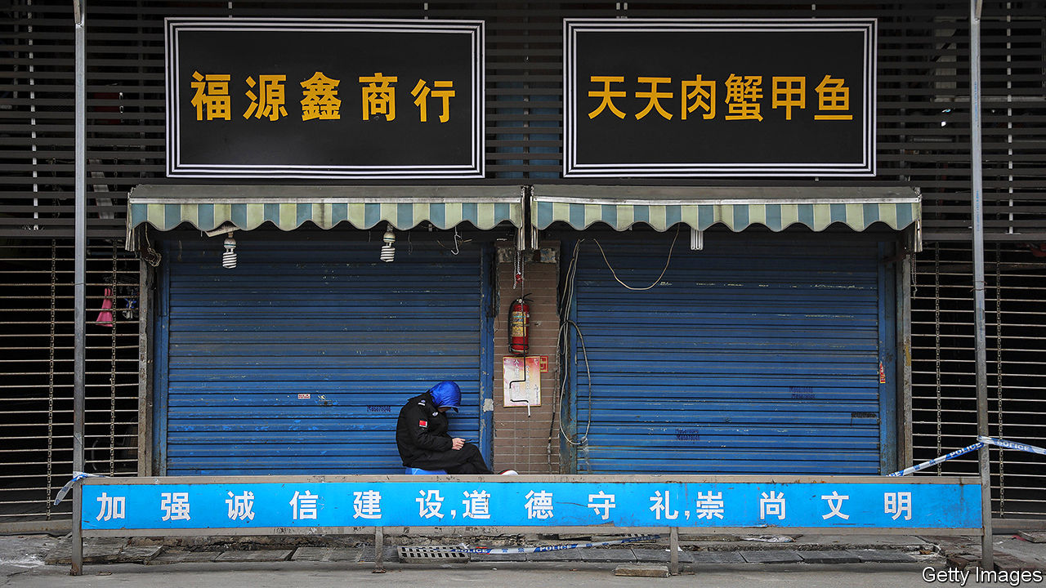

RARELY HAVE plans in China fallen apart so swiftly and so publicly. On January 12th the leaders of Hubei declared that the province’s GDP would grow by 7.5% this year. They made no mention of a new virus fast spreading through its towns and cities. But less than two weeks later it could not be ignored. They placed the province under quarantine, hemming in over 50m people and rendering this year’s flashy growth target almost certainly unreachable.

The lurch from confidence to anxiety has echoed throughout China. In the months before the coronavirus outbreak, the stockmarket had rallied and businesses had been upbeat, not least because China and America had struck a trade deal. But optimism has crumbled as officials have begun to fight the epidemic.

The Chinese stockmarket has fallen by 10% since January 20th. Factories and offices were supposed to reopen in recent days after the new-year holiday. Most provinces have ordered them to stay shut until at least February 10th. Farmers have warned that their chickens might starve because roadblocks have snarled their feed supplies. Few people dare venture out, hitting restaurants and hotels especially hard. In an interview that attracted much attention before being censored, the founder of Xibei, a restaurant chain, said that if the lockdown persisted for a few months, vast numbers could lose their jobs. “Wouldn’t that be an economic crisis?” he asked.

Analysts have rushed to lower their economic forecasts. The consensus had been that GDP would expand about by 6% year-on-year in the first quarter. Now several expect a 4% pace, the slowest since China began publishing quarterly figures in 1992.

Usually, the further into the future you peer, the greater the uncertainty. But as past epidemics have shown, China’s officials can be fairly confident that growth will rebound to its pre-virus trajectory next year. It is the next couple of months that are the black hole. Three unknowns cloud the outlook: how long it takes to contain the virus; when the government relaxes its heavy-handed restrictions on daily life; and how long after that people resume the whirl of activity that normally makes the Chinese economy so vibrant.

This near-term uncertainty presents a challenge for economic policy. Even if growth plummets, a big stimulus package might be dangerous medicine. Given the lag in spending, the boost from projects announced today could kick in just as the economy gathers steam of its own, leading to overheating. Instead, measures to help people and firms through the rough patch are more sensible. These can be pared back when the recovery eventually arrives. Getting them right, though, is not easy.

Officials are combining temporary cash support with market interventions and forbearance. On February 3rd the central bank injected 1.2trn yuan ($172bn) into the financial system by purchasing treasury bonds from banks that promise to buy them back within 14 days. Banks will probably suffer from rising loan defaults in the coming weeks; this gives them more cash to work with in the near term. The central bank can extend the support if needed.

Officials are also meddling in the stockmarket (or, as they would say, managing it). Regulators have told brokers to bar clients from short selling, so as to limit downward pressure, according to Reuters. State media have also played cheerleader, saying that big state-owned insurance companies were primed to scoop up undervalued stocks. Share prices still dropped by 8% on February 3rd. But that was largely a catch-up with the Hong Kong market, which had been open the previous week. Trading has since stabilised, suggesting that the tactics are working.

Finally, officials have been orchestrating forbearance on various fronts. Shanghai was due to raise companies’ social-security contributions on April 1st. That has been delayed by three months, saving firms an estimated 10bn yuan. In Beijing officials have encouraged landlords to cut their commercial tenants’ rents, in exchange for subsidies. And regulators have called on banks nationwide to roll over loans to companies that would otherwise lack the cash buffers to survive.

Even as the death toll mounts, some officials are already thinking about the economic distortions that have arisen in the course of the battle against the epidemic. Hospitals face shortages of masks, gowns and gloves. At the government’s urging, producers have increased output. But as Liu Shangxi, an adviser to the finance ministry, has noted, they will suffer from severe overcapacity after the crisis passes. The government should thus be ready, he argues, to compensate them.

Such proposals are a far cry from the bold plans that Hubei’s leaders laid out only a few weeks ago. Yet the priority these days is not to gee up growth but to ensure that society remains stable as the quarantines drag on. China’s grim new reality is that everything, even economic policy, revolves around beating the virus. ■

This article was downloaded by calibre from <https://www.economist.com/finance-and-economics/2020/02/08/companies-warn-of-an-economic-crisis-as-china-battles-coronavirus>

|  |  |  |  |
| --- | --- | --- | --- |
| Previous | Articles | Sections | Next |

|  |  |  |  |
| --- | --- | --- | --- |
| Previous | Articles | Sections | Next |

#### Contagion effects

# What the coronavirus means for financial markets

The prices of assets most exposed to China have suffered

Feb 8th 2020 |

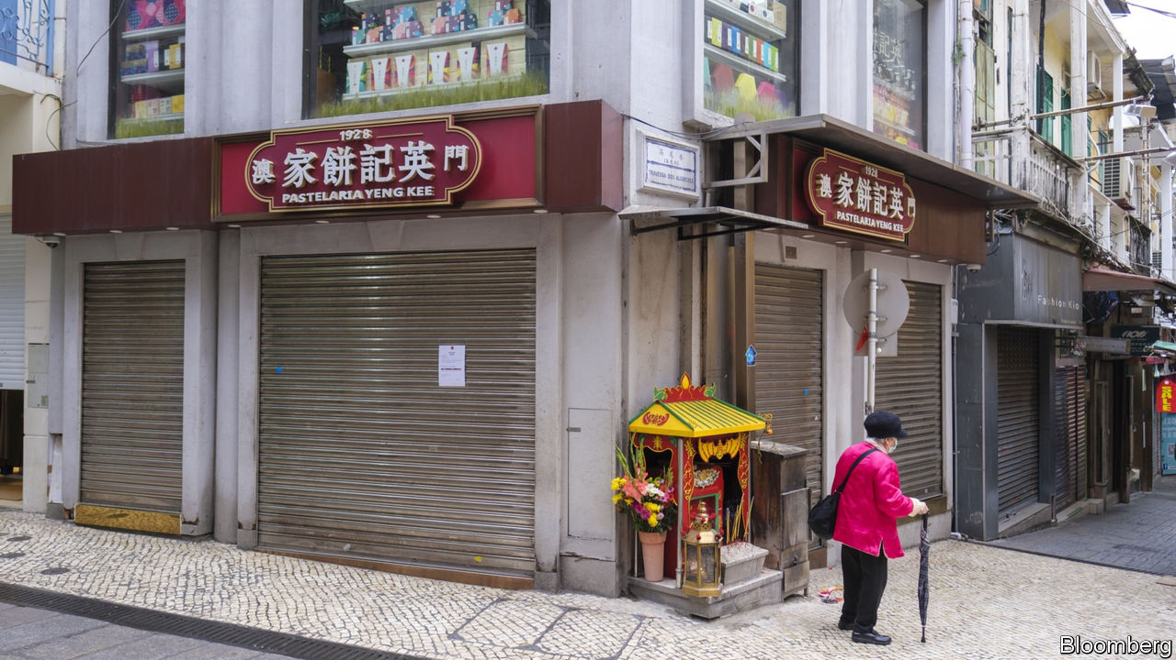

GLOBAL SHARE prices have so far been relatively immune to the spread of coronavirus. But assets most exposed to China have suffered. Currencies of economies integrated with its supply chains have weakened. Prices of commodities, of which China is usually a big buyer, have slid. Share prices of both manufacturing and consumer-facing companies operating in China have fallen, as factories stay shut and people stay home.■

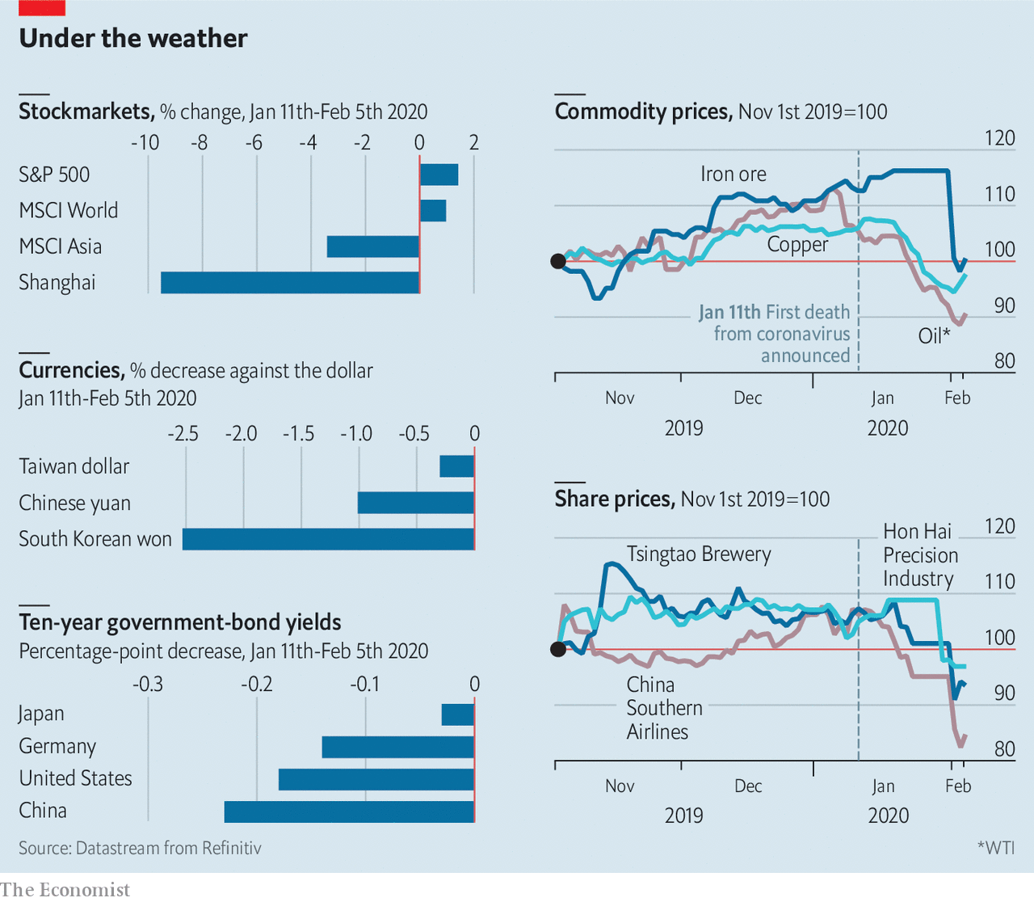

This article was downloaded by calibre from <https://www.economist.com/finance-and-economics/2020/02/08/what-the-coronavirus-means-for-financial-markets>

|  |  |  |  |
| --- | --- | --- | --- |
| Previous | Articles | Sections | Next |

|  |  |  |  |
| --- | --- | --- | --- |
| Previous | Articles | Sections | Next |

#### Knocking off work

# Traders lose interest in America’s jobs report

Markets react less to jobs data than they did before the financial crisis

Feb 8th 2020 |

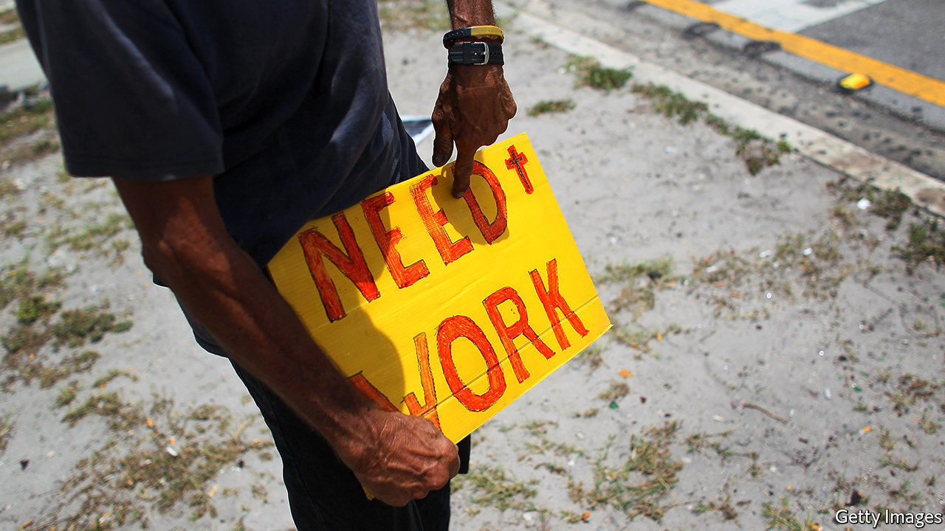

BY 9.30PM ON the first Friday of the month, the bars in Marunouchi, Tokyo’s financial district, used to empty out as foreign-exchange traders returned to their desks. London’s investment bankers, back from lunch, would be sharp and alert, helped by a rare early night. All awaited perhaps the world’s most important data release: America’s jobs report.

The release—which includes figures on non-farm employment, the unemployment rate and wages—often generated sizeable market moves. On average, five-year Treasury yields moved by 0.17 percentage points on the day of the report in 2004. The four biggest daily moves that year occurred after a release. Since then, though, market reaction has cooled (see chart). In 2019 yields barely budged, moving by less than 0.04 percentage points on publication. What explains the lack of excitement?

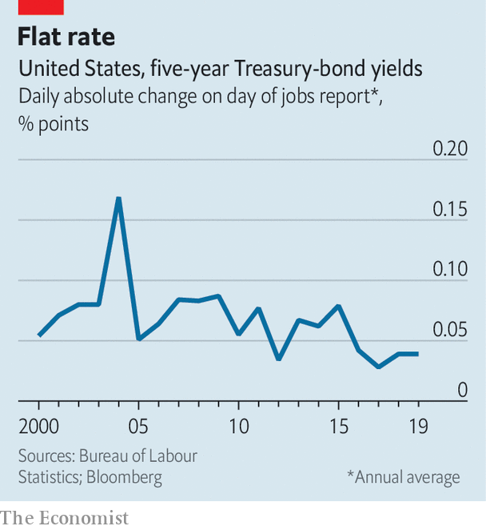

Before the financial crisis jobs data were thought to give a good signal about the likely actions of the Federal Reserve, which is tasked with ensuring maximum employment and stable inflation. The more people in jobs, the thinking was, the closer America got to full employment. A tighter labour market would push up wages and consumer prices. (In other words, what economists call the Phillips curve, which plots inflation against the unemployment rate, sloped downwards.) That made it more likely that the Fed would raise interest rates, making dollar assets more attractive. As most financial assets are priced in dollars, the data took on worldwide significance. Hence Marunouchi’s emptying bars.

The reason for the subsequent lack of interest is that falling unemployment is no longer a good guide to the Fed’s actions. Inflation has been unusually quiescent. The unemployment rate has fallen from 9% in 2011 to 3.5%, the lowest rate in 50 years. If the usual Phillips-curve relationship held, a rise in inflation would have followed. In fact, it has fallen: personal-consumption expenditure inflation, the Fed’s preferred measure, has slipped from 2% to 1.6%. At first that prompted Fed officials to think that there was more slack in the labour market than they had assumed. Lately it has caused them to doubt that the amount of slack is knowable at all, and to wait for inflation to pick up rather than predicting it based on jobs data.

As a result markets no longer expect strong payroll numbers to be followed by interest-rate rises. Traders still pay attention to the wage figures in the report, though. In February 2018 a larger than expected pickup in average hourly earnings, together with a flat unemployment rate, led to a spike in bond yields and a stockmarket sell-off. But pay growth has lost momentum since, even as unemployment has fallen. Ahead of this month’s jobs report, due on February 7th, after The Economist went to press, traders might be forgiven for choosing to stay at the bar. ■

This article was downloaded by calibre from <https://www.economist.com/finance-and-economics/2020/02/08/traders-lose-interest-in-americas-jobs-report>

|  |  |  |  |
| --- | --- | --- | --- |
| Previous | Articles | Sections | Next |

|  |  |  |  |
| --- | --- | --- | --- |
| Previous | Articles | Sections | Next |

#### Market making

# Why Intercontinental Exchange wants to buy eBay

Explaining a new and weird putative corporate combination

Feb 8th 2020 | NEW YORK



THE HIGH STREET and Wall Street feel like very different places. One is lined with soft-lit storefronts showing tempting goods, to entice the customer in. The other is home to rows of gleaming skyscrapers, with snooty receptionists and fiercely guarded lift banks, in order to keep the riff-raff out. But the core purpose is similar. Both are venues for interested parties to get together and trade things—be they Dior suits or shares in Microsoft.

On February 4th the Wall Street Journal reported that Intercontinental Exchange (ICE), a company that owns various financial-markets platforms including the New York Stock Exchange (NYSE), was in talks to buy eBay, an online marketplace for used goods. The deal would value eBay at around $30bn, roughly $2bn more than its market capitalisation before the news broke. Its share price jumped 9%.

The news baffled financial analysts. Christopher Harris of Wells Fargo, a bank, said the deal would go beyond ICE’s “core competency”. ICE’s investors were similarly befuddled. Its share price fell by 7% on the news of the potential deal.

They have a point. ICE was set up in 2000 to run a commodity-futures exchange. It now runs 12 exchanges worldwide and operates six clearing-houses, entities that manage counterparty risk for financial transactions. These involve armies of—mostly—savvy participants and are characterised by abundant liquidity, high transaction volumes and low transaction costs. By contrast, the market for used goods involves amateur buyers and sellers operating under uncertainty about quality, price and authenticity.

ICE has also proven adept at making marketplaces that do not work very well more efficient, though. Since buying NYSE in 2013 ICE has cut its expenses, revamped its outdated trading platform and renovated its historic headquarters.

EBay, for its part, is in a difficult spot. The platform has lagged behind those of Amazon or Walmart. Under pressure from Carl Icahn, an activist investor, it spun off PayPal, an online-payments business, in 2015. Back then the combined firm was worth $80bn, around $45bn of which was in PayPal and the rest in eBay. Today PayPal is valued at $140bn; eBay is worth a little less than it was in 2015.

Activists have not left eBay alone. Elliott Management and Starboard Value, two activist funds, pushed for it to spin-off StubHub, a ticket reseller, and its classifieds business. EBay later acquiesced, selling its ticket business and giving the activists board seats. But shortly after that Devin Wenig, its long-standing chief executive, stepped down, citing differences with the new board. The firm has yet to find a permanent replacement.

Whether the deal goes ahead is still unclear. ICE has acknowledged its approach, but both companies say they are not in formal talks. That ICE took an interest at all, though, is curious. Helped by better data and whizzy algorithms, some retail platforms are already exhibiting financial-market characteristics, such as dynamic pricing. That a financial-markets behemoth wants to muscle into retail suggests that it too sees a future in which the high street looks more like Wall Street. ■

This article was downloaded by calibre from <https://www.economist.com/finance-and-economics/2020/02/08/why-intercontinental-exchange-wants-to-buy-ebay>

|  |  |  |  |
| --- | --- | --- | --- |
| Previous | Articles | Sections | Next |

|  |  |  |  |
| --- | --- | --- | --- |
| Previous | Articles | Sections | Next |

#### Small change

# Ujjivan is a rare bright spot in Indian finance

Its shares are up 50% since an IPO in December

Feb 8th 2020 | BANGALORE

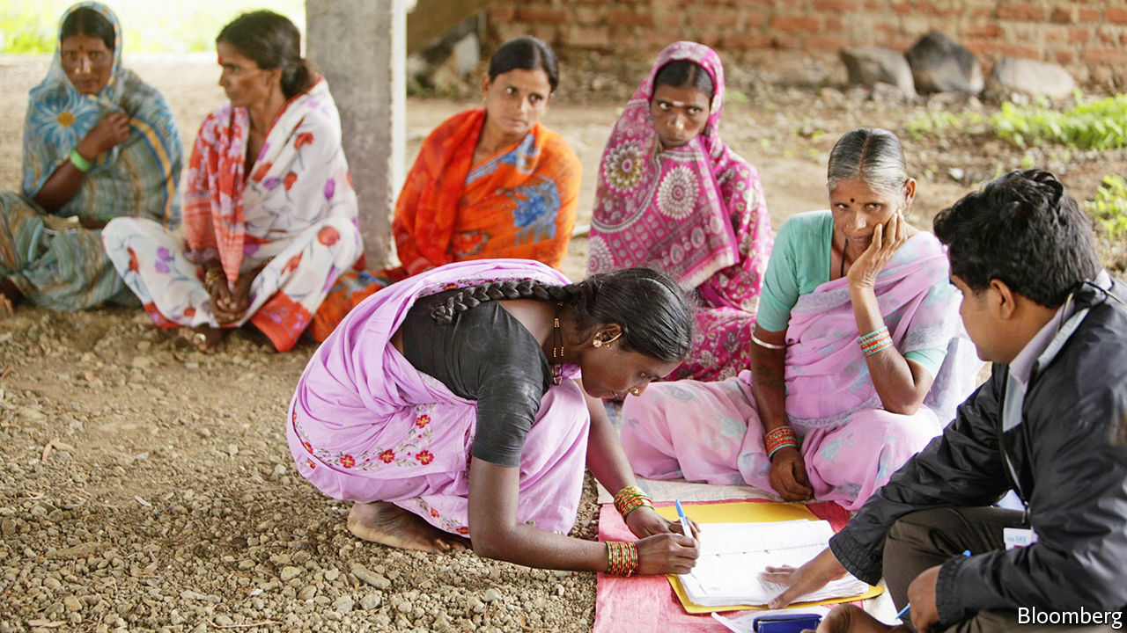

A DOZEN WOMEN dressed in saris sit on benches at the branch of the Ujjivan Small Finance Bank on Koramangala 80 Feet Road, awaiting disbursements of tiny loans. The money is needed for school fees, to finance home businesses or, in a couple of cases, bigger ventures that will have employees and assets. One is hoping to produce pickles; another wants working capital for a welding shop.

Ujjivan (“uplift” in Sanskrit) was founded in 2005 to bring the group-lending techniques being pioneered in rural microfinance to urban slums. The Koramangala branch is now one of 552 in India. This growth, and the extension of the ideas underpinning microfinance to loans for small rather than tiny businesses, reflect how the approach is maturing. Samit Ghosh, the founder, has held senior roles in Citibank and HDFC Bank, both of which played big parts in transforming Indian retail banking for the middle classes and above. Yet, despite that pedigree, raising a few hundred thousand dollars as seed capital was, he says, the hardest task of his career.

How times have changed. Many of India’s largest banks are on a perpetual hunt for fresh capital or a government bail-out; Ujjivan, which as a condition of its banking licence was forced to list its shares in December, was flooded with eager investors. Its share price is up 50% since then, doubtless a source of joy to its 17,000 employees, who all hold stock.

What drew investors was its stunning growth. It now has 5m clients and $1.8bn in assets. Around 70% of its lending is administered through groups, with members receiving an average loan of under $500. The rest goes to individuals in chunks that are three times as large. The women in saris have been solid borrowers. Losses are only 0.3% of assets per year, return on assets is 2.5% and return on equity 20%. Reinvested profits have enabled remarkable loan growth: assets are up by almost half in the past year. Few lenders in India produce returns anywhere close; among them are Equitas and AU Small Finance, which have similar histories and clients.

Perhaps the most important factor behind this success is the size of the potential market—300m people who are just above very poor, says Nitin Chugh, who took over as chief executive from Mr Ghosh in December. The competition comes from loan sharks, who charge at least 4% a month—60% a year—and sluggish state banks. Ujjivan charges 22% a year for group microfinance, 18% for micro- and small businesses, and 12% for housing. This, of course, is still steep. The spread between its lending and funding costs is 11%. For many large banks, the figure is less than 3%.

Inevitably, that will contract, if only because Ujjivan’s success attracts competition. But for now the costs inherent in making small loans might put rivals off. Nine of the 11 bankers in Ujjivan’s Koramangala branch spend their days straining to make 15-20 sales calls to customers who may not understand banking. Better methods may, however, be coming, particularly because of the adoption of technology.

India’s government has created identification cards and payment networks that make opening accounts easier. Ujjivan is in the midst of a serious effort to make that digitised network work for the illiterate—a large if unquantified proportion of its customers—in ways that both broaden the bank’s appeal and reduce its costs. Already, its app’s voice-recognition feature can understand and speak in nine languages, which will soon increase to 14 and then 22. This will work in tandem with a picture-based interface that allows customers to conduct electronic transactions without needing to read.

Ujjivan’s success stands in stark contrast to much of the rest of India’s financial system, which is in a slow-boil crisis, with answers being demanded from large banks, regulators and politicians. But the rise of an innovative lender engaged with poorer customers suggests there are grounds for optimism, albeit arising from the country’s slums, not its leaders. ■

This article was downloaded by calibre from <https://www.economist.com/finance-and-economics/2020/02/08/ujjivan-is-a-rare-bright-spot-in-indian-finance>

|  |  |  |  |
| --- | --- | --- | --- |
| Previous | Articles | Sections | Next |

|  |  |  |  |
| --- | --- | --- | --- |
| Previous | Articles | Sections | Next |

#### Buttonwood

# The culture wars between economists and markets practitioners

The latest spat is over whether the Fed is doing QE by the back door

Feb 8th 2020 |

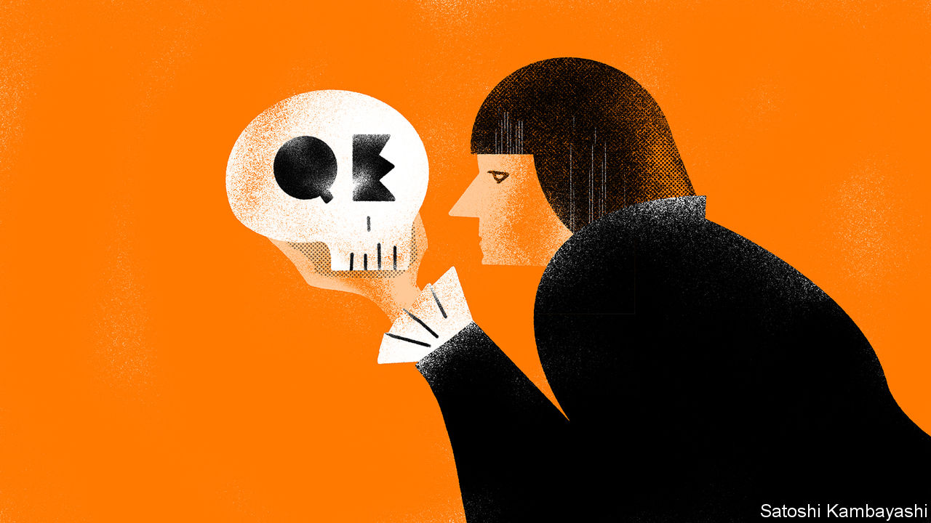

SHOVE HARD and any group can be sorted into contrasting stereotypes: larks and owls; thinkers and doers; conservatives and progressives. Shove again (or simply stir), and you have the makings of a clash. There is a culture war of this kind even in finance. The two bickering tribes are economists and practitioners, such as traders and fund managers. Economists use formal models based on theory. They are rigorous, sometimes to the point of pedantry. Practitioners’ thinking is looser and more intuitive.

The battleground, invariably, is monetary policy and its effects. To outsiders their latest spat—over whether the Federal Reserve’s large-scale purchases of Treasury bills since October counts as a stealthy revival of quantitative easing (QE)—seems obscure. Yet it is part of a broader question that has important implications. For a vocal group of practitioners, central-bank policy has grossly distorted financial markets for a decade. For central bankers and their economist outriders, asset prices are a sideshow.

Who is right? Everybody likes to think they exhibit the best attributes of both schools—the rigour of the economist and the market-smarts of the practitioner. In fact they may borrow the worst habits from each. So, allow Buttonwood to walk into the trap that has been set for him: both camps are wrong.

There is certainly no love lost. For economists, a lot of market talk is shallow and naive. A decade ago a charge heard mainly from practitioners was that QE would lead to hyperinflation. The context seemed not to matter: that QE was pushing against powerful deflationary forces; that the huge increase in central-bank reserves met a deep need in financial markets for safe and liquid assets. Central bankers and economists have not been forgiven for getting that one right. Yet it also the case that a lot of central-bank speak is disingenuous. One of the many talents of Mario Draghi, the former head of the European Central Bank, was to keep a straight face whenever he claimed the sole aim of the ECB’s bond-buying programme was to meet its inflation mandate. Why, you would be a fool to think that capping borrowing costs for indebted euro-zone countries, or devaluing the euro, was the goal.

Mr Draghi is excused, because his policies kept the euro zone intact. But the slipperiness of the Fed is a harder for practitioners to stomach. The roots of their latest spat go back to the end of 2017, when the Fed began to reverse QE. It was keen to put the process on autopilot, shedding so many bonds from its balance-sheet each month. This would be plain sailing, it said. Many practitioners were unconvinced. The markets had got used to functioning with ample central-bank liquidity. Sure enough, last September, money markets were suddenly short of cash. Overnight interest rates spiked. The Fed responded by liberally lending overnight cash. It has since bought truckloads of T-bills. Its balance-sheet, which had shrunk from $4.5trn to $3.8trn, has been expanding again ever since. Reserves are up, shrieked the practitioners. QE is back!

Case closed? Actually, no. The Fed has not admitted it screwed things up, which is galling. But it is nevertheless quite correct that the remedy it has fixed on is not QE. When the Fed adopted the policy after the financial crisis, it had run out of room to cut short-term interest rates, and so decided to drive long-term interest rates down by buying longer-dated bonds. The goal was to extend the stimulative effect of monetary policy by depressing the term premium—the reward investors get for holding long-term bonds instead of a series of short-term bills. In essence, it was a swap of cash for assets. This is very different from what the Fed is now doing. It is essentially swapping cash (central-bank reserves) for its closest substitute (T-bills) in order to keep the Fed’s key policy instrument (short-term interest rates) where it wants it to be. This is monetary policy as described in textbooks. It is not QE by the back door.

The practitioners are paying the Fed a strange compliment. They attribute an almost mystical quality to the size of its balance-sheet. In fact central banks are mostly responding to events, not shaping them. Despite some extraordinary monetary loosening, inflation has hardly budged. In their own peculiar ways, practitioners and economists are anxious about what this long period of low interest rates might eventually entail. The economists deal with the uncertainty by clinging to their models; the market types by trashing the economists. QE or not QE is not really the question.

This article was downloaded by calibre from <https://www.economist.com/finance-and-economics/2020/02/08/the-culture-wars-between-economists-and-markets-practitioners>

|  |  |  |  |
| --- | --- | --- | --- |
| Previous | Articles | Sections | Next |

|  |  |  |  |
| --- | --- | --- | --- |
| Previous | Articles | Sections | Next |

#### Free exchange

# Economists discover the power of social norms

That makes some policies better at tackling gender inequality than others

Feb 8th 2020 |



OVER THE past generation women have made substantial economic gains, even as progress on other measures of social equality has been uneven. Their average level of education has caught up to that of men across rich and poor countries alike. Indeed in much of the rich world the share of young women with a college degree is now above that of men. Income may be divided less equally across the workforce as a whole, but it has become more evenly spread between men and women. In America women account for nearly 30% of the top tenth of earners, up from 5% in the 1960s. That said, progress is far from complete. Gaps in labour-force participation and pay persist. The nature of the obstacles holding back further progress has changed. Although economics ought to be keenly interested in such matters, not least because of gender inequalities in the profession, it has not always been of much help in understanding them. That is changing, however, in ways that could transform the field.

This evolution was apparent in January, in a lecture given by Marianne Bertrand of the University of Chicago. Over the past few decades, gender gaps in the rich world have had ever less to do with overt discrimination, she argued, and ever more to do with women’s decisions. Their choice of degree subject is one. Jobs in science, technology, engineering and maths have smaller gender pay gaps than others. But men are around twice as likely as women to graduate in such fields. More powerful still is the effect of childbirth. The birth of a first child has essentially no effect on a man’s earnings trajectory. By contrast a woman experiences a profound and lasting hit to her pay. The motherhood penalty, suggested Ms Bertrand, is easily the largest remaining contributor to gender gaps in labour markets.

Men and women alike opt to become parents, of course. But the unequal effect on earnings reflects their different responses to childbirth. Women are more likely to leave the labour force or to switch to part-time work. They often choose jobs that allow more flexibility, and accept lower pay as a consequence. Some studies, for instance, suggest that women take jobs with shorter commutes, to make time for their care responsibilities. In France, noted Ms Bertrand, the sacrifice in earnings associated with such decisions is estimated to explain 10-15% of the gender pay gap. It is women’s greater willingness to accept these trade-offs that accounts for diverging labour-market fortunes.

Economists, historically, have let the matter rest there, chalking such choices up to rational self-interest. Perhaps families decide that women have a comparative advantage in child-rearing, and should handle the parenting while men focus on their careers. Gary Becker, the late Nobel prize-winning economist, argued that households specialise in this way. Alternatively, perhaps women’s choices simply reveal their preferences: for subjects other than maths, for instance; or for time spent caring for children, rather than long hours at the office. And such preferences, economists have generally assumed, are to be taken as given. De gustibus non est disputandum, they say: there is no accounting for tastes.

But perhaps there is. As Ms Bertrand noted in her lecture, other social sciences, like social psychology, reckon that preferences are socially determined. In this view, people’s choices are influenced by norms, which specify the roles and behaviours that are appropriate for men and women. Survey evidence shows that, across a broad range of rich and poor countries, both men and women support the view that men should be first in line for a vacancy when jobs are scarce. The level of support varies—for instance it is much higher in Egypt than in Switzerland. But even in Switzerland, roughly a fifth of women agreed with the statement, similar to the share of men. Gender gaps in maths scores are larger in places where gender attitudes are more conservative. This suggests that social influences matter.

Defying social norms is possible but costly. Men who sacrifice their careers to raise children while their partners work may bear emotional costs, if, say, they are seen as being unmanly. Similarly, women who are seen to put their career before their family may face an emotional toll, related to their own guilt or the judgment of others, because of their decision to flout gender norms. The choices made under these pressures are still voluntary, but they reflect the influence of a self-perpetuating gender bias. Human resources may be allocated across the economy in a way that reflects this bias, rather than people’s abilities. Economists know these biases exist. Historically, however, they have tended to regard them as blunt descriptions of the state of the world, rather than evolving social forces that influence behaviour.

## Puncturing the patriarchy

Mitigating bias is not easy. Seemingly helpful interventions, such as generous maternity leave, can backfire if they reinforce the norm that women are natural caregivers. Better, Ms Bertrand argued, to favour measures that have no such implications, such as generous support for child care. Her own research suggests that a mother’s working status shapes her children’s perceptions of labour-market norms. Those surrounding men’s behaviour matter too. Survey evidence from Japan suggests that many men feel positively about taking paternity leave. But, because they wrongly believe other men do not feel the same way, they take less time off than they would like. Firms could potentially make their workers better off by, say, choosing to make paternity leave mandatory.

Ms Bertrand’s arguments may not seem particularly subversive. But they carry implications that extend beyond gender discrimination. Her analysis suggests that the decision to participate in a market is not simply about maximising utility given a set of tastes and constraints. Markets, rather, are part of a suite of fluid social forces that shape behaviour. Economists cannot claim to understand the markets until they understand those forces. ■

This article was downloaded by calibre from <https://www.economist.com/finance-and-economics/2020/02/08/economists-discover-the-power-of-social-norms>

|  |  |  |  |
| --- | --- | --- | --- |
| Previous | Articles | Sections | Next |

|  |  |  |
| --- | --- | --- |
| Finance and ... | Sections | Books and arts |

Science and technology

Agriculture: Farming with Tom, Dick and Harry

.

Oncology: The topography of tumours

.

Neuroscience: Lost in the city

.

|  |  |  |
| --- | --- | --- |
| Finance and ... | Sections | Books and arts |

|  |  |  |  |
| --- | --- | --- | --- |
|  | Articles | Sections | Next |

#### Farming

# Using artificial intelligence, agricultural robots are on the rise

Down on the farm with Tom, Dick and Harry

Feb 8th 2020 | WEST DEAN

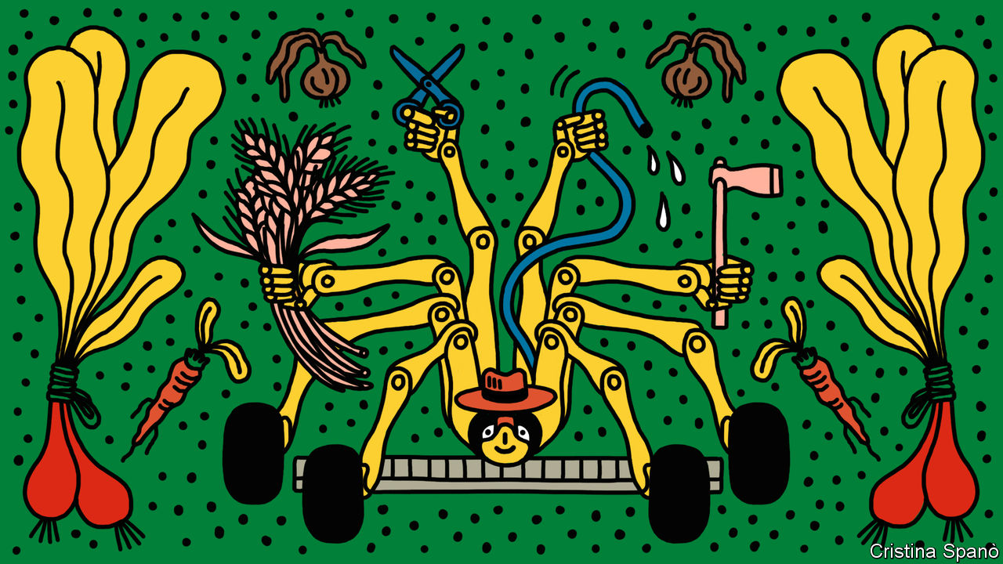

SLOWLY BUT surely, a spidery machine about the size of a golf cart swings an electrode over a tray of plants. Every few seconds there is a small puff of smoke as a weed keels over, having been zapped with a high voltage. The device doing the zapping is a prototype weeding robot developed by the Small Robot Company, a new firm operating out of an old munitions depot near Salisbury, in south-west Britain.

Such machines, called “agribots”, are appearing in many shapes and sizes from a variety of companies. Muddy tracks from other prototypes lead into the Small Robot Company’s workshop, where a row of 3D printers make bright orange components out of plastic. That makes parts easier to find should they fall off in a field, which is a sure sign that farmers are at work here, with roboticists and scientists.

Weed control is essential for improving crop yields, but it is getting increasingly difficult. Some weeds are becoming resistant to herbicides, which face stricter regulation and in some cases are being banned. On top of that, many consumers want organic produce. And labour shortages mean that repeatedly tilling the soil to disrupt weed growth using a mechanical hoe towed behind a tractor is costly, time consuming and not always practical.

Weeding is a chore that most farmers would happily hand to robots. But for a robot to do the job properly it must be able to distinguish a weed from what is being cultivated. That is becoming easier with advances in computer vision. Artificial-intelligence (AI) algorithms are getting better at classifying images. Some phone apps can now identify a plant from just a photo. Robots equipped with cameras will not only weed but automate other farming roles. Agribots, driverless tractors and other types of farm automation form an industry that is expected to grow at around 23% a year and to be worth more than $20bn by 2025, according to MarketsandMarkets, an American research firm.

Having spotted a weed, there are several ways to try to kill it. The Small Robot Company’s weeding agribot, called Dick, electrocutes them. The robot’s wheels work like an electrode to make contact with the ground while another electrode is moved to touch the plant. This makes a circuit through the plant and creates heat, effectively boiling the plant’s cells and killing it from stem to root instantly. It can take several thousand volts, although this is adjusted according to the type of weed. The remnants of the plant can then be left to naturally decompose into the soil.

## Shocking

Dick will work with two other agribots, Tom and Harry, all of them electrically powered. The idea, says Ben Scott-Robinson, one of the company’s co-founders, is that Tom will routinely scan fields to a level of detail of just a few centimetres. Using its cameras and other sensors, the spindly four-wheel-drive machine can cover about 20 hectares a day, mapping the health of every plant, along with soil conditions. When weeds appear, Dick will be dispatched to zap them. Harry, the third agribot, is under development for tasks such as seeding and applying precise levels of fertiliser to each plant, a process known as microdosing.

Tom will go into commercial production in August. Early versions are already in use on some farms in Britain, including the Leckford Estate, which is run by a large supermarket chain. Dick will begin trials later this year. Tom has already learnt how to spot broadleaved weeds and is being trained in the more difficult art of identifying grass-type weeds, which look similar to cereals. Unlike many vegetables, cereals are grown more densely in rows, which makes the mechanical hoeing of weeds a tricky operation. Armed with Tom’s algorithms, Dick should be able to zap grassy weeds in cereals accurately.

The company will offer its robots as a service. Tom will live in a kennel on the farm, where it will download data for the farmer and recharge. Dick and Harry will be delivered to farms as and when they are needed, much as farmers already bring in contractors. This business model, reckons Mr Scott-Robinson, will demonstrate to farmers that the cost of using agribots will be competitive with other weed-control measures and provide additional benefits, such as being chemical-free.

Dick’s zapping system is supplied by RootWave, another small British company, based near Leamington Spa. RootWave, which calls the process “electricide”, already makes a hand-held version for spot weeding. Electricide does not disturb the soil or harm microbes, says Andrew Diprose, the firm’s boss. As for safety, agribots would—like all farm machinery—need to be handled by trained operators. Built-in safety features, such as sensors that detect an approaching person or animal and shut the robot down, would reduce risks.

RootWave is working with other companies interested in electricide. These include Steketee, a Dutch producer of agricultural equipment. Its tractor-towed hoes already benefit from computer vision. Steketee equips one machine with cameras that detect well-spaced crops, such as vegetables, and then moves the hoeing knives in and out to weed not just along the rows, but also between individual plants.

Agribots can also hoe. Sebastien Boyer, an AI expert who has worked for IBM and Facebook, co-founded FarmWise, a San Francisco-based company, in 2016 to develop farming robots. After field trials, the firm is about to launch its first agribot, called Titan. This can navigate autonomously around a field of vegetables, such as lettuce, broccoli and cauliflower, identifying individual plants and their location. As it moves, Titan deploys a series of rotary blades, which are automatically adjusted to slice into the soil at an appropriate depth to dispatch any weeds. Future versions will do other jobs, such as seeding and microdosing fertiliser and pest treatments directly to individual plants. “It is personalised care for plants,” says Mr Boyer.

Self-contained agribots will have to compete with systems towed by smart tractors. Most modern tractors and combine harvesters can steer themselves across fields using satellite positioning and other sensors. Some tractors use digital maps of crops obtained by satellites and drones to highlight the places that require fertiliser or pesticides. Big tractor-producers, such as John Deere and CNH Industrial, which makes Case and New Holland machines (and whose largest shareholder owns shares in The Economist Group), are developing fully autonomous tractors.

When chemicals are required on crops, both tractor-towed systems and agribots could apply microdoses to the individual plants that require them, rather than spraying an entire field. Some trials have suggested microdosing could reduce the amount of herbicide being sprayed on a crop by 90% or more. BASF, a German chemical giant, is working with Bosch, a German engineering firm, on a spraying system that identifies plants and then applies herbicides in just such a targeted way.

The development of harvesting agribots is also being driven by AI. These machines tend to come in many different shapes and sizes and use a variety of systems specifically tailored to pick individual crops, such as tomatoes, asparagus and lettuce. This suggests that agribots that weed and care for plants will evolve in a similar manner, their form depending on the crop concerned and its location, which could be a field, a vineyard or an orchard. Some may be smart machines towed by fully autonomous tractors, while in other cases swarms of small agribots will be employed. The one sure thing is that farmers won’t spend a penny on any of them unless they prove they are up to the job.■

This article was downloaded by calibre from <https://www.economist.com/science-and-technology/2020/02/08/using-artificial-intelligence-agricultural-robots-are-on-the-rise>

|  |  |  |  |
| --- | --- | --- | --- |
|  | Articles | Sections | Next |

|  |  |  |  |
| --- | --- | --- | --- |
| Previous | Articles | Sections | Next |

#### Advancing oncology

# Scientists reveal the most extensive genetic map of cancers ever made

It shows how hard tumours will be to crack

Feb 8th 2020 |

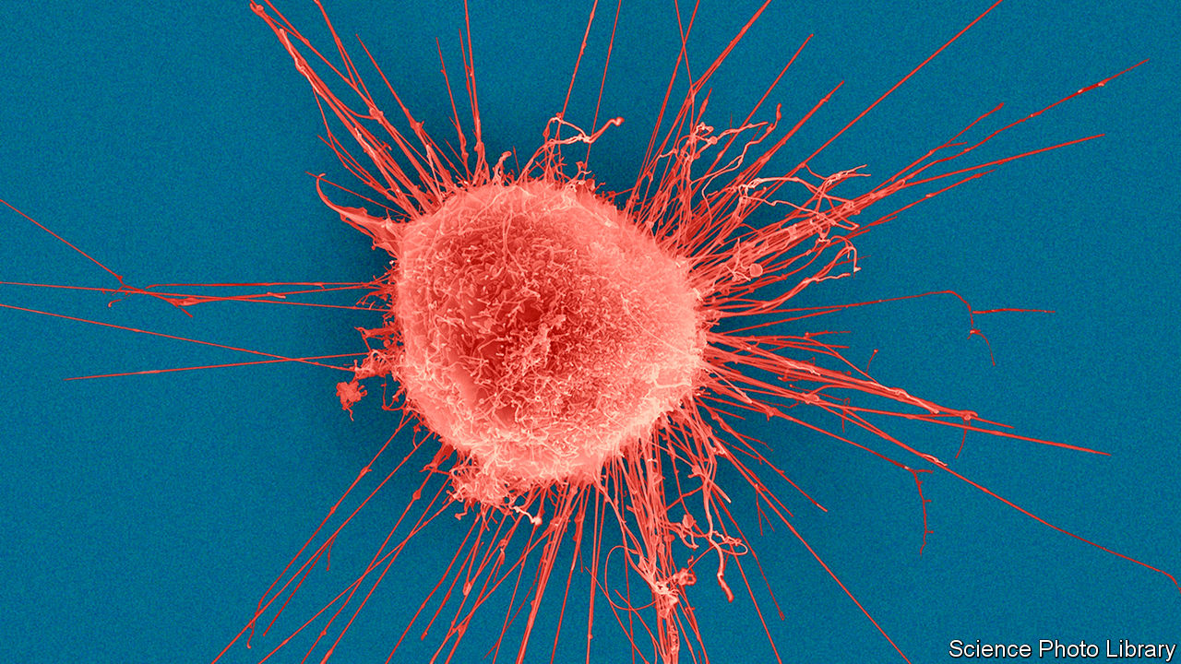

PERHAPS MORE than any other, cancer is seen as a disease of genes gone wrong. So, as genetic-sequencing technology has become cheaper and faster, cancer scientists are using it to check which changes to genes cause tumours to spread.

The latest insights from one group, the international Pan-Cancer Analysis of Whole Genomes (PCAWG), are revealed this week in Nature. In an analysis of the full genomes of 2,658 samples of 38 types of tumour taken from the bladder to the brain, the researchers give a blow-by-blow account of how a series of genetic mutations can turn normal cells into runaway clones. It provides the most comprehensive analysis yet of where to find this damaging disruption to DNA and, by unpicking the genetics of what makes cancer tick, just how hard it will be to tame.

For each of the cancer samples, the team produced a read-out of the tumour genome—the 3bn or so individual DNA letters—and compared it with the genome sequences of healthy cells taken from the same patients. In this way they could look for the genetic signatures of the cancer cells, where specific mutations had warped the genetic information.

Most mutations in the genome are harmless. But driver mutations, where genetic changes cause a cell to multiply more easily and faster than other cells, can trigger tumour growth. Many driver mutations have been found over the past decade and a handful have been translated into new medicines. In a fifth of breast cancers (pictured), for example, a driver mutation in the gene HER2 makes cells produce more of a protein on their surface that encourages them to grow and divide out of control. A series of drugs, including Herceptin, target this protein, and lead to significantly improved survival rates. The same HER2 mutation also appears in some lung cancers, raising hopes that similar therapies could work against that disease.

The problem is that most cancers have multiple driver mutations. Indeed, the PCAWG work found that on average each cancer genome carried four or five. And with some clever genetic archaeology they also found that some driver mutations can occur years before symptoms appear.

To discover this, researchers used a new concept called “molecular time” to reconstruct the cellular evolution of tumour cells. By comparing the DNA of cells within tumours, the researchers could place mutations in chronological order based on how many cells they appeared in. Earlier mutations occur more frequently. For example, driver mutations in a gene called TP53 were found to have originated at least 15 years before diagnosis in types of ovarian cancer, and at least five years before in types of colorectal and pancreatic cancer. Driver mutations in a gene called CDKN2A were found to have occurred in some lung cancers more than five years before diagnosis. In theory, that provides a window in which to find people at risk of developing these diseases, and perhaps prevent the cancer ever appearing.

The new study closes down talk that significant numbers of unknown driver mutations could lurk in the relatively unexplored regions of the human genome. One such driver mutation in non-coding DNA was found in 2013—a mutation in the TERT gene across many different cancer types. To check for more like this, the consortium sequenced and analysed all the DNA letters of these non-coding regions (which account for 98% of human DNA) for the first time. They found that non-TERT driver mutations occurred at a rate of less than one per 100 tumours in these regions.

Peter Campbell of the Wellcome Sanger Institute in Cambridge, Britain, and a member of the PCAWG consortium, says an important contribution of the study is that by sequencing so many tumours it has raised the number of patients in whom a genetic contribution to their cancer can be identified from less than 70% to 95%. The goal, he says, is for genome sequencing of tumours to become routine. Efforts to introduce this are under way in some countries, including Britain, the Netherlands and South Korea, he adds.

## Results, results, results

Insights are all very well, but what about cold, hard clinical progress? Turning genome sequences into meaningful predictors of cancer will require comparisons between samples from tens of thousands of patients, say the researchers, along with data on their treatments and survival rates. Processing this would be beyond the reach of any single organisation. Instead, a follow-up project is planned that includes national funding agencies, charities and corporate partners from more than a dozen countries around the world. It aims to link full sequences of 200,000 cancer patients to their clinical data by 2025.■

This article was downloaded by calibre from <https://www.economist.com/science-and-technology/2020/02/08/scientists-reveal-the-most-extensive-genetic-map-of-cancers-ever-made>

|  |  |  |  |
| --- | --- | --- | --- |
| Previous | Articles | Sections | Next |

|  |  |  |  |
| --- | --- | --- | --- |
| Previous | Articles | Sections | Next |

#### Neuroscience

# Growing up in a city weakens the brain’s navigational skills

Country folk can find their way more easily

Feb 8th 2020 |

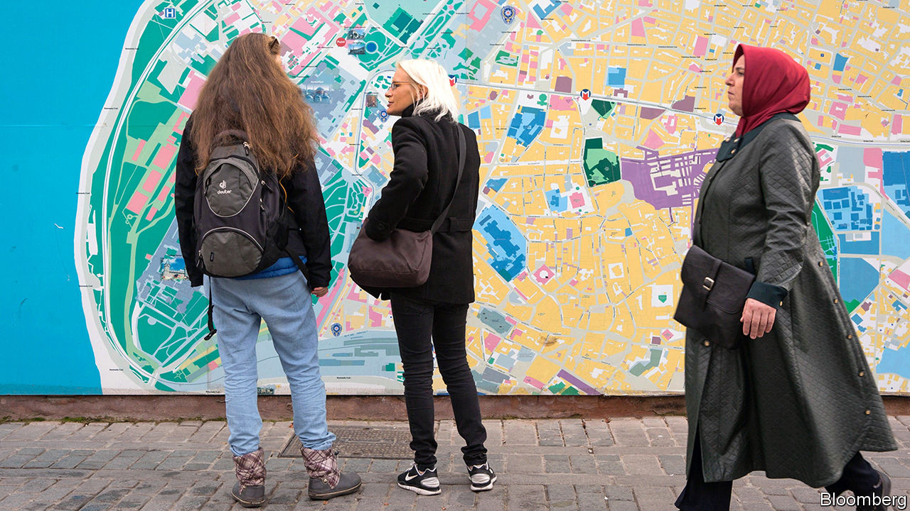

RURAL FOLK can blame Aesop—of the moralising fables—for centuries of stories that mock them as bumpkins. The ancient Greek storyteller’s tale of the Country Mouse and the Town Mouse was only the first to emphasise their supposed simpler tastes and habits when compared with more sophisticated urbanites. So listen for the cheers from Somerset to Kansas as neuroscientists announce that, in fact, it is city living that can dull the wits—at least when it comes to finding one’s way in the world.

Growing up in a city, a vast global survey has found, has a lifelong negative impact on a person’s ability to navigate. When looking for a half-remembered restaurant in a poorly-lit side street, it seems Country Mouse would be a more useful companion.

In the new study, posted to the online repository bioRxiv, scientists led by Antoine Coutrot at Nantes University in France and Hugo Spiers at University College London describe how they used a dataset gathered from 4m players of a computer game called “Sea Hero Quest”, which tests way-finding skills by asking players to memorise a map showing the location of checkpoints and then measuring how well players can steer a boat to find them, guided only by their mental map.

The game was released in 2016 and all players have since been asked for basic information about themselves, including their age, gender, home country, and whether or not they grew up in a city.

From that database, Dr Spiers and his colleagues examined a subset of 442,000 players from 38 countries: those who had answered all the questions and who had played the game until they reached the later levels. He found that the strongest indicator of a high score was a player’s age—older people performed relatively poorly, which chimes with what researchers know about age-related cognitive decline. But the benefit of rural living was strong enough to offset some of that. Data from American players showed that a 70-year-old who grew up in the countryside had the navigational abilities of an average 60-year-old across the dataset.

The gap between the navigation skills of rural and city people was largest in America (about six times wider than for Romania), and the researchers think they know why. They gave each country a complexity score by analysing how the streets were laid out in its largest cities. And they found that countries dominated by simple layouts of grid-based cities (most common in America and Argentina) dragged down navigation skills more than growing up in a city based around more complicated networks of streets, such as Prague.

The study does not show why cities have this impact on people growing up in them. It cannot rule out that an external factor, such as the effect of air pollution on a developing brain, might play a role. But Dr Spiers says that the brain’s navigational abilities probably weaken in the less challenging city environment because they are not being used as much. Although cities may appear more elaborate, they also feature more clues to help residents find their way, such as numbered streets. As many city-dwellers on a visit to the countryside can attest, one field tends to look much the same as another, so there are fewer external landmarks to help guide the way.

## Street smart

Neuroscientists already know that living and working in more complex environments can influence the function and structure of the brain. Brain scans of London taxi drivers who have gained an encyclopaedic memory of the city’s streets by learning “The Knowledge” show that they tend to have an enlarged hippocampus—a region of the brain acting as a neural GPS, sensing position and trajectory on an internal map of the environment.

The detrimental effect of city living on navigation (taxi drivers aside) is probably most acute in people under 16-18, Dr Spiers says, because their still-developing brains respond and change the most according to external stimuli. And while people who live in cities with young children should not be alarmed, the study does raise some interesting ideas for urban planners: keep their city designs not so simple perhaps. And for everyone else, it might be an idea to turn off Google Maps.■

This article was downloaded by calibre from <https://www.economist.com/science-and-technology/2020/02/08/growing-up-in-a-city-weakens-the-brains-navigational-skills>

|  |  |  |  |
| --- | --- | --- | --- |
| Previous | Articles | Sections | Next |

|  |  |  |
| --- | --- | --- |
| Science and ... | Sections | Economic and ... |

Books and arts

French cinema: Sounding the alarm

.

Literature and beyond: Marriage story

.

Trade secrets: As you sow

.

Indian fiction: Tales of a city

.

War and its aftermath: The inferno

.

|  |  |  |
| --- | --- | --- |
| Science and ... | Sections | Economic and ... |

|  |  |  |  |
| --- | --- | --- | --- |
|  | Articles | Sections | Next |

#### Sounding the alarm

# A new wave of French films tackle social problems and taboos

As “La Haine” did a quarter of a century ago, “Les Misérables” explores life in the banlieues

Feb 8th 2020 |

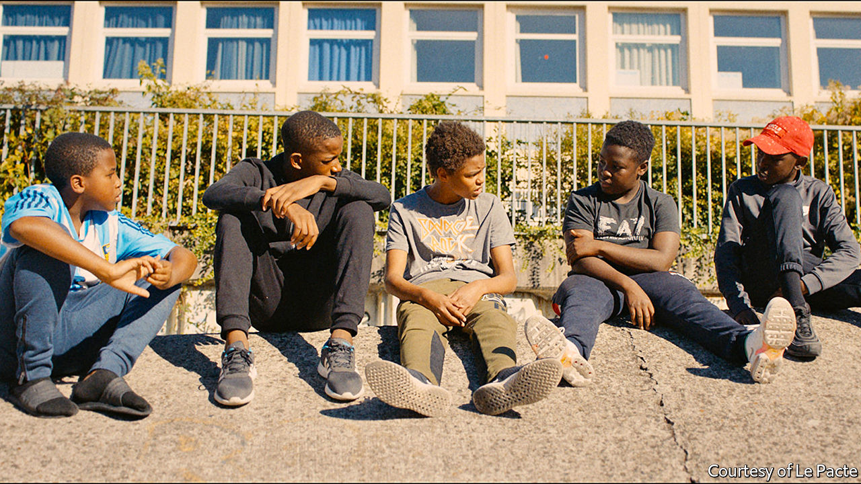

IT IS THE long hot summer holiday in the year that an ecstatic France has celebrated victory in the football World Cup. Issa, a boy from the brutalist housing estates north of Paris who shared that joy, has been picked up by the police for theft. So far, so banal. But it turns out that Issa stole live chickens—and he took them to feed a lion cub he has snatched from a visiting circus. From this improbable, captivating incident, which reflects Issa’s boredom as much as his naivety, flow a series of devastating events that end childhood innocence and expose the muscular friction of daily life in the French banlieues.

Once in a while, a film of raw energy and emotional authenticity emerges on the big screen in France and shakes the cinematic establishment. “Les Misérables”, which was nominated for best international feature film at the Academy Awards on February 9th—and picked up the Prix du Jury at Cannes last year—is an example. Co-written and directed by Ladj Ly, a Malian-born film-maker who grew up in one of the concrete estates in Montfermeil where the movie is set, it follows a trio of cops and a band of lanky boys. The sense of tracking the action is made literal: when the run-in between Issa (played by Issa Perica) and the police goes horribly wrong, the moment is inadvertently recorded from above by Buzz (Al-Hassan Ly, the director’s son), another youngster. Buzz fills his empty days by flying a drone from the top of his high-rise.

The tension of the initial chase escalates into a fast-paced, troubled quest by the policemen to seize the video and cover up what happened. In this, Mr Ly’s touch is refreshingly even-handed. His camera hovers over his subjects and their confined neighbourhood like the boy’s drone. As the film gathers pace, les flics confront each other as well as their consciences, weighing self-preservation and team loyalty against moral misgivings. Local Muslim elders feature, but religion does not intrude. For their part, the boys (pictured) veer between youthful exuberance—sliding gleefully on plastic lids into a concrete dump, or staging water-pistol fights—and terrifying violence. In one scene, when the kids’ game collides with the cops’ patrol car, a boy who looks no older than ten chillingly holds the gaze of a policeman and draws his finger across his throat.

Inevitably, critics have compared “Les Misérables” to “La Haine”, a famously angry monochrome drama released a quarter of a century ago, which also features police violence (and few women) in the banlieues. That film opened the eyes of a generation of cinema-goers, more used to French art-house movies shot in parquet-floored apartments, to the angular bleakness and rage beyond the capital’s périphérique (ring road). Indeed, Mr Ly has acknowledged that he, like so many others, was “greatly inspired” by it. If anything, and despite moments of wry humour, “Les Misérables” is bleaker still. It dwells on the latent anger and disorientation of a younger generation of boys than its predecessor.

In some ways “Les Misérables”, which takes its name from the novel by Victor Hugo in which the former village of Montfermeil appears, is really an action flick that uses the banlieue as a backdrop. “We didn’t think of it as a banlieue film as such,” says Toufik Ayadi, one of the film’s producers, referring to the minor genre that has emerged in France since “La Haine”. Rather, says Christophe Barral, his co-producer, the idea was to draw on the human stories that happen to be so rich there. “There is a much greater imagination”, he says, “just a few kilometres from Paris.”

Yet the movie is also political, or what the French call a film engagé. Mr Ly, the first black French director to have his work nominated for the Oscars, has described it as a “warning cry”. As an aspirant film-maker, he used to record the real police violence he witnessed, and this eye lends the film its authenticity. President Emmanuel Macron is said to have been taken aback after watching a private screening at the Elysée Palace.

“Les Misérables” thus fits into a rising trend towards a new, unabashed social frankness in French film-making. Even in the wake of “La Haine”, for the most part “French auteur cinema tends to be very middle-class, looking at the Parisian microcosm,” says Ginette Vincendeau, professor of film studies at King’s College London. “When it comes to social realism, we often refer to British cinema, and the films of Ken Loach, and say that we don’t have this in France.”

## Beyond the bourgeoisie

Now that seems to be changing. A number of recent French films have taken a hard, often bittersweet look at contemporary social issues. As French politics has been upended by Mr Macron, film-makers seem to have spied an opportunity to make new arguments, and ask new questions, on the big screen—in an echo of the experimentation in French cinema in the 1950s and 1960s. Last year alone, such movies explored educational disadvantage (“La Vie Scolaire”, “La Lutte des Classes”), farming and rural suicide (“Au Nom de la Terre”), redundancy and factory closure (“En Guerre”) and society’s attitude to autism (“Hors Normes”).

Olivier Nakache and Éric Toledano, the pair behind “Hors Normes”, made their name with “Intouchables”, a blockbuster comedy. In their latest film they turn to the efforts of two social workers in Paris (one played by Vincent Cassel, who memorably starred in “La Haine”) to offer shelter and purpose to severely autistic youngsters whom the social-welfare system fails. When the central autistic character, Joseph (Benjamin Lesieur), pulls the alarm in the metro, it serves as a wider metaphor. “The important thing”, Mr Nakache has said, is “to break the taboo on certain subjects”.

As a movie, “Hors Normes” has touching moments, although in the end its message gets in the way of a truly compelling drama. Such is the risk with the genre. The politically engaged films made in the 1990s after “La Haine” were also of patchy quality. Nor are these politically sensitive films always simple to finance. “Les Misérables” itself struggled, initially winning no backing from official French cinematic institutions. Still, whether or not Mr Ly’s disturbing, sharply observed story claims an Oscar, in France, at least, it has already made its mark. “It’s good that French film is offering something other than bourgeois cinema,” says Mr Barral, the co-producer. “Perhaps people have had enough of that.” ■

This article was downloaded by calibre from <https://www.economist.com/books-and-arts/2020/02/08/a-new-wave-of-french-films-tackle-social-problems-and-taboos>

|  |  |  |  |
| --- | --- | --- | --- |
|  | Articles | Sections | Next |

|  |  |  |  |
| --- | --- | --- | --- |
| Previous | Articles | Sections | Next |

#### Marriage story

# The temptations of Tolstoy, on the page and in the flesh

Andrei Zorin’s subtle biography weaves together the novelist’s life and writing

Feb 6th 2020 |

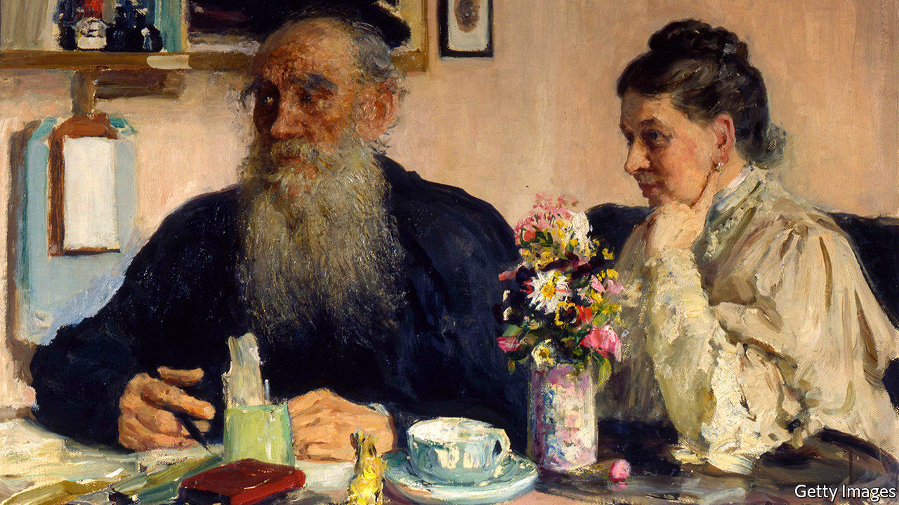

Leo Tolstoy. By Andrei Zorin. Reaktion Books; 224 pages; $19 and £11.99.

LEO TOLSTOY was an inveterate quitter. All his life, he gave up the things that mattered to him, or tried to. He bolted from university without a degree, left the army, renounced the privileges of aristocracy. He rejected the Orthodox church and abjured fiction as a vanity. He forswore the libertinism of his youth, and—eventually—fled his tortured marriage, in the fatal escape that ended at the railway station in Astapovo.

This urge to shed distractions and commitments is one of the continuities that Andrei Zorin, a cultural historian at Oxford, traces in his beautiful account of Tolstoy’s long, astonishing life. Born in 1828 at Yasnaya Polyana, a family estate, Tolstoy studied in Kazan, fought in the Caucasus, became the world’s most famous author and founded what amounted to a new religion. He was an avid farmer, an education reformer and a champion of famine relief. Strive as he might to repudiate fame, in 1910 the world’s media besieged the stationmaster’s house as he lay dying inside.

Death had preoccupied him since his service in Crimea (his depiction of the wastefulness of the war led to an early run-in with the tsarist censors). But sex preoccupied him more. Notoriously, before their wedding he made Sofia, his much younger fiancée, read the diary he began while being treated for gonorrhoea, which detailed his liaisons with prostitutes and concubines; the marriage was consummated in the carriage after the service. His libido was matched by his remorse and self-disgust. He wept beside the bed in which he lost his virginity; even his desire for Sofia came to seem “loathsome” and “criminal”. The hero of “Father Sergius”, one of his late stories that were published posthumously, is a penitent aristocrat who takes holy orders and cuts off a finger to ward off temptation.

Tolstoy’s ceaseless interrogation of Sofia’s feelings and his own helped make their relationship excruciating. In their last decades, amid a lifetime’s worth of resentments and mounting bereavements, it became intolerable. (“There is no death,” Tolstoy intoned as he trudged in the snow after the youngest of their 13 children perished in 1895.) At the end, after Tolstoy finally walked out, Sofia was banished from his deathbed in Astapovo and had to peer at him through the window. Yet it was in this agonising marriage that he produced “War and Peace” and “Anna Karenina”.

In an ingenious, seamless approach that distinguishes his biography from others, Mr Zorin treats the events of Tolstoy’s life and his writing as a single, indivisible whole. As he says, the genius of Tolstoy’s art lay in its combination of verisimilitude and depth: “from any occasion, however trivial it may seem, he is ready to derive major conclusions about humankind.” He sketches his subject’s relations with Gorky, Turgenev, Chekhov (whose plays Tolstoy thought very bad) and Dostoyevsky (over whose death Tolstoy wept, though they never met). He notes the political upheavals, above all the emancipation of the serfs, which were the novels’ wider context.

In a country where other forms of authority were discredited, writers had a special, oracular status. Still, for Tolstoy, literary acclaim came to seem meaningless. Writing fiction was not the way to improve the world; as with the pleasures of the flesh, he berated himself when he lapsed into it again. (Rereading “War and Peace”, he felt “repentance and shame…not unlike what a man experiences when he sees the remains of an orgy in which he has taken part.”) His political and moral views—anarchistic, radical, anti-modern—fused in a heretical new version of Christianity and a dissident activism, at once cranky and heroic, which made him a star all over again. His creed rejected all kinds of violence and oppression, which, for him, included the strictures of lust as well as state power.

On the eve of his death he was still inveighing against capital punishment. He was buried at Yasnaya Polyana—which, Mr Zorin observes, he left many times but, unlike many other attachments, he never abandoned—in a glade where, as a child, he hunted for a magical stick that could rid the world of evil. His unmarked, turf-covered grave has an aura of eerie calm. ■

This article was downloaded by calibre from <https://www.economist.com/books-and-arts/2020/02/06/the-temptations-of-tolstoy-on-the-page-and-in-the-flesh>

|  |  |  |  |
| --- | --- | --- | --- |
| Previous | Articles | Sections | Next |

|  |  |  |  |
| --- | --- | --- | --- |
| Previous | Articles | Sections | Next |

#### As you sow

# How seed-rustling in Iowa fed American fears of China

Mara Hvistendahl’s account of a commercial-espionage scandal reads like a thriller

Feb 8th 2020 |

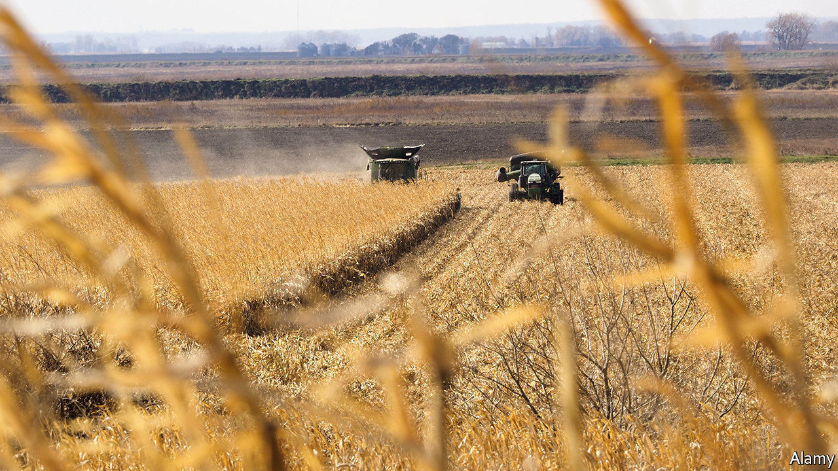

The Scientist and the Spy. By Mara Hvistendahl. Riverhead Books; 336 pages; $28

IN THE AUTUMN of 2011 two ethnic Chinese men were seen digging up seeds in a cornfield in Iowa. When approached, they sped away in a hired car. A routine report of trespassing quickly spiralled into a long FBI investigation that uncovered a plot by DBN, a Chinese agricultural company, to reverse-engineer seed lines belonging to two American firms, Monsanto and DuPont Pioneer. When the probe became public, America’s media had a field day. “Hey China!” screamed Bloomberg Businessweek. “Stop Stealing Our Stuff.”

Mara Hvistendahl’s compelling account of the drama reads in parts like a spy thriller, replete with car chases, phone-tapping and aerial surveillance as agents track the shovel-carrying suspects across America. The anti-hero is Robert Mo, an American-based Chinese research scientist who took a job with DBN to help pay his mortgage. Pressed into seed-rustling, he darts from field to field, yanking genetically modified strains from the ground, while posing as a grower to buy others from wholesalers for thousands of dollars in cash.

He ends up with almost comically large quantities—wrapped in napkins swiped from Subway or stashed in microwave-popcorn boxes. Some of the seeds are taken to be grown and monitored on a plot in Illinois, conveniently close to Chicago’s international airport. Later arrested and accused of conspiring to steal trade secrets, Mr Mo would plead guilty and serve a three-year sentence. None of his suspected co-conspirators was prosecuted.

As Ms Hvistendahl explains, industrial espionage goes back centuries. Early examples often involved the West stealing from the East, such as undercover efforts to learn about Chinese tea and porcelain production. For much of the 20th century America and Europe worried most about each other’s spies. The idea of China as thief-in-chief is new. So is America’s tough legislation against stealing trade secrets, which was not a federal crime until 1996. Before then it was regulated by state laws and civil suits brought by aggrieved companies.

Fears over Chinese pilfering of intellectual property (IP) and technology have soared under President Donald Trump, fuelling trade tensions and a tech stand-off. In 2018 there was talk in the White House of banning all students from China out of concerns over spying. The recent charging of a Harvard academic for failing to disclose Chinese state funding highlights anxieties about Beijing-backed “talent programmes” at American universities.

But the picture is not as clear as Mr Trump paints it. Both China and America are locked in internal struggles as well as with each other, says Ms Hvistendahl—in China’s case between “the duelling forces of copying and innovation” (it has oodles of its own patents) and in America’s between openness and security. Nor are motives simple to unpick. The seed plot was driven in part by Chinese ambition (to be a world leader in GM crops) but also by fear. Shortfalls of grain to feed their people, as well as poor yields, are a huge food-security headache for Communist Party leaders.

Nor, indeed, is the source and size of the threat always clear. DBN is a private outfit, albeit one with the mission of “rewarding the state with agricultural development”. Some firms have their own incentives to steal; others may be responding to what they see as official incitement, as when President Xi Jinping urged Chinese businesses to master “core technologies”. Not all of these are acquired through subterfuge. In 2016 ChemChina, a state-owned group, paid $43bn for Syngenta, a Swiss seeds-to-pesticides company. Estimates of the scale of Chinese IP theft, which value it as high as $600bn a year, are based on wild extrapolations, Ms Hvistendahl shows.

She also questions whether safeguarding IP is an unalloyed good. Sometimes tight protection may benefit the powerful but hamper innovation. One reason cited for Silicon Valley’s success is its ban on non-compete agreements, which makes it easier for whizzes to start their own firms.

What is clear from this book is that America’s response to China has often been misguided. The FBI and CIA, looking for new threats after the cold war, piled resources into combating economic espionage, often hamfistedly. Ms Hvistendahl describes overzealous investigations that skimped on science and relied on racial profiling. The agencies have yet to eschew the idea that China relies mostly on its vast population, an army of amateur snoops, rather than technology or covert operations. This, she says, is “as if China were to develop a theory of how the CIA functioned based on American individualism”. ■

This article was downloaded by calibre from <https://www.economist.com/books-and-arts/2020/02/08/how-seed-rustling-in-iowa-fed-american-fears-of-china>

|  |  |  |  |
| --- | --- | --- | --- |
| Previous | Articles | Sections | Next |

|  |  |  |  |
| --- | --- | --- | --- |
| Previous | Articles | Sections | Next |

#### Tales of a city

# A mystery that uncovers the underside of modern India

Deepa Anappara’s debut novel is narrated by an ebullient nine-year-old boy

Feb 8th 2020 |

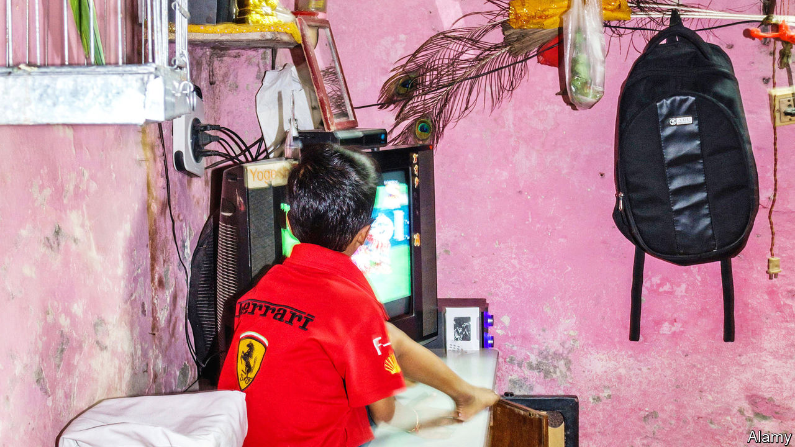

Djinn Patrol on the Purple Line. By Deepa Anappara. Random House; 368 pages; $27. Chatto & Windus; £14.99.

JAI LOVES a mystery. He watches true-crime shows on television, even though his mother says that, at the age of nine, he is not old enough.

Ma switches off the tv right in the middle of a murder because she says it’s too sick-making. But sometimes she leaves it on because she likes guessing who the evil people are and telling me how the policemen are sons-of-owls for never spotting criminals as fast as she can.

He cannot be banished from the television, for Jai lives with his parents and 12-year-old sister Runu-Didi in one room in an unnamed Indian city. There is joy in this small home: “Papa likes to say that this room has everything we need for our happiness to grow.” But then children begin vanishing from the neighbourhood, and Jai decides it is up to him to solve their disappearance.

Deepa Anappara’s debut novel has echoes of others in which children’s curiosity casts light on the prejudices and perils of their society. Harper Lee’s “To Kill a Mockingbird” is the most famous example—Stephen Kelman’s “Pigeon English” also comes to mind—but Jai’s sprightly narrative voice is all his own. As he applies his abundant energy to his self-imposed and secret task, readers get a tour of his city and its residents. The place bears some resemblance to Delhi (where, as in the novel, the metro lines are known by their colours).

As well as Jai’s, Ms Anappara tells the stories of the disappeared: brief, third-person portraits which efficiently sketch lives of a kind that are seldom chronicled in literature. Her prose is full of fine, vivid images. A flush of shame spreads across a character’s chest “as if someone has spilled a hot cup of tea on her”. When Jai senses his mother is upset with him, her “eyes loop me like a red-ink pen around a wrong answer”.

This moving and stylish book pulls off a difficult trick. It is an engaging, amusing tale, powered by Jai’s ebullient personality; at the same time it is an insightful portrait of the underside of 21st-century India. The author worked there as a journalist before settling in Britain and studying creative writing at the University of East Anglia. Her novel was inspired by the struggles she encountered during her reporting (an afterword gives details of children’s-rights charities in India). As Dickens did, Ms Anappara understands the power of fiction to bring alive the plights of people readers might otherwise overlook.

This article was downloaded by calibre from <https://www.economist.com/books-and-arts/2020/02/08/a-mystery-that-uncovers-the-underside-of-modern-india>

|  |  |  |  |
| --- | --- | --- | --- |
| Previous | Articles | Sections | Next |

|  |  |  |  |
| --- | --- | --- | --- |
| Previous | Articles | Sections | Next |

#### The inferno

# The destruction of Dresden, the “Florence of the Elbe”

A compassionate new history of an infamous Allied bombing raid

Feb 8th 2020 |

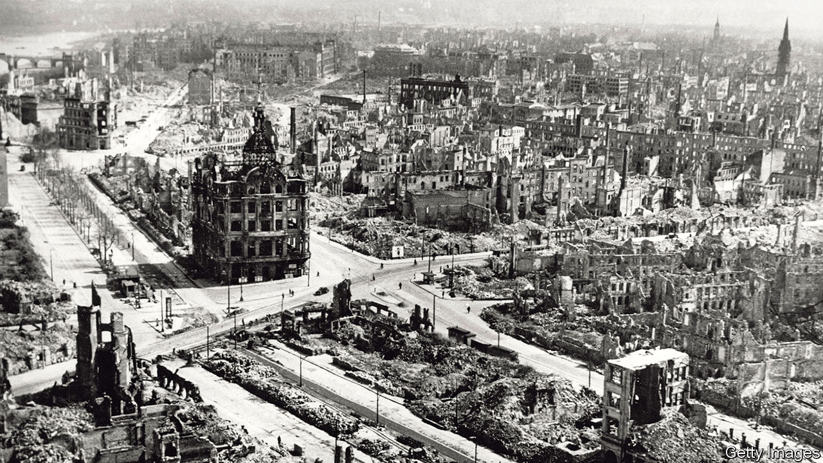

The Fire and the Darkness: The Bombing of Dresden, 1945. By Sinclair McKay. St Martin’s Press; 400 pages; $32.50. Published in Britain as “Dresden: The Fire and the Darkness”; Viking; £20.

SEVENTY-FIVE YEARS ago, on February 13th 1945, Dresden’s citizens were weary and apprehensive. Since the middle of January trains packed with refugees fleeing the relentless advance of the Soviet Red Army had been arriving at the city’s huge railway station. Having crossed the Oder, Marshal Zhukov’s troops were getting close. But despite the anxiety, Dresdeners were trying to summon up the carnival mood of Fasching, the festival that marks Shrove Tuesday. It was a day of socialising and drinking, while children donned colourful costumes and played street games.

At 9.40pm what had passed for jollity came to a sudden end as the drone of air-raid sirens echoed through the streets. Resignedly people made their way to shelters, for the most part wretchedly inadequate basement cellars. There had been many false alarms in the city, but only two raids had materialised to date. Both had been carried out by the Americans, each resulting in several hundred deaths.

Dresden’s inhabitants knew only too well the devastation that mass bombing raids had brought to other German cities. In Hamburg, firestorms whipped up by incendiary bombs had killed 37,000 civilians. But many were convinced that their city, the “Florence of the Elbe”, would be spared because of its cultural importance. Soon after 10pm those hopes were dashed as the first wave of 796 RAF bombers began dropping their 4,000lb “blockbuster” bombs, opening gaping holes in roofs for incendiary devices to fall through.

In the course of that single night, the historic heart of the city and much of its suburbs became a conflagration that left around 25,000 dead. But the Allies were not finished. The morning saw another wave of attacks, this time by 311 American B-17s. Even after the dropping of atom bombs on Hiroshima and Nagasaki, Dresden was to stand as a symbol of wanton destruction. Increasingly, the wider “area bombing” campaign, which killed more than half a million Europeans and of which Dresden was a tragic climax, was questioned on both moral and military grounds.

There have been many books on the bombing of Dresden (not least Kurt Vonnegut’s novel, “Slaughterhouse Five”), but Sinclair McKay’s account is a worthy addition. For one thing, it is scrupulously fair. Before describing the city’s extraordinary contribution, from the early 18th century onwards, to the arts and science, he paints a picture of a community that had accommodated itself to Nazism all too comfortably. At the time of the raid, Dresden’s Jewish population, so central to that creativity, had fallen from more than 6,000 to 198. Slave labourers toiled in its factories. Even before the war, the beautiful Semper Synagogue was burned down. How could “such violent hatred against Jews”, Mr McKay asks rhetorically, “have festered in a city that had stood above all for art, and the intellect, and the commingling of cultures?”

He provides a harrowingly detailed narrative of the horrors experienced during the night of the raid by Dresdeners from many walks of life, illuminated by eyewitness descriptions, letters and diaries (including those of Victor Klemperer, a Jewish philologist). But he also extends human sympathy to the mostly very young men who had been sent to destroy the place, and whose chances of completing their tours of duty were slim. Of the 125,000 air crew who served in the RAF’s Bomber Command, 72% were either killed, seriously wounded or became prisoners-of-war.

Was the attack a war crime, as many believe? Winston Churchill’s omission of the bombing campaign when reeling off British military triumphs in his victory speech was telling, as was the post-war reluctance to award its veterans a campaign medal, a slight still felt deeply by their families. The campaign’s architect, Sir Arthur Harris, continued (if unconvincingly) to claim the “military necessity” of the raid—Britain’s Soviet allies had been demanding it as a way to spread chaos behind enemy lines—while insisting that he was not responsible for individual targeting decisions.

Mr McKay’s purpose is neither to condemn nor condone, but to record what happened and why. Eschewing easy moralising, he prefers to reflect on Dresden’s intensely moving annual ceremony of remembrance and the episode’s place in collective memory. Above all, he rejoices in the modern city’s resurrection. ■

This article was downloaded by calibre from <https://www.economist.com/books-and-arts/2020/02/08/the-destruction-of-dresden-the-florence-of-the-elbe>

|  |  |  |  |
| --- | --- | --- | --- |
| Previous | Articles | Sections | Next |

|  |  |  |
| --- | --- | --- |
| Books and arts | Sections | Graphic detail |

Economic and financial indicators

Economic data, commodities and markets

.

|  |  |  |
| --- | --- | --- |
| Books and arts | Sections | Graphic detail |

|  |  |  |  |
| --- | --- | --- | --- |
|  | Articles | Sections | Next |

# Economic data, commodities and markets

Feb 8th 2020 |

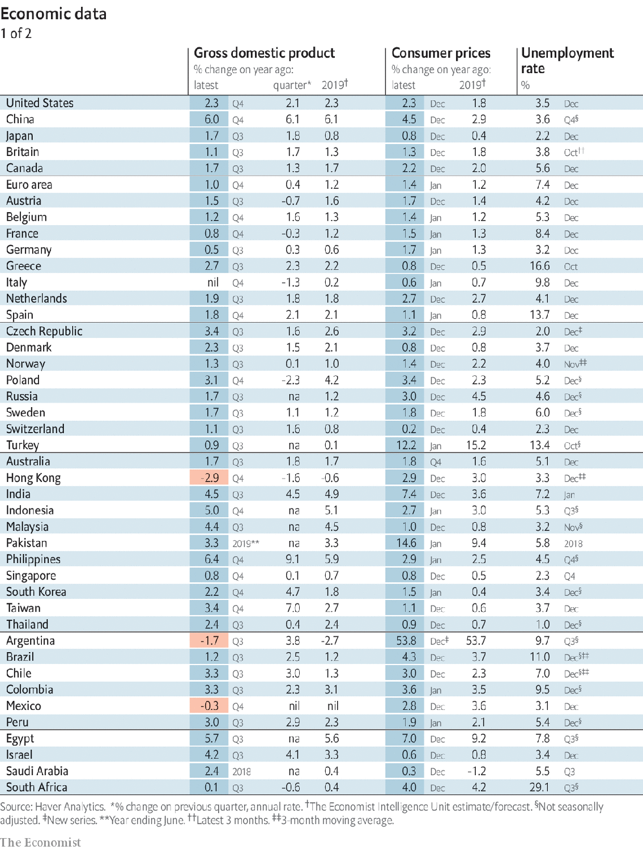

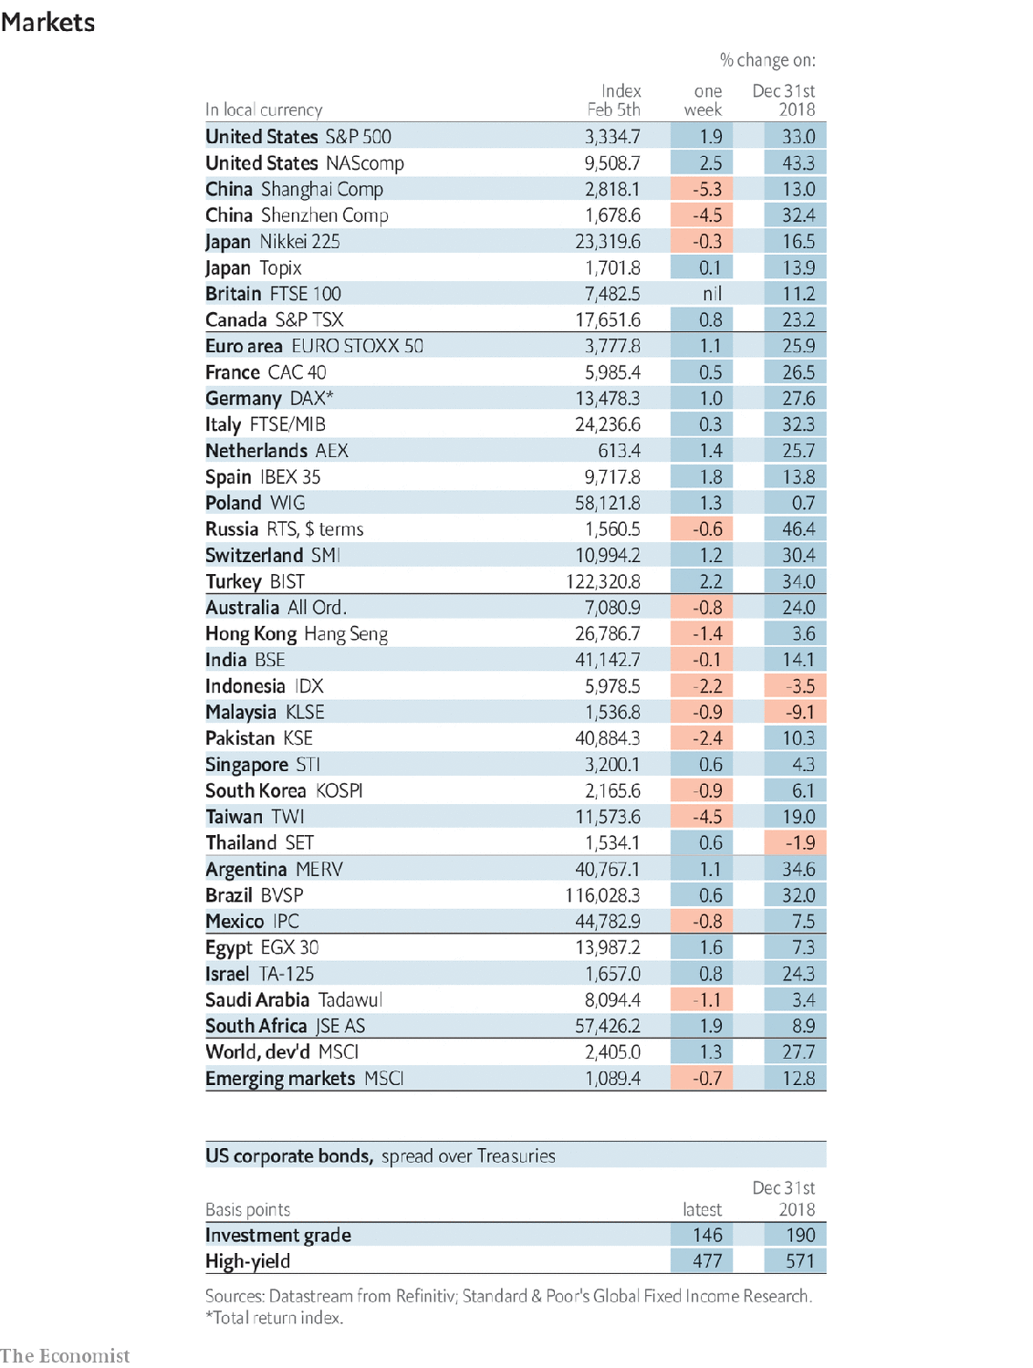

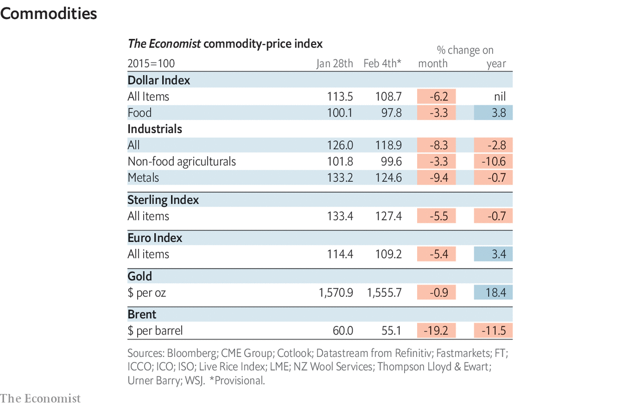

This article was downloaded by calibre from <https://www.economist.com/economic-and-financial-indicators/2020/02/08/economic-data-commodities-and-markets>

|  |  |  |  |
| --- | --- | --- | --- |
|  | Articles | Sections | Next |

|  |  |  |
| --- | --- | --- |
| Economic and ... | Sections | Obituary |

Graphic detail

Music and moods: Sad songs say so much

.

|  |  |  |
| --- | --- | --- |
| Economic and ... | Sections | Obituary |

|  |  |  |  |
| --- | --- | --- | --- |
|  | Articles | Sections | Next |

#### Sad songs say so much

# Data from Spotify suggest that listeners are gloomiest in February

Around the world, the most popular tunes this month will be depressing ones

Feb 8th 2020 |

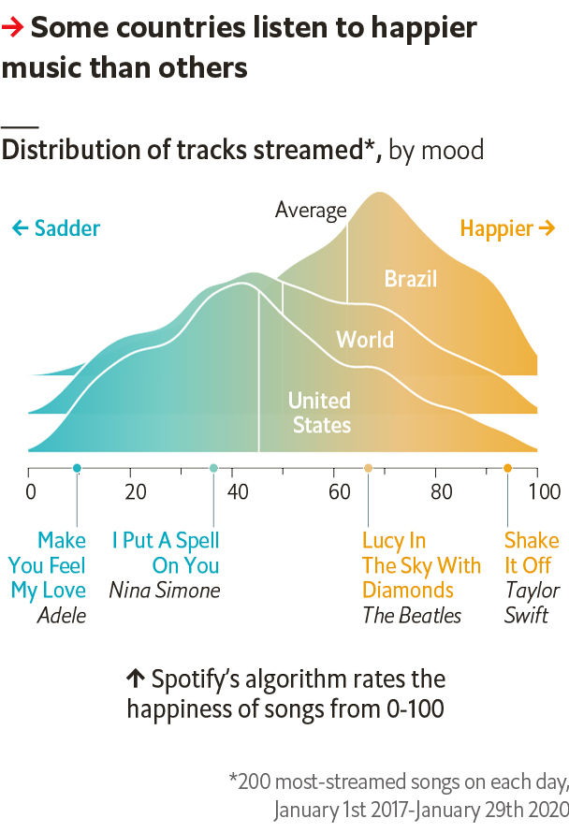

RESIDENTS OF THE northern hemisphere might think that their moods are worst in January. Christmas is over, the nights are long and summer is a distant prospect. Newspapers often claim that “Blue Monday”, in the third week of January, is the most depressing day. To create a quantitative measure of seasonal misery, The Economist has analysed music consumption.

Our calculations use data from Spotify, which offers 50m tracks to 270m users in over 70 countries, mostly in Europe and the Americas. The firm has an algorithm that classifies a song’s “valence”, or how happy it sounds, on a scale from 0 to 100. The algorithm is trained on ratings of positivity by musical experts, and gives Aretha Franklin’s soaring “Respect” a score of 97; Radiohead’s gloomy “Creep” gets just 10. Since 2017 Spotify has also published daily tables of the 200 most-streamed songs, both worldwide and in each country. We gathered data for 30 countries around the globe, including 46,000 unique tracks with 330bn streams, to identify the annual nadir of musical mood. Drum roll, please.

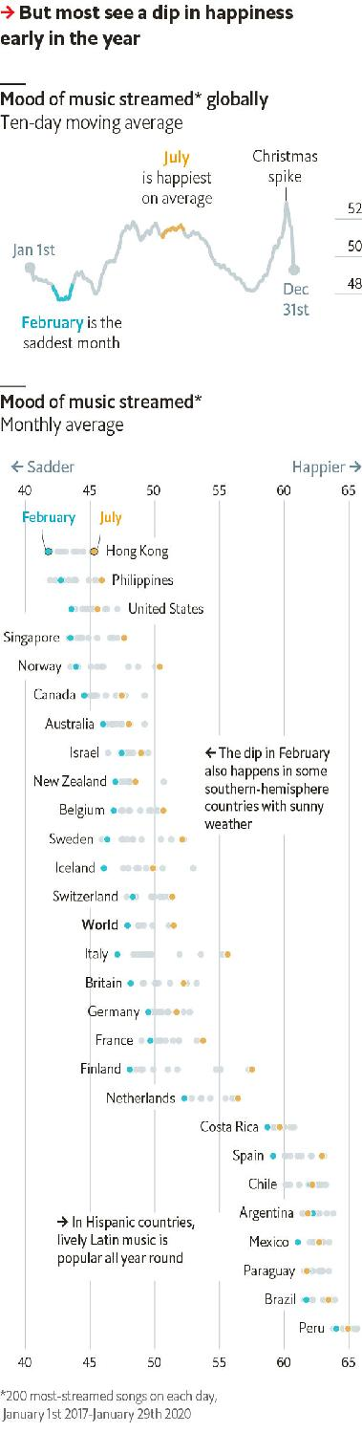

The global top 200 songs are gloomiest in February, when their valence is 4% lower than the annual average. In July, the perkiest month, the mood is 3% higher. The most joyful spike comes at Christmas.

Strikingly, this February slump occurs in some countries near the equator, such as Singapore, and far south of it, such as Australia—even though their musical tastes differ. A few Latin American countries lack such a dip, perhaps because the algorithm sees Latin music as mostly happy.

The icy north shows the biggest seasonal swings. Finland’s mood in July is 11% happier than usual. Overall, on days when a country gets one more hour of sunlight than its annual average, the valence of its streams increases by 0.6%. In contrast, wet days bring particularly downcast tunes.

So why might some countries with long days and clear skies in February get the blues? The cause is not a deluge of mopey singles, since we found no evidence that songs released then were particularly sad. The most played tune of all—Ed Sheeran’s “Shape Of You”, with a valence score of 93 and a remarkable 2.4bn streams—came out in January 2017.

Perhaps the global dip is explained simply by the calendar. For most people, the first weeks of a promising new year have disappeared with little sign of improvement. Anyone for some Joy Division? ■

Sources: Spotify; The Economist

This article was downloaded by calibre from <https://www.economist.com/graphic-detail/2020/02/08/data-from-spotify-suggest-that-listeners-are-gloomiest-in-february>

|  |  |  |  |
| --- | --- | --- | --- |
|  | Articles | Sections | Next |

|  |  |  |
| --- | --- | --- |
| Graphic detail | Sections |  |

Obituary

Homero Gómez: Logger turned saviour

.

|  |  |  |
| --- | --- | --- |
| Graphic detail | Sections |  |

|  |  |  |  |
| --- | --- | --- | --- |
|  | Articles | Sections | Next |

#### Logger turned saviour

# Homero Gómez was apparently murdered on January 13th

The protector of Mexico’s overwintering Monarch butterflies was 50

Feb 8th 2020 |



EVERY YEAR, in early autumn when the chill begins, clouds of bright orange Monarch butterflies rise from the flowers on which they have been feasting in eastern Canada, and head south. They overfly the American Midwest and Texas until, below them, lie the scattered stone houses and corrugated shacks of El Rosario and Ocampo, in the western Mexican state of Michoacán. There, after an astonishing flight of around 4,500 kilometres, they descend to mountain forests of oyamel pine, their favourite tree; and on these they hang to rest and overwinter, so many thousands of them that the branches are weighed down and the trees seem draped with orange leaves. About half of all Monarchs come to this exact, remote place every year, and always from around the same day: November 2nd, Día de Muertos, the day of the dead.

For two decades no one welcomed them more eagerly than Homero Gómez, manager of El Rosario’s Butterfly Sanctuary. In the videos he tweeted daily he stood among them as they arrived, a big moustachioed man in a white guayabera, his arms spread wide as if he longed to fly himself. They greeted him too, settling on his head, his chest and even his nose, basking. They were his darlings, his little voyagers—and also angels, the souls of the local dead returning home. So his grandfather said, and so ran the legends of the indigenous Purépecha, who saw ancestral spirits in their colours. Nothing else so neatly explained why they always came back to this particular place, flexing their marigold wings as if they knew that was the flower of the dead, at this particular time.

Yet he also loved them for more down-to-earth reasons. He had built the El Rosario Sanctuary into the largest reserve for Monarchs in Mexico and, therefore, the biggest in the world, and every video was an appeal for more visitors in the four months the Monarchs were there. “Gran espectáculo”, cried his tweets; “Open daily, 8-5”. Visitors could take a guided tour for 50 pesos, or go on horseback for 100; buy their own butterfly wings in the shop, or have their wedding photos taken, with Monarchs attending, under the trees. In good seasons about 140,000 people came, and from November to March the villagers had money in their pockets.

They had few other ways to make it. Before the reserve people simply cut and sold wood from the forest, and grew maize on plots of cleared communal land to which, under the ejido system set up in 1912 after the revolution, they had no rights of ownership. He did the same. His parents, bringing up ten children, were timber merchants, and he—though he studied agronomy at Chipango University—ended up as a logger, felling the butterflies’ oyamel pines. When the reserve was first proposed, he was fiercely against it. As the natural straight-talking leader of the ejidatarios, he wanted compensation if they were going to save any trees.

But then, around 2000, he changed his mind. He had always marvelled at the butterflies, like everyone else; with a memory as exact as a Monarch’s, he remembered the very date, January 9th 1975, when as a four-year-old he had first brushed close to one. And now, with over-cutting, their forest was fast diminishing. He wanted both to preserve and extend it, planting new trees even on the maize plots and growing more in nurseries. Most of the 260 other ejidatarios thought him crazy, but he talked them round. True, the butterflies did not stay long; but then he himself ran a poinsettia-growing business that did almost all its trade on Christmas Eve. The reserve did not make anyone rich; he still had to struggle to support a wife and four children, and the plaster was still peeling off his sitting-room walls from among the china birds and butterflies. But it gave quite a boost to a poor spot in Michoacán.

Over the years, powered by his enthusiasm, El Rosario prospered. It weathered even the terrible snowstorm of March 2016 when butterflies froze on the pines—though, he was quick to say, the great majority survived. Volunteers helped to plant at least 1m new trees, reforesting 150 hectares. The World Wildlife Fund gave money and bright blue jackets for the guides. State and national officials, on the other hand, once they had banned logging there, did very little beyond coming to get their pictures taken and their salaries justified in a pleasing cloud of Monarchs.

But he faced increasingly dangerous enemies. Illegal loggers, many tied to narcotrafficantes and often armed, came at night to take out timber or to clear the ground for avocados, which made big money. He organised patrols of ejidatarios to keep constant watch: at four in the afternoon, every day, ten men would go into the forest, walking ceaselessly, in silence and without lanterns, all night long to intercept intruders. He swore that if they did not stop cutting down trees he would beat them to a pulp, and worse.

This was risky talk. He told some family members about death threats, though he reassured others that no one had troubled him recently. Nonetheless when his body was found in a holding pond, after he had been to celebrate a patronal festival in Ocampo, few people thought it was just a death by drowning. There were signs of a blow to the head; and some days later one of his guides, Raúl Hernández, was found dead too, battered by something sharp. They were two more in the tally of around 1,600 murders in Michoacán, almost 35,000 in Mexico as a whole, with journalists and activists picked out, in a little over a year.

In El Rosario, at peak season, the trees and the air still thronged with butterflies. There could never, he thought, be too many. But in Mexico there were far too many days of the dead. ■

This article was downloaded by calibre from <https://www.economist.com/obituary/2020/02/08/homero-gomez-was-apparently-murdered-on-january-13th>

|  |  |  |  |
| --- | --- | --- | --- |
|  | Articles | Sections | Next |